Summer Project 2019
Sexual Harassment of Women in the Streets of Kabul, Afghanistan
Asian University For women (AUW)



Frough Tahiri (170205)
Fatima Rezayee (160204)
Supervisor: Professor Dr. Sharin Shajahan Naomi
January, 2020

Abstract
Sexual harassment of women is one of the most pressing problems for women in Afghanistan. Many women in Afghanistan not only suffer from illiteracy, gender discrimination at work place and patriarchal oppression at home, they also encounter different forms of harassment by men in the streets. This summer project research under the grant of Asian University for Women (AUW) aimed to explore the reasons and features of sexual harassment of women in the streets of Kabul from the perspectives of Afghan youth. This research surveyed about 90 students from different universities in Kabul, Afghanistan. The researchers also held several discussion meetings with different students of different universities, such as, Kabul University. The analysis shows that the reasons for sexual harassment of women are deeply rooted in gender inequality and patriarchy in Afghan family, community and tribal culture, and economic and social factors. The data and analysis are obtained from the relevant secondary data sources and the author's surveys and interviews in Kabul in summer 2019.
Key words: Sexual harassment, Patriarchy, Afghan women, Women Rights, Public Space, Violence against Women, Sexual harassment, Afghan youth, Gender Discrimination.
Introduction
Afghanistan is a conservative male-dominant society where the rights of women are suppressed in both private and public sphere. Women’s sexual harassment in public space is a form of violence against women which can limit women’s freedom to a great extent. It has a negative impact on women’s physical and mental well-being. Harassment of women in public spaces could reduce the women’s self-esteem and constrain their social, political, and economic activities. According to a survey report from Afghanistan Independent Commission of Human Rights, 85.4% of Afghan women has faced some forms of harassment in public places by men (2018). Sexual harassment of women in the streets is one of them.
Since the fall of Taliban regime, women in Afghanistan have made remarkable progress in various fields including education, employment and society involvements. Many women have to fight against patriarchal customs in their homes as well at work space for appearing outside their home. Amidst this struggle, sexual harassment of women in streets can hinder many women to engage in education, employment and socio-political activities. Undoubtedly sexual harassment in the streets is one of the bitter experiences for women in Afghanistan who are still fighting for their basic rights.
Sexual harassment of women in the streets is not a new problem in Afghan society. What is new is its alarming rise due to the increasing rate of Afghan women’s mobility in the public space. Women from earlier generations also experienced harassment by men in public spaces, such as, market, which prevented many of them to appear in public spaces. However, the difference between the women in the past and women in today’s world is that women became more educated and vocal to speak up and protest in social and public media. High rate in women motilities, job opportunities, and education opportunities have been increased after the fall of Taliban regime, so does the increasing rate of women’s sexual harassment in streets.
Despite the fact that many Afghan women, especially in Kabul have become educated, the stigma against women is still influencing their decisions to report the case for justice. Many of them “are more likely to hide sexual harassment they experience outside their homes. Many women feel that sharing such cases or reporting to authorities will harm the honor of their families, and it will also challenge their dignity.” (Qaane, 2017).
Literature Review
Sexual harassment as a worldwide issue threat woman around the world. Afghanistan is not an exception. According to a report of Afghanistan Independent Commission of Human Right “1307 out of 1530 women confirmed that they themselves were victims of one or more types of harassment practiced by men. The figure makes up 85.4% of the total number of interviewees. Thus, only 223 people (14.6% of all interviewees), have confirmed that they had not been harassed by Men so far.” (2018). However, the types and intensity of sexual harassment being practice in the countries and communities varies from each other.
The women’s sexual harassment is defined as “using words or committing acts by any means, which causes damage to the personality, body and psyche of a woman.” (EVAW, article 3) The UN bulletin define sexual harassment as “Sexual harassment is any unwelcome sexual advance, request for sexual favor, verbal or physical conduct or gesture of a sexual nature, or any other behavior of a sexual nature that might reasonably be expected or be perceived to cause offence or humiliation to another, when such conduct interferes with work, is made a condition of employment or creates an intimidating, hostile or offensive work environment.” (UN bulletin, Article 1.3).
Afghanistan constitution penalized rape and sexual assault against women and men, but the law does not specifically address women sexual harassment or harassment of women in the street. (Afghanistan penal code, article 429). The Elimination of Violence against Women (EVAW) Law was adopted by the former President of Afghanistan, Hamid Karzai in 2009. It is the first law for women directly addressing the women’s harassment in public spaces in Afghanistan.
Moghadam, Valentine M in an article called Patriarchy, the Taleban, and politics of public space in Afghanistan noted that women in Afghanistan were oppressed for many years. Taliban era was the worst period for women. Women were not allowed to appear outside their home for work, education, or engage in socio-political activities (pp.1, 2002). After the collapse of the Taliban regime, many women managed to start new life again despite extreme patriarchal and conservative traditions and customs that forced them not to raise voice and be obedient to male supremacy.
Angela Joya, an Assistant Professor, Department of International Studies, University of Oregon, in an article titled Shocking violence against Afghan women reveals a crisis in status of Afghan men in The Conversation website says that “women’s role in the private and public spheres have been interpreted through traditional, rural and conservative norms that subordinate women to men.” (2015). The article states that in a patriarchal society, men are considered as breadwinners and men are the ones who take decisions. There is no doubt the women empowerment and their social status “seen as a direct threat to the deep-seated, traditional power of men.” (2015). This deeply rooted patriarchal culture and belief system coupled with history of Islamic fundamentalism have created a culture of silence and women’s objectification and suppression in Afghanistan. High rate of women’s sexual harassment in the streets are one of the consequence of this history, culture and practice that normalize gender discrimination and gender disparity.

Methodology
This research includes a survey 90 students and focus group discussions in different universities in Kabul, Afghanistan. The questionnaire consisted of a mixture of multiple choice and short open ended answers to questions. The questionnaires were distributed among the students who were from different levels of different departments including law, social science, and economics.
The reason for using questionnaire is that some students might not be able to express themselves as they should on this sensitive topic. Some would be getting nervous, as public speaking was stressful, and some other would be feeling embarrassed to share their thoughts. We found that students were more comfortable to write or choose their answers more clearly and confidently in paper without any stress or embarrassment. There were MCQ questions as well open ended questions, which let the participant to express their own thoughts and experiences.
The research also had focus group discussions among the students from Kabul University (KU) and American University of Afghanistan (AUAF) to analyze the data of the survey.
Finally, literature review is another method used in this research. Not many research has been done by scholars on the topic of “Harassments of women in Afghanistan.” However, we found some NGO reports on the topic on related topics. The reason for choosing literature review as secondary data in this research is to see what has been found before on the similar topic, and what issues were not addressed before. Literature reviews of these resources were very helpful I to critically analyses some issues regarding gender.

Findings
Types of Sexual Harassment in Kabul
This research project depicts different types of sexual harassment of women that are common in the streets of Kabul Afghanistan. The most common harassments include; singing songs (12%), winking (11%), staring and leering (10%), kissing sound and action (10%), catcalling (9%), pinching and poking (7%), sneaking and laughing disrespectfully (7%), whistling (6%), following and stalking (5%), pushing against you in public transport or rubbing body (4%), threatening and frightening (4%), touching/itching his private parts publically with an intention to make uncomfortable (3%), deceiving (3%), pulling the purse or scarf (3%), taking pictures and video without permission ( 2%), passing lewd/ sexually explicit remarks about looks/ body (2%), and touching and groping (1%).

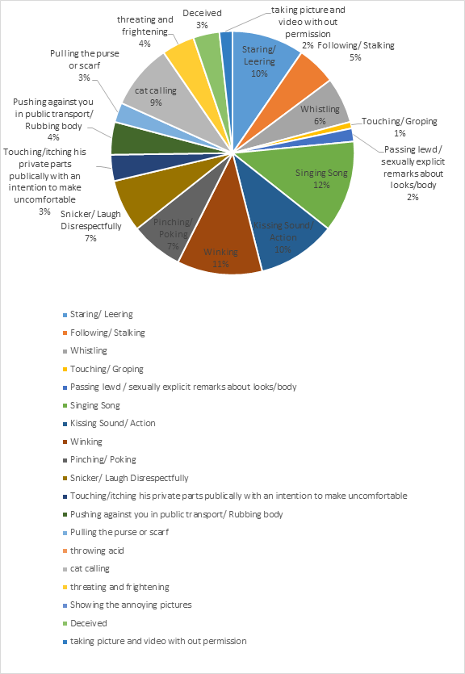
Confronting sexual harassment in a conservative society of Afghanistan is a serious problem for women. Some of the Afghan young ladies are trying to confront the issue while a few number of them responded that they felt helpless. According to the data of study, 32% of the females who have been harassed in the streets of Kabul said that they felt bad, 24% felt bad and learnt to live with it, 12% felt bad and helpless, and 5% took it lightly. Demonstrate through the following graph.
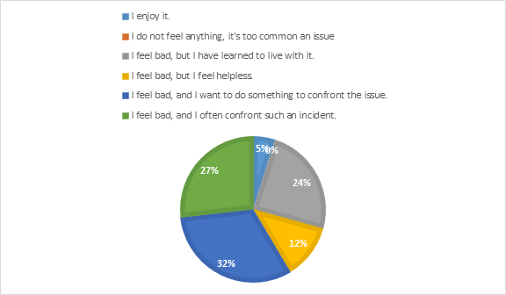
Reasons behind the Sexual Harassment
According to research findings, 19% of the perpetrators thinks it is a time-pass, 18% consider culprit does harass women as a habit, 15% believe that men do it because it makes them ‘manly”, 11% think people do it as fun, 15% blame the poor law and order, 8% could relate it to the culture, and 6% has opinion that men do it with a belief that women might enjoy it. 12% believe that women choose to be harassed.
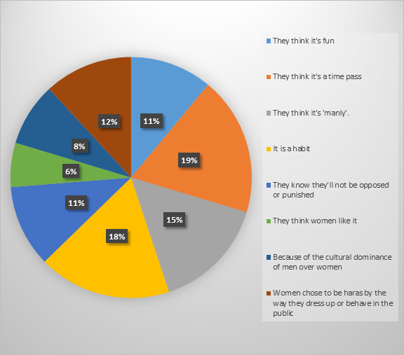
We found that gender dynamics of Afghan families and economic crisis are the two major reasons for women harassment in the streets of Kabul. Afghanistan is a country ruled by tribal leaders till 1974. Patriarchy always played a significant rule throughout history of Afghanistan. Women from very past did not have equal opportunity to get a job outside their home and getting an education.
In Afghan society, usually men are accepted as breadwinners and women are supposed to rely on men members of their families, which makes men the decision makers in the families. The patriarchal society of Afghanistan, caused women to be the second sex in Afghan society. A good woman was portrayed as an obedient woman to man who stays in the house and take care of her children.
Moreover, some people replied women enjoy the teasing and take that as a complement. A student of Law department of Kabul University said: “Teasing is not a sexual harassment because that would not make the women uncomfortable in fact they like compliments.” Since the women were not free to express their feelings and freely in the home and society, especially in terms of relationship and marriage. Women are mostly appreciated to remain silent and pretend to be shy even sometimes resist, these traditions lead to misunderstanding today.

Respondents also identified the economic problems are also counted as a reason behind sexual harassment. According to World Bank, a quarter of labor forces in Afghanistan are unemployed. (2019.) TOLO News, a famous NEWS channel in Afghanistan reported that, 30% of Afghans are unemployed (2018). The high rate of unemployment in Afghanistan cause the youth’s frustration. The high rate of unemployment and lack of healthy entertainment among youths in Afghanistan engage them in to sexual harassment. During the focus group discussion, a senior student of the Kabul University in law department said: “The unemployed youths are not able to get married due to the high cost of marriage, while the rich old men marry four wives. The youths try to chase women, trying to open a conversation or just looking at women give them a pleasure.” Thus, the youths who are unemployed harass women for the purpose of time pass.
However, some responders think that at a broader level the reasons behind the sexual harassment in the streets of Kabul is more of political and security issues. Based on our findings; 58% think that the police are inefficient in ensuring a safe environment.

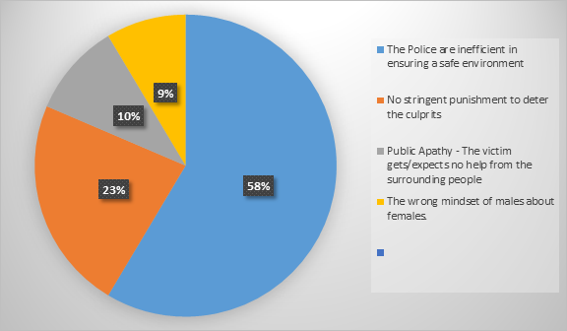
Respondents strongly think that police are inefficient to prevent or address the sexual harassment in streets. Most often sexual harassment is not taken seriously in the legal system, since the main focus of judicial and executive systems is on the domestic violence. Thus, the sexual harassment is not taken seriously by the police which makes the rate of sexual harassment increasing day by day. If a woman is being harassed in the streets of Kabul and they refer to police in order to file a case, most often police judge and blame the victim instead of punishing the culprit. In the worst scenario, police tease women. One scholar of American University of Afghanistan said: “The police assigned on the streets usually stare or would say a very rude thing that hurt your soul. They are there to protect us, instead they harass us. Even my male friends who are fair enough are being harassed by the police”. Based on our findings 58% of women would confront the situation while 22% would not. 20% responded that their decision depends on the situation. If there was anyone who helps them they would try to confront, if not they would ignore the incident. However, the incident would affect their mental health. A student of American University said that she became isolated and upset whenever she faced harassment and she was not able to confront the issue.
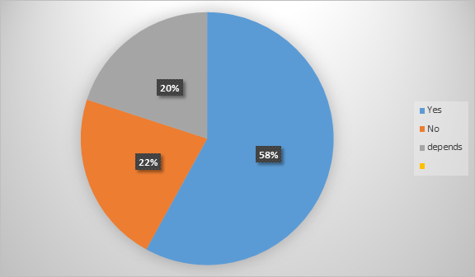
58% of men responded that if they would witness an incident of sexual harassment they would interfere and try to help the survivor. 12% responded that their decision would depend if the woman asks for help. 30% of them said that they would not do anything since women most often in these case do not dress properly. We noticed in focus group discussion that dressing code can hugely affect the perspective of people for judging a woman in conservative society of Afghanistan. For instance, a woman who covers her body is considered to be a good Muslim woman. Whereas, if she is not covering herself in the religious and cultural way, she is considered to be a bad woman who invite troubles to herself. Thus, these stigmas affect the behavior of bystanders and their approach to sexual harassment in the streets.
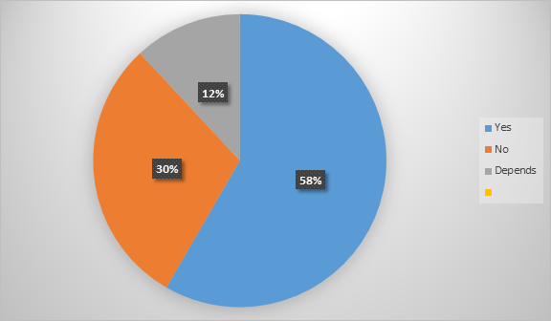

In addition, the misinterpretation of Islam is another reasons for women’s sexual harassment. Many girls are experiencing teasing for wearing the cloths that according to some people don’t meet the standards in Islam even if they are covered fully. In this regard, female participants in focus group discussions shared that some man stopped them and criticized their way of clothing on the street, which was a bitter and humiliating experience.
Discussion and analysis
This paper has discussed reasons for sexual harassment of women in Kabul, Afghanistan. The most important reason was found to be gender inequality in Afghan families and community that influenced patriarchal approach to sexual harassment in streets. Findings show that 18% see harassment as a habit, 15% relate it with being ‘manly”, 11% think people take it as fun, 8% blame the culture, 6% think that men do it to make women enjoy and 12% consider women choose to be harassed. This along with the findings from focus group discussions show how gender dynamics in a patriarchal context could influence how men treat women in a public place.

Since childhood, boys and girls in an Afghan family are treated differently. Boys are more valued by society and families. Families tend to invest more on education for male children because ultimately they will become the breadwinner of the family. Girls, on the other hand, are supposed to be a guest in their fathers’ home and they are considered as a member of another family. Because they are going to get married. As a result, there is no financial investment for the empowerment of girls. In an Afghan family and community, men become the decision maker and women are considered to be “the second sex”. This social construction of gender has a huge influence in treating women as an object in public space through sexual harassment.
The famous article of Ms. Maga Rahmani, Afghan Woman or Zan-e- Afghan published in 1952 reflects the gender dynamic in Afghanistan. Through which she wrote: “Everyone would accept if one claims that women in Afghanistan are missing their basic rights and freedom. Young women do not have the right to choose their husband and marry them, a woman is not allowed to raise her child according to her beliefs, she is supposed to obey and follow her husband’s will. In addition of personal life, they are not enjoying their social life such as right of voting, doing an official job in the society and getting education however, getting an education is a request of Islam. The young ladies are being exchanged with money, the one who pays the highest amount of money own the girl. In some parts of the country the khans (the ruler of a place) own three or four wives and none of the wives would get justice.” (Arvand, Atiq 100-105). Afghanistan indeed has a history of gender discrimination against women. The practice of men having power of decision making in family, and seeing women as second sex cause women to not be valued the same as men in Afghan society even today.
Besides patriarchal belief, economic and social factors are also liable for sexual harassment of women in the street. A research in the northern part of India depicts the relationship between unemployed and sexual harassment. Mr. Chris Fuller wrote: “The young men come together in groups and discuss different types of topics such as; movies, gossiping, politics, sports drink tea and smoke a cigarette. They usually sat together and crack jokes, staring at women and engage in to women sexual harassment. (33,2011). Our findings show that financial crisis and unemployment of men in Afghanistan are reason to harass women in public spaces. Many of the young boys are not able to get married due to the poverty and high expenses of the wedding applied from the girl family.
Moreover, the conservative Islamic ideas are also seeming to victimize women. Many men claimed that women want to be harassed because of their outfit. This attitude resulted from strict sex segregation of men and women not only in families but also in society.
Findings show the reluctance and stigma of women to file cases for sexual harassment. If a woman tries to raise her voice against the sexual harassment, she would be judged and labeled as a bad woman. Basically such incidents discourage women to file their case as mentioned in the Afghanistan Independent Commission of Human Rights research report: “According to the findings of the study, out of 1,307 women who have experienced harassment (3,888 cases of harassment in total), only 1,817 people have tried to address this problem to the responsible authorities and family members and friends. Altogether, 74 cases were reported to the police and 37 cases were filed with human rights organizations. Also, in 333 cases, they have shared the issue with family members and in 212 cases with their friends, and have asked for their help.” (12, 2018).

Conclusion
Women in Afghanistan are the victims of sexual harassment in the streets. Our research shows that the types of sexual harassment of women include cat-calling, staring, touching, and whistling. This harassment is the result of patriarchy, gender inequality corrupted police, less implementation of laws and conservative society. Gender inequality in Afghan family and community and economic crisis are the main reasons for women’s sexual harassment in Kabul, Afghanistan. This summer research project has opened other possible areas of research that would likely to be conducted in Kabul, Afghanistan in the coming years including the effects of sexual harassment on educated and uneducated women in Afghanistan, the ways harassment limits women’s mobility in Kabul, more hollistice solutions for it from the perspectives of Afghan Youth, and the impact of harassment on social pattern on the communities.
Based on our research, the following recommendations are provided to address women’s sexual harassment more effectively;

Recommendations
· Raising awareness on gender equality and human rights in family and community
· Having free legal aid support for sexual harassment
· enforcing strict laws for sexual harassment in public space
· Giving psychological aid and support to victims and their families
· Engaging youth in economic and cultural activities for healthy entertainment and self-confidence
· More research about the street sexual harassments in terms of gender dynamic and masculinity
· To encourage the progressive interpretation of Islam for gender inequality

Work Cited
“OSAGI - OFPW Harassment Policy Including Sexual Harassment.” United Nations, United Nations, www.un.org/womenwatch/osaginew/fpsexualharassment.htm.
The Constitution of Islamic Republic of Afghanistan . 26 Jan. 2004, www.diplomatie.gouv.fr/IMG/pdf/The_Constitution_of_the_Islamic_Republic_of_Afghanistan.pdf.
Billaud, Julie. Kabul carnival: Gender politics in postwar Afghanistan. University of Pennsylvania Press, 2015.
Moghadam, Valentine M. "Patriarchy, the Taleban, and politics of public space in Afghanistan." Women's Studies International Forum. Vol. 25. No. 1. Pergamon, 2002.

United Nations. “Summary Report Survey of Harassment of Women and Children in Afghanistan.” Refworld, https://www.refworld.org/country,,AIHRC,,AFG,,5ab132f74,0.html.

“Afghanistan Has Highest Unemployed Work Force: ILO.” TOLOnews, https://tolonews.com/business/afghanistan-has-highest-unemployed-work-force-ilo.

“Overview.” World Bank, https://www.worldbank.org/en/country/afghanistan/overview.
Arvand , Atiq. Either Savageness Or Socialism . 1st ed., Amiry Publication , 2020.

Pain, Adam, and Jonathan Goodhand. Afghanistan: the current employment and socio-economic situation and prospects. No. 993522183402676. International Labour Organization, 2002.

“A person who, through violence, threat, or deceit violates the chastity of another (whether male or female), or initiates the act, shall be sentenced to long imprisonment, not exceeding seven years. (2) In the case where the person against whom the crime is committed is less than eighteen years old, or the person who commits the crime is one of the persons specified under paragraph 2 of Article 437 of this law, the offender shall be sentenced to long imprisonment, not exceeding ten years.”

