Assessing the Quality of Education for Rohingya Refugees in Cox's Bazar and Its Potential Outcomes.
by
Mosaddika Mounin

Asian University for Women

Master of Aarts in Education

Submitted to
Professor Dr. Sayed Mohammad Nazim Uddin
5th December, 2024

Acknowledgment
I am profoundly grateful to my advisor, Dr. Sayed Mohammad Nazim Uddin, whose constant support and invaluable insights have helped develop this research. I extend special appreciation to Mr. Akib Jabed, the Coordinator of CCCEH, whose coordination and dedication have been indispensable. My deepest gratitude goes to the hardworking research assistants whose input has made this project possible.

Declaration of AI
This paper recognizes using AI tools, particularly ChatGPT, to collect ideas, information, and initial directions toward generating content. It is helpful to make it clear here that all the final analyses, interpretations, and conclusions in this study are done by the author independent of the collaborators.

Table of Contents
Acronyms 7
Abstract: 8
1. Introduction: 9
1.1 Background of the study: 9
1.2 Statement of the Purpose: 11
1.3 The objective of the Study: 11
1.4 Significance of the Study: 12
1.5 Research Questions: 12
2. Literature Review: 13
3. Methodology: 19
3.1 Research Design: 19
3.2 Sample and Sampling Techniques: 19
3.2.1 Quantitative phase: 19
3.2.2 Qualitative phase: 20
3.3 Data Collection Methods: 20
3.3.1 Quantitative Data: 20
3.3.2 Qualitative Data: 20
3.4 Data Analysis 21
3.4.1 Quantitative Data Analysis: 21
3.4.2 Qualitative Data Analysis: 21
3.5 Ethical Consideration: 21
3.6 Data Collection Area 22
4 Findings and Discussion: 23
4.1 Quantitative Data Analysis 23
4.1.1 Descriptive Statistics: 23
4.1.2 Demographic Distribution of Respondents: Gender 25
4.1.3 Gender-Based Perceptions of the Classroom Environment for Effective Learning: 26
4.1.4 Effective Learning and Quality Education 28
4.1.5 Evaluating the impact of Current Education on long-term positive changes for Rohingya Refugee students: 29
4.1.6 Prioritize Areas for Educational enhancements in the camp: 38
4.1.7 Languages used for Teaching in the Camp: 41
Discussion: 43
5. Qualitative Data Analysis 45
5.1 Thematic Analysis (11th Grade students) 45
6. Teacher’s Perspectives on the Current Education System and its Improvement to Quality Education: 48
7. Limitations: 51
8. Recommendation: 52
9. Conclusion: 53

Acronyms
UNICEF: United Nations International Children Emergency Fund
UNHCR: United Nations High Commissioner for Refugees
YPSA: Young Power in Social Action
JPH: Japan Platform
NGOs: Non-governmental organizations
INGOs: International non-governmental organizations
PRIO: Peace Research Institute Oslo
CODEC: Community Development Centre

Abstract:
This study examines Rohingya refugees' educational quality and outcomes in Cox's Bazar, explicitly focusing on Camp 11. The mixed method and a 360 data set were used, where parents, elementary and secondary school students, eleventh graders, and their instructors contributed to my data set. This study encompasses parents, primary and secondary students for quantitative analyses, students in the 11th grade, and teachers to gather qualitative data. The primary emphasis is placed on the educational environment, the quality of educators, and the advancement of education and higher education within Rohingya camps. The findings of the study give different scenarios of learning centers. Access to resources, teacher training, and curriculum application were identified as areas that could use improvement based on quantitative analysis, showing strengths and weaknesses in the current educational services. The qualitative insights elucidate the arduous experiences encountered by students in pursuing higher education, as well as the teachers' perspectives regarding the education system. Policymakers, educators, and humanitarian groups engaged in refugee education worldwide can draw broader implications from the study's findings than those specific to Cox's Bazar. Refugee education and fundraising efforts can be strengthened globally with these new understandings. This research emphasizes the importance of incorporating cultural sensitivity and a focus on rights into educational practices. By prioritizing educational programs that honor the culture and rights of Rohingya refugee communities, we can make a real difference in their future.

Keywords: Rohingya refugee, Quality education, Higher education, educational outcomes.

1. Introduction:

1.1 Background of the study:
In the context of displacement, education is one of the most essential elements that is the cornerstone of human development. For refugee children, education is the hope of the future and the lighthouse of acquiring knowledge. In refugee settings, however, education opportunities are very few, and the challenges that deny individuals equal chances for quality education are many. The Rohingya people suffered violence and persecution in Myanmar. They became refugees that are living in overcrowded shelters, challenged by the lack of basic facilities, access to resources, and minor assistance to improve education. These challenges are, however, magnified where there is a need for quality higher secondary education, particularly among students who want to progress to the next level beyond the 10th grade.
In Myanmar, the Rohingya people have been the target of brutality, prejudice, and oppression for decades (UNHCR,2024). In August 2017, a devastating wave of violence erupted in Rakhine State, Myanmar, causing over 742,000 people, including over 500,000 children, to flee to Bangladesh in search of safety (2024). Cox’s Bazar, with the size of one of the largest refugee camps globally, has attracted Rohingya refugees since 2017. Nevertheless, as optimizing education quality, availability, and sustainability for these refugees is still temporal and a challenge for improvement, numerous international organizations and NGOs try to help and deliver education to these students, especially for secondary-level learners. These students are severely challenged when they shift to higher secondary education regarding the following challenges: qualified teachers, resources, and financial crisis. Since there is no structured system of education for grades 11 and 12 students, Rohingya children have no options but to follow their dreams in an unstructured way and without any support, which hinders their chances of getting into colleges and universities and, therefore, getting quality employment. In Cox's Bazar Refugee camp, CODEC is one of the NGOs that provide education under the UNHCR project (CODEC, 2024). YPSA has taken steps to provide education for Rohingya children, which is “ECW-MYRP-II” (Education cannot wait), with technical and financial support, and this project has been started in camps 13 and 14 (YPSA, 2022). JPF is also working on education for youth and adolescents for Rohingya refugee children (JPF, 2023). According to a JPF report, Rohingya refugee camps—Camps 1, 3, and 6,7 have improved access to Functional Literacy and Numeracy (FLN) education programs run by local communities (2023). In Rohingya refugee camps, older children and teenagers are denied opportunities to learn or earn a living and risk becoming a "lost generation," ready prey for traffickers and others who would use them for political or other purposes. UNICEF has taken steps to help the Rohingya children avert a "lost generation," UNICEF and its partners have enrolled almost 300,000 children in school (UNICEF,2023). Rohingya children and their parents have made it plain that they desire a Myanmar-based education, and keeping this in mind, by March 2023, more than 160,000 learners have completed their home country's curriculum (UNICEF,2023). The question remains whether Rohingya children receive quality education or not; those students who finished the Myanmar curriculum have access to higher education or not.
This study wants to examine the education context of the Rohingya refugee students studying in Cox’s Bazar and evaluate the quality of education delivered amid such conditions, focusing on the 11th-standard students. With the identified barriers of financial problems, resource limitations, and lack of infrastructure, this research will provide expanded knowledge on how these barriers influence such students' learning processes and personal transformation. It aims to give potentially sustainable solutions regarding the issue of educational equity, effectiveness, and availability for the Rohingya refugees, as they should be able to achieve their potential and create a better life for themselves.

1.2 Statement of the Purpose:
This research focuses on the tremendous issue of Rohingya children who, despite the need for quality education for all, have no access to formal education for the 11th grade. Although there is a need for educational programs and activities designed for young school children, even fewer programs are available for older students interested in pursuing their education. Rohingya refugee students who would further their studies to Secondary education beyond grade 10 faced various challenges. These have been said to include a need for more NGO-supported education for the 11th and 12th grades, inadequate teacher facilities, and having to travel long distances to access education from camps. Moreover, savings for private tuition becomes impossible as many students have to work during their studies and care for their families. These challenges lead to better education disciplines, better learning resources, and better quality of education. If no action is taken, these barriers will remain barriers for the Rohingya students, and they will have a poor chance of achieving success in both academic fields as well as in their personal lives.

1.3 The objective of the Study:
The primary objectives of the research proposal are as follows:
1. To assess the educational quality of Rohingya refugees in Cox's Bazar.
2. To understand the educational options and resources accessible to Rohingya refugee
children and adolescents.
3. To explore the effects of quality education on the Rohingya refugee community.
4. To identify the obstacles and challenges to providing quality education to Rohingya
refugees.

1.4 Significance of the Study:
This study is essential for many reasons. First, it presents a systematic qualitative description of the mass educational difficulties the Rohingya refugee students encountered, especially emphasizing the 11th-grade students rarely sampled in academic studies. Second, by concentrating on the quality of education, the study underscores the recommendation for far-reaching changes to the quality of education for refugees by embracing improvements in academics and infrastructure. The conclusion drawn from this study could make direction and progression of the policy and program for improving education access and quality for the Rohingya and other displaced people having similar barriers. In addition, it presents suggestions for improvement for NGOs and humanitarian organizations engaged in supporting education for refugees. Still, it needs to be more comprehensive in understanding the context of older refugees, especially the students. More specifically, it is hoped that the research findings will inform international discourse on the right of refugees to be educated and receive quality education.

1.5 Research Questions:
- What is the present situation regarding facilities, teaching personnel, curriculum, and learning materials for Rohingya refugee schooling?
- What are the main problems and barriers for Rohingya refugee children in Cox's Bazar to gain and get quality education?
- How will Rohingya refugee students' future educational outcomes and achievements compare to national and worldwide benchmarks?

2. Literature Review:
How can we make sure that education in one of the world’s most volatile regions is accessible and can meet the refugee’s quality standards? This inquiry posits that providing education to displaced populations across the globe is challenging. Dryden-Peterson (2011) notes that in the societies of the world’s refugees, education is seen as a way to open the door to peace in the future and as a source of hope amidst fear because they do not know what tomorrow holds. Education is seen as the ultimate panacea by them because it offers them hope of something positive when everything around them is indeed uncertain. Their belief that education is essential drives them to establish an empowering quality education system for their children. According to the UNCHR (United Nations High Commissioners for Refugees) (2011) documentation, refugees, migrants, and asylum seekers have the right to education in the following international documents: The 1951 Convention relating to the Status of Refugees; the draft resolution to the human rights council on this issue; resolution 64/290 of the United Nations General Assembly’s human rights council on this subject of the right to education in emergencies. This global support for the education of refugees should make us more optimistic that something positive can happen. Despite numerous international documents on refugee education, the theoretical and practical commitments to refugee education have never been enough globally. In 2011, the UNCHR on refugee education claimed that irrespective of where they are or how they have been displaced, refugees have restricted and differential access to education for boys and girls and secondary education. While 63% of refugee children attend secondary school in the international community, this rate has now been reduced to 24%; in higher education, only 3% of students are refugees, while 37% are non-refugee students (Morrice, L, 2021). The circumstances of a humanitarian crisis on an international scale are slowly becoming evident as the share of refugee students in secondary schools is decreasing, and the share of refugee students in universities is declining even more. The biggest challenge to learning for refugee students is that 85% of the learners reside in L&M-income countries, and most are also likely to get a worse education (Morrice, L, 2021). This makes them have an uncertain future, and so they become unable to achieve the goals of social and economic emancipation.

One of the essential agenda items of the Human Rights Council (HRC56) was the issue of attacks on education, which is still topical today (Neven. V,2024). Refugee children must understand that it is possible to resolve disputes through learning because learning is vital in ending many ongoing conflicts and reducing future conflicts. V,2024). Nevertheless, this does not happen in practice, and the result is that international human rights law is violated and the human rights of the refugee speculative students are refused (Neven. V 2024). They said that global attacks on education, in which violence and conflicts push one in every five children out of their homes, therefore leaving them vulnerable to multiple types of violence and denying them education. Excluding occasional episodes in the prior year 2021, more than 3000 acts of aggression on educational facilities were upward of 20% compared to the previous year in 2022; several recent attacks in Myanmar, the Central Sahel region, Northeast Nigeria, Ukraine, Gaza, and the occupied Palestinian territory led to thousands of damaged or destroyed schools (2025). The occurrence of such incidents harms the refugee learner and translates education provision and equity for marginalized groups into a mirage.

The specific objective in this part of Goal 4 is to “Promote equity and inclusion within education systems that prepares youth and adults worldwide for learning throughout the lifespan Learning” (Borkowski, A. 2023). The term ‘all’ encompasses various means of all people, for instance, gay, lesbian, African-American, Mexican, Canadian, and everybody else, as well as the notion that every learner deserves a good education. As stated in the UNICEF report (2024), the access of all students to high-quality education with particular emphasis on vulnerable groups of children, inclusive of rural children, children with disability, Indigenous children, and refugee children. Sematlane. M (2022) stated the definition of quality education which UNICEF gives that quality education encompasses the following: Learners who are healthy, well-nourished, and ready to learn; conditions that support the learning activities; content that consists of these elements and peace; processes that are participatory, integrated, child-centered, competent and self-motivated; and tangible outcomes in terms of knowledge, skills, and willingness to learn and live as well as responding to national aims and objectives of the education (education equity) with attendant virtues of positive social interaction. In any case, all these aspects of quality education are not attainable and are offered to refugee children. The present education will not result in positive changes impacting their present and future life. Wings (2023) said that according to an Education-Based Organization, quality education focuses on every learner's individual, academic, social, and emotional development regardless of their sex, skin color, ethnicity, ability to pay for their education, or where they come from.
Instead of just aiming at raising the literacy rate, quality education should be based on principles involving inclusiveness and equity (2023). Even though everyone requires quality education, refugee children face numerous challenges toward this noble goal. Regardless of immigration status, families with such children should be provided with an age-appropriate curriculum and enrolled in school per the local authority's standard for all children. P,2024). Under quality education, physical security is one of the aspects that facilitate the growth of the child’s social-emotional development. Several factors have been known to have an impact on children’s wellness and learning outcomes, such as home environments, positive relationships with adult caregivers, a safe learning environment, and social and emotional skills (Ndibalema. P,2024; Ndijuye and Benguye, 2023, Ndijuye and Pambas, 2022). The above learning achievements raise a concern about refugee children's lack of access or limited access to education to a level that other groups of children did not experience (UNICEF, 2024). There is limited access to primary education and quality of education among Rohingya refugees, be it in kind, quality, and time spent on learning (Shohel, 2020). As a result of the lack as mentioned above of education, child refugees, mainly the girl children in the Rohingya refugee camps, are more vulnerable to exploitation and involvement in child labor like income-generating activities such as work and firewood collection and especially the girl child in Rohingya refugees camps may be at high risk of being exploited sexually (Prodip & Garneet,2019) in November 2021, UNICEF coping with this necessity of education, the Myanmar curriculum pilot for Rohingya children, where they get a fundamental right to education (UNICEF,2022). There are roughly 400,000 school-age Rohingya children in Bangladesh refugee camps, and 300,000 of them attend learning centers with UNICEF partners implementing the most extensive education program in the world’s largest refugee settlement. UNICEF says it has many 10,000 Rohingya refugee children in Bangladesh not in school, and they are trying to get them to school to prevent any hindrance to going to school being removed (2022). This means there remain challenges for children in refugee camps, such as cultural and trained teachers, sufficient teaching and learning resources, and a shortage of teaching workforce. This means that quality education is vital to the Rohingya refugee children for their freedom.

The PRIO (Peace Research Institute Oslo) data shows that Rohingya children are denied their right to education, and children believe that if they do not receive a quality education, they have no hope for the future (Rahman, 2023). This is the way to improve the quality of life. To this end, they require good education to offset this problem by at least providing some stability by giving the children a sure footing to set themselves right. They need education for their family needs and the realization of individual dreams. Finally, quality education, knowledge, and related skills have been identified from recent research as the most viable factors of the long-term destinies of refugees in exile and the adjustment of their resettlement provinces in their homelands (Rahman et al., 2022). Education, especially quality education, may enormously benefit the lives of Rohingya refugees. The research considering education as a human right revealed that it positively impacts mental development, psychological health, and social inclusion. Quality education also gives Rohingya refugees information and skills that can sustain refugees’ independence in the long term, leading to socioeconomic development. For example, Shohel (2020) said that challenges of education for Rohingya refugee children include challenges in classroom space, staffing and resources, language, and psychological, social, cultural, and political barriers. As a result, refugee children are disadvantaged in many ways and cannot progress from one grade to another. Rohingya students remain locked out of even primary education and poverty following shortages of resources, qualified teachers, and funding. It illustrates the significance of effective intervention in infrastructure, teaching, and psychosocial care. However, as it stands, Rohingya refugee children in Bangladesh encounter numerous and diverse challenges to access quality education, and this requires a coordinated strategy at the national and international levels. In the refugee camps, there are only a limited number of Learning Centers (L.C.s) in which the children that live there can learn the basics. However, children have proven they do not want to attend School (2022). Lack of variety and lack of job prospects are barriers to children. For students to excel, there is a need to expand access, improve the quality of education, and offer training for vocation and language.

Education can have a personal and community impact on Rohingya refugee students if they receive the quality education they deserve. As the World Bank (2020) noted, good education can lead to better lives or living conditions, reduced risk of exploitation, and better community cohesion. This is especially true in resettlement and integration into host communities where refugees are supposed to start all over. Nonetheless, it is difficult to compare the achievement rates of refugee students at the national and international levels. After getting support, refugee kids fail to perform as well as other children, especially those in different classes (UNESCO et al., 2019). These gaps require definite, consistent funding, new policies, and industry partnerships. Thus, developed in INEE (2010), educational programs must be efficient and particular, the curriculum must be contextualized, teachers need training, and psychosocial support must be integrated. The Global Partnership for Education works on partnerships between aid and development organizations and governments to reduce gaps and develop the necessary policies.

3.Methodology:
The study occurred in Camp 11, part of the Rohingya Refugee camp in Cox's Bazar. The map shows the camp layout (Figure 1), highlighting the nine areas where data was collected from 9 learning centers and households. This study uses both quantitative and qualitative approaches. The questionnaires and interviews conducted among Rohingya refugee students and teachers in Cox’s Bazar synthesized questions and views to assess the education opportunities available to the children. This method was chosen to capture statistical trends and additional detailed information regarding the instructors' and students' real-life experiences.

3.1 Research Design:
As it is mixed, there are two phases: the quantitative survey and the qualitative interviews. Using a sequential explanatory design, quantitative data offered a comprehensive understanding, while qualitative insights were utilized to delve into underlying factors.

3.2 Sample and Sampling Techniques:

3.2.1 Quantitative phase:
Among the 360 sample sizes, 19 were parents, 14 were primary students, and 327 were secondary students. The kind of sampling adopted here included random and convenience sampling. This method provided a balanced sample in that hired individuals who belonged to different age groups, had various levels of education, and were comprised of both males and females.

3.2.2 Qualitative phase:
In the qualitative phase of the study, eleven students were interviewed, and the selection was made through purposive sampling. This method ensured that multi-sectional eleventh graders with different learning capabilities were chosen for the study. Moreover, informal interviews and case studies were employed to obtain teacher data.

3.3 Data Collection Methods:

3.3.1 Quantitative Data:
The structured questionnaire was employed for quantitative data collection. The survey blended closed and Likert scale questions to assess the students’ perceptions of the educational service quality, supporting material availability, and challenges.

3.3.2 Qualitative Data:
11 students were asked questions modified to give basic information about their problems and their ideas concerning the higher educational system's functioning. To do that, the interviews were relatively unstructured so that participants could express whatever they desired. Concerning emergent themes, aspects of resources, teaching, and learning were some of the top research questions identified. Teachers were informally asked for their opinions to understand better the strategies used and the issues encountered in the classroom.

3.4 Data Analysis

3.4.1 Quantitative Data Analysis:
Statistical methods, such as inferential and descriptive statistics, were used to examine the quantitative data and discover correlations and patterns. The results are displayed in graphical and analytical formats to make them easier to understand.

3.4.2 Qualitative Data Analysis:
The transcribed qualitative data is thematically analyzed. Finding commonalities and trends required a coding procedure. Subsequently, these themes are grouped to shed light on essential insights about students' experiences and the higher education system as a whole.

3.5 Ethical Consideration:
This study strictly followed ethical considerations to protect participants' rights and values. A written constant was obtained from each participant before data collection began, and they were informed about the study and its purpose.

3.6 Data Collection Area
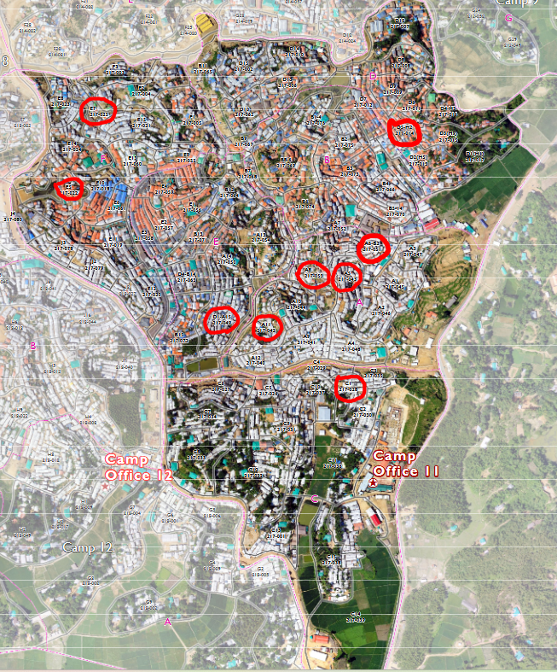
Figure 1: Reliefweb(2023)

4 Findings and Discussion:
This section furnishes essential information concerning analyzing the educational provisions and potential outcomes of Rohingya refugee students in the study. Probing the fundamental aspects of experience, including the nature of learning environments, teachers’ readiness, available resources, and curricula, assures that the findings expose all aspects of students’ experience. Variations and trends reveal the complicated dynamic between education assistance (or lack of it) and students’ aspirations and outcomes in the present and the future.
Finally, this section evaluates the current state of learning in higher education for Rohingya refugee students and teachers’ perception of learning in camps. Providing a need cum input for more effective education of Rohingya refugee children, the findings outlined here reveal systemized issues and avenues for targeted poverty reduction. Through statistical tests pointing out the first significant correlations and predictors of educational success that follow the participants' demographics, refugee education as it currently stands and what the situation would be if they received quality education is described.

4.1 Quantitative Data Analysis

4.1.1 Descriptive Statistics:
Age, family size, and current level of education
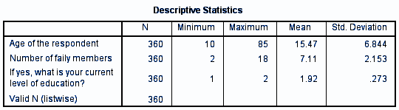
Table 1
Table 1 provides an overall demographic description of the respondents in terms of their age, family size, and current level of education.
Age of the respondent: The above chart clearly shows that the “Age of the respondent” ranged between 10 and 85 years, with a mean age of 15.47 and a standard deviation of 6.844. Most respondents were adolescents, but since other age groups were also presented, there were also adult students or caregivers in education. This discovery provides information on various age groups of people attending education in the camp.
Number of family members: The number of households in this study was distributed between two and eighteen people; still, respondents provided an average of seven households with 0.5 persons (SD= 2.153). Multiple family members inhabit camps hosting refugees; hence, the sizes of the families are relatively more significant than expected. The way resources, such as places to study and books, are managed is also affected.
The current level of education: The most educated subjects of the study were those in the secondary level, as revealed by a mean score of 1.92 (SD=0.273) in this area of education level on a range of 1 being primary education and 2 being secondary education or above. This result suggests that there are limited education opportunities and that students need an advanced level of education to pursue higher education.
Overall Implication: The findings suggest that students face problems studying in their households due to their large family size and have no access to higher education. As a result, these problems are essential to improve teaching and outcomes, and access to higher education is needed.

4.1.2 Demographic Distribution of Respondents: Gender
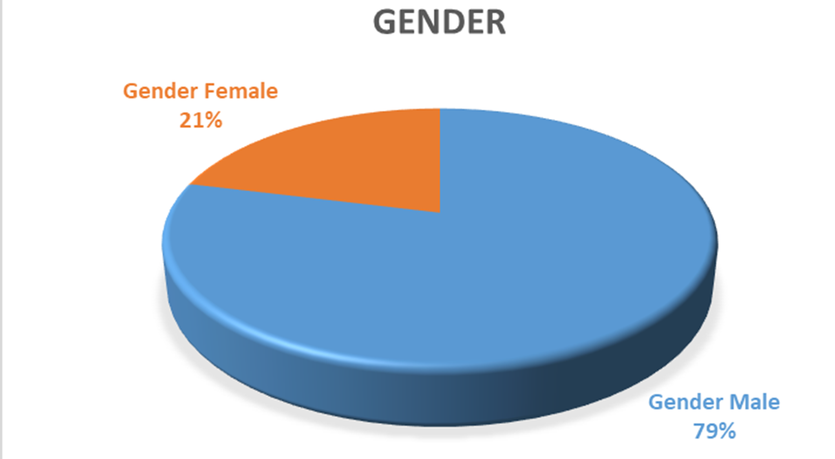
Figure 2

In this study, the survey was conducted on male and female students, and the result shows that the imbalance of the percentage of female students is only 21%, whereas males is 79%. That reflects, to some extent, the gender balance in the refugee camp; cultural and social barriers could affect children's participation in educational activities. It also reflects that, in the Rohingya refugee camp, female students are not present in the learning center. So, future research or any program should encourage the parents and female students to attend the learning center.

4.1.3 Gender-Based Perceptions of the Classroom Environment for Effective Learning:
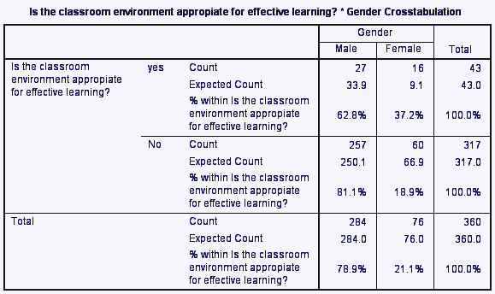
Table 2
This crosstabulation table presents the relationship between “gender” and “the effective environment of the class” and whether students find the classroom compelling.
Yes: The findings show that 360 participants, 27 males (62.8 %) and 16 females (37.2 %), found the present classroom environment in the camp compelling, which is the key element of quality education. The expected count shows that more males (33.9%) and fewer females (9.1%) found a positive environment.
No: In the case of the response “No,” 257 males (81.1 %) and 60 females (18.9 %) reported that the classroom environment is not appropriate for effective learning. The expected value is 250.1 for males and 66.9 for females.
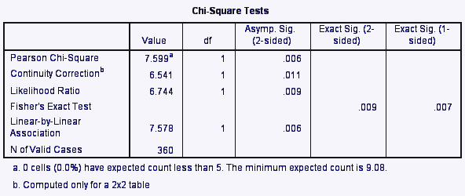
Table 3
In the Pearson Chi-Square test, the Pearson Chi-square equals 7.599 and has 1 degree of freedom (df). The p-value (Asymp). Namely, according to the results of the Sig. 2-sided) test, the relationship between Gender and Perception of Classroom Environment Effectiveness is statistically significant, and it equals 0.006, which is significantly less than 0.05.
Focusing on gender as the independent variable and the perceived effectiveness of the classroom environment as the dependent variable, data analysis revealed that the two are significantly related (χ² = 7.599; df = 1; p = 0,006). The statistically significant gender differences observed showed that male students were more likely than female students to indicate that the classroom environment interfered with effective learning of the subject. This result suggests possible gender differences in how students perceive their learning environment.

4.1.4 Effective Learning and Quality Education
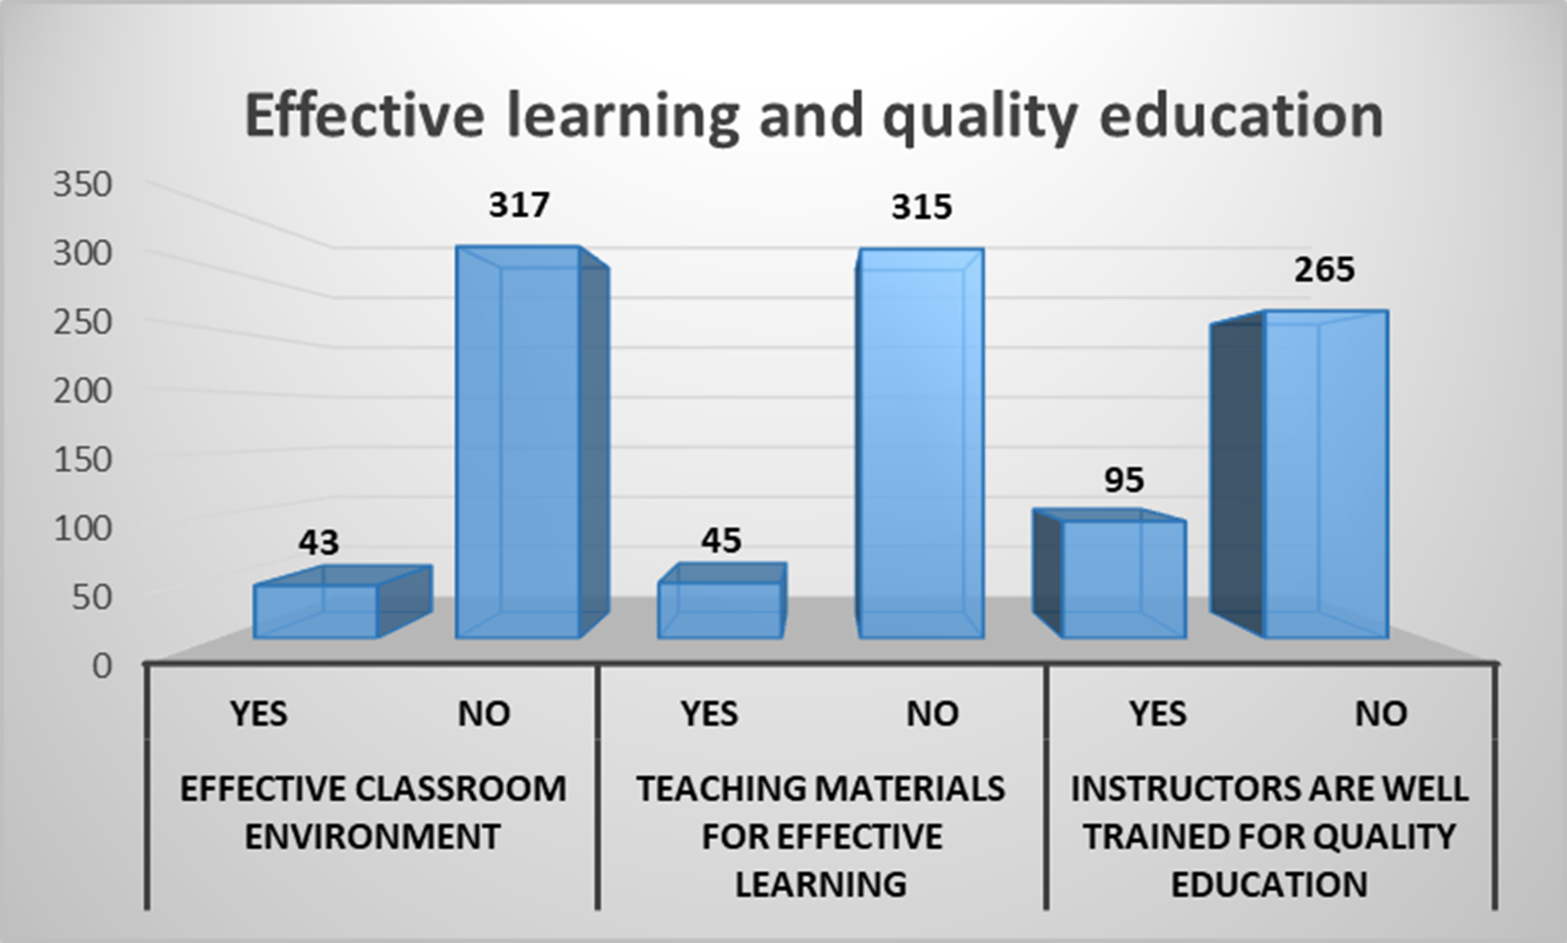
Figure 3
This figure depicts the effective learning environment and the quality of education in Rohingya refugee camp 11. Three variables are necessary for quality education: “Effective Classroom Environment, Teaching materials for effective learning, and Instructors who are well trained for quality education.” Among 360 respondents, 315 stated that the teaching materials received are insufficient for quality education, and only 45 responded that the present materials are enough for a complete quality education.
The instructors are well-trained to provide quality education: in this part, 265 participants stated “No,” which is a large number among 360 participants. One student explained, “Our teachers need excellent quality training, and we need more teachers.”
This study tries to find out the quality of education for Rohingya refugees, and for that, these three variables are included in the survey question. From the results, it is clear that Rohingya students do not receive quality education because there are around 40-60 students in a classroom, the class infrastructure needs to be better structured, the learning centers are beside the road, and students break their concentration during the class. Also, the teaching materials they receive are insufficient, and a teacher mentioned, “Students need practical materials to improve their learning quality, and also they need access to technology because we want our students like others.” The number of teachers is small, and as a result, students and teachers face problems like a teacher needing to take classes on different subjects, which decreases the lecture quality, and the teacher training they receive is not high quality. A teacher stated, “We need quality-full training, and we receive teacher training, but I think it is not that effective.” So, these are needed to improve for Rohingya refugee students in camps.

4.1.5 Evaluating the impact of Current Education on long-term positive changes for Rohingya Refugee students:
The hypothesis is tested for this test: “The current education in the camps will lead to positive changes for Rohingya refugees in the long term.” The independent variables are “increased knowledge, improved literacy skills, reduced educational gap, improved quality of life and empowerment,” and the dependent variable is “prepare for the future.” That means that through this current education, Rohingya refugee students can prepare for the future and understand how it will affect them in the long term.

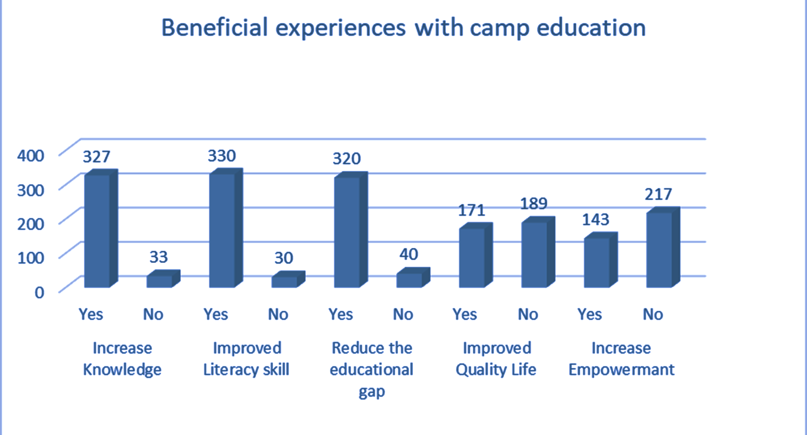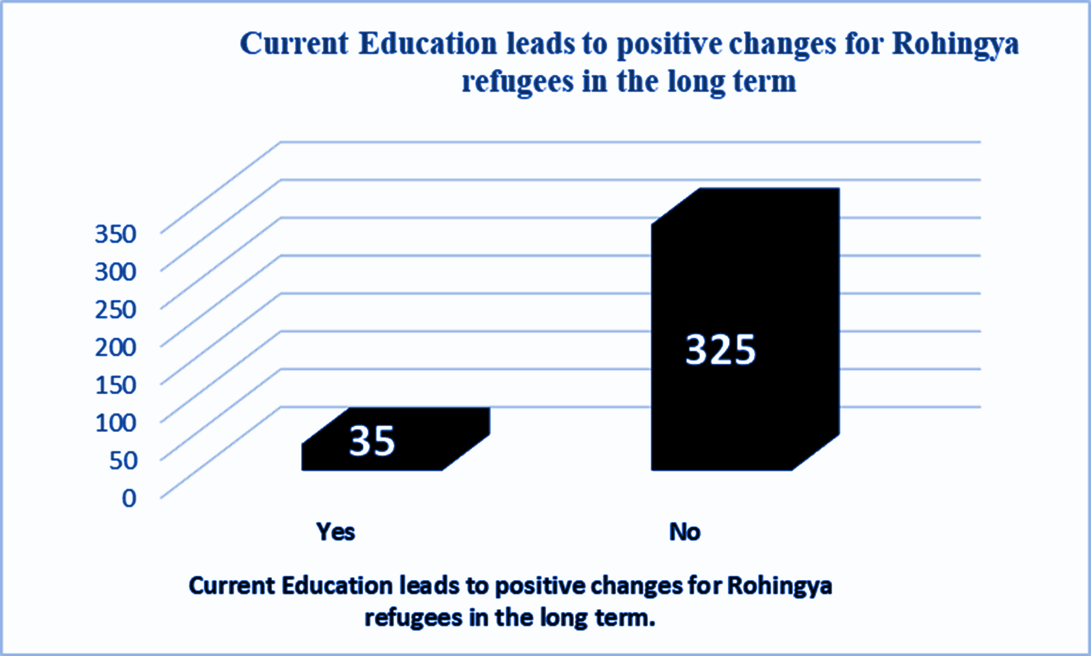

Figure 4 Figure 5
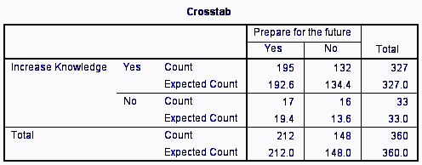
Table 4
The crosstab table shows the relationship between increased knowledge from current education and preparation for the future. One hundred ninety-five participants responded that their current education helps to improve their knowledge and also allows them for the future in the long term. On the other hand, 132 respondents said that their present education helps them increase their knowledge, but it will only work in the short term.
In the count section, 17 respondents do not think education opens their eyes broadly but affirm it prepares them for the future, and 16 respondents think there needs to be added knowledge.
To sum up, if education is seen as the accumulation of knowledge, then future benefits are also seen (195/212), as per the last row of the table. However, 132 respondents who agree that education raises knowledge of different matters do not agree that it helps them in the future.
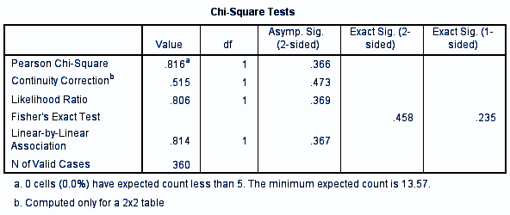
Table 5
In Chi-Square tests, Pearson Chi-Square (p = .366): The result also revealed that the p-value (.126) is more significant than 0.05, suggesting that the association between these two variables is insignificant. As it is insignificant, other issues may play a role in preparedness for the future.
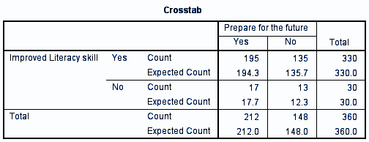
Table 6

This result shows that among 360 participants, 195 respondents said “Yes,” which means that their literacy skills have improved and will also help in the future. And 135 agree that current education improves literacy skills but does not prepare for the future. 17 respondents noted that they reject the idea that schooling enhances literacy skills, but at the same time, they acknowledged that education prepares them for the future. 13 respondents disagreed with the statement that education helps with literacy and that it prepares them for the future.
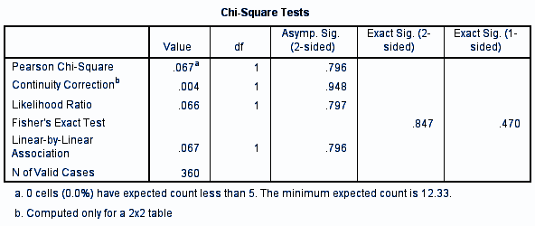Table 7
The Chi-Square test further shows no significant relationship between picking up on improved literacy skills and preparing for the future; that is, χ²(1) = 0.067, p .05 = 0.796. This has implications for the notion that literacy skills have increased but does imply that there is a perception of better preparedness for similar challenges in the future among the Rohingya refugees. The results presented stress a call for change in the type of education in schools, primarily focusing on literacy skills rather than the long-term ones.
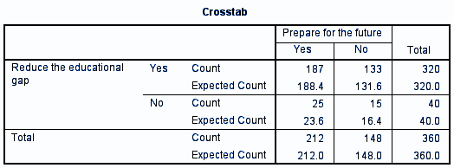
Table 8
The crosstab shows the relationship between reducing the educational gap and preparing for the future. 187 respondents agree that the present education system reduces the academic gap and prepares them for the future. 133 agree with reducing the education gap but do not agree with the well-being of future preparation. On the contrary, 25 respondents disagree with the opinion that education narrows the gap but agree that it makes them ready for the future, but 15 of them disagree with both statements.
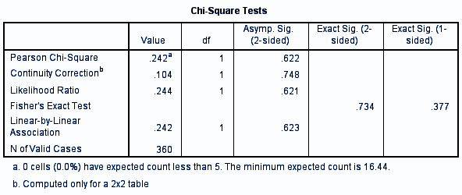
Table 9

The p-value, equal to 0.622, is more significant than the alpha level; the significance level is often set at point (0.05). This means that they have yet to deem it necessary to suggest a correlation between the decrease in the education gap and the fact that current education prepares for the future. As in the goodness of fit test, the Continuity Correction and Likelihood Ratio tests also produce non-significant results (0.748 and 0.621, respectively). Hypothesis Testing with Fisher’s Exact Test confirms this with p=0.734, far from 0.05.
Although 90% of respondents believe education helps narrow the gap, it is separate from views about readiness for the future. This implies that education eradicates present inequity; however, confidence in future returns is still lacking. Thus, this study suggests some directions for additional interventions to increase perceptions of future preparedness through education.
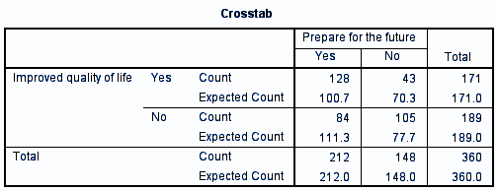
Table 10
Of the 128 participants convinced that education enhances their quality of life, the same participants were confident that education prepares them for the future. 43 said it improves quality of life but does not help prepare for the future.
According to the prediction, the expected number of respondents who agree with ‘Yes’ regarding the two statements, which are Improved Quality of Life & Future Preparedness, is 100.7.
For the category “No” (Improved Quality of Life & No Future Preparedness), the actual confirmed cases (43) are notably lower than the theoretical number of such cases, which would be expected given the current Brierley data (70.3).
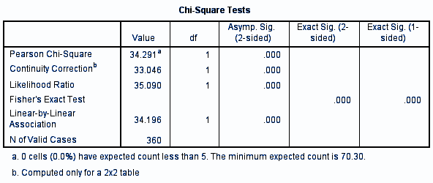
Table 11
The significance level for all five tests, Pearson Chi-Square Test, Continuity Correction, Likelihood Ratio, and Fisher’s Exact Test, is 0.000, significantly significant at any conventional significance level, such as 0.05.
The Chi-Square test further shows a substantial relationship between enhanced quality of life and perceived readiness for the future (χ²=34.291,p<0.001). This suggests that some quality-of-life enhancements have boosted confidence in the long term, underlining the need for comprehensive education frameworks for the Rohingya refugees.
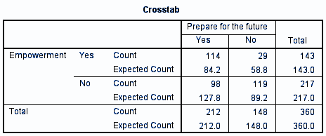
Table 12
The empirical frequency distribution of empowered individuals ready for the future is 114, while the theoretical frequency distribution is 84.2.
On the other hand, the number of empowered individuals who feel they need more preparation (29) is less than the expected number (58.8). The number of empowered employees is less than the number of unempowered employees in the case of prepared people (98, 127.8) and unprepared people (119, 89.2).
This result supports the idea that although education empowers the Rohingya refugees, the correlation between the two and future readiness and confidence is very significant.
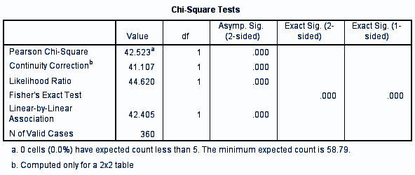
Table 13
The Pearson Chi-Square value (42.523, p < 0.001) suggested a strong correlation exists between the aspects of empowerment of the learners and the way they are prepared for the future. Due to the p-value being less than 0.05, we can reject the null hypothesis. The continuity correction also remains significant in the likelihood ratio (p = 0.000), confirming this result. A p-value of 0,000 was also obtained for the suitable Fisher’s Exact Test for Stata for small samples.
This result further supports calls for increased educational interventions as such programs are to enhance an empowered future amongst refugees.
However, control and multiple regression analyses demonstrate that changes in quality of life and the view of education as a pathway to empowerment are among the essential positive life changes expected from education in the context of Rohingya refugees. Though gaining knowledge, literacy, and minimizing gaps in education are elementary constituents, they need to produce sufficient preparedness for the future.
Therefore, contemporary educational interventions implemented in the Rohingya camps must focus on activities that empower learners and bring fundamental changes into their lives. This effort will enhance education's role as a driver of change and the refugee community's future preparedness for sustainability.

4.1.6 Prioritize Areas for Educational enhancements in the camp:
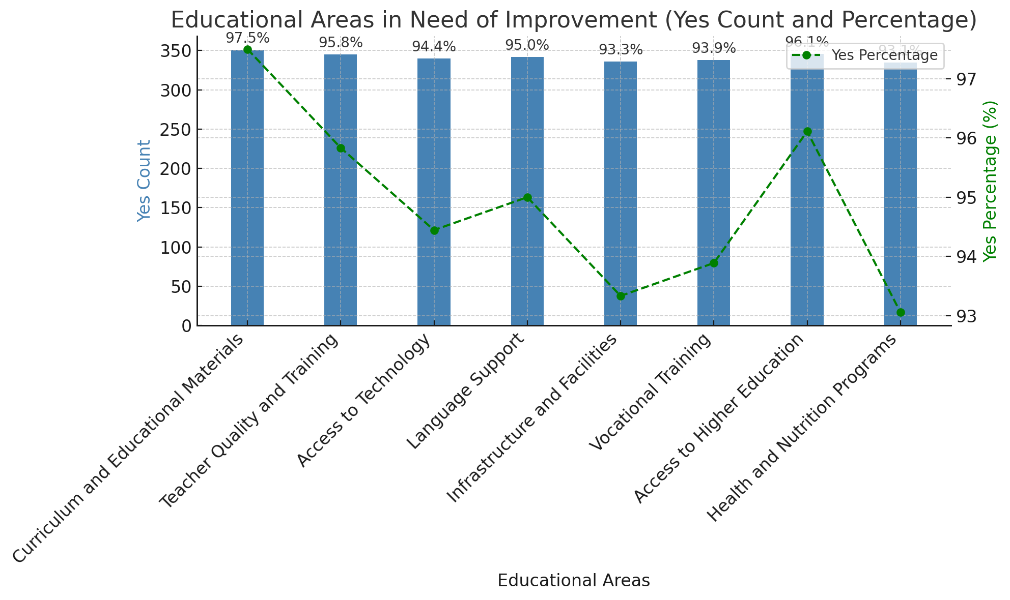
Figure 6
This graph shows the Rohingya refugees' responses regarding the count and percentage of the educational areas they think require improvement. The x-axis represents different academic areas, while the y-axis shows two scales: one for the direct count of the “Yes” responses and the second for the percentage of the “Yes” responses.
Curriculum and Educational Materials: Yes Count: 351 (97.5%)
The current area that received the highest level of agreement is that 97.7% of the respondents agreed there is a need to improve the curriculum and educational materials. Thus, the significant difference shows that refugees who attended school fully agree with the need to improve the content of the educational materials.
Teacher Quality and Training: Yes Count: 345 (95.8%)
In this section, we also got very high participation (95.8%) in increasing the quality of teachers and teacher training. This implies that there is much faith in increasing tool proficiency to address educational needs in the country as viewed by more equipped teachers.
Access to Technology: Yes Count: 340 (94.4%)
The above findings from the survey demonstrated a need to improve access to technological learning tools since 93.7 % of the respondents agree with the statement to improve access to technology.
Language Support: Yes Count: 342 (95.0%)
A similar percentage (95%) of respondents said there was a need to improve language support. This might be because of language difficulties in learning and expressing oneself.
Infrastructure and Facilities:
Yes Count: 336 (93.3%)
Of all the responses received, approximately 93.3% of respondents felt that more infrastructure and facilities were required. This situation calls for sufficient infrastructure and resources to provide efficient education to the students.
Vocational Training: Yes Count: 338 (93.9%)
Most respondents, or 93.9%, stated that vocational training required enhancement. This indicates concern for projects that would prepare refugees for limited hands-on courses, enabling them to be more reliant on themselves.
Access to Higher Education: Yes Count: 346 (96.1%)
Constriction to the education part, the desire for increased access to post-basic education level was also revealed, with 96.1% of the respondents agreeing to the statement.
Health and Nutrition Programs: Yes Count: 335 (93.1%)
Although the response rate is a little lower compared with the other areas, 93.1 percent of respondents continued to acknowledge that there is much need to enhance the health and nutrition programs and demonstrate a realization of the significance of education concerning overall health status.
A large majority of the respondents believe that these five areas must be developed in their educational system. The most concerning aspects are curriculum content, teachers, teaching technology, and access to higher education. However, even for low-response areas like health and nutrition response programs, the indices revealed moderate demands for improvement.
Most students mentioned higher education because they don’t have access to it. After secondary school, there is no higher education in camp; even those students in classes 9 and 10 stated that they do not get the quality education they need.
The results suggest that refugees’ perception of education is similar to international education priorities, emphasizing the need for technology, the quality of teachers, and better infrastructure. These areas should be highlighted in the following Rohingya refugees’ educational programs to empower them to develop skills and increase their chances of social and economic mobility.

4.1.7 Languages used for Teaching in the Camp:
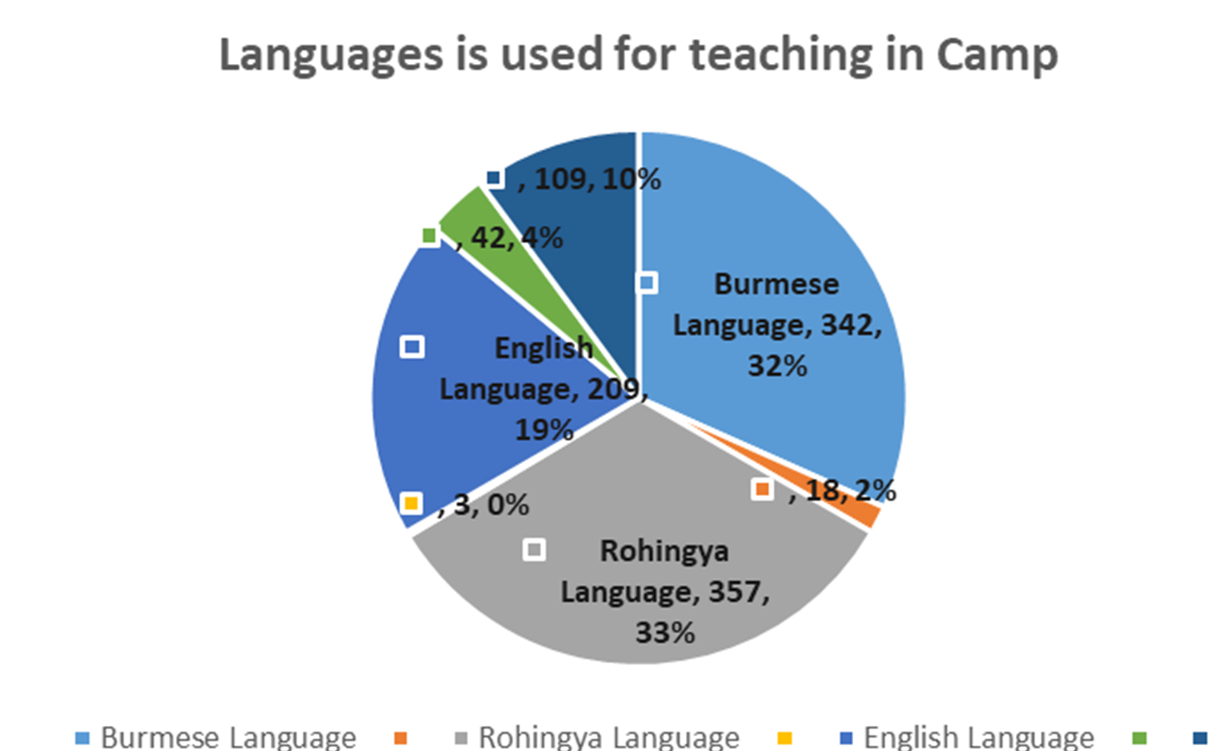
Figure 7
The Pie chart illustrates the mode of instruction in the camp according to the usage frequency and ratio. The emphasis on the English Language is of special importance concerning the function of language for international communication and for being admitted to further educational or job offers.
This chart shows that the Burmese (32%) and Rohingya (33%) languages are used mainly, but English is used less than in the other two. This raises a significant concern, especially if English is needed in international colleges, universities, and future job markets outside the refugee situations.
While exploring the results of the previous analysis, Language Support was recognized as the focus area with the highest percentage of respondents (95%) who pointed to the significance of this issue. This finding is supported by the fact that the use of English in the camp was infrequent. To close this gap, there is an obvious need to enhance the teaching of English in the camp. One of the students mentioned, “ We do not have a good English teacher, and we want to speak in English.” The primary purpose is that the Rohingya refugee students don’t have any idea tomorrow what is happening to them. Also, they are concerned about their higher education, where English is needed. They believe they should know English, which will help them in the future.
4.1.8 Curriculum Needs for a Bright Future:
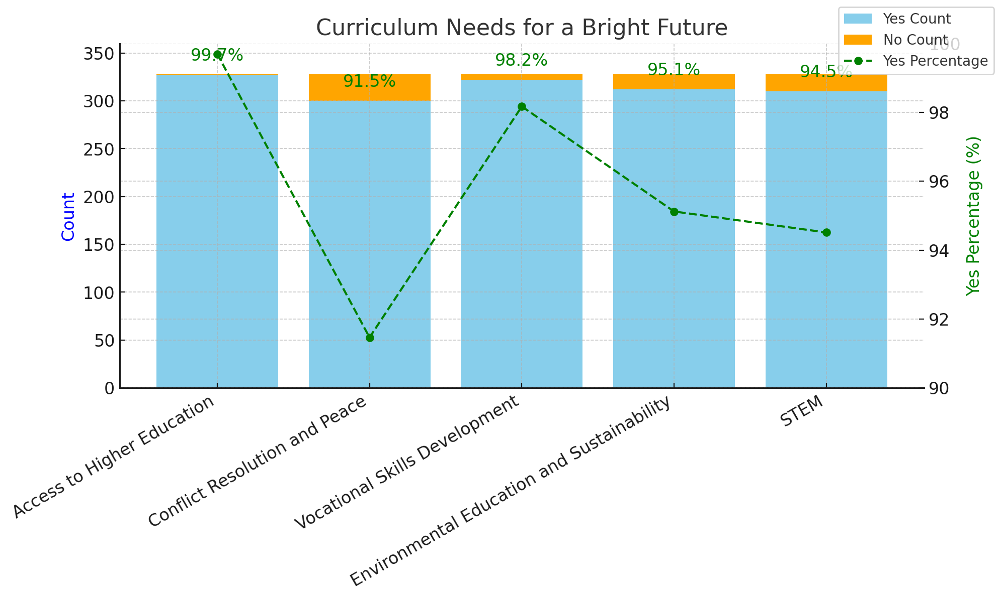
Figure 8
The ‘Curriculum Needs for a Bright Future’ is a detailed graphical representation of the condition, which is vital and required to improve the education standard of the Rohingya refugees’ children. Five curricular areas deemed necessary are rated according to the number of agree/disagree responses obtained.
Access to Higher Education: This area gained the highest endorsement, as 327 (99.7%) of the respondents appreciated the necessity of this area. One person alone dissented in this regard.
This underlines the virtually unanimous understanding of higher education as an essential route for the future success of refugee students.
Conflict Resolution and Peace: Although the participants recognized this category as crucial, 300 participants (91.5%) supported it. The existence of conflicts warrants conflict education, as the camp environment requires the promotion of harmony.
Vocational Skills Development: Another factor was vocational training, which received a favorable response, with 322 (98.2%) agreeing on the value of vocational training, which could enable them to gain employment quickly.
Environmental Education and Sustainability: 311 respondents (95.0%) considered environmental awareness as crucial, remarking that sustainable education must be provided to guarantee the permanence of positive impacts for improving society.
STEM: The 310 respondents had a median score of 4.905; 94% of the respondents supported STEM-asserting, which is education for the future and a key component in any future-oriented country.

Discussion:
The findings justify that higher education and vocational course education are the two areas that are available to make a better future for Rohingya students. Another critical aspect in high regard in the curriculum is conflict solving and environmental protection, which is evidence of the development and provision of a complete educational system. Science, Technology, Engineering, Mathematics, or STEM education is below support but essential in today’s skills-based learning.
Rohingya refugee students believe that besides the Myanmar curriculum, they need these because, at present, as they are refugees, they need more certainty. They need quality education, which is separate from the current education in the camp. As a result, they need this access to have a bright future.

5. Qualitative Data Analysis
This section presents the results of a thematic analysis performed on Camp 11 students in eleventh grade. The recognized themes are educational accessibility and availability, financial obstacles, instructional quality, resource constraints, and program development. Here, the 1st tables 1-4 are from 11th-grade students’ perspectives, and the 2nd tables 1- 5 are from the teacher’s perspective.

5.1 Thematic Analysis (11th Grade students)
- Access and Availability of Education  - Limited access to education due to the absence of NGO classes.  - Students Are required to travel to Camp 9 for teachers. | - Financial Barriers  - Monthly payment requirement poses financial strain.  - Students working jobs for study and family support.
3. Quality of Teaching  - Burmese teachers only, potentially lacking diversity.  - Limited teacher availability and resources. | 4. Lack of Resources  - Need to purchase teaching materials independently.  - Need more study time due to other commitments.
Table 14
Access and Availability of Education: For the Rohingya refugee students in the camp still, there is no formal 11th and 12th-grade education by NGOs. As a result, students who finish their secondary education and are willing to continue higher education must continue by themselves. No one at Camp 11 has the credentials to teach the 11th grade Myanmar curriculum book, say the eleven students spoke with. The only place they can go to get an education is Camp 9, and there's only one teacher there.
Financial Barriers: As there is no formal 11th-grade education, students continue their education privately and must pay individually. And one person has to pay 1000 tk to the teacher every month. As a result, they have to work to earn money so that they can pay as well as support their family.
Quality of Teaching: The students mentioned that the quality of teaching could be better, and as only one teacher teaches all the subjects, it does not carry quality lectures. And no diversity in education. They don’t have any access to practical, and they only have specific books to follow.
Lack of Resources: Students face financial pressure because they have to buy all the materials themselves, which is an enormous burden. To pay monthly, they work in NGOs to get a small amount. As a result, they don’t get enough time to study, which is a significant problem and will have a negative effect in the future.
The Rohingya students who migrated to Bangladesh as refugees also need a formal higher education system and resources. Therefore, they are also constrained by money and other resources while seeking higher education. The lack of NGO-supported education in 11 and 12 classes makes students use single teachers in distant camps, which hinders them and degrades the possibility of proper education. A single teacher does all the instruction, and there is no possibility of passing practical sessions, so the offered knowledge is limited, hurting the students. As a result, these barriers negatively affect student's personal development, and ensuring this underserved group has equal access to high-quality education and improves their outcomes depends on fixing these problems.
Discussion:
Adoptively, the findings of the quantitative data provided solid evidence to corroborate the hypothesis, suggesting that enhancing the standard of education for the students of the Rohingya refugees indeed bears the fruits corresponding to a better prepared, empowered, and prosperous future. The analysis of the Chi-Square values (p < 0.001) for each macro-variable dismisses the null hypothesis and validates the intervention's effect on quality education.

As such, international students require more focused attention to improve educational participation, the academic program, teacher professional development, and funding. By doing so, the stakeholders consider the factors more than the academic achievements of Rohingya refugees. This will create enabling environments for the students to actualize their potential in future employment or business ventures.

6. Teacher’s Perspectives on the Current Education System and its Improvement to Quality Education:
This section primarily focuses on the interviewees' perspectives on education and the obstacles to providing Rohingya students with a quality education, drawn from their conversations with teachers at Camp 11.

1. Infrastructure & Resources  -Classroom space  -More classrooms  -Classroom environment  -Technology access | 2. Educational Opportunities  •Higher education  •Vocational education  •Curriculum development | 3. Teaching & Learning  •Class time duration  •Teacher training  •Qualified teachers(English)
4. Supporting Students  •Student certificates  •Student ID cards  •Student uniforms | 5. Program Development & Implementation  •Curriculum development  •Instructional support
Table 15
Infrastructure & Resources: In Camp, there needs to be more learning centers for the students; as a result, there are around 40-60 students in one classroom. The school environment could be more effective, and the infrastructure needs to be better structured. In Camp 11, a few learning centers don’t have any benches for students, so students face difficulties in their learning. Rohingya refugee students don’t have access to technology for their education purposes, which is one of the barriers to quality education. So, they are behind others, which is their right to improve themselves and their present.
Educational Opportunities: There needs to be more than just reading books to gain proper knowledge; students need practical knowledge that helps them understand clearly. But the Rohingya students don’t get an opportunity to gain helpful knowledge. They are limited to reading books only in the Myanmar curriculum. They need other curricula besides the Myanmar curriculum because they have access to education till grade 10 but not in an appropriate way. So, they need vocational education, STEM, environmental education, and conflict resolution, which are more significant and essential for their life. In camps, thousands and thousands of students have no access to higher education where they can find their lives in the dark. Students need access to higher education and curriculum development for a bright future.
Teaching & Learning: The number of teachers is smaller, and a teacher has to take more classes, which is a big challenge for teachers and students. Teachers think they need proper training, which helps them teach effectively, and they need good English teachers. From quantitative data, we can find the result on language use in the camp where the English language is used less than others.
Supporting Students: Teachers think students need ID cards and uniforms to identify students from others, but NGOs do not provide them. The critical thing is the certificate for the students because they think that when they move from here to any other country or their own country, they can show the certificates and be allowed for the next class. Due to not getting certificates, students are worried about their education cause when they cannot show the certificates; they have to enroll in the same class again, which will impact their age.
Program Development and Implementation: In the camps, students need development programs like environmental, self-improvement, conflict resolution, and well-being development programs should be provided. And whatever steps NGOs take, it should be implemented in the camps. As a result, students can learn the crucial lessons in their life.
Discussion: If the Rohingya refugee children are to be offered quality education, then these challenges must be met. This is because increased access to higher education, increased curriculum diversity of learners, and availability and preparation of adequate instructional resources and teachers can promote learner inclusion and support. Financial constraints must be eliminated, and program improvement must be made so that students get better academic results and become competent and responsible members of society.
Finally, the aim is to increase the quality of education for Rohingya refugees, focusing on the prospective social and economic benefits for the improved quality of the refugees’ lives and the ability to create a stronger, more empowered Rohingya community. Consequently, these findings re-emphasize the need to develop specific strategies to reduce barriers to education so that this minority can secure proper employment when they grow up.

7. Limitations:
This study has potential limitations, and several factors likely affected the results of this study. The following are some of the limitations: Firstly, the participants may need to give a sampling of the various experiences of the refugees as the study targeted only the youth within the Rohingya refugees in Camp 11. Furthermore, lack of time meant that data was collected and analyzed within a limited range, limiting the amount of detail collected and the comprehensive nature of the data collected. The study population was restricted to a significant number of secondary school students, which could have averted the views of primary school learners, which impacted the study's coverage in some ways. Moreover, the primary data source may have been biased by personal bias in the methods used to collect or in how the participants reported their information. The above limitations should be considered while making conclusions and recommendations on how to help enhance the quality of learning for the Rohingya refugees. To eliminate these limitations, further research should recruit a larger participant group covering Refugee experience, ages, and education levels. Longitudinal investigations also offer additional information regarding the consequences of educational treatments over long-term periods. However, other methods, such as questionnaires with primary students and observation, might eliminate self-report bias and provide richer data. Such approaches complement knowledge and contribute towards better ways to address the quality of learning for the Rohingya refugees.

8. Recommendation:
Therefore, it is crucial to assess the quality of the education interventions for the Rohingya children of Cox’s Bazar camp through education recovery and improvement through integrating culture-sensitive teaching and learning for the student beneficiaries. Academic activities should incorporate experience and skills-based elements, meaning students should learn more than just bookish knowledge. Also, more citizens need to advance their learning to higher education levels. Every attempt should be made to provide scholarships, loans, and other forms of vocational training for students who wish to pursue university education. Teachers also need access to professional continuing education in English and teaching methods compatible with refugee education to interact with students. Engaging parents, community members, and other stakeholders will also go a long way in creating awareness and supporting students through community support network construction. In addition, a close relationship with parents through parent-teacher associations and community persons through any other means, such as block leaders, business people, and local administrative heads, will also be necessary for education support for the students. Lastly, monitoring and evaluating educational programs frequently is needed to know the impact of programs launched for Rohingya students and find areas of improvement and opportunities for modification for better educational improvement of Rohingya students. All these will go a long way in dealing with the preceding challenges and creating an equal and positive education environment for this group of learners.

9. Conclusion:
This study contributes to the realization of the need to account for quality education for the Rohingya refugee students in Cox’s Bazar and understand the implications of the learning challenges and prospects of education interventions in the camp settings. Education is a basic need and a critical building block for any society, though for thoroughly displaced communities, meaning the Rohingya population, education means a challenge. These sanctions strongly suggest that higher secondary education is relatively inaccessible, expensive, resource-scarce, and taught by unqualified teachers. These challenges regress students’ dreams and prevent them from being prepared for further jobs.
The thematic analysis conducted in this study has revealed areas of concern, as Illustrated below. Few students attend higher education classes, and those few only get a few teachers to teach them, or they have to go to remote camps to get lessons. Existential problems exist in this regard, with the financial barriers acting as a thorn in the sides of learners who are often compelled to work while in school to afford their fees and books. Besides, the effectiveness of the teaching is impacted because of the need for more development of a pool of qualified multiple instructors and relevant, practical experiences. Inadequate textbooks and technology significantly hinder learning and make students experience difficulty in coursework.
For the teachers, there are also difficulties. These challenges include the lack of adequate infrastructure to support the population of learners in each classroom, the structural challenge of overcrowding, and the lack of support structures for teachers, which makes it hard to offer quality education. Participants also highlighted the importance of.
However, several recommendations can make ways for improvement even if these challenges exist. More and more Rohingya children attend school, schools are improving, and teachers are being trained to improve their abilities as educators; addressing community responsibilities can help guarantee equity in education for Rohingya students. That way, it can provide regular and adaptive monitoring of new concerns to ensure work continues over the long term. Teachers stress the problems of professional development, coursework reconsideration, and better instructional materials. They also propose increased community engagement and support systems to improve learning achievement.
The importance of this research is evident in the hope that its findings might be used to shape policy and future efforts to enhance educational access for refugees. By overcoming the given challenges and applying the suggestions, the stakeholders will be able to seek work towards a better and more effective environment for learning. That will eventually enable the Rohingya students to fulfill their academic dreams and become productive citizens. Thus, education remains the only hope for these students, giving them a new Lease of life to look forward to.

References
Ahsan Ullah, A. K. M. (2020). Rohingya crisis in Myanmar: Seeking justice for the “stateless.” Journal of Social Welfare and Human Rights, 8(2), 1–22. https://doi.org/10.1080/20004508.2020.1823121
Admin. (2024, June 26). Development services for Rohingya and host community. CODEC. https://codec.org.bd/development-services-for-rohingya-and-host-community/
2023 JPF Youth and adolescents education support in Cox’s Bazar District, Bangladesh. Jagorani Chakra Foundation. (2024, November 13). https://jcf.org.bd/2021-jpf-youth-and-adolescents-education-support-in-coxs-bazar-district-bangladesh/#
Dryden-Peterson, S. (2016). Refugee education: The crossroads of globalization. Educational Researcher, 45(9), 473-482.
Dryden-Peterson, S., & Giles, W. (n.d.). Higher education for refugees. Refuge. https://refuge.journals.yorku.ca/index.php/refuge/article/view/34717
Human Rights Watch. (2019). “Are we not human?” Denial of education for Rohingya refugee children in Bangladesh. https://www.hrw.org/report/2019/12/03/are-we-not-human/denial-education-rohingya-refugee-children-bangladesh
IGI Global. (n.d.). The universal language of sustaining quality peace and resilience. https://www.igi-global.com/dictionary/the-universal-language-of-sustaining-quality-peace-and-resilience/46442
Leverage Edu. (n.d.). Quality education: What is it and why is it important? https://leverageedu.com/blog/quality-education/
Rahman, M. (2023). Lives of the Rohingya children in limbo: Childhood education and children's rights in refugee camps in Bangladesh. ResearchGate. https://www.researchgate.net/publication/370505115_Lives_of_the_Rohingya_children_in_limbo_Childhood_education_and_children's_rights_in_refugee_camps_in_Bangladesh
ReliefWeb. (2018). Rohingya refugee sites: Camp 11, Ukhia, Cox’s Bazar, Chattogram, Bangladesh. https://reliefweb.int/map/bangladesh/rohingya-refugee-sites-camp-11-ukhia-coxs-bazar-chattogram-bangladesh-6-december-2018
ReliefWeb. (2023). Bangladesh: Rohingya refugee students expelled. https://reliefweb.int/report/bangladesh/bangladesh-rohingya-refugee-students-expelled
Shakir. (2023, June 4). YPSA distributed start-up kits/materials for “education cannot wait” project at Rohingya camps and host community. Young Power in Social Action (YPSA). https://ypsa.org/2022/10/ypsa-distributed-start-up-kits-materials-for-education-cannot-wait-project-at-rohingya-camps-and-host-community/
Soroptimist International. (2020). Safeguarding education in conflict zones. https://www.soroptimistinternational.org/safeguarding-education-in-conflict-zones/#:~:text=Children’s%20right%20to%20education%20cannot,and%20recruitment%20by%20armed%20groups
Tomasevski, K. (2001). Human rights obligations in education: The 4-A scheme. Right to Education Initiative. https://www.right-to-education.org/sites/right-to-education.org/files/resource-attachments/Tomasevski_Primer%203.pdf
Tomlinson, M. (2009). Education and development in conflict zones: Education for all as reconstruction and peace-building in Nepal. Globalisation, Societies and Education, 7(2), 145–160. https://doi.org/10.1080/009140390909763
UNESCO. (2020). Education in conflict zones: A report on the global state of education in emergencies. https://unesdoc.unesco.org/ark:/48223/pf0000371554
UNESCO. (2023). Education report: All-inclusive campaign for refugee education. https://www.unhcr.org/media/unhcr-education-report-2022-all-inclusive-campaign-refugee-education
UNICEF. (2023). Bangladesh case study: Refugee education. https://www.unicef.org/media/102011/file/Bangladesh%20case%20study%20-%20refugee%20education.pdf
UNICEF. (2023). Education milestone for Rohingya refugee children: Myanmar curriculum pilot. https://www.unicef.org/press-releases/unicef-education-milestone-rohingya-refugee-children-myanmar-curriculum-pilot
UNICEF. (2023). Substantial progress in providing education for hundreds of thousands of Rohingya refugees. https://www.unicef.org/rosa/stories/unicef-substantial-progress-providing-education-hundreds-thousands-rohingya-refugees
UNHCR. (2023). Young Rohingya refugees strive to keep dreams of education alive. https://www.unhcr.org/news/stories/young-rohingya-refugees-strive-keep-dreams-education-alive
UNHCR. (2022). Education report: All-inclusive campaign for refugee education. https://www.unhcr.org/media/unhcr-education-report-2022-all-inclusive-campaign-refugee-education
YPSA. (2022). Educational content need assessment for young Rohingya refugees in Cox’s Bazar. https://ypsa.org/ypsa/wp-content/uploads/2023/04/Educational-Content-Need-Assesment-Young-Rohingya-Refugees-in-CoxsBazar-2022.pdf

