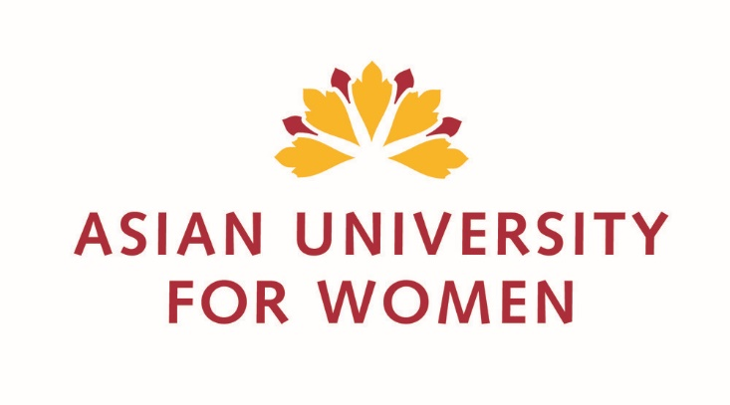
Impact of increased Salinity on
Women's Health: Exploring Hypertension Trends in a Changing Climate

A thesis submitted in partial fulfilment of the requirements
for the degree of Bachelor of Science Environmental Sciences
At Asian University for Women (AUW), Chattogram, Bangladesh

By
Iffat Mahjabin

Supervisor Co-Supervisor
Dr. Sayed Mohammad Nazim Uddin Dr. Tuhin Biswas
Associate Professor, Environmental Assistant Professor,
Sciences. Public Health.

Asian University for Women
Spring of 2024.

Declaration

I, Iffat Mahjabin, hereby declare that the report of my senior thesis with the title of “Impact of increased Salinity on Women's Health: Exploring Hypertension Trends in a Changing Climate” is a record of my own research under the supervision of Dr. Sayed Mohammad Nazim Uddin. I solemnly declare that, to the best of my knowledge, I did not commit any form of academic dishonesty at the time of working of the study and the thesis does not infringe upon anyone’s copyright. I have cited and acknowledged all the sources of my references that have been used for writing the thesis. I also declare that the rights or privacy of any humans have not been violated to conduct the research.

Name: Iffat Mahjabin
Signature: Iffat
Date: 19th Day of May, Year 2024.

Acknowledgement

This thesis has been approved and funded by Asian University for Women (AUW). A special thanks goes to the department of Environmental Sciences for making approving all the financial budgets for the study.
I would like to express my utmost gratitude to my supervisor and academic adviser Dr. Nazim who has been motivating me to pursue my own research since the day I declared my majors. He has constantly and enthusiastically encouraged me to continue with my thesis and has been there in every step from writing the proposal till defending the thesis. This work would not have been possible without his constant guidance, prompt feedbacks and encouragements.
I express my gratitude to Dr. Tuhin Biswas, co-supervisor of my thesis. From making the questionnaire to the data analysis, his helping hands were there to guide me to navigate the study.
My deep appreciation goes to Ms. Taqia Ahmed, a senior student of Politics, Philosophy, and Economics (PPE) at the Asian University for Women (AUW) for supporting me by travelling to Satkhira and by collecting the data alongside me.
I am thankful to my team at Satkhira, who could proficiently follow up with my plans and helped me to collect data from the most climate-vulnerable population.
Thanks to my amazing juniors- Shaika Mohammad Chowdhury for expanding her hands in helping me write the report and provide her valuable feedbacks, and Fahmida Begum, for helping me with the GIS mapping.
I express my gratitude to all the people from both of my majors with whom I had the privilege of sitting in the classrooms for the last 3 years. Their knowledge, passion, and dedication encouraged and inspired me every day.
Finally, I acknowledged the constant understanding, moral support and encouragements of my family and friends in completing this thesis.

Abstract

This study investigates the effects of elevated drinking water salinity on women's health, with a particular focus on trends in hypertension in areas where anthropogenic activities and climate change have resulted in elevated water salinity. To examine salinity levels across different places, precise maps were constructed using the most recent Geographic Information System (GIS) software. The HI98319 digital salinity tester was used to test water samples from 200 participants, and a digital blood pressure monitor was used to take their blood pressure. The findings showed a substantial positive connection between salinity levels and both systolic (r = 0.62, p < 0.01) and diastolic (r = 0.58, p < 0.01) blood pressure. Specifically, compared to 10.7% of people with poor quality water, 47.2% of those with access to good quality water had hypertension. These results emphasize the vital connection between environmental conditions and health outcomes, emphasizing the pressing need for public health initiatives and regulations to guarantee the availability of clean drinking water. Subsequent investigations ought to concentrate on enduring health consequences and sustainable approaches to alleviate the hazards linked to elevated salinity levels in water.

Table of Contents

Declaration
Acknowledgement
Abstract
- INTRODUCTION…………………………………………………………………………………………………………6
- Literature Review………………………………………………………………………………………………………8
2.1 Impact of Water Scarcity on Health and Environment………………………………………….8
2.2 Health Impacts of saline water consumption……………………………………………………….9
2.3 Health Impacts of saline water consumption……………………………………………………….9
2.4 Health Impacts of saline water consumption…………………………………………….………..10
2.4.1 Gender Disparities and Domestic Roles in Water Management………………..…..10
and Access
2.4.2 Necessity to Promote Gender Equality and Women's Empowerment…………….11
2.5 Local and international policies regarding water…………………………………………………12

3. Methodology………………………………………………………………………………………………………………14
4. Result and Discussion……………………………………………………………………………………………………18
5. Limitation……………………………………………………………………………………………………………………...24
5. Conclusion & Recommendations……………………………………………………………………………………25

APPENDIX I – Survey Questionnaire……………………………………………………………………………………………………..30

Introduction
Bangladesh is facing the worst possible climate change impacts. Human health is the number one concern in this case. Among the numerous impacts that climate change is making, increased salinity is often overlooked. But it is a critical problem in the coastal and arid regions of Bangladesh. Increased salinity can be driven by many reasons like the sea level rising, lack of precipitation, and overuse of groundwater. One important feature that renders deltaic regions more sensitive to climate change is sea level rise. Higher mean sea levels are likely to combine with other environmental conditions, such as tropical cyclones, to cause bigger storm surges and more flooding (Vienis et al., 2019). The salinity impacts other environmental elements as well. Problems with the salinity of the soil and water have been directly linked to the rise in saline areas. Low-lying locations in coastal areas are inundated by sea water, and sea water intrusion into the aquifers with fresh water contribute to the salinization of the coast (Velmurugan et al., 2019). The known relationship between high blood pressure and salt consumption makes hypertension the main health concern associated with this environmental change. Reports from the local community indicate that in addition to hypertension and stroke, high salt intake can be the cause of various other health issues. According to WHO, lowering population salt intake is a top goal for public health (Vienis et al., 2019). As the global climate change is occurring at a constant range, it has become crucial to understand the impacts of salinity especially on women for their climate vulnerability.
The status of women as secondary citizens in Bangladesh makes them especially vulnerable to climate change. Due to frequent flooding, river erosion, and salt-water intrusion women’s health is at higher risk. This is not unique to Bangladesh. Less than 50 nations clearly mention women's engagement in rural sanitation or water resource management in their laws or regulations (UN Water, 2021). Women spend long hours walking in order to collect water for their families which has a negative impact on their physical health. (Jordan, 2019) Women’s hygiene needs including well-secured and gender-specific toilets, availability of sanitary products, and proper disposal systems are not widely available due to the lack of water. Bangladesh is exposed to the Bay of Bengal in the south and salt-water intrusion has become very common and increasingly problematic for health. The salinity has reached 20 parts per thousand whereas the human body can take up to only 5 parts (New Age, 2021).
The scientific literature has provided ample evidence of the correlation between hypertension and salinity. One of the main ingredients in salt, sodium, is essential for controlling blood pressure. Excessive use of salt has a direct correlation with hypertension, a medical condition marked by consistently high blood pressure. Being a primary cause of morbidity and mortality globally, hypertension is a key risk factor for cardiovascular disorders such as heart attacks, strokes, and heart failure. According to the 2002 report of a Joint Expert Consultation of the Food and Agriculture Organization (FAO) and the World Health Organization (WHO), the recommended daily consumption of salt has been set at 5 g. The maximum permitted amount of chloride in drinking water is 250 mg/L. Recommendation levels in nations where iodine shortage is prevalent are contingent upon the iodine status of the relevant populations. Although tiny amounts of salt are necessary to maintain the body's fluid equilibrium, consuming more salt than is advised has been linked to negative health outcomes (Vienis et al., 2019). From a study by Khan et al., it was found that, among the coastal women populaton, drinking water salinity is linked to a higher risk of (pre)eclampsia and gestational hypertension. It is critical to develop and assess cost-effective strategies for supplying water with low salinity because coastal populations in nations like Bangladesh are exposed to high salinity, and this exposure is expected to worsen due to sea level rise and other environmental factors (Khan et al., 2014).
Women’s health suffering is far from superficial as they are impacted not just socially, but ecologically. And in return, the family suffers, especially the children. Due to the scarcity of fresh or clean water, and also due to high salinity, during pregnancy, puts both mother's and children’s health in danger, as it causes several negative outcomes, which include incomplete or bad growth development of the children. (Giudice et al., 2021). In the end, working under fatigue, and having to already carry the burden of life that is physically demanding, women always have to pay the price not just in the health of herself and her children that she has to look after, but socially.
To deal with these problems, it is necessary to go through steps once at a time and consider how water salinity impacts the entire community keeping women as a primary focus. Possible solutions include community rainwater harvesting or artificial ponds. These would alleviate some of the burdens faced by women whose duties in water collection entail long hours and exposure to the elements, including high temperatures, for water that is shared by a family of 5-6 members on average. And also, to ensure hygiene, it is important to improve separate gender toilets and make sure that women can receive a properly sanitized environment, especially during their period, which can keep them healthy and ensure their dignity. These challenges have to be addressed immediately and the practices must be installed through climate change adaptation with proper policy implications.
A report on a study based on Integrated Water Resources Management (IWRM) belonging to SDG 6.5 from GWP and UNEP-DHI (2021), mentions gender mainstreaming aligned to SDG 6.5.1, highlighting the low placement of women in Water Resource Management (WRM); and SDG 5’s goal of achieving gender equality by empowering all women and girls. According to their report, there still remains a gap between policy and practice due to strategic failures such as weak plans, inadequate funding, and lack of proper monitoring measurements.
The methodology of this study includes a quantitative method yet with a qualitative approach. Interviews were conducted to understand the socio-economic and cultural understanding of salinity impact on women. Women’s role in the family and society was also considered to understand the extent of the impact. Epidemiological data was collected on spot to understand the trend of hypertension in the study area. Environmental evidence such as salinity level was also collected.
It is necessary to understand that it isn’t just about fixing technical problems, but also to change how women are perceived in society and who gets to make the decisions regarding their safety and proper health management. Creating strict policies that can ensure that women can be given more rights to have a say in water management and disaster preparations through creative strategic methods is important. (Prüss-Ustün et al., 2014). It is highly necessary to make sure that women get treated fairly and receive the same rights as men in rural societies, where they are usually both the co-providers and caretakers of their entire family, having to overlook many mistreatments and judgements from society. These policies will help them become more united and stronger, and they will be able to handle such tough situations, not just for themselves, but for their entire community.

- Literature Review
  - Impact of Water Scarcity on Health and Environment
Water scarcity results in threatening environmental sustainability, human health, and socio-economic development of a country. It is one of the direct impacts of climate change. It impacts people’s lives on a regular basis. Health hazards due to pure drinking water are very common in developing countries like Bangladesh, where vulnerable populations suffer heavily from the aftereffects of water scarcity, and environmental degradation. Every year, some 3 million people die from illnesses associated with water, most of them youngsters under the age of five (DFID, EC, UNDP, and WB, 2002). According to Shaw and Thaitakoo (2010), 1.1 billion people worldwide lack access to clean water. This literature review focuses on such threats, with a focus on gender dimensions of water scarcity challenges, as women often are not included in the ways of water management.
For a healthy and prosperous existence, there must be an adequate quantity of water that is both economical and accessible (Hunter et al. 2010). Waterborne disease, dehydration, and saltwater intrusion in freshwater sources are some of the major problems faced by the inhabitants of the southwestern part of Bangladesh. Due to climate change, the temperature of the world keeps rising, causing ice caps to melt which, in turn, is causing global sea level rise; where the consequences are far-reaching. A survey conducted in Shyamnagar, a sub-district of Satkhira district demonstrates that the local population thinks that freshwater sources and health are being significantly impacted by climate change. Diarrhea, dysentery, and skin conditions were named as the three main waterborne health concerns brought on by climate-related safe water scarcity by more than 70% of the respondents (Abedin et al.,2019). The southwestern part of Bangladesh, although somewhat protected by the Sundarbans mangrove forest, is increasingly exposed to the waters of the Bay of Bengal, polluting freshwater sources and leading to increased drinking water scarcity; these contaminations heavily include saltwater inclusions. This also limits agricultural productivity, which affects farm-earning household members (Mekonnen & Hoekstra, 2016).

  - Health Impacts of saline water consumption
Drinking salted water increases the risk of several health problems, which are made worse by rising salinity levels in the world as a result of anthropogenic activity and climate change. The main effect of consuming water with a high salinity level is to overstimulate the body with sodium chloride, or salt. Dehydration may result from prolonged exposure to high-salinity water since the body needs more water to eliminate the extra salt. In one of the JCI's issues, the authors refute this idea and show how osmotic balance in response to a high salt intake is the result of a multifaceted regulation mechanism impacted by fluctuations in hormones, metabolism, food intake, water intake, and renal salt and water excretion. The surprising finding that long-term high salt intake increases water retention rather than increasing human water consumption is reported by Rakova et al. Furthermore, variations in glucocorticoid and mineralocorticoid hormones affected the equilibrium of salt and water. Extending these results in animal models, Kitada et al. found that increasing protein intake leads to an increase in urea and urea transporters in the renal medulla, which in turn promotes the water retention required to maintain osmotic equilibrium (Zeidel, 2017).

In the areas where freshwater is hard to get, women tend to drink the saline water for saving the small amount of freshwater for the family members. Long terms impact of consuming the saline water can cause hypertension which is very risky for women of reproductive age. According to a study by Talukdar et al., In coastal Bangladesh, it is found that 53% of young individuals (19–25 years old) have average urinary sodium contents (106 mmol = 2.4 g sodium ≈ 6.2 g salt, or sodium chloride) that are higher than what is advised. According to Rasheed et al. (2014), 59% of adults (25 years of age and older) were exposed to high levels of salt in this area, based on the WHO cut-off value for sodium intake (Talukder, et al., 2016).
There is a well-established physiological connection between hypertension and salinity. Many biological processes, such as neuron signaling, muscular contraction, and fluid equilibrium, depend on sodium. Excessive consumption of sodium, however, upsets this equilibrium, increasing blood volume and, in turn, blood pressure. In Massachusetts, USA, a prospective study examined two matched cohorts of high school students from towns with a high (272 mg/L) and low (20 mg/L) salt levels in public drinking water, and found that after controlling for dietary salt intake, systolic and diastolic blood pressures in the high-sodium area were considerably higher by 3–5 mmHg. According to a Chicago study on comparable cohorts, the group consuming 405 mg/L of sodium in their drinking water had a 2 mmHg higher diastolic blood pressure than the group consuming 4 mg/L (p = 0.040 for males and p = 0.016 for female males) (Vienis et al., 2019).
Increased salt in drinking water has significant and varied health effects. The burden of consuming salted water is substantial, ranging from general health effects like dehydration and gastrointestinal problems to more serious long-term repercussions including hypertension and cardiovascular disorders. Comprehending the physiological mechanisms that associate salinity with hypertension and contrasting health consequences across varying salt levels of water offer crucial perspectives for formulating focused interventions and regulations aimed at reducing these health hazards.

  - Hypertension
Hypertension in local language most commonly used as high blood pressure is a medical condition characterized by the blood flow in the arteries. Hypertension is a major risk factor of different cardiovascular diseases like heart attack, stroke, and heart failures. Hypertension has a significant contribution to the disability adjusted life years, mortality, and morbidity. The Seventh Joint National Committee on Hypertension report states that hypertension (HTN) is currently a significant public health issue that affects &50 million people in the US and &1 billion people globally. If comprehensive and effective preventive measures are not put in place, the prevalence of HTN will rise even more as the population ages.1. Over the past few decades, epidemiological research has demonstrated the ongoing, persistent, and independent relationships between HT and cardiovascular disease (CVD) (Wang, et al., 2006).
People are diagnosed with hypertension if Primary outcome measures sustained increased blood pressure (BP; defined as clinic systolic BP ≥140 mmHg or daytime ambulatory BP ≥135 mmHg, and/or clinic diastolic BP ≥90 mmHg or daytime ambulatory diastolic BP ≥85 mmHg), which was defined as a binary outcome of incident hypertension (Cuffee et al., 2016). In order to appropriately assess the need for therapy, choose the best course of action, establish goals, and assess the effectiveness of treatment, cardiovascular risk factors must be taken into account. It is risky to wait for indications of organ involvement since frequently, sudden death, stroke, or myocardial infarction are the first signs of organ involvement. Both lowering blood pressure and improving the composite risk profile are necessary for optimal treatment (Kannel, n.d.).

2.4 Women’s Role in water
2.4.1 Gender Disparities and Domestic Roles in Water Management and Access
Water management is very important for protecting people from the scarcity of water. Deep tube wells, sand filters, and protected ponds are some of the ways of preserving water. For regulating all of these pure water sources, good water management is required. In most cases, water management is predominantly male-dominated, leaving women out of decision-making processes. The effects of climate change are unevenly felt across social strata, despite the fact that it is already increasing the vulnerability, marginalization, and suffering of many people worldwide. Different people experience and respond to the effects of climate change in different ways due to intersectionalities of social differences, particularly along gender identity (Sultana, 2018). The gendered ramifications of climate change caught the attention of COP in 2007, under the slogan “No Climate Justice without Gender Justice” (Sultana, 2018). Women’s status can change according to socio-economic conditions, marital status, age, and race, and thus may have different levels of intensity in terms of these conditions. Researchers have usually observed that natural resource shortages and environmental degradation disproportionately affect women, especially marginalized and poor women. Although women and men are affected by water crises differently, it is often believed that women suffer disproportionately from water shortages and water-related disasters (Sultana, 2007).
Domestic roles in a family vary depending on gender in Bangladesh. It is a social norm that men would be doing more physical labor whereas women are expected to handle household chores. But in terms of water, the situation is not quite the same. For example, women’s micro-level water usage in terms of kitchen garden, and cattle raising is often ignored according to the literature. Men use motor pumps to collect water for agricultural purposes; whereas women collect water from shallow hand pumps which require more physical labor. In the southwestern part of Bangladesh, many tube wells get polluted with flood water which requires women to walk long distances to collect water. Due to the increased workload and difficulties in carrying out home duties, there is a greater chance that women would experience marital male aggression as retaliation for their failure (Karim et al., 2012). The long walking period, familial instability, and lack of water for proper sanitation have negative impacts on women’s physical and mental health, with women of reproductive particularly vulnerable, as malnutrition rates are alarmingly high among them and the children.

    - Necessity to Promote Gender Equality and Women's Empowerment
As it is made clear how much male dominance there is in water management, in terms of climate change, water scarcity is enhanced in multiple folds, this causes so many problems in countries like Bangladesh as over 4 billion people worldwide are facing severe water scarcity according to UNICEF (n.d.); not just because of climate change, but massive population growth. (Mekonnen & Hoekstra, 2016). For this, Vörösmarty et al. (2000) highlighted the vulnerability of global water resources as it is urgent to create adaptive measures to ensure sustainable water management practices. The efforts necessary to address the water scarcity and climate change problems are much more complicated and require a multidisciplinary development strategy, especially regarding inadequate water resources, sanitation, and hygiene practices in low and middle-income countries. (Prüss-Ustün et al., 2014). Similarly, it is crucial to enhance the nutritional status of the people in the communities, especially women and children and prevent waterborne diseases; Aaronson et al. (2002) state the importance of breaking gender stereotypes and promoting women’s empowerment in water management and access to water and sanitation (Karim et al., 2012). It goes beyond providing clean water and sanitation facilities, it requires challenging the patriarchal norms to make sure that the women population can fully participate in such decision-making process; from household water management to communities. Such empowerments and regulations can help entire future generations from making similar patriarchal-based mistakes, and everyone can build resilience to rapid climate change and achieve sustainable development goals.

  - Local and international policies regarding water
Water Management Policies and Initiatives: International and national cooperation and collaboration are essential as stakeholders to address the overall nature of water scarcity and climate change. For example, in terms of shared water resources across the country’s river basins and ocean borders, they have to prevent spills of chemicals that are polluting the Bay of Bengal. This can prioritize sustainability, and prevent conflicts (Vörösmarty et al., 2000). In Bangladesh, through regional initiatives, such as the South Asia Water Governance Program, policymakers need to prioritize investments in water and climate-resilient infrastructure, and sanitation facilities, so that everyone can have access to clean water and food security; for example, by addressing the National Water Management Plan of 2011, flood control, and groundwater management programs, etc. (Mahbub, 2022).

Key-Informant Authorities for Water Management: From Mahbub’s (2022) findings, we found the below-listed regulatory authorities in Bangladesh -

Ministry of Water Resources
- Bangladesh Water Development Board (BWDB)
- Water Resources Planning Organization (WARPO)
- River Research Institute (RRI)
- Joint Rivers Commission (JRC)
- Bangladesh Haor and Wetland Development Board
- Institute of Water Modelling
- Dhaka Water and Sewerage Authority
- Chattogram Water and Sewerage Authority.

SDG 6 Integrated Water Resources Management (IWRM) Support Programme
Promotions of gender equality and women empowerment must be disseminated across all sectors, not just for water resource management, but overall to ensure unity in terms of proper planning for the country’s overall improvement. This should be effective to make sure that Southern Bangladesh will be heavily influenced by such policies, to improve their communities. Reports from the IWRM Support Programme of GWP and UNEP-DHI (2021) specifically target SDG 5.5 ensuring women’s full and effective participation, and equal opportunities for leadership at all levels of decision-making in political, economic, and public life; which has to be integrated as soon as possible in WRM, as most often, such plans are drafted and finalised before the problems of gender inequality in these roles are properly discussed and is disassociated. When we focus on women, it isn’t about equal rights, but about removing the obstacles that prevent women from accessing those rights irrespective of their social background. IWRM support programme listed actions ranging from basic overachieving mechanisms to more specific and comprehensive mechanisms to ensure that created policies can be stronger. Implementing them can change Bangladesh just like it has impacted several Asian countries.

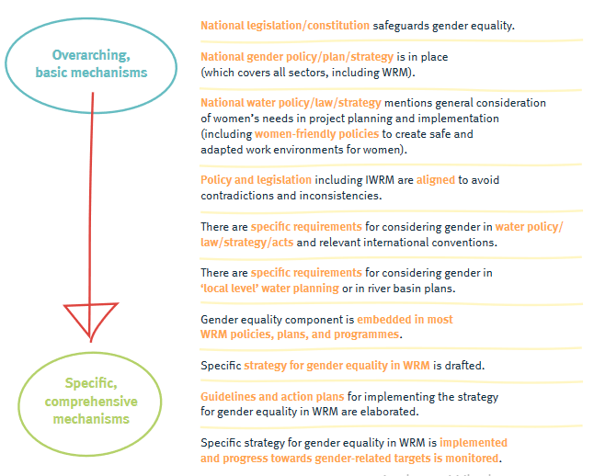
Fig: Legislative and policy framework and governance (GWP & UNEP-DHI, 2021)

Aim: To generate evidence on women’s physical and mental health issues that are related to climate-induced water scarcity in the coastal part of Bangladesh.

Objective:
1. To assess the extent and types of climate-induced water scarcity in coastal parts of Bangladesh.
2. To Identify the physical health status of women in coastal parts of Bangladesh.
3. To determine the association physical status of women and climate-induced water scarcity in southwestern Bangladesh.

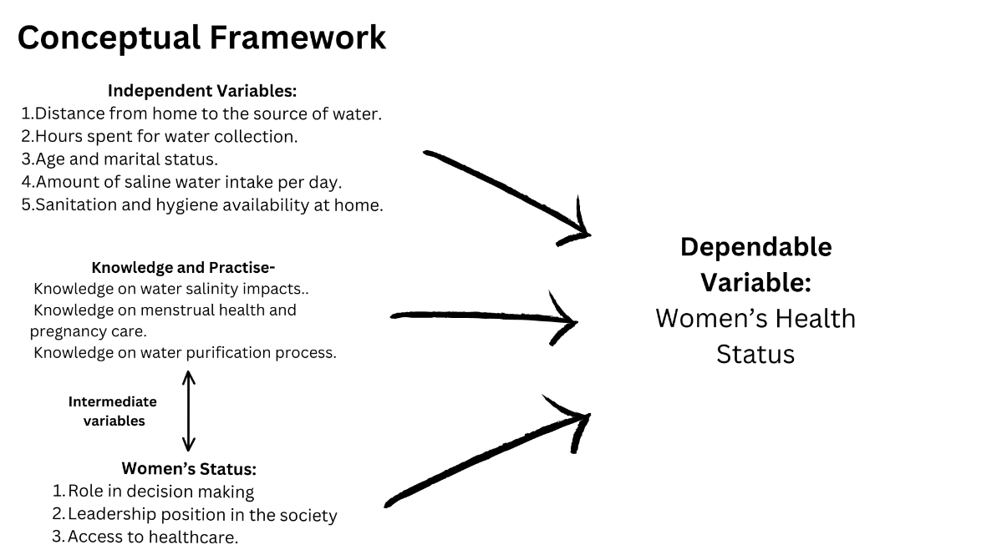

- Methodology

The methodology will include collecting data from the vulnerable population of the southwestern part of Bangladesh. The data has to be collected and analyzed in a systematic and synchronous manner as the condition of the population is very vulnerable due to climate change, salt-water intrusion, and water scarcity. There might not be smooth access for multiple chances of data collection, that’s why the research design for the study will be cross-sectional study. This design will help us to collect data one time and analyze. We will collect the data at a specific point of time which will be analyzed to determine their health impacts caused by the water scarcity.

3.1 Study Area
The southwestern Bangladesh more specifically Shyamnagar Upazilla in Satkhira district is the study site. All the water samples and interviews have been conducted in 6 different Union Parishads. The southwestern part of Bangladesh has been affected by climate change noticeably. Because of the location, the sea water has intruded this area as Bangladesh shares the Bay of Bengal at the southern part of the country. The location of the Sundarbans also makes this district vulnerable to salt water contamination which leads to the scarcity of drinking water in the area. Our targeted population is the women of the reproductive age- The women population of Satkhira sums up to approximately 49% of the population (Banglapedia, 2021). Comparatively higher number of women made it easier for us to collect the data. It will allow a larger sample size and more precise results.

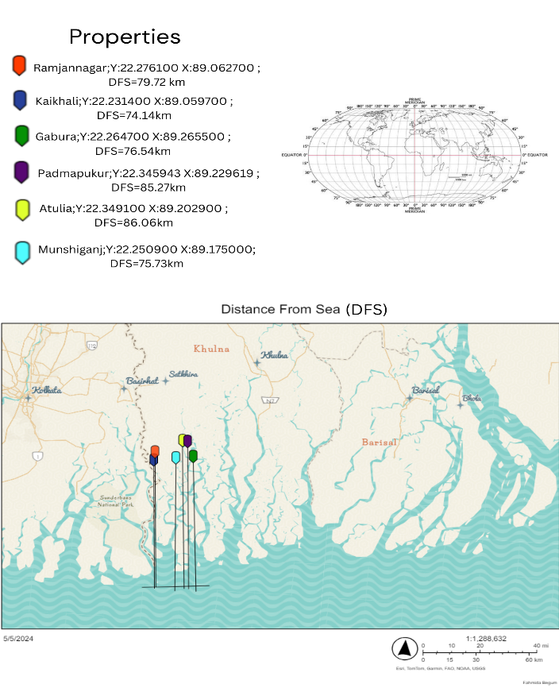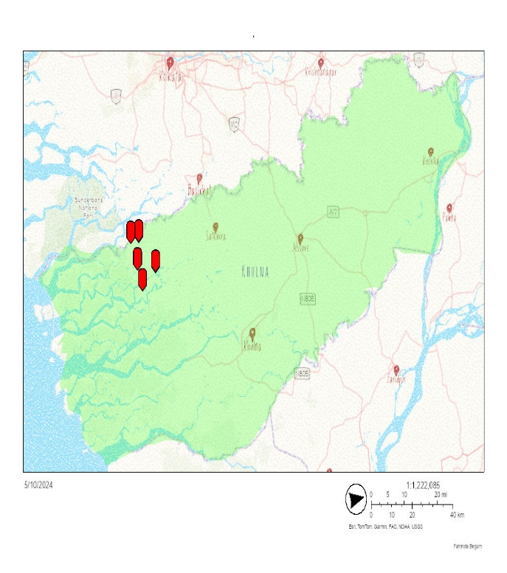
Figure 2: Left: Distance from sea level of the study site. Right: study area in the map of Khulna.
Satkhira is crucially close to the sea level which increases the salinity of all the waterbodies including canals and rivers.
Satkhira includes 3858.33 square kilometers of area with a population density of 483 per square kilometers. Satkhira consists of 7 Upazilas- Shyamnagar being the largest among the 7. But the surprising fact is that Shyamnagar has the lowest density of population which makes it an interesting site for the study (Banglapedia, 2021). Shyamnagar is located between 22.33 degree north longitude and 89.10 degree east latitude in the Satkhira district. It is bordered by the Bay of Bengal and the Sundarbans at the south. Some of the major rivers of the area include: Kalindi, Raymangal, Kobadak etc (Banglapedia, 2021). The study region experiences a tropical monsoon climate with significant monthly temperature variation. About 24.5 °C is the yearly average temperature. The wintertime minimum temperature can drop as low as 8 °C while the summertime highest can reach 35.5 °C (Abedin et al., 2019).
The most recent version of Geographic Information System (GIS) software was used to make the maps. Extensive cartographic representation and accurate geographical analysis were made possible by this sophisticated software. The generated maps provide superior data visualization, more accuracy, and thorough geographic insights by utilizing the newest features and capabilities of the updated GIS software. These characteristics are critical for making well-informed decisions and effectively communicating spatial information.

3.2 Questionnaire survey
The questionnaire was based on the most recent literature and the primary objectives of the study. Women of reproductive age were interviewed which tried to explore the scientific and anthropological impacts of increased salinity. The questionnaire includes around 62 questions which covers geographical data, involvement, climate impacts and water-based lifestyles.

Figure 3: Response distribution based on location.

200 interviews were conducted. All of the women are the permanent residents of the particular union parishads. The sample size was constrained by the time and resources. Each participant was informed about the purpose of the questionnaire and asked whether they would agree to be included in it. After taking the consent the interview was conducted and the water samples were tested.

3.3 Water Sample Collection
Samples were taken from each interviewee and examined using the Hanna Instruments HI98319 digital salinity tester to determine the salinity levels of the water. This specialist instrument shows results in parts per thousand (ppt), specific gravity (S.G.), or Practical Salinity Units (PSU). It was created especially for use in saltwater aquariums. The amperometry conductivity probe on the HI98319 allows for precise measurement of the water's salinity. It can test salinity up to 70.00 ppt and has an exposed temperature probe for quick response. Because of its waterproof design, which guarantees dependability and longevity during fieldwork, it is the perfect fit for our project.
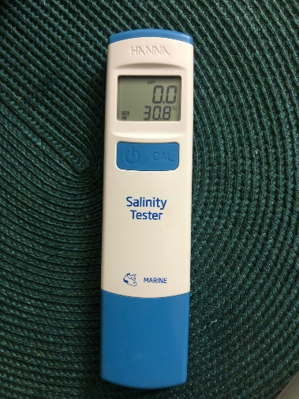
Figure 5: Salinity Meter.
For each household both drinking water and usage water was checked. Even though most of the houses had different sources of water for use and drink, many of them used the same water collected from the nearby pipeline services or ponds.

  - Blood pressure record
To determine the frequency and severity of hypertension in the study subjects, blood pressure readings were taken. For this reason, an OMRON digital blood pressure equipment was used, which guaranteed precision and consistency in all readings. To ensure accuracy, the particular model that was utilized underwent frequent calibrations.
Before the assessment, participants were told to sit quietly for at least five minutes to ensure they were relaxed and to reduce outside influences that could affect blood pressure results. The participant's left arm was measured with the arm raised to heart level, in accordance with accepted medical practice.
The heart rate and systolic and diastolic blood pressure readings were automatically collected by the digital blood pressure monitor. Two blood pressure readings were taken for each participant, separated by one minute. A third measurement was made and the average of the two values that were closest to each other was noted if there was a noticeable difference between the two results.
As soon as possible, all readings were recorded to avoid data loss or misunderstanding. This systematic method of taking blood pressure guaranteed accurate and consistent results for every subject, offering a solid foundation for examining trends in hypertension in connection to exposure to saline.

  - Data Analysis
For analyzing the data Statistical Package for Social Sciences (SPSS), version 22.0 was used.

- Result and Discussions
The purpose of the study was to look at the connection between women living in impacted areas' hypertension and higher salinity in their drinking water. Two hundred people in all were part of the study, and blood pressure and drinking water salinity levels were recorded. A digital blood pressure monitor was used to assess the blood pressure, and the HI98319 digital salinity tester was used to analyze the salinity of the water samples.

4.1 Geographical Data
The data was collected with the aim of intersectionality of the women to achieve the most accurate data on climate vulnerability. Based on the geographical location and social acceptability there was not much variety among the profession of the respondents. 87% of the respondents were housewives, where 8.5% were students and 4.5% were fisherwomen. As the area is rural, it is culturally appropriate for women to get married young. Hence 57% of the respondents were married with kids and 25.5% of them are married. Education becomes scarce in disaster prone areas. The example of Shyamnagar, Satkhira can amplify the claim. 47.5% of the respondents had no education. 22.5% of them had primary education as the highest level of education, and only 3.5% have studied past 12th Grade. This trend is much lower than the national average. Women of reproductive age were interviewed. For that, 13 years old women were taken as the lowest limit. 26.5% of them were 41-50 years old which is the highest percentage in the study.

Figure 6: Age distribution of the respondents.

4.2 Sources of water
Understanding the sources of water is very important to know how the salinity is impacting the women in the location. 47.5% of the respondents use tube well for their daily water use. Due to floods and other natural disasters the tube well water get saline. As the groundwater of the area has lowered as well, most of the tube wells pump saline water. Due to poverty most of the people do not own their own any tube wells, instead they share a community tubewells. Initiatives like high platforms for tube well are made in some areas to save the tube well from saltwater intrusion.
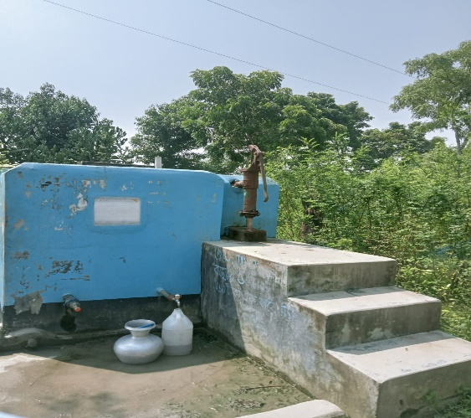
figure 6: High Platform for tube well.
Only 6% of the study population have pipeline services at home. Usually it is very expensive in that area for that reason it is very rare. 67.5% of the respondent said yes when they were asked if they drink surface water. 79% of them do not purify them before drinking. This pose as a risk factor for not only salinity related diseases but also for different communicable and infectious diseases. 45.5% of the women save water for their family use. But they got used to drinking the saline water so much that the rainwater tastes tasteless to them. For this reason, many refrains from drinking rainwater.
Regarding the taste of the water 31.5% of them responded that the water is tasteless. And the rest 68.5% responded that the water is saline. They referred the water to be “Milky salt” to describe the salinity.

4.3 Women’s water role
Women are the most responsible for collecting the water for their household people. 67% of the women are the water collectors for their family. The next highest percentage is 10% which refers to other female members of the family like mother-in-law, daughter-in-law, aunts, or female maid.

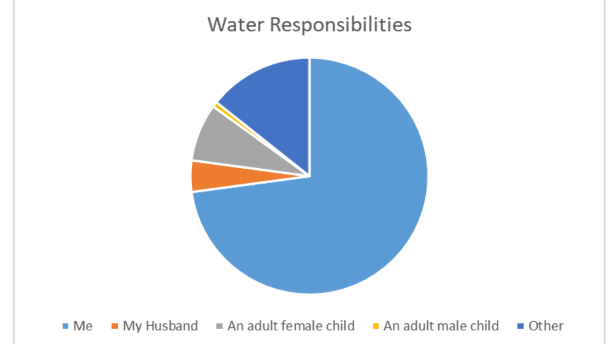
Figure 7: Water responsibility distribution.

Most of the women have to walk to get the water as most of the water services are communal. 67% percent of the women themselves have to walk to get water. The rest either have water facilities at home, or have subscribed to mobile water services at home I which jars of water get delivered to their homes on a daily basis.

Figure 7: Distance, weight and time required for water collection.
Walking such long hours lessens the productivity of the women as they get less time to attend educational institutions or invest their time in their professional sector. Around 38% of them carry more than 10 liters of water at a time which can be very risky for their health. 54% of the women continue their responsibilities even when they are pregnant. This poses a huge risk for both the women and the fetus. In 24.3 % of the households, they have a female child who is actively participating in water collection.
48.5% of the women reported their health to be poor because of the water scarcity. 71.4% of them suffer from dehydration. UTI is prevalent in 78.9% of the respondents. And 55.5% of them have injured themselves at least once in the lifetime while water collection. 20% of the women had miscarriages or difficulty giving birth at least once in their lifetime. All of these reported cases were entered only if the women have visited their local clinics and have proofs of having the following diseases.

  - Hypertension trends
33.5% of prevalence of hypertension was found among the women. According to the recent data of WHO, in Bangladesh the average of hypertension in women in 26.4%. The prevalence is higher in the south west coast of Bangladesh.
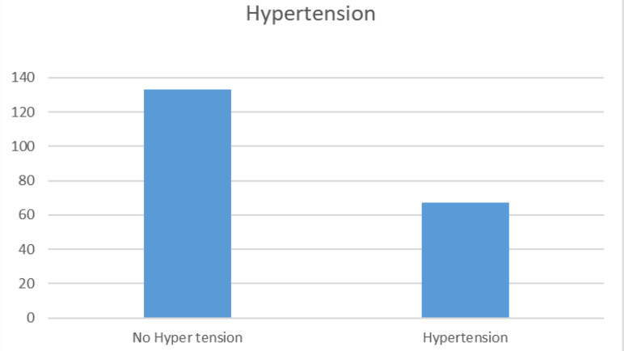
figure 8: HTN prevalence in Shyamnagar.

If someone had the systolic range over 140 mmHg and diastolic range over 90mmHg only then they were marked to have hypertension.
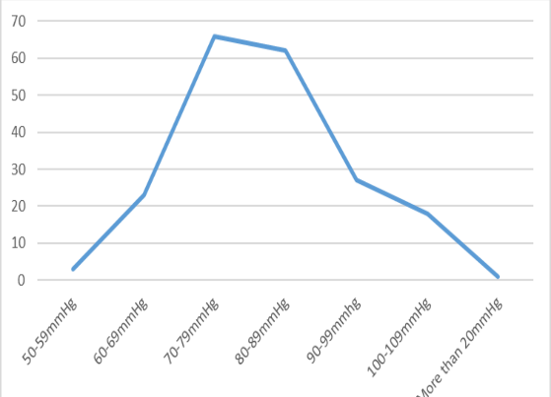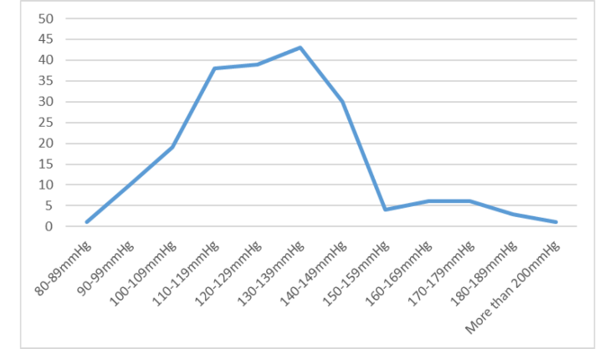
Figure 9: Left to right: Diastolic range, systolic range.

  - Water Salinity:
Salinity under 1 part per trillion (PPT) is taken to be safe for drinking. 84.5 % of the women uses water for cleaning and washing purposes which has salinity over 1PPT. Only 37.5% of the respondents drink freshwater, rest heavily depend on drinking saline water.

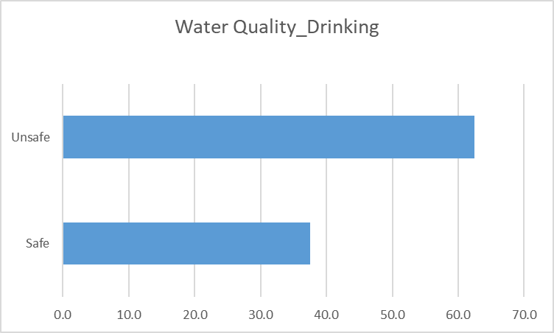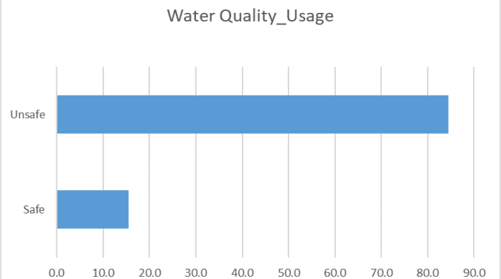

Figure 9: water quality.

  - Disasters
The study area is frequently impacted by natural disasters. 96.5% of the women responded that they are mostly impacted by frequent flooding which includes both cyclones and high tides. For saving themselves from disasters 89.3% of the women stay at cyclone centers with their families. Many areas do not have permanent cyclone centers, people from those areas either move to neighbors’ houses or move to higher grounds. 31.5% of the respondent face water intrusion on a daily basis, meaning during high tides the saline water submerges their freshwater reservoirs or rivers.
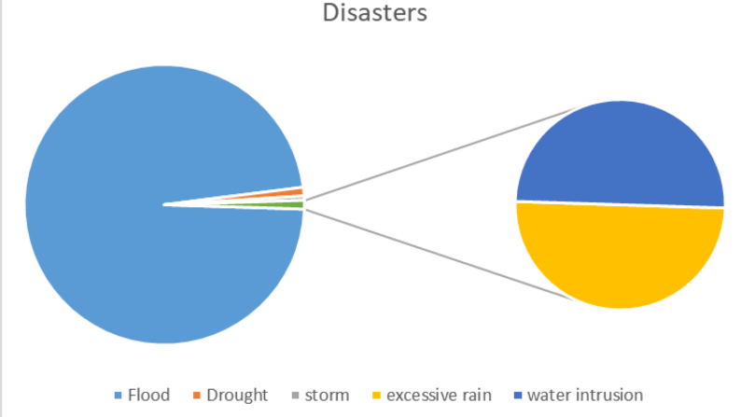
Figure 10: Disasters faced by the respondents.

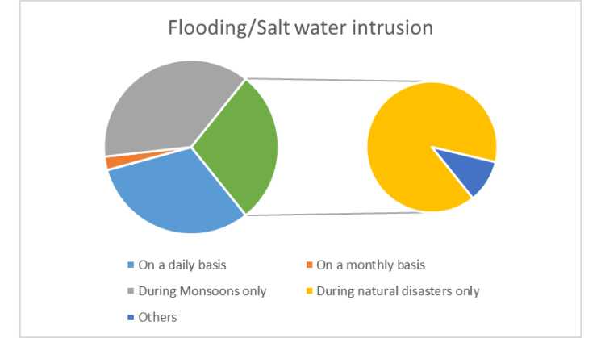
Figure 11: Salt water intrusion

  - Correlation between salinity and hypertension:
A chi-square test was used to examine the relationship between water salinity and hypertension, and the results were significant. The findings showed a strong correlation with the prevalence of hypertension when they were categorized by the quality of the drinking water (Bad vs. good) where good means the safe drinking water with PPT under 1, and Bad means unsafe water with PPT over 1. 10.7% of people who drank low-quality water had hypertension, compared to 89.3% who did not. On the other hand, 52.8% of those who drank water of high quality did not have hypertension, whereas 47.2% did.
The observed variations in hypertension prevalence across the groups with differing water quality are statistically significant, as indicated by the chi-square test, which produced a p-value of less than 0.05. This finding implies that the individuals' outcomes with regard to hypertension are significantly influenced by the salinity levels of their drinking water.

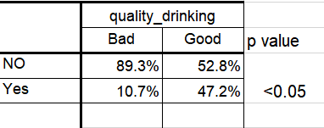
Figure 12: Chi-Square test

The significantly larger percentage of hypertensive people who drink high-quality water than those who drink low-quality water points to a complex connection that needs more research. These results could be influenced by additional confounding variables like access to healthcare, socioeconomic position, or general lifestyle. However, the strong p-value highlights the need for focused public health efforts to address water quality and reduce related health risks by confirming a clear relationship between hypertension and salinity in water.

5. Limitations of the Study

The limitations of the study include:
- Data was collected in October, right after rainy season. The salinity would have been increased if it was done in summer.
- Recall bias among the respondents regarding dry season.
- The sample size can be increased to look into the broader aspect of the study.

6. Conclusion and Recommendations

6.1. Conclusion
This study offers strong evidence of the harmful effects of higher salinity in drinking water on women’s health, emphasizing the strong link between heightened salinity levels and hypertension in women. The results show that higher salt in drinking water is substantially connected to increased blood pressure by accurate measurement of water salinity using the HI98319 digital salinity tester and blood pressure evaluations via a digital blood pressure monitor.
Public health interventions are desperately needed, as evidenced by the high incidence of hypertension among study participants and the strong positive relationships between water salinity levels and both systolic and diastolic blood pressure. These findings support the established physiological pathways by which consuming too much salt from saline water causes hypertension and are in keeping with the body of current research.
Climate interventions are required to control the climate impacts the study location is receiving. The problem of water salinization is expected to spread due to global trends of increasing sea levels and altered precipitation patterns brought on by climate change. Therefore, in order to reduce the health concerns associated with drinking salty water, it is imperative to put methods like desalination technologies, greater access to fresh water, and educational initiatives into place. Water quality control and monitoring must be given top priority by policymakers in order to protect public health, especially in areas that are particularly vulnerable.
The study's conclusion emphasizes the crucial relationship between environmental changes and public health and the necessity of taking comprehensive, preventative action to reduce the health concerns brought on by salinized water. Future study should be focused on long-term health impacts of climate induced water salinity and on developing sustainable methods and strategies to ensure safe drinking and usage water for everyone.

6.2. Recommendations

The respondents were asked to provide their recommendation for elevating their situations. The following graphs depicts their responses.
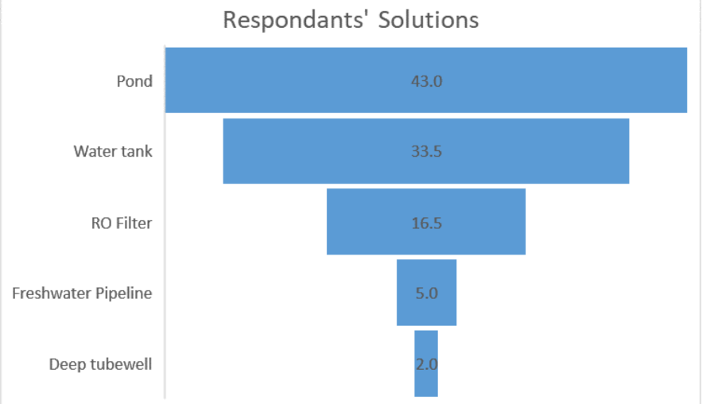
Figure 13: Recommendations
43% of the women recommended to have ponds where they can store rainwater, similarly 33.5% of them wanted water tanks as ponds are in risk of having salt water intrusion. Only wealthier families can
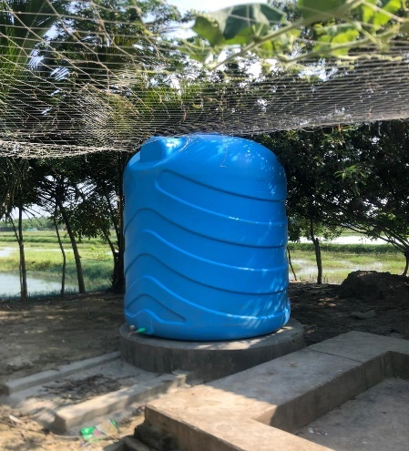
Figure 14: Water Tank for rain water harvesting

afford such tanks. The respondents expect help from government or NGOs. 16.5% of the respondents requested for desalinizing technology like the RO filters.

Further recommendations:
1. Using Desalination Technologies: Following up with the respondents, desalinization technology will be of great use. In areas with high water salinity levels, invest in and use desalination technologies. Communities can benefit from having access to clean, fresh drinking water using desalination facilities and portable desalination units, which can lower sodium consumption and lower the risk of hypertension.
2. Encourage Public Health Education: For the lack of education, most women have no knowledge on the impacts of the consumption of saline water. Create and carry out public health education programs to increase knowledge of the dangers of drinking salt water. Teach communities about the negative effects excessive sodium consumption has on their health and offer doable solutions to lower exposure, including switching to alternate water sources or easy DIY desalination techniques.
3. Promote and Facilitate Community-Based Water Management Initiatives: Promote and facilitate community-based water management programs that enable the local people to responsibly manage their water resources. Communities should be given the tools and training necessary to adopt water-saving measures, safeguard clean freshwater sources from pollution, and make use of rainwater collection strategies. Women’s participation and leadership are the most crucial component of it for its success.

Appendix I

Sample Structured Questionnaire
“Climate change induced water insecurity on women’s physical health in the coastal area of Bangladesh”
Water Insecurity on women survey: Satkhira, October, 2023.
Basic interview data and informed consent:
Hello. My name is Iffat Mahjabin, I am a final year undergraduate student at Asian University for Women. I am doing a double major in public health and environmental sciences. I am here to invite you to take part in an interview which will be a part of my senior thesis.
The purpose of the study is to find out the effects of water: scarcity, quality, quantity on women’s physical health. You are invited to participate in this study because you are currently residing in Satkhira and if you choose to participate, you will be asked to answer questions on your water use, water situation, your household situation, and some of your livelihood activities. It is expected that the questions should not take any longer than 20 minutes.
You are invited to participate in this study because you are currently residing in Teknaf and if you choose to participate, you will be asked to answer questions on your water use, water situation, your household situation, and some of your livelihood activities. It is expected that the questions should not take any longer than one hour.
Taking part in this research project is voluntary. You do not have to participate and should you wish to withdraw at any time, please inform a member of the research team.
By using pen and paper, the research team will take input of your answers. Please note that you will be requested to provide a sample of water from your household. Additional photographs might be taken on the water usage of your family, prior consent will be taken.
By taking part in this research you are acknowledging that you understand the terms of participation and that you consent to these terms.
CONSENT QUESTIONS FOR PARTICIPANTS:
I acknowledge that the study has been explained to me. I have also been given the opportunity to ask questions. In signing this consent form, I acknowledge that I am a woman residing in the coastal area and consent to participate in this study.
0=No 1=Yes.
We would like to take photos of your compound and dwelling to help our understanding of water uses. Do you agree that we can take photos?
0=No 1=Yes.
We would like to collect water samples from your household to understand the level of salinity in drinking water. Do you agree that we can collect water?
0=No 1=Yes.

_______________________________
Date and Signature of the interviewee
Participant number:
Date:
Location:
Personal Information:
Age
Relationship Status: | - Single  - Married  - Widowed  - Divorced  - Married With Children.
Occupation:
Education: | - No education  - Primary  - Secondary (class 10)  - Higher Secondary (Class 12)  - Above
2. Water Availability and quality:

What is the main source of water? | - Tubewell  - Pipeline at home  - Tank  - Surface water (Pond, river)  - Bore holes  - Stored rain water  - Others
What is the taste of the water? | - Tasteless  - Saline  - Others
Does your household have pipeline water service? | - Yes  - No
If yes, What’s the availability? | - Available all the time  - Only certain period of the day  - Others
Does your home have a sewage facility? | - Yes  - No.
How far is the water source from the latrine pit? | 1.0-30 ft  2. More than 30ft  - others.
Do you have to fetch water from the source? | - Yes  - No (Jump to section 3)
If yes, How many Kilometers do you have to walk to fetch water? (Round way) | - Less than 1KM  - Between 1-3 KM  - More than 3 KM
If yes, How much time do you spend fetching water on a daily basis? | - Less that 1 hour  - Between 1-3 hours  - More than 3 hours.
If yes, How much water do you carry each time? | - 5 or less than 5 liters  - 5-10 liters  - More than 10 liters
Who is the most responsible for bringing water? | - Me 2. My Husband 3. An adult female child 4. An adult male child 5. Others
How many female children (under 18) do you have in your family?
Are they actively involved in bringing water? | - Yes 2. No.

3. Climate and Water:

Have you faced water scarcity in your area in the last few years? | - Yes  - No.
Describe the level of scarcity | - Mild  - Moderate  - Severe
What is the reason for water scarcity? | - Lack of rainfall  - Lack of groundwater  - Increased salinity  - Draughts  - Others
What are the natural disasters your area faces generally?
How do you tackle these?
Does your community have a freshwater reservoir for emergency usage during disasters? | - Yes  - No  - Don’t know.
Is rain water harvesting a popular practice in your area? | - Yes  - No.
Do the water sources of your area face saltwater intrusion? | - Yes  - No
How often do they face that? | - On a daily basis (High tide)  - On a monthly basis.  - During monsoons only  - During natural calamity only  - Others.
4. Water and women’s health:

How do you feel about the water availability in your life? | - Very dissatisfied  - Dissatisfied  - Neutral  - Satisfied  - Very Dissatisfied.
How would you rate your overall health? | - Excellent  - Good  - Fair  - Poor
How many glasses of water do you drink everyday? | - 1-3 glasses  - 4-6 glasses  - 7 or more
Do you use the same water for drinking and cooking that you use for other purposes? | - Yes, after purifying  - Yes, Without purification  - No.
Have you felt any physical health issues due to water scarcity in the last 1 year? | - Yes  - No
Have you faced any of these health issues in your lifetime? | - Dehydration  - High BP  - Skin Diseases  - UTI  - Difficulty giving birth  - Kidney problems  - Others.
Did you ever have a miscarriage? | - Yes  - No  - Not applicable.
Do you drink saline water when freshwater is unavailable? | - Yes  - No
If yes, then how often? | - Rarely  - Often  - Regularly
Did you ever face any domestic violence due to water collection? | - Yes  - No
If yes, please describe when and where, and how often.
Have you ever faced any water conflict at the water collection spot? | - Yes  - No
If yes, Please describe when, where and how often it happens.
Have you ever injured yourself while fetching water? | - Yes  - No
If yes, please describe when, where, and the injury.
Do you have to continue your duties of water fetching when you are sick? | - Yes  - No  - Others
Did/do you continue your duties of water fetching while you are pregnant? | - Yes  - No  - Not applicable.
5. Water Hygiene practices

Do you purify the collected/tap water? | - Yes 2. No
How do you purify it? | - Filter  - Boil  - Adding Chemical Tablets
How do you carry your water? | - Earthen pot  - Jerry can  - Plastic container  - 2 liter water bottle  - Bucket  - Others
Do you cover the water while traveling from the source? | - Yes  - No
How often do you clean the water container? | - Daily 2. Weekly 3. Monthly.

6. Water Security:

Which Month of the year do you not have to worry about water? | - January- December as options.
What do you think is the main reason of water scarcity in your area?
What will you do if there is not enough water for your family?
In the last 4 weeks, how frequently has your main water source been interrupted or limited (e.g. water pressure, less water than expected, river dried up)?
Were those expected or unexpected?
In the last 4 weeks, how frequently have you had to change what was being eaten because there were problems with water (e.g., for washing foods, cooking, etc.)?
In the last 4 weeks, how frequently have you or anyone in your household had to go without washing hands after dirty activities (e.g., defecating or changing diapers, cleaning animal dung) because of problems with water?
In the last 4 weeks, have you felt threatened physically or mentally by your family members because of water scarcity?
Suggestions:

Do you consider moving to another area to get rid of the water scarcity?
What do you think the government should do to resolve this situation?

Water Quality (Drinking)
Water Quality (Usage)
Systolic Pressure:
Diastolic Pressure:

END OF THE SURVEY QUESTIONNAIRE.

References

Abedin, M. A., Collins, A. E., Habiba, U., & Shaw, R. (2018). Climate change, water scarcity, and health adaptation in southwestern coastal Bangladesh. International Journal of Disaster Risk Science/International Journal of Disaster Risk Science, 10(1), 28–42. https://doi.org/10.1007/s13753-018-0211-8
Cuffee, Y., Ogedegbe, C., Williams, N. J., Ogedegbe, G., & Schoenthaler, A. (2014). Psychosocial Risk Factors for Hypertension: an Update of the Literature. Current Hypertension Reports, 16(10). https://doi.org/10.1007/s11906-014-0483-3
Dangour, A. D., Watson, L., Cumming, O., Boisson, S., Che, Y., Velleman, Y., Cavill, S., Allen, E., & Uauy, R. (2013). Interventions to improve water quality and supply, sanitation and hygiene practices, and their effects on the nutritional status of children. Cochrane Library. https://doi.org/10.1002/14651858.cd009382.pub2
Dasgupta, S., Kamal, F. A., Khan, Z. H., Choudhury, S., & Nishat, A. (2015). River Salinity and Climate Change: Evidence from Coastal Bangladesh. In WORLD SCIENTIFIC eBooks (pp. 205–242). https://doi.org/10.1142/9789814578622_0031
Durack, P. (2015). Ocean salinity and the global water cycle. Oceanography, 28(1), 20–31. https://doi.org/10.5670/oceanog.2015.03
Ercin, A. E., & Hoekstra, A. Y. (2014). Water footprint scenarios for 2050: A global analysis. Environment International, 64, 71–82. https://doi.org/10.1016/j.envint.2013.11.019
Falkenmark, M. (2003). Freshwater as shared between society and ecosystems: from divided approaches to integrated challenges. Philosophical Transactions - Royal Society. Biological Sciences, 358(1440), 2037–2049. https://doi.org/10.1098/rstb.2003.1386
Gain, A. K., Giupponi, C., & Renaud, F. G. (2012). Climate Change Adaptation and Vulnerability Assessment of Water Resources Systems in Developing Countries: A Generalized Framework and a Feasibility Study in Bangladesh. Water, 4(2), 345–366. https://doi.org/10.3390/w4020345
Giudice, L. C., Llamas‐Clark, E. F., DeNicola, N., Pandipati, S., Zlatnik, M. G., Decena, D. C. D., Woodruff, T. J., & Conry, J. A. (2021). Climate change, women’s health, and the role of obstetricians and gynecologists in leadership. International Journal of Gynaecology and Obstetrics, 155(3), 345–356. https://doi.org/10.1002/ijgo.13958
Hoekstra, A. Y., Mekonnen, M. M., Chapagain, A. K., Mathews, R. E., & Richter, B. D. (2012). Global Monthly Water Scarcity: Blue Water Footprints versus Blue Water Availability. PloS One, 7(2), e32688. https://doi.org/10.1371/journal.pone.0032688
Jordan, J. C. (2018). Deconstructing resilience: why gender and power matter in responding to climate stress in Bangladesh. Climate and Development, 11(2), 167–179. https://doi.org/10.1080/17565529.2018.1442790
Karim, K. M. R., Emmelin, M., Resurreccion, B. P., & Wamala, S. (2012). Water development projects and marital Violence: experiences from rural Bangladesh. Health Care for Women International, 33(3), 200–216. https://doi.org/10.1080/07399332.2011.603861
Khan, A. E., Ireson, A., Kovats, S., Mojumder, S. K., Khusru, A., Rahman, A., & Vineis, P. (2011). Drinking water salinity and maternal health in coastal Bangladesh: Implications of climate change. Environmental Health Perspectives, 119(9), 1328–1332. https://doi.org/10.1289/ehp.1002804
Licenses List | Creative Commons. (n.d.). http://creativecommons.org/licenses/
Lohr, K. N. (2002). Assessing health status and quality-of-life instruments: attributes and review criteria. Quality of Life Research, 11(3), 193–205. https://doi.org/10.1023/a:1015291021312
Mabe. (2022, May 17). Advancing towards gender mainstreaming in water resources management - UNEP-DHI. UNEP-DHI. https://unepdhi.org/advancing-towards-gender-mainstreaming-in-water-resources-management-report/
Mekonnen, M. M., & Hoekstra, A. Y. (2016). Four billion people facing severe water scarcity. Science Advances, 2(2). https://doi.org/10.1126/sciadv.1500323
Nahian, M. A., Ahmed, A., Lázár, A. N., Hutton, C. W., Salehin, M., & Streatfield, P. K. (2018). Drinking water salinity associated health crisis in coastal Bangladesh. Elementa, 6. https://doi.org/10.1525/elementa.143
Prüss‐Ustün, A., Bartram, J., Clasen, T., Colford, J. M., Cumming, O., Curtis, V., Bonjour, S., Dangour, A. D., De France, J., Fewtrell, L., Freeman, M. C., Gordon, B., Hunter, P. R., Johnston, R. B., Mathers, C., Mäusezahl, D., Medlicott, K., Neira, M., Stocks, M., . . . Cairncross, S. (2014). Burden of disease from inadequate water, sanitation and hygiene in low‐ and middle‐income settings: a retrospective analysis of data from 145 countries. TM & IH. Tropical Medicine and International Health/TM & IH. Tropical Medicine & International Health, 19(8), 894–905. https://doi.org/10.1111/tmi.12329
Rahman, M., Zaman, M. M., Islam, J. Y., Chowdhury, J., Ahsan, H. N., Rahman, R., Hassan, M., Hossain, Z., Alam, B., & Yasmin, R. (2017). Prevalence, treatment patterns, and risk factors of hypertension and pre-hypertension among Bangladeshi adults. Journal of Human Hypertension, 32(5), 334–348. https://doi.org/10.1038/s41371-017-0018-x
Risk Factors in Hypertension : Journal of Cardiovascular Pharmacology. (n.d.). LWW. https://journals.lww.com/cardiovascularpharm/abstract/1989/00131/Risk_Factors_in_Hypertension.3.aspx
Sorenson, S. B., Morssink, C., & Campos, P. A. (2011). Safe access to safe water in low income countries: Water fetching in current times. Social Science & Medicine, 72(9), 1522–1526. https://doi.org/10.1016/j.socscimed.2011.03.010
Stocks, M. E., Ogden, S., Haddad, D., Addiss, D. G., McGuire, C., & Freeman, M. C. (2014). Effect of Water, Sanitation, and Hygiene on the Prevention of Trachoma: A Systematic Review and Meta-Analysis. PLoS Medicine, 11(2), e1001605. https://doi.org/10.1371/journal.pmed.1001605
Sultana, F. (2007). Water, water everywhere, but not a drop to Drink:Pani Politics(Water politics) in rural Bangladesh. International Feminist Journal of Politics, 9(4), 494–502. https://doi.org/10.1080/14616740701607994
Sultana, F. (2017). Gender and water in a changing climate: challenges and opportunities. In Water security in a new world (pp. 17–33). https://doi.org/10.1007/978-3-319-64046-4_2
Talukder, M. R. R., Rutherford, S., Phung, D., Malek, A., Khan, S., & Chu, C. (2015a). Drinking water contributes to high salt consumption in young adults in coastal Bangladesh. Journal of Water and Health, 14(2), 293–305. https://doi.org/10.2166/wh.2015.129
Talukder, M. R. R., Rutherford, S., Phung, D., Malek, A., Khan, S., & Chu, C. (2015b). Drinking water contributes to high salt consumption in young adults in coastal Bangladesh. Journal of Water and Health, 14(2), 293–305. https://doi.org/10.2166/wh.2015.129
Tsai, A. C., Kakuhikire, B., Mushavi, R., Vořechovská, D., Perkins, J. M., McDonough, A. Q., & Bangsberg, D. R. (2015). Population-based study of intra-household gender differences in water insecurity: reliability and validity of a survey instrument for use in rural Uganda. Journal of Water and Health, 14(2), 280–292. https://doi.org/10.2166/wh.2015.165
Velmurugan, A., Swarnam, P., Subramani, T., Meena, B., & Kaledhonkar, M. J. (n.d.). Water demand and salinity. In Water Demand and Salinity.
Vineis, P., Chan, Q., & Khan, A. (2011). Climate change impacts on water salinity and health. Journal of Epidemiology and Global Health, 1(1), 5. https://doi.org/10.1016/j.jegh.2011.09.001
VöRöSmarty, C. J., Green, P., Salisbury, J., & Lammers, R. B. (2000). Global Water Resources: Vulnerability from Climate Change and Population Growth. Science, 289(5477), 284–288. https://doi.org/10.1126/science.289.5477.284
Wang, W., Lee, E. T., Fabsitz, R. R., Devereux, R., Best, L., Welty, T. K., & Howard, B. V. (2006). A longitudinal study of hypertension risk factors and their relation to cardiovascular disease. Hypertension, 47(3), 403–409. https://doi.org/10.1161/01.hyp.0000200710.29498.80
Water scarcity. (n.d.). UNICEF. https://www.unicef.org/wash/water-scarcity
Zeidel, M. L. (2017). Salt and water: not so simple. the Journal of Clinical Investigation/the Journal of Clinical Investigation, 127(5), 1625–1626. https://doi.org/10.1172/jci94004

