
Prevalence and Impacts of excessive use of gadgets among students of age group 15-25 in Bangladesh
(Thesis submitted for the partial fulfillment of Undergraduate Degree in Public Health Studies)

Submitted By-
Mithila Chakraborty (180126) Rubaiya Akhter Marwa (180046) Jannatul Nayeem Tabia (191002)

Thesis Supervisor

Dr. Mohammad Manir Hossain Mollah, Assistant Professor in Public Health, Asian University For Women, Chattagram, Bangladesh.
Dr. Nazmul Alam, Associate Professor in Public Health, Asian University For Women, Chattagram, Bangladesh.

May 2022
Asian University for Women
Acknowledgement
Firstly, I would like to express our sincere gratitude to Asian University For Women for providing us the opportunity to conduct this research.
We would like to thank our supervisor Dr. Mohammad Manir Hossain Mollah, assistant professor in Public Health, Asian University for Women (AUW) to continue supervising throughout the study process and guiding us to the right path. I would also like to express our gratitude to the co-supervisor Dr, Nazmul Alam, Associate Professor in Public Health, Asian University for Women (AUW) to help us with proper guidance in our research.
We would like to convey our heartfelt thanks to the Ethical Review Committee of Asian University for Women (AUW) for allowing us to conduct this research.
Our special thanks to the all participants who gave their valuable time to us and actively participated in the survey
We would like to thank the Almighty for giving us strength and courage to complete the study.
Finally, We would like to thank our family; friends for giving us their constant support and love in the successful completion of our thesis.

Table of contents
Abstract……………………………………………………………...………..4
1| Introduction…………………………………………………………………..5-7
1.1General Background……………………………………………………..7-9
1.2|Literature Review……………………………………………………… .9-12
1.3| Research Question……………………………………………………….12
1.4| Research hypothesis……………………………………………………..12
1.5| Aim………………………………………………………………………12
1.6| Research objective ………………………………………………………13
1.7| Conceptual framework………………………………………………….14
2| Methodology…………………………………………………………………. 15
2.1| Study design…………………………………………………………… 15
2.2| Study site ………………………………………………………………..15
2.3| Sample population……………………………………………………….16
2.4| Sample size determination……………………………………………….16-17
2.5|Sample method, sampling Unit , budget & language to be used ,……………………………………………………………………………….17
2.6|Study Criteria..............................................................................................17
2.7| Description of data collection……………………………………………18
2.8| Data analysis and management ………………………………………….18-19
2.9| Ethical Statement…………………………………………………………19
3| Result……………………………………………………………………………19
3.1| Respondent’s Socio demographic characteristics………………………...19-22
3.2| variation in types of gadget use…………………………………………..22-23
3.3| Purpose of using gadget…………………………………………………..23-24
3.4| Possession of using gadgets ……………………………………………...24-25
3.5| Prevalence of using gadgets (except educational purposes or important tasks)..................................................................................................................25-26
3.6| Impact on physical health due to excessive use of gadget………………..26-27
3.7| Impact on mental health due to excessive use of gadget………………….27-28
3.8| Association between Socio Demographic characteristics of participants and the amount of time they spend on gadget………………………………………….28-30
3.9|Association between physical impacts of gadget use and the time spent on gadgets…………………….……………………………………………………30-32
3.10| Association between mental impacts of gadget use and the time spent on gadgets………………………………………………………………………….32-34
4| Discussion………………………………………………………………………...34-36
4.1| Significance of the study…………………………………………………..36
4.2| Limitation and future direction……………………………………………37
5| Conclusion & Recommendation…………………………………………………37-38
6| References……………………………………………………………………….39-42
Prevalence and Impacts of excessive use of gadgets among students of age group 15-25 in Bangladesh
Abstract
Background: Mechanization has made our life undoubtedly easier. At the same time this excessive use of gadgets has made us disinterested about real life socialization ,which is expanding through generation to generation but predominantly affecting the teenagers. Compulsion for gadgets is an indestructible urge that leads to psychological infiltration below standard concomitantly decaying the scholastic and executive accomplishment along with hindering individuals' household entity elevating probable warning directing to complication in the coming future.
Objective: Along with interrogating about mental health and physical healthiness of juveniles through demonstration of gadget addiction, our study intends to explore the prevalence of gadget addiction, to define the state / level of addiction towards gadgets followed by the identification of the impacts of gadget addiction on physical health. Beside this, to analyze the impacts of gadget addiction on psychological complexity.
Method: Primary data collection has been done through online surveys by sharing the google form link. Students of Chittagong and Dhaka cities among the age group 15-25 years have been chosen as study population. Convenience sampling method is preferred here.
Findings: The prevalence of excessive use of gadgets has been seen high in undergraduate students who are among 21-23 years.
Conclusion: To sum up we can say, any kind of excessive use of devices is harmful and should be controlled at any cost. Excessive use of gadgets among juveniles is one such phenomenon that has been an alarming issue in the last few decades. In order to prevent the physical and mental health related hazards that come along with gadget usage, there's no other alternative other than to put a full stop on this or control it in a better manner.
Key words: Gadgets , Compulsion, health, impacts, students

1| Introduction
The terminology gadgets refers to the portable electronic device containing both pros and cons. Juvenile drug addiction has always been a worry for all societies around the world; however, drug addiction has now become a more censorious issue in the modern period (Lee, et al., 2005). During the past few years carrying a miniature computer which is a smartphone in a pocket, has become ordinarily trendy. According to the Global mobile market report, there are approximately more than a hundred million smartphone users in Bangladesh. Bangladesh is the ninth major active smartphone user in the world with above hundred million internet users(Lu , et al., 2016, p.776), (Tal et al., 2021). Individuals who were born before the 1980s had more interrelation with real life rather than with personal gadgets in terms of comparing with the juvenile. The young generation’s inclination towards modern technological tools including laptops, Tablets, Smartphones. In terms of age 15-24 years old participants Identify themselves as the largest 80.7% smartphone users in Bangladesh and most parents think that social networking websites influence their teenage ability to socialize normally. Parents view gadgets as “digital babysitters''since the child seems more serene while using it (Kumar, et al., 2018, p.3626). Juveniles use gadgets for playing games, watching videos, movies, listening to music, chatting with friends and browsing websites and habitually they prolong time with these activities regardless of screen brightness, distance from the screen to the eyes, posture position which considerably affect the health and exility of their eyes (Aparna, et al., 2019, p.6) (Rahmat, et al., 2017, p.336). Excessive consumption patterns adversely impact the analytical and creative abilities of juveniles and leads to less concentration on live focus on imparting. Being obsessed with electronic gadgets, spends slighter time with outdoor activities ,limiting social environmental interconnection (Rachmat , et al., 2020, p.5538). Due to overuse of gadgets young people avoiding physical activities become the sufferer of strain on the muscle, obesity, neck ache, eyeache, headache. A study stating that technology addiction has direct and indirect influence on physical activity and obesity (Handayani, et al., 2021, p.6). Apart from depression and anxiety, behavioral change , the blue light from the technological devices subdues melatonin hormones that interrupts natural sleeping cycles. (Rashid, et al., 2019). Researchers have shown that during the use of smartphones, excessive amounts of dopamine get released from the body on frequent interaction with a rewarding stimulus which acts as a “rewired”for the brain. According to one of the studies , an American psychological institution issued a report about extreme use of gadgets leads to depression. From an article investigation, it was discovered that the internet is destroying connections, putting information at risk, and causing other concerns, despite having a number of good influences. (Ahad, et al., 2017, p.70). Individuals these days prefer virtual life over actuality since digital technology has changed our lifestyles to incredibly pleasant. This study was undertaken during a time when a zoonotic disease spread over the world. It will provide an overview of the status, prevalence, and impact of technology addiction on early adolescents in two major parts of The region: Dhaka and Chittagong. Aside from deaths caused by viruses, countless fatalities have been reported among Bangladeshi students. Even after post covid time, many adolescents are glued to social media apps like Netflix and Tik-Tok, as well as playing time-consuming games. This has a deleterious influence on individuals' etiquette, as well as their interaction, leaving them with an immoderate style of responding, and thinking. According to a study of 226 participants belonging to the age group of 12-18-year-old adolescents to evaluate the influence between families and gadget dependency, it was found that overuse leads to impaired family functioning and infrastructural facilities.(Chasanah,,et al., 2018, p.354). Moreover, Since this obsession has become so widespread, it is critical to eliminate or manage it until it becomes a catastrophe.
1.1| General Background
Though many research on gadget addiction and its effects have been conducted in other countries, just a handful have been conducted in Bangladesh.. Numerous studies have already been completed in the western world, however, there seems to be little solid research in emerging nations including prominent students of the university in Bangladesh (Hoque, et al., 2018, p.38). According to A study, Leading to a shortage of mentorship, young adults in Kerala use the web more immorally than their main equivalent, according to a survey (Kovakkai , et al., 2010, p.1). Kerala's position is comparable to that of Bangladesh's urban youth, who spend the majority of their time using electronics despite not attending any form of educational institution. As a result, the purpose of employing a device for educational purposes can be eliminated from this section . Gadgets also give a getaway from concerns, according to the participants, and nearly half of them say it assists them to overcome anxious thoughts. In consequence, it works like a narcotic to assist individuals to overcome their fear and confidence issues, and depression for a short time. Technology addiction was predicted by self-perceived need of help for the psychiatric condition or problematic smartphone utilization. This demonstrates that pupils are aware of the pitfalls, but their wants stay unsatisfied. Furthermore, learners with distress were 2.64 times more likely than those without depression to develop a technology addiction. These findings back up previous data linking cell phone and website use to mental health problems.(Haug, et al., 2015, p.301), (Leung, 2006, p.210), (Yoo, et al., 2014, p.198). This demonstrates the physical impact due to overuse of gadgets.In developed and developing countries, the association between excessive social media use and mental health concerns is similar showing a higher rate of reported depression (Haand, et al., 2020, p.784). According to a study Since gadget addiction has an adverse effect on spinal flexibility of movement and neck functionality, it is suggested that physiotherapy trainees should refrain from using devices in a compulsive way in order to avoid the long-time neck handicap (Karkusha, et al., 2019, p.4036). Depression has a major impact on adolescents due to a lack of consciousness, many individuals desire to commit suicide rather than deal with their challenges. This scenario worsened during the Covid -19 pandemic, when most of them were frustrated when they had to stay at home, spending their time on electronics. Accorsing to study conducted in Bangladrsh, one Daffodil International University student committed suicide during Covid as a result of anxiety, melancholy, aggravation, and household burden, which really is tragic. (Emon, et al., 2020, p.38). Moreover, in a study it is demonstrated that Even though it was shorter and more virtual, parents believed that devices offered advantages during virtual classrooms, such as gaining inspiration from the instructor, eliminating juvenile monotony at residence, and interacting and conversing with peers during pandemic (Suzana, et al., 2020, p.8026). This assertion may be contradictory in rural areas, where many families did not own any devices but had to purchase smartphones in order to continue their children's schooling, beside this internet access was becoming a hindrance as well. According to a research conducted in Bangladesh, all students from both higher education institutions use gadgets, computer technologies along with the internet in their daily lives. By utilizing advanced technologies, there is no differentiation between academic institutions, which is a positive indicator, but it also has a massive effect on their life spans, which can be risky(Rahaman, et al., 2018, p.58). In this situation, learners of this generation may jeopardize their future prospects if they continue to spend their valuable time on social networking sites rather than on potential drudgery. The majority of young adolescents are becoming increasingly reliant on ICT infrastructure so they spend more time socializing than outdoors, and in some circumstances, they are completely cut off from reality. Family and social gatherings can resolve this perilous issue, not the internet as well as the digital reality. Although they come from a low-income family, a large part of these young adults do not receive good parenting as a result they remain unguided. Adults should be more cautious when using cyberspaces and gadgets because someone could be negatively impacted by the overuse of them (Mahmood, et al., 2016, p.20).
1.2| Literature Review
Ingenious things that are invented by humans are called gadgets, that come in various sizes and shapes. Furthermore, In terms of functionality and categories, gadgets vary. One article states that sophisticated technological apparatus plays a significant role in 21st century daily entities (Bruner, et al., 2007, p.336).One more extension of this notion is something created primarily for human profit. According to Mariam Webster dictionary gadget is an inborn artificial device that is made for personal use. This gadget functions in contrast with refrigerators, TV, Air conditioner, Car which is also considered as a gadget.The gadgets are transportable, self-sufficient equipment linked to a person's anatomy for specific functions and thus designed for just a certain period of time.According to a study in Malaysia, the frequency of accessing social media, the duration of social media activity (the evening, night, and before sleeping), and the use of electronics before resting on the bed were the most impactful characteristics that were substantially related to insomnia among students at a private institution (Abdalqader, et al., 2018, p.290). According to a study the main source of concern is radio frequency (RF) emission delivered by smartphones and ground stations which collect and broadcast impulses. Utilizing electronic gadgets results in sleeping lately and for a shorter time frame. Technological invention has an impact on the mind, exciting it or making it difficult to sleep, while resting near gadgets, noise and fluorescent lighting might create unwelcome sleep disturbance. According to an article, addiction is a fundamental, chronic disease that affects brain benefits, provocation, recollection , and related processing; if left untreated, it can lead to relapse, progressive development, and even death (Smith, et al., 2012, p.3). One article states that excessive internet use has been linked to alienation, deviant values, inferior interpersonal skills, and melancholy (Esen, et al., 2010, p.30). Technology is by far the most effective component for functioning in the societal, intellectual, and industrial worlds. Networking sites, online games, multimedia sites, and devices like iPods and smartphones, and phones have all become part of the youth culture (Simuforosa, et al., 2013, p.6), (UNICEF, 2011).Young people use gadgets for a variety of reasons, along with keeping modernized news, accessing streaming media, and communicating with companions and social colleagues; beside this youngsters consider gadgets, specifically smartphones as a piece of stylish equipment in their social lives. According to a study 78% of teenagers own a phone, and roughly a quarter of them, 47 %, own smartphones (Honey, et al., 2005). The same article mentions that a laptop computer is used by 23% of youths, which is equivalent to the older adult population. 95% of youths use the web, and 93% of teenagers possess or even have access to the computer at home(Honey, et al., 2005). Considering today's modern Generations rely heavily on the web and internet, individuals are more likely to use gadgets such as smartphones, laptops, and tablets. According to a study , overuse of technological devices appears to lead to obsession and has a serious influence on individuals' psyche and lives (Hoque, et al., 2018, p.36). From the statistical evidence, we can state that gadget addiction exists where anyone could be a victim and these figures are worrisome.. One article states that the ability of a smartphone to connect to the internet wirelessly is one of its most valuable features. Individuals from all over the globe can use virtual space to interchange emails, have audio-video conferencing conversations, use social media platforms, access to recreational and media, obtain routes to a location, and so forth, as long while they have internet connectivity to their handsets (Ahmed, et al). Here we can state that unless the percentages are handled quickly, every community will soon have a technology junkie. More than 100 million members worldwide use electronics gadgets or cellphones to activate social media applications, resulting in substantial use of social networking sites. According to a study, the digital revolution and technological devices have both beneficial and detrimental consequences, including neurocognitive issues in users who are often obsessed with gadgets.(Santoso, et al., 2021, p.68). Over compulsion on gadgets has both short and long-term effects on people, resulting in behavioral changes. In addition to this another study shows that exposure to RF radiation can also have two direct consequences on health: thermal (heated) repercussions, which are primarily induced by holding smartphone phones adjacent to the person, and perhaps non-thermal effects(Kumar, et al., 2018, p.3625). One article states that, roughly 2/5 of the students used electronic devices in the seated state, moreover the preponderance of learners kept their devices at chest height while using (Lunge, et al., 2019). Long-term use of the device in this state regardless of the causes ended in back and shoulder pain. When compared to individuals who shared a phone with father, mother, siblings, or acquaintances, those who owned a private phone were twice as probable (Odds Ratio=2.98) to have a technological dependency.(Jamir , et al., 2019, p.36). As a result, it is obvious that while gadget addiction does not appear to be a major problem, it does have an influence on individuals. Due to a lack of competent counseling, the majority of the adolescents had no idea how to overcome their addiction. Furthermore, despite their best efforts, the youngsters fail to avoid excessive usage of electronic devices.

1.3| Research Question
- How screen time affects relationships with family, friends and acquaintances?
- To what extent do academic grades get affected through this addiction?
- What are the impacts on mental health due to gadget addiction?
- What are the impacts on physical health due to gadget addiction?

1.4| Hypothesis
Excessive use of gadgets hampers daily life activities.

1.5| Aims
The aim is to demonstrate the gadget addiction and to interrogate mental health and physical healthiness of juveniles.

1.6| Research objective

General Objective:
To interrogate about mental health and physical healthiness of juveniles through demonstration of the gadget addiction

Specific objectives:
● To explore the prevalence of gadget addiction
● To define the state / level of addiction towards gadgets
● To identify the impacts of gadget addiction on physical health.
● To analyze the impacts of gadget addiction on psychological complexity.
● To determine the dependency on gadgets in terms of social connection.
● To observe the inter-relation between gadget addiction and academic performance.

1.7| Conceptual Framework
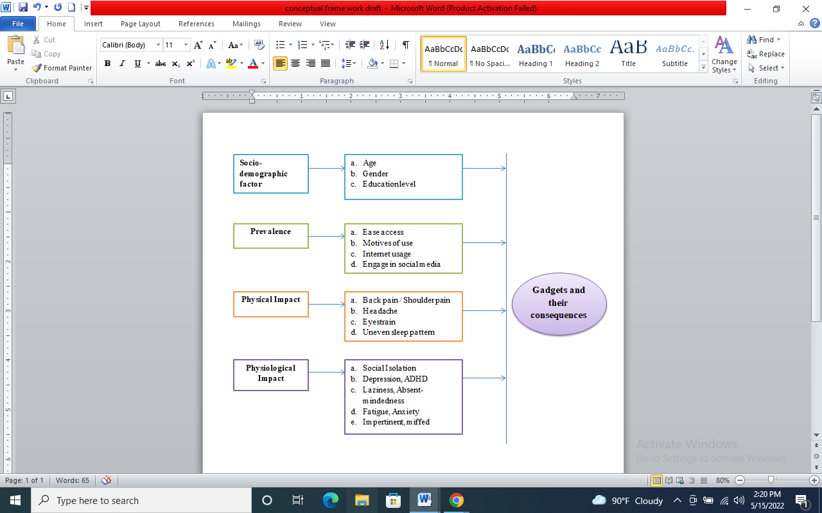

2| Methodology:
The methodology part will cover study population, study site, sample size, sample method , sample unit, data collection method, the language which was used for making the questionnaire , inclusion and exclusion criterias etc
2.1| Study design:
A cross-sectional study was conducted using an online platform (google form were sent through social media such as facebook , messenger and the gmail itself ) due to COVID-19 pandemic to study the prevalence and Impacts of excessive use of gadgets among students of age group 15-25 in Bangladesh

2.2| Study Site
The study has been conducted in Chittagong and Dhaka cities. Dhaka is the capital of Bangladesh which is situated in the south east. The latitude and longitude of Dhaka are respectively 23.8103° N and 90.4125° E. On the other hand , The latitude and longitude of Chittagong are respectively22.3569° N and 91.7832° E. Dhaka is mostly populated and being the capital,students tend to choose this city as their first priority for continuing their education as this city offers multiple opportunities and Chittagong comes after that. The interviews have been taken mostly from the university students of these cities .

2.3| Study population
The research has been conducted among the students of age group 15-25 in Bangladesh. As it is mentioned in the introduction, participants of age 15-24 years old are the largest smartphone users in Bangladesh, and the percentage is 80.7% (Kumar, et al., 2018, p.3628). In addition to this, the Global mobile market report shows that, in Bangladesh there are approximately more than a hundred million smartphone users and this country is in the ninth position of being the major active smartphone user around the world.

2.4| Sample Size determination:
n = Z²₁-α/₂ p(1-p)
d²
Where,
n= Sample size
p= Population proportion
d= Absolute precision required on either side of proportion
1-α= Confidence level
Therefore,
p= 50.9% = 0.509 (Mostafa, et al., 2019)
d= 5%= 0.05
1-α= 95% (α= 0.05) (Zα= 1.96)
n= (1.96)²× 0.509 (1-0.509)
(0.05)²
n= 384
Considering 20% non-response rate,
20% of 384= 76.8= 77
n= 77+384
n = 461

2.5| Sample method, sampling Unit , budget & language to be used
The Convenience sampling method has been used in this study to classify the collected data. This study has used both qualitative data and quantitative data. For the questionnaires, both close ended and open ended questions are used. The questionnaires will be made in English.Sampling unit was the students of age group 15-25 in Bangladesh. In addition to this, No amount of money was spent during this research.

2.6| Study criteria
Students who are below age group 15 and over age group 25 were not included in this study. Also we have not included those who do not have any access to the internet as the interviews have been conducted through google forms which require internet access. Television has been excluded from the list of the gadgets for this study because we are referring to the gadgets which are small electronic devices like mobile phones, computers, laptops, tabs etc wireless devices. We have included the respondents who belong to the Chittagong and Dhaka district only.
2.7| Description of data collection:
We, Rubaiya Akhter Marwa, Jannatul Nayeem Tabia and Mithila Chakrabarty , who have similar background knowledge, had collected the data together. We had prepared a questionnaire and had sent it to the participants online and they were asked to fill the questionnaire which was basically a google form. It took almost a month to convince people that they filled the form and we collected all the responses. All the participant responses anonymously as we did not include any sort of personal information such as name or email address. The Questionnaire was divided into three sections where section A includes socio-demographic characteristics, section B includes Impacts of gadget use on physical health and section C includes Impacts of gadget use on mental health.

2.8| Data Analysis and Management
The data collected was analyzed by using Statistical Package for Social Science software (SPSS) and the associations between the prevalence and impacts were determined using logistics regression , p value and Chi-square.The demography of the participants were presented in graphs, tables, percentage, mean and standard deviation and frequencies. Values with p value ≤ 0.05 were considered statistically significant.The data collected were secured safely in order to ensure confidentiality, As no personal information was collected, we won't be deleting the datas. We will be reserving them for further research on this topic. The Chi-squared test was used for identifying three associations. Firstly, the association between socio-demographics characteristics and time spent on gadget use. Secondly, the association between time spent on gadget use and physical health and last but not the least the association between the time spent on gadget use and the mental health

2.9| Ethical Statement:
The ethical approval for this research has been taken from the Ethical Review Committee of Asian University For Women, Chittagong. Before conducting research,the purpose of this research was explained to the participants and they were asked at the very beginning for their consent whether they are willing to participate and share their responses or not. The privacy and confidentiality of the data were strictly maintained. All the participants participated voluntarily and some of them did not respond and withdrew from filling out the form.For managing the data accuracy, datas will be stored in a google drive for the easy procedure in the research study. The data will be stored and put in with a trustworthy software application and they will be kept as a soft copy with backup. Thus there will be less chance of losing the data.

3| Result
3.1| Respondent’s Socio Demographic Characteristics
A total of 317 students from secondary, higher secondary, undergraduate and graduation level among the age group 15-25 years old participated in this study. From them 164 (51.7%) students were from Dhaka city and 153 (48.3%) students were from Chittagong city. The socio demographic characteristics of the participants are presented in table 1. Number of female participants (62.8%) was higher than the number of male participants (37.2%). Most participants of this study belonged to undergraduate students (86.4%) followed by secondary/ O level (7.6%), intermediate students (3.2%) and graduate students (2.8%). Huge proportion of participants belonged to the age group of 21-23 years (76.3%). The mean age was 1.83 ± 0.68 and the mean of types of gadget use was 0.93 ± 0.852.

TABLE 1: Distribution of gadget use by socio-demographic characteristics of the participants (n = 317)
A total of 317 students from Chittagong and Dhaka participated in the survey where mail and female both were included. From them, the frequency for Chittagong district’s students (51.4%) was a bit higher than Dhaka district’s students (48.6%). Participants were from four different age groups like 15-17 (7.9%), 18-20 (8.5%), 21-23 (76.3%), 24-25 (7.3%) years old. So here the age group of 21-23 years old who were mostly the undergraduate students (89%) were the most prominent participants of the study. Among them, the majority of the participants claimed that they use all of these kinds of gadgets like computer/laptop, mobile phone/ smart phone, tablet etc. and the frequency of that is 69.1%.
Table 1: Socio demographic characteristics:
Demographic Variables | Frequency | Percentage (%)
Age Category  15-17  18-20  21-23  24-25 | 25  27  242  23 | 7.9  8.5  76.3  7.3
Gender  Male  Female | 199  118 | 62.8  37.2
District  Dhaka  Chittagong | 154  163 | 48.6  51.4
Education Level  SSC/O level  Intermediate  Undergraduate  Graduate | 26  2  282  9 | 8.2  0.6  89  2.8
Types of gadgets used  Computer/Laptop  Mobile phone/ Smart phone  Tablet  All of above | 12  83  3  219 | 3.8  26.2  0.9  69.1
Quantitative | Mean± Standard deviation  1.83 ± 0.668  0.93 ± 0.852
Age
Types of gadgets use

3.2| Variation in types of gadgets used
Many variations have been found regarding the variation of the gadgets that participants use. 26.2% of students are found to use mobile phones/ smart phones and 3.8% students are found to use only computers/ laptops as their gadgets. 68.8% students marked the option all of above which means they use both mobile phone/ smart phone and computer/ laptop. Very few students (0.3%) have included other types of gadgets like headphones, bluetooth speakers and tabs.
Figure 1: Variation in the type of gadgets used
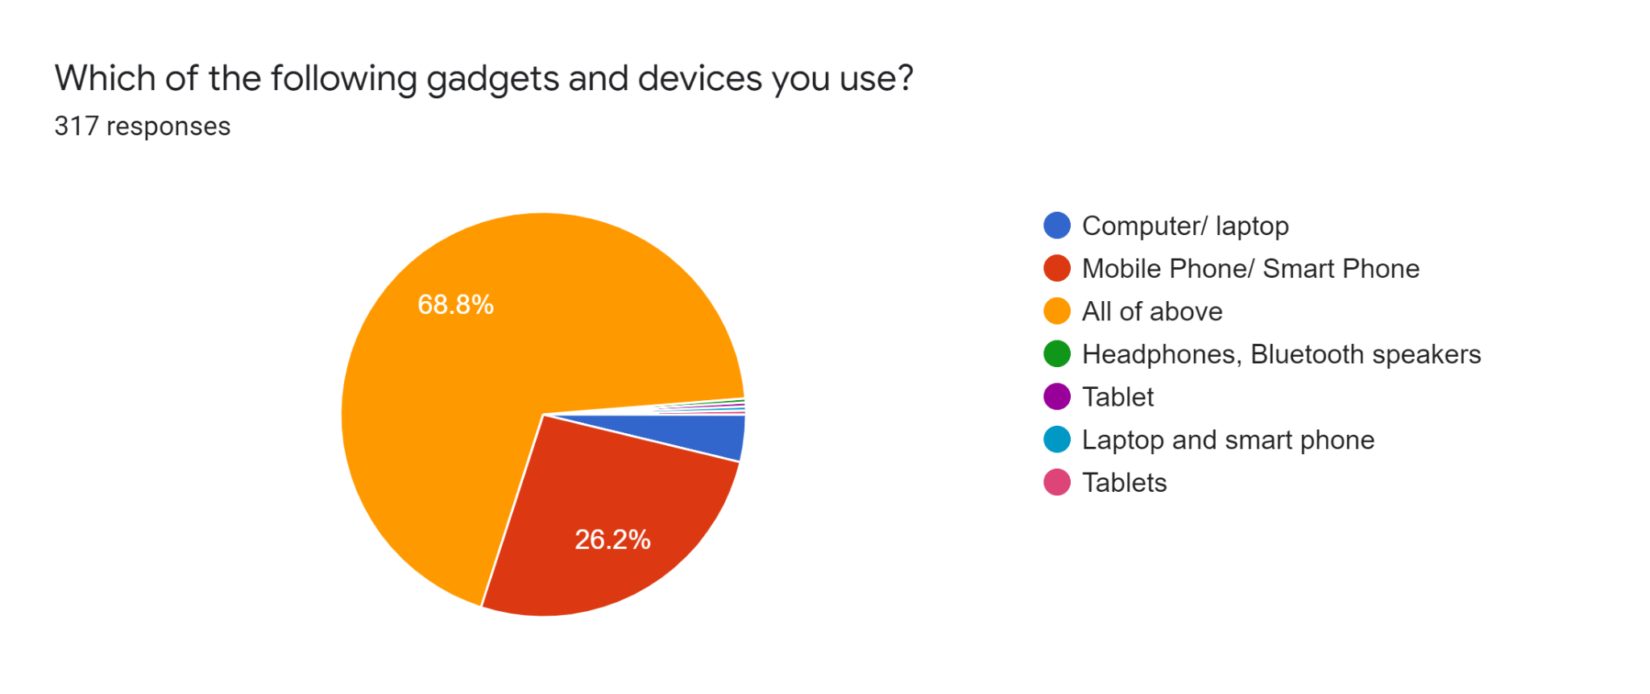
3.3| Purpose of using gadgets
To analyze the impacts of excessive use of gadgets, it is very important to consider the associating purposes behind using those gadgets. To find out the purposes, different categories have been included as dropdown options in the questionnaire. The categories were education, chatting, entertainment, gaming and others. According to their answers, almost every student uses gadgets for education purposes and the quantity is 96.2%. Along with this, 82.3% participants marked entertainment purpose, 77% participants marked chatting purpose and 43.5% participants marked gaming purposes. Beside these categories, 0.33% participants included other purposes to use gadgets which are editing, work, communicating with family, learning soft skills, photography, video making, graphic design etc.

Figure 2: Purposes behind using the gadgets.
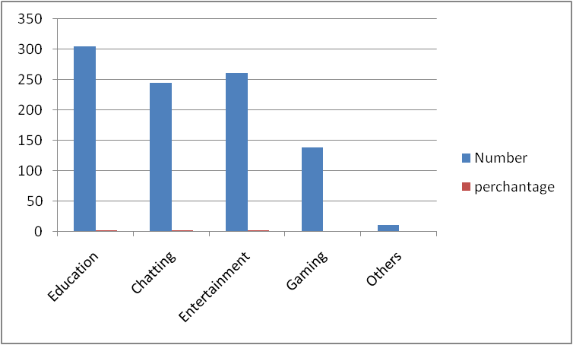

3.4| Possession of using gadgets
Analyzing the possession of gadgets is very much important to find out the excessive usage of gadgets. If the number of gadgets are more, the time spent on those gadgets are also higher. In this study, to find out the possession, the number of gadgets has been categorized in three parts - having one gadget, having two gadgets and having more than two gadgets. The number of respondents using one gadget is 28.40%, using two gadgets is 39.10% and using more than 2 gadgets is 32.50%. So we can say , a prominent number of participants use an average of 2 gadgets in their daily life.
Figure 3 : Possession of the gadgets by the respondents
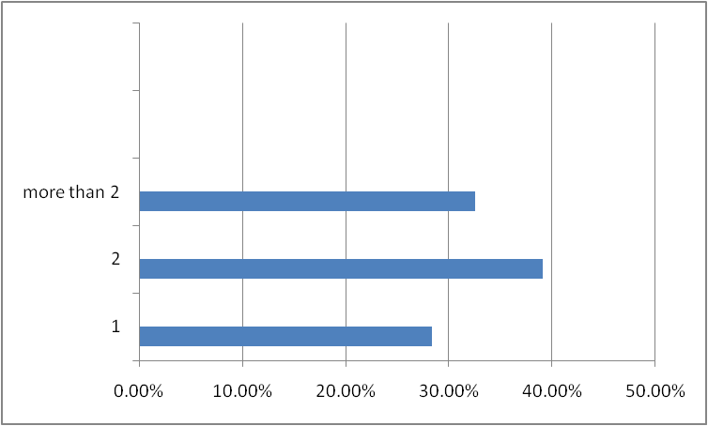
3.5| Prevalence of using gadgets (except educational purpose or important task)
Prevalences of excessive use of gadgets have been tried to find out with the help of some questionnaires like- “How often do you neglect your study to spend time on gadgets? How often do your grades suffer because of the amount of time you spend on gadgets? How often do you find yourself saying “just a few minutes” when using gadgets? How often do you try to cut down the amount of time you spend on gadgets and fail?”. The frequency bar chart for the answers of these questions are given below.
Figure 4: Prevalence of using gadgets among the participants:
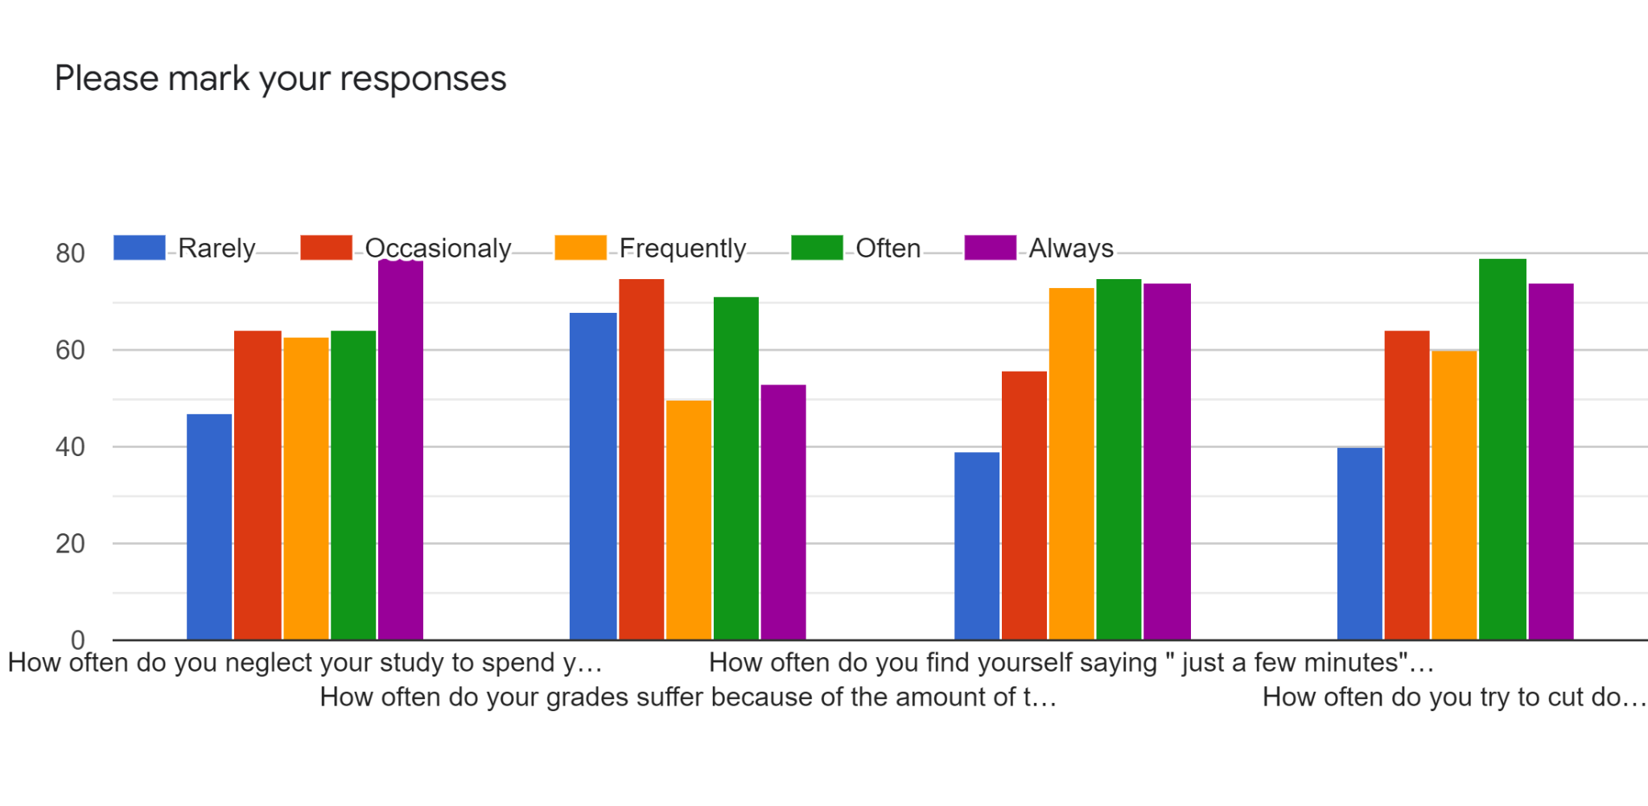
3.6| Impact on physical health due to excessive use of gadgets
According to many researchers, excessive use of any kind of gadgets may result in physical disorders. Sometimes, it can also create serious physical illness. To find out these illnesses, we have included some common physical difficulties that participants may feel in their daily life. Those are: having eye strain (Yes-61.8%, No-10.7%, May be- 21.1%), having shoulder pain (Yes- 61.8%, No-19.6%, May be- 18.6%), feeling headache (Yes- 70%, No-10.7%, May be-19.2%) and having irregular sleeping pattern (Yes- 64%, No-17.7%, May be- 18.3%).
Figure 5: Physical difficulties participants face due to excessive use of gadgets
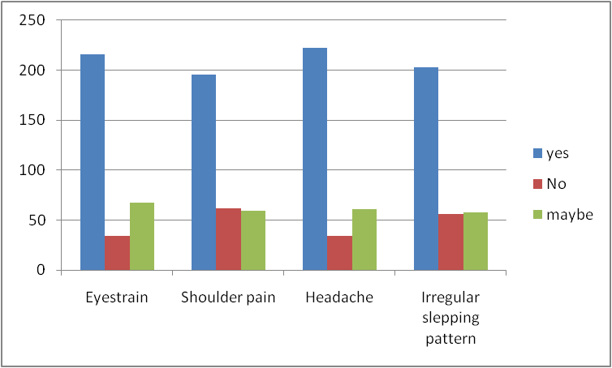

3.7| Impact on mental health due to excessive use of gadgets
Impact on mental health is more reflective while having excessive use of gadgets. In the study survey, we have included different mental health impacts to find out whether participants are facing them or not during excessive use of gadgets. The included effects are if they have any faced behavioral change among themself (Yes- 56.2%, No- 7.2%, May be- 36.6%), if they get depressed, restless or moody when they try to cut down gadget use (Yes- 46.4%, No- 24%, May be - 29.7%), if they get irritated when their gadget use gets interrupted (Yes- 59%, No- 15.8%, May be- 25.2%) and if they have felt lack of social connection towards their family and friends when they use gadgets more than as usual (Yes- 41%, No-30.9%, May be-28.1%). From the below bar chart, we can see that for all of these kinds of mental effects, participants have mostly marked their answer as “yes” which means they have faced these mental effects when they use gadgets more.

Figure 6: Mental impacts participants face due to excessive use of gadgets
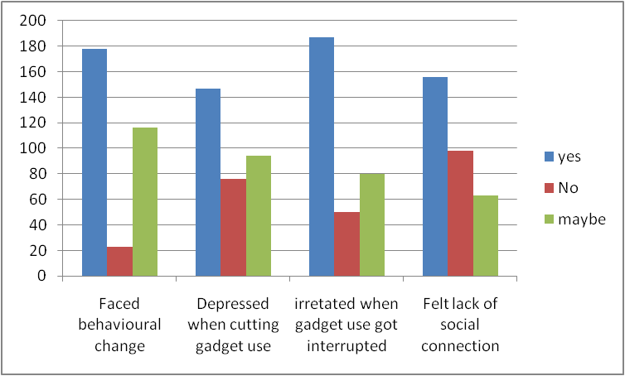
3.8| Association between Socio Demographic characteristics of participants and the amount of time they spend on gadgets:

Table 2 shows the association between the socio demographic characteristics of the participants and the amount of time they spend on gadgets with the help of chi square test and p value. The total number of participants is 317. The time spent on gadgets have been categorized into two sections- one is using gadgets more than 3 hour per day which is referred to as normal use, another is using gadgets equal to or more than 3 hour per day which is referred to as abnormal use or excessive use. None of these socio demographic characteristics, age (P= 0.012), education level (P=0.007) and district (P= 0.001) are significantly associated with the amount of time spent on gadgets as the p value of these characteristics are less than 0.05. However, the variables gender (P= 0.339) and type of gadgets used (P= 0.193) are found significantly associated with time spent on gadgets as the p value is greater than 0.05.

Table 2: association between socio demographic characteristics and time spent on gadgets
Socio Demographic variables | Time spent on gadget |  | Total  N= 317 | Chi square  (χ2) | P value
Socio Demographic variables | Normal use (>3 hour) | Abnormal use (<=3 hour) | Total  N= 317 | Chi square  (χ2) | P value
Age  15-17  18-20  21-23  24-25 | 9 (2.9)  4(1.3)  23(7.4)  1(0.3) | 16(5.1)  21(6.8)  214(69.3)  21 (6.8) | 25(8.1)  25(8.1)  237(76.7)  22(7.1) | 16.521 | 0.012
Education level  SSC (O level)  HSC  Undergraduate  Graduate | 9(2.9)  0(0.0)  27(8.7)  1(0.3) | 16(5.2)  9(2.9)  240(77.7)  7(2.2) | 25(8.1)  9(2.9)  267(86.4)  8(2.6) | 17.804 | 0.007
Gender  Male  Female | 23(7.4)  14(4.5) | 173(56.0)  99(32) | 196(63.4)  113(36.6) | 2.169 | 0.339
District  Chittagong  Dhaka | 26(8.4)  11(3.6) | 134(43.3)  138(44.6) | 160(51.8)  149(48.2) | 13.055 | 0.001
Types of gadget  Computer/ laptop  Mobile/Smart phone  All of above | 3(1.0)  14(4.5)  20(6.5) | 9(2.9)  67(21.7)  193(62.5) | 12(3.9)  81(26.2)  213(68.9) | 8.668 | 0.193

3.9| Association between physical impacts of gadget use and the time spend on gadgets:

Table 3 shows the association between physical impacts of gadget use and the amount of time participants spend on gadgets. Here, some physical effects like having eye strain (P= 507), shoulder pain (P= 0.607), having headache (P= 0.725) and facing irregular sleeping patterns (P= 0.051) are associated with the amount of time they spend on gadgets. But the effect if they have faced any accident or injury due to excessive use of gadgets (P= 0.028) do not have any association with the time spent on gadgets as the P value of this is lesser than 0.05. From this association we can find that those who use gadgets equal to or more than 3 hour per day (referred as abnormal use oor excessive use) face these kinds of physical impacts more than those who use gadgets less than 3 hour per day (referred as normal use).

Table 3: Association between physical impacts of gadget use and time spend on gadgets:

Physical Impacts | Time spent on gadget |  |  | Chi square  (χ2) | P value
Physical Impacts | Normal use (>3 hour) | Abnormal use (<=3) | Total  N= 317 | Chi square  (χ2) | P value
Eyestrain  Yes  No  May be | 9(2.9)  17(5.5)  11(3.6) | 48(15.6)  201(65)  23(7.5) | 57(18.4)  218(70.6)  34(11.0) | 19.909 | 0.507
Shoulder Pain  Yes  No  May be | 4(1.3)  26(8.4)  7(2.3) | 42(13.6)  189(61.2)  41(13.2) | 46(14.9)  215(69.6)  48(15.5) | 2.713 | 0.607
Headache  Yes  No  May be | 4(1.3)  29(9.4)  4(1.3) | 27(8.7)  190(61.5)  55(17.8) | 31(10.0)  219(70.9)  59(19.1) | 2.056 | 0.725
Faced injury  Yes  No  May be | 4(1.3)  31(10.0)  2(0.6) | 53(17.2)  179(57.9)  40(13.0) | 57(18.4)  210(68.0)  42(13.6) | 10.840 | 0.028
Irregular sleeping pattern  Yes  No  May be | 3(1.0)  30(9.7)  4(1.3) | 45(14.5)  173(56.0)  54(17.5) | 48(15.5)  203(65.7)  58(18.8) | 9.461 | 0.051

3.10| Association between mental impacts of gadget use and the time spend on gadgets:

Table 4 shows the association between mental impacts of gadget use and the amount of time participants spend on gadgets. The table defines that all of these mental effects like feeling irritated or angry when gadget use got interrupted (P= 0.135), feeling lack of connection with family and friends due to excessive gadget use (P= 0.147), feeling depressed while cutting down gadget use (P=0.055) and faced any behavioral change (P= 0.086). All of these are associated with the time spent on gadgets as the P values are greater than 3 hour. When the amount of time spent is more (equal to or more than 3 hour), the effects of gadgets are also prominent among participants.

Table 4: Association between mental impacts of gadget use and the time spent on gadgets.

Mental impacts | Time spent on gadgets |  |  | Chi square | P value
Mental impacts | Normal use (>3 hour) | Abnormal use (<=3) | Total  N= 317 | Chi square | P value
Felt irritated or angry  Yes  No  May be | 5(1.6)  28(9.1)  4(1.3) | 45(14.6)  159(51.5)  68(22.0) | 50(16.2)  187(60.5)  72(23.3) | 7.009 | 0.135
Felt lack of connection with family or friends  Yes  No  May be | 13(4.2)  20(6.5)  4(1.3) | 85(27.5)  110(35.6)  77(24.9) | 98(31.7)  130(42.1)  81(26.2) | 6.805 | 0.147
Depressed while cutting down gadget use  Yes  No  May be | 11(3.6)  22(7.1)  4(1.3) | 65(21.1)  125(40.5)  82(26.5) | 76(24.6)  147(47.6)  86(27.8) | 9.263 | 0.055
Faced Behavioral changes  Yes  No  May be | 4(1.3)  27(8.7)  6(1.9) | 19(6.1)  155(50.1)  98(88.1) | 23(7.4)  182(58.9)  104(33.7) | 8.147 | 0.086
4| Discussion
The aim of this study is to demonstrate the significant level of association between the gadget use and socio demographic characteristics and also both physical and mental health difficulties of excessive use of gadgets among the students of age group 15-25 year old within Chittagong and Dhaka district of Bangladesh. While determining association with socio demographic level, it is found that male participants are the dominant user of gadgets though it is reported that no gender bias is there now in terms of using gadgets. This report matches with some previous research. A research study of Payel Sharma in India (2016) shows that boys have more internet addiction than girls .
Another noticeable part of this study is that undergraduate students are found as most users of gadgets. The frequency of undergraduate students participating in this study was 89%. The rate is much higher than other categories. It is also a noticeable fact that the survey was conducted during Covid time. That’s why because of the lockdown period, most of the students got more addicted to gadgets while staying at home as there was no chance of doing outside activities. Most undergraduate students own gadgets more than other students of higher education. A similar study of India also reported that dependency of gadgets was high among the undergraduate students of age group 21-24 years (Kumar.A, Sherkhane.M, 2018)
The present study shows a significant association between impacts of gadgets and the amount of spend participants spend on the gadgets. These impacts include both physical and mental. Most of the physical impacts like eye strain, shoulder pain, headache, irregular sleeping pattern all of this are reported as significantly associated (P>0.05) with the amount of time students spend on those gadgets especially for those who spend more than 3 hours per day on gadgets. Similar findings have been reported in another recent study of Bangladesh where it is found that the frequency of physical impacts is more when the participants belong to the group who use gadgets for more than 2 hour daily (Rashed, et.al, 2021).
Another significant part of this study is participants who are responsible for excessive gadget use, feel a lack of social connection with their family and friends. Also during the survey, 49.2% participants reported that they prioritize gadgets more than socialization and 60.6% participant’s family members often complain about the time they spend on gadgets. It means excessive use of these gadgets are creating a social gap within our surrounding which is also studied in another similar research of Kuwait. It says that lower levels of social isolation has a higher mean of smartphone addiction and overall psychological syndromes (Kandari, A. et.al, 2020) .
An important finding of this study is that the majority of participants (55.5%) have reported that they sleep with their mobile phone next to their pillow or near the pillow which creates health hazards to the participants. The ray exposure from mobile phones, vibration from messages or notifications, and heat generated by charging phones can create disturbance in sleeping patterns. This may result in sleep latency, sleep disturbance and daytime drowsiness among the students (Rafique, N. et.al, 2020).
4.1| Significance of the study:
One of the most important significance of this study is that it awares people about the relationship between gadget use and the physical/mental health impacts. This study could also be useful for further research. If any other researcher wants to research more on this topic, they would definitely be able to know about some of the most highlighting points that we have included in this paper and these will help to take this research topic a step further.

4.2| Limitation:
The study contains a few flaws. It was initially only held in two districts: Dhaka and Chittagong. Another constraint is that the sample size was 484, but only 317 responses were received, which did not meet our expectations. An additional potential source of error is that the research questionnaire was only available to people who seemed to have Gmail, Facebook, or WhatsApp accounts, excluding students who did not routinely monitor or operate on the social networking site. Furthermore, the research was conducted online during the Covid 19 outbreak, which limited us to meeting and interviewing the subjects in person. Finally, some of the responses may be skewed.
5| Conclusion
Gadget addiction is an alarming issue. As the technology is advancing with time, people are getting more prone to gadget use. Using gadgets is not a bad practice as it has become an inseparable part of our lives. But getting addicted to it could deteriorate the situation in many ways which had been already discussed in this paper. A study shows the dependency on gadgets of the study subjects who were in the age group of 21-24 years , which gives us a very pessimistic picture of this situation. (Kumar & Sherkhane, 2018) . But any kind of addiction could be controlled with the help of proper monitoring and guidance. Family can play an important role here to guide adolescents, the families can contribute by ensuring effective responses as well as involvement, behavioral control dimensions as well as problem solving dimension( Chasanah & Kilis , 2018). Considering the detrimental effects of gadget addiction, adolescents must understand the severity of addiction and the impacts which could take a toll on their physical and mental health. But by practicing self control and by monitoring their screen time, they would be able to shun off this addiction which could jeopardize their life.
Recommendations: Some effective recommendations to reduce the habit of excessive use of gadgets:
- Encourage the students to be more productive
- Advise them to play outside and get engaged more with outdoor activities
- Encourage to find a hobby that can remove the concentration from gadgets
- Encourage them to become more social, have conversation with family and friends rather than chatting.

8|References
References
Abdalqader, M. A., Ariffin, I. A., Ghazi, H. F., AboBakr, M. F., & Fadzil, M. A. (2018). Prevalence of insomnia and its association with social media usage among university students in Selangor, Malaysia, 2018. Folia Medica Indonesiana, 54(4), 289-293.
Ahmed, R., Mondal, U. K., & Parvez, N. Patterns of Use and Dependency on Smartphone by the Bangladeshi Urban Youths.
Ahad, A. D., & Anshari, M. (2017). Smartphone habits among youth: Uses and gratification theory. International Journal of Cyber Behavior, Psychology and Learning (IJCBPL), 7(1), 65-75.
American Psychological Association. (2020). Stress in the American 2020 survey signals a growing national mental health crisis
Aparna, J., Devi, R. G., & Jyothipriya, A. (2019). Eye complications in children due to excessive use of electronic gadgets. Drug Invention Today, 12(6).
Bruner, G. C., & Kumar, A. (2007). Gadget lovers. Journal of the Academy of Marketing Science, 35(3), 329-339.
Chasanah, A. M., & Kilis, G. (2018, July). Adolescents' gadget addiction and family functioning. In Universitas Indonesia International Psychology Symposium for Undergraduate Research (UIPSUR 2017) (pp. 350-358). Atlantis Press.
Emon, E. K. H., Alif, A. R., & Islam, M. S. (2020). Impact of COVID-19 on the institutional education system and its associated students in Bangladesh. Asian Journal of Education and Social Studies, 11(2), 34-46.
Esen, B. K., & Gündoğdu, M. (2010). The relationship between internet addiction, peer pressure and perceived social support among adolescents. The International Journal of Educational Researchers, 2(1), 29-36.
Haand, R., & Shuwang, Z. (2020). The relationship between social media addiction and depression: A quantitative study among university students in Khost, Afghanistan. International Journal of Adolescence and Youth, 25(1), 780-786.
Handayani, O. W. K., Yuniastuti, A., Abudu, K. O., & Nugroho, E. (2021). GADGET ADDICTION AND THEEFFECT OF SLEEP HABIT, STRESS, PHYSICAL ACTIVITY TO OBESITY.Malaysian Journal of Public Health Medicine, 21(1), 1-8.
Haug, S., Castro, R. P., Kwon, M., Filler, A., Kowatsch, T., & Schaub, M. P. (2015). Smartphone use and smartphone addiction among young people in Switzerland. Journal of behavioral addictions, 4(4), 299-307.
Honey, M. M., & Spielvogel, R. (2005). Critical Issue: Using Technology to Improve Student Achievement. North Central Regional Educational Laboratory. All rights reserved. info@ ncrel. org.
Hoque, A. S. M. M. (2018). Digital device addiction effect on lifestyle of generation Z in Bangladesh. Asian People Journal (APJ), 1(2), 21-44.
http://www.btrc.gov.bd/content/internet-subscribers-bangladesh-january-2021
https://1e8q3q16vyc81g8l3h3md6q5f5e-wpengine.netdna-ssl.com/wp-content/uploads/2020/5/ Bangladesh-National-ICT-Household-Survey.pdf
Jamir, L., Duggal, M., Nehra, R., Singh, P., & Grover, S. (2019). Epidemiology of technology addiction among school students in rural India. Asian journal of psychiatry, 40, 30-38.
Karkusha, R. N., Mosaad, D. M., & Abdel Kader, B. S. (2019). Effect of smartphone addiction on neck function among undergraduate physical therapist students. The Egyptian Journal of Hospital Medicine, 76(4), 4034-4038.
Koovakkai, D., & Muhammed, P. (2010). Internet abuse among the adolescents: a study on the locale factor. Webology, 7(1), 1.
Kumar, A. K., & Sherkhane, M. (2018). Assessment of gadgets addiction and its impact on health among undergraduates. International Journal of Community Medicine And Public Health, 5(8), 3624-3628.
Lee, D. H. (2005). FCJ-038 Women’s Creation of Camera Phone Culture.
Leung, L. (2006). Stressful life events, motives for Internet use, and social support among digital kids. CyberPsychology & Behavior, 10(2), 204-214.
Lu, X., Ai, W., Liu, X., Li, Q., Wang, N., Huang, G., & Mei, Q. (2016, September). Learning from the ubiquitous language: an empirical analysis of emoji usage of smartphone users. In Proceedings of the 2016 ACM international joint conference on pervasive and ubiquitous computing (pp.770-780)
Lunge, V. R., & Kokiwar, P. R. (2019). Prevalence and purposes of gadget use among medical students.
Mahmood, S. F. (2016). Measuring the Impact of Internet, Technology & Human Communication: A Study on Bangladesh. International Journal of Information and Communication Sciences, 1(2), 17-23.
Mostafa, A., Hoque, R., Chakraborty, R., Haque, M., & Munna, M. S. (2019). Internet use and addiction: a cross-sectional study to ascertain internet utilization level for academic & non-academic purpose among medical and university students of Bangladesh. Konuralp Medical Journal, 11(3), 404-415.
Rahaman, M. M. (2018). Addiction of Information and Communication Technology (ICT) and Internet by the Bangladeshi University Students and Its Impact on Their Future. International Journal of Information Technology and Computer Science, 10(8), 56-68.
Rachmat, I. F., & Hartati, S. (2020). FAMILY ENVIRONMENT, INTERPERSONAL COMMUNICATION, AND SMARTPHONE ADDICTION: DOES IT AFFECT CHILDREN'S EMOTIONAL DEVELOPMENT?. PalArc
Santoso, N. A., & Nabila, E. A. (2021). Social Media Factors and Teen Gadget Addiction Factors in Indonesia. ADI Journal on Recent Innovation, 3(1), 67-77.
Simuforosa, M. (2013). The impact of modern technology on the educational attainment of adolescents. International Journal of Education and Research, 1(9), 1-8.
Smith, D. E. (2012). Editor's note: The process addictions and the new ASAM definition of addiction. Journal of psychoactive drugs, 44(1), 1-4.
Suzana, S., Munajim, A., Casta, C., Pratama, G., Sulaeman, E., Sukarnoto, T., ... & Karim, A. (2020). Gadget and the internet for early childhood distance learning. PalArch's Journal of Archaeology of Egypt/Egyptology, 17(7), 8019-8028.

Yoo, Y. S., Cho, O. H., & Cha, K. S. (2014). Associations between overuse of the internet and mental health in adolescents. Nursing & health sciences, 16(2), 193-200.

