

Impact of Covid 19 Lockdown on Mental Health of Youth Attending Educational Institutions in Thimphu, Bhutan

A thesis submitted to Asian University for Women in conformity with the requirements for the degree of Bachelor of Science in Public Health

Submitted By
Tshering Yuden (180072)
Tika Maya Ghalley (180074)
2022
Thesis supervisors
Dr. Nazmul Alam, Associate professor in Public Health
Dr Mohammad Manir Hossain Mollah, Assistant professor in Public Health

Table of Contents
Abstract...................................................................................................................4
- Introduction..................................................................................................5
- Background……………………………………………………………….6-7
- Research Question .....................................................................................7
- Literature Review.......................................................................................8-10
- Hypothesis………………………………………………………………...11
- Research Aim……………………………………………………………..11
- Objectives………………………………………………………………...11
- Methodology...............................................................................................12
8.1. Study design………………………….. …………………………….12
8.2. Study population.................................................................................12
8.3. Inclusion Criteria................................................................................12
8.4. Study Site.............................................................................................12
8.5. Sample size calculation.......................................................................12
8.6. Sampling Method................................................................................13
8.7. Data Collection method..........................................................................13-14
8.8. Data Management and Analysis............................................................14
- Result…………………………………………………………………………15
9.1 Socio-demographic characteristics……………………………………..15-17
9.2 Mental health Status……………………………………………………..18
9.3 Comparison of mental health status by demographic characteristics…19
9.4 Risk factors of mental health symptoms…………………………………22-23
- Discussion………………………………………………………………………24-25
- Limitation………………………………………………………………………25
- Conclusion………………………………………………………………………26
- Apex……………………………………………………………………………..26-29
- References……………………………………………………………………….30-34

List of figures
Figure 1: conceptual Framework…………………………………………………11
Figure 2: bar graph showing loneliness during lockdown………………………19
Figure 3: bar graph showing thought of self-harm during lockdown…………..19
Figure 4: bar graph showing fear of death during lockdown……………………20

Lists of Tables
Table1: socio demographic characteristics……………………………………………..15-16
Table2: comparison of mental health status by demographic characteristics……….16-17
Table3: Adjusted and Unadjusted Odds ratio table ratio……………………………..20-22

ACKNOWLEDGEMENT
First and foremost, we would like to express our sincere gratitude to Asian University for Women for providing us the opportunity to conduct this research. We would also like to express our deep and sincere gratitude to our thesis supervisor Dr. Nazmul Alam, Associate Professor in Public Health at Asian University for Women (AUW) for his continued supervision and guidance throughout the entire research work. We also would like to express our sincere thanks of gratitude to our co-supervisor Dr. Mohammad Manir Hossain Mollah, Assistant Professor in Public Health, Asian University for Women for his invaluable guidance throughout this research work and analysis. We would like to thank The Ministry of Education of Bhutan for granting permission to conduct this research in four high schools in Thimphu. Then we would like to thank the school administration of Motithang Higher Secondary School, Yangchenphug Higher Secondary School, Kelki Higher Secondary School and Pelkhil Higher Secondary School for allowing us to do surveys in their schools and making this research possible. We would also like to take a moment to thank all the participants who took their precious time out to participate in the survey and help us complete this research and also would like to thank school counselors for their guidance and support throughout the research. Without them, the research would not have been possible and completed. Lastly, we would like to thank our family and friends for their invaluable contributions and support in successful completion of our thesis.

ABSTRACT
COVID-19 pandemic and lockdown has brought about a sense of fear and anxiety around the globe. This phenomenon has led to short term as well as long term psychosocial and mental health implications for children and adolescents. Lockdown and quarantine approaches completely changed students' learning methods. It has completely shifted students' learning system from face to face learning to online learning with students being isolated and maintaining social distance which could have an impact on their mental health. The lockdown due to the coronavirus pandemic may have exacerbated mental health problems in the school going students. We collected prospective data on students’ mental health in two instances: (i) students were asked to answer questions related to lockdown experience and (ii) Generalized Anxiety Disorder test was done asking students questions related to anxiety over the last two weeks prior to the study. A total of 403 high school students in Thimphu aged 18 and above completed socio-demographic questionnaires, fifteen questions related to the mental health set up by the researcher and generalized anxiety disorder GAD-7. We applied multiple regression models to evince any changes in the aforementioned questionnaire scores after lockdown with respect to the scores during lockdown. The study findings showed that being abandoned by teachers, feeling distanced from friends, feeling loneliness during lockdown during lockdown, thought of harming themselves and worrying about exams and studies are the contributing factors that lead to the development of mental health symptoms in the students during the covid 19 lockdown. This study supports the view that depressive symptomatology may be aggravated during lockdown but reduced after lockdown and students reported on average worse depressive symptoms during lockdown and students are more likely to have anxiety after the lockdown is lifted.

Keywords: COVID-19, Lockdown, Depression, Anxiety, Loneliness, Self-harm

1. INTRODUCTION
Mental health is a psychological, behavioral, social and emotional well being of an individual. World health organizations(WHO) define mental health as a state of well being in which an individual can make his or her own choice, can handle everyday stress and activities, can work productively and can be someone who can contribute to his or her community. Mental health is an important part of health because health is not just the physical well being and the absence of disease rather it is a state of complete physical, mental and social well-being (WHO, 2018). Mental health plays a vital role in an individual's life with its ability to think, communicate with others, show emotions, support oneself and live a comfortable life. For these reasons, in recent years promotion, protection and restoration of mental health is regarded as a top priority for individuals, communities and societies throughout the world. According to WHO one of the leading causes of disability in the younger generations is depression and suicide is the second leading cause of death among 15-29 year olds. Though mental health is a preventable physical condition, everyday thousands of people suffering from severe mental health conditions lose their life at such an early age. In spite of changes and development taking place, in some countries people with mental health conditions faces discrimination, human rights violation and stigmatization. WHO states that the effective treatment coverage of mental health conditions remains extremely low despite the low cost treatment. The particular reason for this circumstance is the gap between people needing care and those with access to care. The situation gets worse in the current pandemic situation where people cannot reach out for help. Major epidemics and pandemic outbursts have several negative impacts on individual and collective mental health in the society (Jeong et al, 2016). The previous Middle East respiratory syndrome (MERS) and severe acute respiratory syndrome (SARS) severely impacted the local people’s mental health (Lau et al, 2010). Likewise the mental health of many individuals is potentially affected by COVID-19 in many ways. Family members and friends of patients with COVID-19, their close contacts, isolated or suspected population, healthcare providers, and the general population experience extra mental health burden during the COVID-19 pandemic (Xiang et al, 2020). Therefore, understanding the impact of the COVID-19 pandemic on an individual’s mental health might reduce many current and future mental health issues.

2. BACKGROUND
On March 11, 2019 WHO declared covid 19 as a pandemic with its rapid spread and transmission. The COVID-19 pandemic has had a serious effect on people’s lives. Several face challenges that may be nerve-wracking, overwhelming, and cause robust emotions in adults and youngsters. Fear, worry, and stress are the normal response when they are faced with uncertainty (WHO). In this pandemic people are experiencing fear and worry in the context of contracting the virus, getting sick, not being able to reach out for help and worrying about yourself and family safety and resources which could be a risk factor for mental health disorders. Public health actions, such as social distancing and quarientin, are necessary to reduce the spread of the virus, but faced with new realities of working from home, temporary unemployment, online classes, and lack of physical contact with other family members, friends and colleagues make one unhappy, isolated and lonely and might increase stress and anxiety. Loneliness is associated with heightened risk of mental and physical illness and suicidal behaviour. The resulting economic decline in countries creates unemployment which could be another factor that negatively affects people’s mental health and creates new barriers for people already suffering from mental illness. So, having less interaction with the outside world, staying in the same place and on top of that financial crises makes one over think about the situation and might lead to affecting or deteriorating one’s mental health.
Covid 19 pandemic is the greatest global health challenge of this generation, and a greatest world challenge since world war two. The virus was first confirmed to have reached Bhutan on 6th March, 2020 when a 76 years old American tourist tested positive for covid19. Like any other counter Bhutan was vastly affected by the crisis and due to increasing cases everyday, on 22 March, 2020 all the schools, institutes and offices were officially closed and on 11 August, 2020 Bhutan imposed first nationwide coronavirus lockdown for 21 days. Students and office workers were encouraged to study and work from home to control the spread of the virus (Unicef Bhutan, 2020). Schools and institutes were almost shut down for 6-7 months and it was opened in February 2021. Bhutan has a total population of 778,383 people and has a median age of 26.9 years (National Statistics Bureau, 2020) that is half of the population is below 26.9 years of age. People aged 15-19 and 20-24 are 68,286 and 75,415 respectively (National Statistics Bureau, 2019) which makes up approximately 19.5% of the total population. The capital city Thimphu has a variety of educational institutions; it has 28 schools, 1 vocational institution, and 4 private/autonomous institutions (Thimphu Thromde, n.d.; National Statistics Bureau, 2019). Thus, there are thousands of students confined at home feeling anxious, stressed and worried but they are neglected as the government and the adults give priority to the bigger issues. There are no previous studies conducted to find the association of learning environment and lockdown with mental health of youths in Bhutan. With little existing literature on mental health in Bhutan but no literature in association of lockdown and mental health in youth, it fails to address the wellbeing of mental health in the future generations of the country who as suggested by several researchers in other countries are vulnerable to have more impact than other age groups. This research aims to serve as a bridge in the research gap concerning the topic of interest so as to identify the impact of covid 19 lockdown among the youths attending educational institutions in the capital city of Bhutan.

3. RESEARCH QUESTION
As governments around the world imposed lockdown and quarantine approaches to prevent the spread of the virus. So, schools and universities were shut down, students were encouraged to maintain social distance and an online learning system was being widely implemented in various learning institutes. This paper strives to identify the impacts of covid 19 lockdown on students studying in four high schools of Thimphu as of 2021. Hence, the paper raises the following research question:
- What are the impact of social distancing measures and lockdowns on the mental health of youths attending educational institutes in Thimphu, Bhutan?
This paper further examines the mental health of students during the lockdown when they were isolated at home and started the online learning system and the mental health of students after the lockdown was lifted and started regular school. This will then lead to findings which will show if social distancing measures and lockdown impact the mental health of the students or have no effect on the mental health of school going students.

4. LITERATURE REVIEW
There are more than 2.2 billion children in the world making up 28% of the world's population and 16% are those aged between 10 to 19 years (UNICEF, 2019). COVID-19 has negatively impacted the lives of people around the world including children and adolescents in many manners. For following the public health protocols many countries have started regional and nationwide lockdowns since January, 2020. One of the essential measures taken during lockdown has been closure of schools, educational institutes and playgrounds. These unusual situations have led to stress, anxiety and a feeling of loneliness. According to research the current pandemic may have more impact and long term consequences on children and adolescents than adults (Shen et al., 2020). Students learn in an environment with their friends and one-to-one interaction with their mentors. “ According to UNESCO as of April 8, 2020, schools have been suspended nationwide in 188 countries and over 90% of enrolled learners, that is 1.5 billion young people worldwide, are now out of education” (2020). The home confinement of children and adolescents is linked with stress and anxiety which leads to disruption in their education, physical activities and social networks (Jiao et al., 2020). Staying home for a longer period of time and absence of a proper environment for school results in disruption in routine, boredom and lack of innovative ideas for engaging in various academic, socializing and extracurricular activities (Lee, 2020; Liu et al., 2020; Zhai and Du, 2020). Lack of interaction with the outside world and long term shift in their routine made these children more dependent on their parents. It is presumed that children might resist going back to school after the lockdown and may face difficulty in socializing, establishing good bonds with their mentors after the schools reopen. Consequently, the restriction of movement during the pandemic might leave a long term negative effect on their overall psychological well being (Lee, 2020).
According to one study older students like university and senior high school students are worried regarding cancellation of examinations, exchange programs and academic events (Lee, 2020). Studies have shown that school shutdowns prevent only 2-4% mortality which is quite less if compared to expenditure used in the interventions thus, researchers suggest that the policy makers should adopt other interventions and strategies for students if the schools are shut down for the longer time due to the pandemic (Lee, 2020; Sahu, 2020; Viner et al., 2020a). Oosterhoff states “In the present pandemic era it is found that among youth social distancing is viewed primarily as a social responsibility and it is followed more sincerely if motivated by prosocial reasons to prevent others from getting sick”. Further, staying home for longer duration leads to children’s increased use of the internet and social media, giving them access to unpleasant content and also increases their vulnerability for getting bullied or abused (Cooper, 2020). On top of that during such situations when help centers are closed studnets are unable to report violence, abuse and harm that some face at home making them helpless and vulnerable (Cooper, 2020; UNICEF, 2020).
A Study was done on the senior high school students in Greece through an online survey, with participants of 442 students on 16-30 April 2020 regarding their concerns on the impact of mental health. The study results showed that a high rate of 48.5% of positive screens for depression before the pandemic was found and it was due to exam-related academic pressure like getting into a university and pressure relating to family and social expectations. The rates of positive screen for depression and anxiety during the lockdown increased significantly to 64% and 50% respectively and were similar to those reported for the senior grade three students during the COVID-19 outbreak in China (Zhou et al., 2020). Among the participants students who have thought of self harm or suicidal thoughts increased from 26% before the pandemic to almost 30% during the lockdown period and in those who have these thoughts every day increased from 6% to 11.1%. The limitations of this study is that the data was collected by online surveys with no random sampling, thus there is a chance of sampling bias. (Giannopoulou, Efstathiou, Triantafyllou, Korkoliakou, & Douzenis, 2020).
Italy was one of the countries which was heavily affected by the infection. In order to control the spread of the virus the country imposed the nationwide lockdown on March 10, 2020. (Cellini, Canale, Mioni, & Costa, 2020). This study was done on a student's mental health before, after and during the lockdown. The study used three different time period: (i) in October and December 2019 (ii) in April 2020 during lockdown in Italy and (iii) in mid-May/June 2020, after the lifting of lockdown. A total of 358 Italian students aged 18–30 completed the survey and the result showed that depression among the students was significantly higher during lockdown than before the imposition of lockdown. Anxiety symptoms decreased after the lifting of lockdown (Elmer, Mepham, Stadtfeld, 2020). The limitation of the study is that it is a self-reporting questionnaire and the findings do not reflect upon the general population as the study only deals with the mental health of students (Ren, Huang, Pan, Huang, Wang, & Ma, 2020).
The study in the UK, they used longitudinal data to characterize effects on mental health and behaviors of students measuring diurnal preference and sleep quality, anxiety and depression symptoms, wellbeing and loneliness and alcohol use. Self-report data was collected from 254 undergraduates (35 males) during the two phases: before the pandemic (2019) and during the lockdown (2020) (Evans et al., 2021). This longitudinal analyses showed a significant rise in depression symptoms and a reduction in wellbeing during the lockdown. The sample can be classed as clinically depressed during lockdown compared to 15% at the baseline. Evans et al. said that increase in depression symptoms was highly mainly correlated with worsened sleep quality (2021). They also observed the reduction of alcohol use and significant shift towards an ‘evening’ diurnal preference. Most students were worried about the situation of COVID-19 and it was high. So the main result from their study concluded the urgent need for strategies to help and support young people’s mental health (Evans et al., 2021). The limitation of this study is that it self-reports from a single university so it cannot be generalized to other students from different universities. Another limitation was the sample included more females than males where the gender was controlled in the analyses.
Another longitudinal study in Austria was reported about impair mental health during emergency the COVID-19 pandemic and after 6 month (Pieh et al., 2021). They survey the students using depression (PHQ-9), anxiety (GAD-7), perceived stress (PSS-10), sleep quality (ISI), quality of life (WHO-QOL BREF) and well-being (WHO-5). They had 437 samples (52.9% women) who participated in both survey questionnaires and the number of participants with clinically relevant depressive, anxiety, or insomnia symptoms did not differ statistically significantly between t1 and t2 (p ≥ 0.48) Pieh et al., 2021). They found that there was no clinically relevant change in mental health during the time of COVID-19 lockdown and after lockdown of 6 months. So the major result was that the COVID-19 pandemic caused long-lasting detrimental effects on mental health. Their limitation was small sample size since the people who did survey in the first one did not complete out for the second survey.
According to the literature reviewed, following are the identified gaps: the previous research has different questions than my present research, previous research was not conducted in Bhutan, the research was not conducted on specific age group of 15- 24 years and it was online research where the data was collected by online surveys with not random sampling, thus there is a chance of sampling bias.
5. HYPOTHESIS

Lack of physical contact with friends and spending increasing amounts of time alone in one place, impacts the mental health of youths who are regular school students.

6. RESEARCH AIM
To contribute to the overarching goal of increasing mental health awareness among the young population and making them aware of the mental health services available so as to improve this population’s mental health and overall well being.

7. OBJECTIVES
- To study the prevalence of mental health issues in Thimphu, Bhutan.
- To identify the association between lockdown and mental health of students.
- Explore the psychological impact from public health measures to contain the outbreak of covid 19 such as prolonged quarantine and restriction of public life.

Conceptual Framework
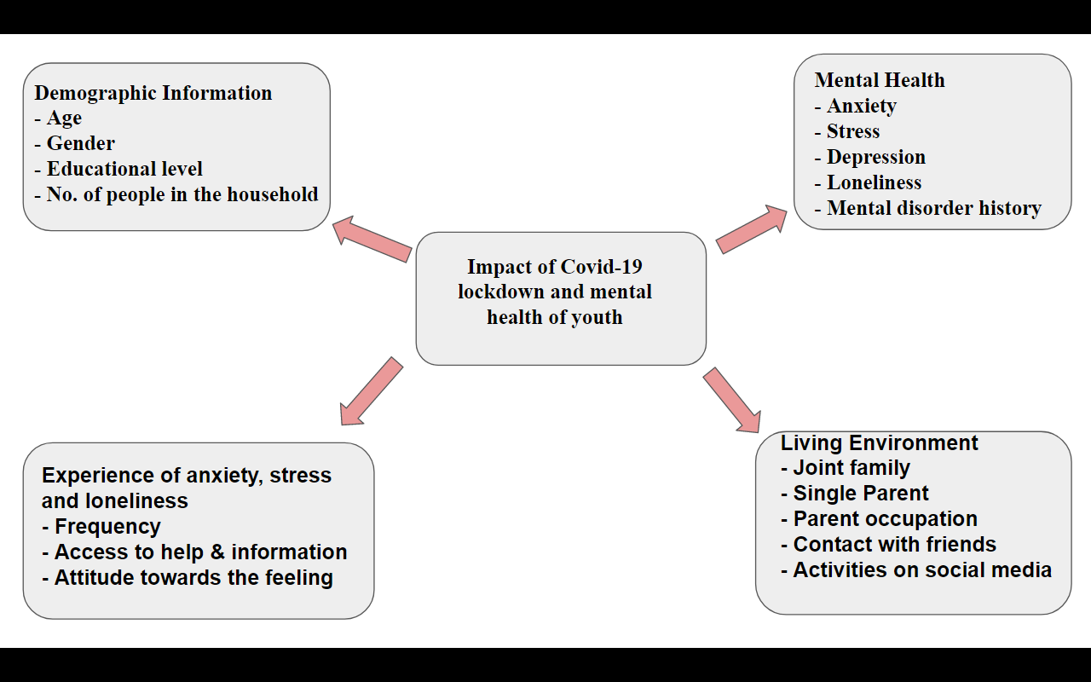
Figure 1: conceptual framework

8. METHODOLOGY
8.1. Study Design
The study design is a cross sectional study and the data was collected using the cross sectional survey method. The cross sectional study is a type of observational study design in which the exposure and the outcome of interest on the study participants are measured at the same time. The cross sectional survey method deals with collection of information through selection of representative samples in a certain population at a certain point in time. This will allow student researchers with limited time and financial resources to collect data within a short period of time.

8.2. Study Population
The study population includes grade twelve students, males and females of age 18 years and above and who are attending an educational institution in the capital city of Thimphu as of 2021.

8.3. Inclusion Criteria
Youth aged 18 years and above attending any educational institution in Thimphu city. The minimum age for school admissions in Bhutan is 6 years of age, that is children will be enrolled in pre-primary school only at 6 years of age (Ministry of Education, 2017). Given the minimum age for enrollment, participants will reach the minimum age required for this research by 12th grade if they have not repeated any previous grades. The samples were only recruited from high schools grade 12 students to meet the minimum age requirement.

8.4. Study Site
The study was conducted in four high secondary schools in Thimphu, which was selected according to the convenience sampling method from the educational institutions that meet the criteria of students aged eighteen and above years of age. Following are the selected study site;
- Motithang Higher Secondary School
- Yangchenphug Higher Secondary School
- Kelki Higher Secondary School
- Pelkhil Higher Secondary School
8.5. Sample Size Calculation
The sample size was calculated manually as follows:
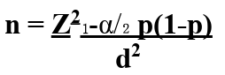
Where,
n= Sample size
p= Population proportion
d= Absolute precision required on either side of proportion
1-𝛂= Confidence level
I.e,
p= 0.5
d= 5%= 0.05
1-𝛂= 95% (𝛂= 0.05), 𝛂= 0.05 (Z𝛂= 1.96)
n= (1.96)² x 0.5 (1-0.5) / (0.05)²
n= 384.16≆384
Considering a 5% non-response rate:
5% of 384= 19.2≆ 19
n= 384 + 19 = 403

The sample size for the present study was calculated with an estimated prevalence of mental health as 50% and permissible error as 5% with a 95% confidence interval. The sample size was calculated as n= 384 and was further increased with a non-response rate of 5%. The final sample size was 403.

8.6. Sampling Method
Purposive sampling method and self- administered questionnaire and General Anxiety Disorder 7 test was used to collect data. The study participants are recruited using the disproportionate stratified sampling method. Participants are provided with a participant information sheet and consent form before they fill out the survey questionnaire. The survey questionnaires take approximately 15 minutes to fill and are collected on the spot.

8.7. Data Collection Methods
The data of the study participants are collected using the English version of Generalized Anxiety Disorder (GAD-7) and fifteen questions related to the mental health of students during and after the lockdown that was set up by the researcher. Recognizing signs of mental health disorders is not always easy. Generalized Anxiety Disorder (GAD-7) is a diagnostic tool for mental health disorders used by healthcare professionals that is quick and easy for patients to complete. In addition to consent form young participants were given an option to contact, if they felt they needed guidance and they were given the right to withdraw from the study anytime.
The questions are presented in three sections; part 1: socio-demographic characteristics - age, gender, education level and residence. Part 2: students were asked to fill questions related to during and after lockdown (like feeling lonely during and after lockdown, feeling distanced by friends during and after lockdown, and fear of death during and after lockdown etc..) and were asked to rate on a 5-point scale (1=not at all, 2= slightly, 3=moderately, 4=very, 5= extremely). Part 3: The Generalized Anxiety Disorder 7-Item Scale (GAD-7) consists of seven basic questions that evaluate respondents’ anxiety disorder. The total score ranges from 0 to 21. Each question has four different scores depending on the response: 0 (not at all), 1 (several days), 2 (more than half the days) and 3 (nearly every day). Higher score indicates high degree of anxiety, divided into four different segments, where <5, 5–9, 10–14 and 15–21 indicate no, mild, moderate and severe anxiety, respectively. In order to see whether feeling loneliness during lockdown, feeling ignored by friends and teacher, worrying about studies and exams, having fear of deaths and thought of self harm during lock down have any association with having anxiety symptoms after lock down a simple regression was used to find the association between an independent anxiety symptoms dependent variable (gender, loneliness, self harm etc.). Table 1 below displays the questionnaire of this study.

8.8. Data Management and Analysis
Information obtained from the survey was entered in MS excel with a secured password. SPSS 26 program was used to carry out descriptive analysis, p-value test, bivariate and multivariate analysis. Multivariate regression analysis was performed to assess the risk factors of anxiety. Age, gender, residence, loneliness, too much worry, fear of death and thought of self harm were used as predictor variables. The score from the generalized anxiety disorder test was categorized into two variables: normal (score below 5) and symptomatic (score 5 and above). Odds ratio and crrosponding 95% confidence intervals were calculated.

Ethical Considerations
Ethical approval was obtained from the Ethical Research Committee of Asian University for Women. Permission was obtained from the Ministry of Education of Bhutan and school administration. The research did not record the names or identity of the study participants. The participants will not be able to be identified once the filled out questionnaires were collected on the spot. Written informed consent was obtained from the subjects for participation in the present study.

9. RESULTS

9.1. Socio-demographic characteristics
The lowest age of the study is 18 years and the highest age is 23. The mean age ( ±SD) of the study subjects was ± 18.90 ( ±1.065) years. There were a total of 403 participants, of which 216 (53.6) were female and 187 (46.4) were male. The maximum participants resided in the town area (77.9%) and only (22.1%) in the rural or isolated area. This is shown below in Table 2.

Table 1: Socio demographic characteristics of the study participants
Socio demographic Variables | Frequency  N= 403 | Percentage (%)
Sex category  Female  Male | 216  187 | 53.6  46.4
Age category  <=19 Years  >20 Years | 301  102 | 74.7  25.3
Resident Category  Rural area  Town area | 32  314 | 22.1  77.9

Table 2: Comparison of mental health status by demographic characteristics
Variables | Normal (%)  n=307 | Symptomatic (%)  n=96
Gender  Female  Male | 155 (71.8)  152 (81.3) | 61 (28.2)  35 (18.7)
Residence  Town area  Rural area | 252 (75.9)  55 (77.5) | 80 (24.1)  16 (22.5)
Loneliness during lockdown  Not at all  Slightly  Moderate  Very  Extremely | 107 (80.5)  92 (75.4)  49 (75.4)  35 (64.8)  24 (82.8) | 26 (19.5)  30 (24.6)  16 (24.6)  19 (35.2)  5 (17.2)
Abandoned by teachers during lockdown  Not at all  Slightly  Moderately  Very  Extremely | 162 (76.1)  65(76.2)  54 (77.1)  18 (85.7)  8 (57.1) | 51 (23.9)  20 (23.8)  16 (22.9)  3 (14.3)  6 (42.9)
Feeling ignored by Friends during lockdown  Not at all  Slightly  Moderately  Very  Extremely | 179 (79.2)  81 (77.1)  26 (63.4)  8 (66.7)  12 (66.7) | 47 (20.8)  24 (22.9)  15 (36.6)  4 (33.3)  6 (33.3)
Thought of self harm during lockdown  Not at all  Slightly  Moderately  Very  Extremely | 278 (83.0)  19 (47.5)  7 (35.0)  2 (33.3)  1 (50.0) | 57 (17.0)  21 (52.5)  13 (65)  4 (66.7)  1 (50.0)
Fear of death during lockdown  Not at all  Sightly  Moderately  Very  Extremely | 169 (76.8)  72 (80.0)  34 (79.1)  19 (63.3)  13 (65.0) | 51 (23.2)  18 (20.0)  9 (20.9)  11 (36.7)  7 (35.0)
Worry about exam/studies during lockdown  Not at all  Slightly  Moderately  Very  Extremely | 64 (85.3)  42 (84)  73 (73.7)  67 (72)  61 (71.8) | 11 (14.7)  8 (16)  26 (26.3)  26 (28)  24 (28.1)

9.2. Mental Health Status
Out of 216 female participants, 71.8% female participants showed normal during anxiety test (GAD-7) and 28.2% female participants were found to show symptoms during anxiety test, that is participants who had GAD score 5 and above. From 187 male participants, 81.3% showed normal during the anxiety test and 18.7% were found to be symptomatic. From a total of 314 participants living in the town area 75.9% showed normal during the anxiety test and 24.1% found to be symptomatic or have anxiety. Out of 213 participants who did not feel abandoned by their teachers during lockdown, 76.1% showed normal in the anxiety test and 23.9% found to have anxiety. From 85 participants who slightly felt that they were abandoned by their teachers 76.2% showed normal in the anxiety test and 23.8 showed to have anxiety. There were 70 participants who moderately felt that they were abandoned by their teachers and from them 77.1% were found to be normal and 22.9% were found to be symptomatic. From 21 participants who very much felt abandoned by their teachers 66.7% showed normal in the anxiety test and 33.3% showed anxiety. Lastly, out of 14 participants who extremely felt they were abandoned by their teachers 57.1% showed normal in the test and 42.9% showed anxiety. The participants were also questioned whether they felt they were distanced or ignored by their friends during the lockdown or not and the results showed that out of 226 participants who did not felt they were distanced for ignored by their friends 79.2% showed normal in their anxiety test and 20.8% showed to have anxiety. 105 participants felt they were slightly ignored by their friends during lockdown and from which 77.1% showed normal in the anxiety test and 22.9% showed anxiety. From 41 participants who moderately felt they are ignored by friends 63.4% showed normal in the anxiety test and 36.6% showed to have anxiety. Out of 12 participants who very much felt ignored by friends, 66.7% showed normal and 33.3% found to have anxiety. Lastly, there were 18 participants who extremely felt that they were either ignored by or distanced from friends during lockdown form which 66.7% of the participants showed normal during the anxiety test and 33.3% showed to have anxiety after the lockdown is lifted.

9.3 Comparison of mental health status by demographic characteristics
Figure 2: Loneliness during lockdown
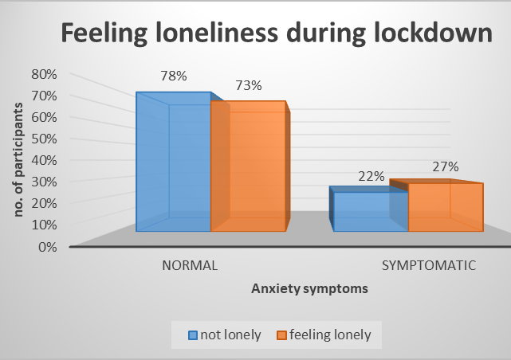
The above Figure 1. Illustrates how much percent of participants felt loneliness during the lockdown. From 255 students who did not feel lonely during the lockdown, 78% of them showed normal anxiety test scores and 22% showed anxiety that is in the GAD they have score 5 or above. From 148 participants who felt lonely (that is participants have selected slightly, moderately, very and extremely), 73% of them showed normal in the anxiety test scores and 27% showed to be symptomatic.

Figure 3: Thought of self harming
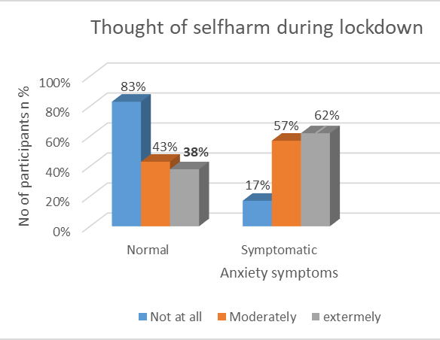
This figure 2. Demonstrates how much percent of participants thought of self harming during lockdown. From 335 participants who did not think of self harm, 83% of participants showed normal in the anxiety test and 17% of them showed to have anxiety. Out of 60 participants who thought of harming themselves at a moderate scale, 43% of them showed normal in the anxiety test whereas 57% showed to have anxiety. From 8 participants who thought of harming themselves at an extreme scale, during lockdown 38% showed normal in the anxiety test and 62% showed anxiety.

Figure 4: Fear of death during lockdown
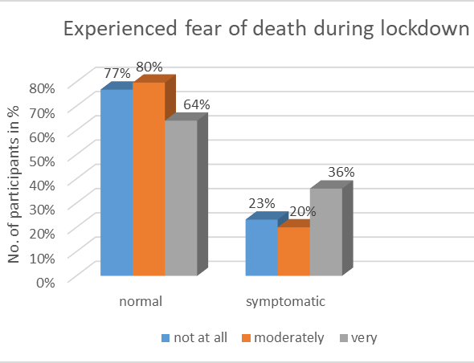
This figure 3 illustrates the percent of respondents who had fear of death during the lockdown. Out of 220 participants who did not experience the fear of death during lockdown, 77% showed normal in the anxiety test and 23% showed to have anxiety or found to be symptomatic. From 113 participants who moderately experienced fear of death during the lockdown, 80% of them showed normal in the anxiety test and 20% showed anxiety. Lastly, out of 50 participants who had extremely experienced fear of death during the lockdown 64% of them showed normal and 36% showed anxiety during the generalized anxiety disorder test.

Table 3: Adjusted and Unadjusted odds ratio table
Simple Linear Regression |  |  | Multiple Linear Regression
Variable | UOR (95% CI) | P-value | AOR (95% CI) | p-value
Gender  Female  Male | 1.70 (1.06-2.74)  (reference) | 0.26 | 1.50(0.90-2.50) | 0.11
Resident Category  Rural isolated area  Town area | Reference  1.091 (0.59-2.01) | 0.77 | 1.03 (0.96-1.84) | 0.83
Feeling loneliness  Not at all  Slightly  Moderately  Very | (reference)  0.597 (0.315-1.132)  0.802(0.428-1.503)  0.803 (0.384-1.678) | 0.114  0.490  0.559 | 0.717 (0.327-1.575)  0.855 (0.404-1.811)  1.108 (0.303-1.705) | 0.408  0.683  0.043
Thought of self harm during lockdown  Not at all  Slightly  Moderately  Very | (reference)  0.123 (0.029-0.529)  0.663 (0.139-3.156)  1.114 (0.203-6.105) | 0.005  0.606  0.901 | 0.149 (0.032-0.696)  0.842 (0.164-4.309)  1.453 (0.240-8.798) | 0.684  0.836  0.016
Abandoned by teachers during lockdown  Not at all  Slightly  Moderately  Very | (reference)  0.909 (0.400-2.066)  0.889 (0.358-2.205)  0.856 (0.334-2.194) | 0.821  0.799  0.746 | 1.558 (0.564-4.300)  1.098 (0.368-3.277)  0.807 (0.261-2.497) | 0.392  0.867  0.710
Feeling distanced from friend during lockdown  Not at all  Slightly  Moderately  Very | (reference)  0.525 (0.230-1.197)  0.593 (0.24501.436)  1.154 (0.429-3.105) | 0.126  0.247  0.777 | 0.705 (0.264-1.877)  0.729 (0.261-2.035)  1.237 (0.388-3.944) | 0.484  0.547  0.720
Worry about exam / studies during lockdown  Not at all  Slightly  Moderately  Very | (reference)  0.440 (0.215-0.902)  0.488 (0.214-1.111)  0.912 (524-1.587) | 0.025  0.087  0.744 | 0.479 (0.219-1.046)  0.543 (0.219-1.349)  1.020 (0.550-1.892) | 0.949  0.188  0.015
Fear of death during lockdown  Not at all  Slightly  Moderately  Very | (reference)  0.536 (0.278-1.035)  0.444 (0.205-0.964)  0.471 (0.185-1.198) | 0.063  0.040  0.114 | 0.854 (0.393-1.852)  0.577 (0.239-1.395)  0.564 (0.191-1.660) | 0.690  0.222  0.298

9.4. Risk factors of mental health symptoms
We performed binary logistic regression analysis to determine the association between dependent and independent variables (table 4). It is seen that females are 2 (OR=1.50, CI= 0.90-2.50) times more likely to have mental health symptoms. Since the p-value is more (0.11>0.05), it does not have a significant impact on the mental health of the students. Participants Living in the town area are more likely to have mental health symptoms compare to the participants living in rural areas isolated area (OR=1.03, 95% CI (0.96 - 1.83, p=0.83) but by looking at the P value we can see that it is greater than the standard value 0.83>0.05 thus, living in town area or isolated areas do not have any significance impact of the mental health of the students. Students who have felt extremely lonely during lockdown are more likely (OR=1.108, CI= 0.303 - 1.705, p= 0.043) to have anxiety compared to students who did not feel lonely during lockdown. Also feeling loneliness during lockdown has a significant impact on mental health of the students as the p-value is less than the standard 0.05. Participants who had extreme thought of harming themselves during lockdown are more likely (OR = 1.453, CI = 0.240 - 8.793. P-value = 0.016) to have anxiety compared to those who did not think of harming themselves during lockdown. As the p-value is less than the standard value of 0.05, students thinking about harming themselves during lockdown has a significant impact on the mental health of students. Students who have felt slightly abandoned by their teachers are more likely (OR = 1.558, CI = 0.564 - 4.300, P-value = 0.392) to have anxiety compared to students who did not feel abandoned at all. Students who have felt moderately abandoned by their teachers are also more likely (OR = 1.098, CI = 0.368 - 3.277, P-value = 0.867) to have anxiety than the students who did not feel abandoned by their teachers at all. As p- value is greater than (0.392>0.05, 0.867>0.05), we can say that students feeling abandoned by the teachers during lockdown do not have a significant impact on the mental health of the students. Also students who felt extremely distanced from their friends during lock down are more likely to have anxiety symptoms than the students who did not feel distance from their friends and as p -value (0.720>0.05) is greater than the standard value, feeling distanced from /ignored by friends does not have a significant impact on the mental health of the students. Students who are extremely worried about their exams and studies during lockdown are more likely (OR = 1.020, CI = 0.550 - 1.892, p-value =0.015) to have anxiety symptoms compared to students who did not worry about their exam or studies. The p-value is less than the standard value of 0.05 thus students worrying about their exam and studies during lockdown has a significant impact on the mental health of the students. Whether students have experienced fear of death not at all, slightly, moderately or extremely during the lockdown it does not has any significant impact on the mental health of the students since all the p-value are greater than the standard p-value of 0.05 (0.69>0.05, 0.22>0.05, 0.298>0.05)

10. DISCUSSION
The study findings revealed that gender does not have any significant association with having anxiety symptoms after lockdown. However, female respondents are more likely to have anxiety symptoms than males as women are mentally weaker than the men when they are faced with situations like lockdown and entrance exams. Also women are part of the disadvantaged population in our society thus, they may not get equal opportunities or support like men. Whether participants live in town or in an isolated area, participants' residence does not have any significance with mental health symptoms but respondents living in town areas are more likely to have anxiety symptoms than those living in isolated areas. So we can conclude that as students who live in a town are always surrounded by people, they will have more impact on mental health from social distance than those living in the isolated area. Participants who have felt lonely during lockdown showed to have anxiety symptoms thus, proving that feeling loneliness during lockdown is a contributing factor to mental health. Participants who have felt that they have been abandoned by their teachers or felt distanced from their friends are more likely to feel lonely during lockdown and this could be a risk factor for having mental health problems as loneliness is a major contributing factor in anxiety. Participants who have thought of harming themselves during lockdown are likely to have anxiety after lockdown and suffer from mental illness. Also participants who worry about their exams and studies are also more likely to have anxiety after lockdown is lifted.
Students who have felt they were being abandoned by teachers, distanced from friends, and who felt lonely, thought of harming themselves and worried about exams and studies shown to have anxiety which is one of the mental health problems. Normal school going students who always interact with their teachers and are surrounded by friends, especially students those living in populated town areas who always interact with people can face mental health problems when they are suddenly put under strict social distancing and lockdown for more than two months. When students stay home for a longer period of time at home they feel abandoned by their teachers and feel distanced from their friends, which can lead to feeling loneliness. On top of that the study participants are grade twelve students who have to sit for BCSEA (Bhutan Council for School Examinations and Assessment) examination so they have lots of stress and worry about exams and studies during the lockdown can lead them to having a thought of self harm. Feeling loneliness and thinking of self harm and worrying about exams or studies are major factors that contribute to mental health problems. As the variables like loneliness, self harm, worrying about exams during lockdown has p-value less than 0.05 we reject our null hypothesis and accept our hypothesis that stated “Lack of physical contact with friends and spending increasing amounts of time alone in one place, impacts the mental health of youths who are regular school students”.
A cross-sectional study conducted in Bangladesh to assess the impact of the COVID-19 pandemic on mental health among the Bangladeshi population found that the associated factors behind the mental health issues are female sex, low economic status, being a student or unemployed, and living without a family. The findings showed a much higher rate of loneliness, depression, anxiety and sleep disturbance among Bangladeshi people during the COVID-19 pandemic. Similar study conducted in Italy among the university students found that students would experience a clinically significant worsening of depressive symptoms during lockdown.

11. Limitations
The present study has some limitations. First the research uses Non random sampling in our research so, our research lacks generalizability and the findings might not represent our selected population very well as there could be a chance of bias sampling. Second, this research includes the data collected during and after the lockdown and it lacks data on the mental health of the students before lock down. If it had data before the lockdown the study findings might be more specific thus this is one of the limitations. Third, the findings from this research do not reflect upon general populations as the study only deals with the study of mental health of the students. Lastly this is the first research done to find the association between lockdown and mental health of the students in Bhutan thus further research is needed to find more findings. The present study also has some advantages. First, this is the first ever study in Bhutan to find an association between covid 19 lockdown and the mental health of students. This study provides an idea about the mental health of the Bhutanese school going students during the COVID-19 pandemic.

13. CONCLUSION
In conclusion, we can say that variables like student’s residence, self harm, loneliness and fear of death can affect the mental health of students during the lockdown. They should be given proper guidance and time from their parents or guardians so that they do not feel ignored or distanced from their loved ones. They are more likely to harm themselves if they are ignored by their friends and teachers. According to UNICEF Bhutan (2021), “Every 90 hours, Bhutan is at risk of losing another life to suicide”. Having said this, mental health is not a widely discussed topic in Bhutan and it is still stigmatized in the society. Thus, the ministry of health of Bhutan has to work towards removing the stigma related to mental health and bring in effective solutions to reduce mental issues among the youths. there should be. As mental health plays a significant role in one's life and also as adolescence is a crucial period we suggest active awareness programs and campaigns in schools across the country. We suggest intensive mental health care services and centers should be installed for the adolescents in every corner of Bhutan. Protective and supportive environments in the family, at school and in the wider community are important to reduce the mental health issues in Bhutan.

Study Questionnaire

- Age
- Gender | - Female (0)  - Male (1)
- Where do you live? | - Rural isolated area (1)  - Town area (2)
- Please recall during lockdown did you feel loneliness? | - Not at all (1)  - Slightly (2)  - Moderately (3)  - Very (4)  - Extremely (5)
- Do you feel lonely now? | - Not at all (1)  - Slightly (2)  - Moderately (3)  - Very (4)  - Extremely (5)
- During lockdown did you feel you were distanced by your friends? | - Not at all (1)  - Slightly (2)  - Moderately (3)  - Very (4)  - Extremely (5)
- Do you feel you were distanced by your friends now? | - Not at all (1)  - Slightly (2)  - Moderately (3)  - Very (4)  - Extremely (5)
8. During lockdown did you feel you were abandoned by your teachers? | - Not at all (1)  - Slightly (2)  - Moderately (3)  - Very (4)  - Extremely (5)
9. Do you feel you were abandoned by your teachers now? | - Not at all (1)  - Slightly (2)  - Moderately (3)  - Very (4)  - Extremely (5)
10. During lockdown did you worry about your studies and exams? | - Not at all (1)  - Slightly (2)  - Moderately (3)  - Very (4)  - Extremely (5)
11. Do you worry about your studies and exams now? | - Not at all (1)  - Slightly (2)  - Moderately (3)  - Very (4)  - Extremely (5)
12. During lockdown have you experienced fear of death? | - Not at all (1)  - Slightly (2)  - Moderately (3)  - Very (4)  - Extremely (5)
13. Do you still have fear of death? | - Not at all (1)  - Slightly (2)  - Moderately (3)  - Very (4)  - Extremely (5)
14. During lockdown have you ever thought of harming yourself? | - Not at all (1)  - Slightly (2)  - Moderately (3)  - Very (4)  - Extremely (5)
15. Do you still think about harming yourself? | - Not at all (1)  - Slightly (2)  - Moderately (3)  - Very (4)  - Extremely (5)
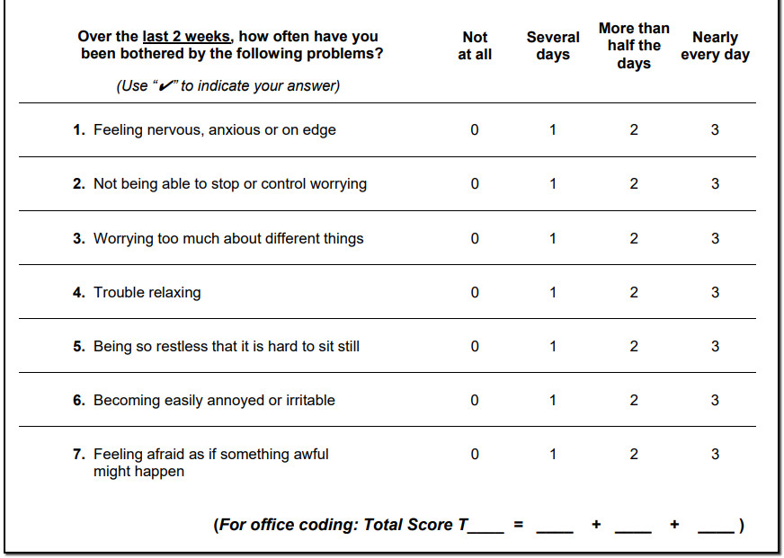

14. References
- Amerio, A., Brambilla, A., Morganti, A., Aguglia, A., Bianchi, D., Santi, F., . . . Capolongo, S. (2020, August 17). COVID-19 lockdown: Housing BUILT ENVIRONMENT'S effects on mental health. Retrieved March 14, 2021, from https://www.mdpi.com/1660-4601/17/16/5973
- Arafat, S., Kar, S., Marthoenis, M., Sharma, P., Apu, E., & Kabir, R. (2020, May 06). Psychological underpinning of panic buying during pandemic (covid-19). Retrieved March 14, 2021, from https://www.sciencedirect.com/science/article/abs/pii/S0165178120310039?via%3d Ihub
- Bhutan reports FIRST COVID-19 CASE. (2020, March 10). Retrieved March 13, 2021, from http://www.bbs.bt/news/?p=129299
- Bhutan. National Statistics Bureau. Retrieved from https://bhutan.unfpa.org/sites/default/files/pub-pdf/SRH%20of%20Youths%20and%20Adolescents%20in%20Bhutan.pdf
- Cellini, N., Canale, N., Mioni, G., & Costa, S. (2020, May 15). Changes in sleep pattern, sense of time and digital media use DURING COVID‐19 Lockdown in Italy. Retrieved March 14, 2021, from https://onlinelibrary.wiley.com/doi/10.1111/jsr.13074
- Department, P., & 26, N. (2020, November 26). Global population of CHILDREN 2100. Retrieved March 14, 2021, from https://www.statista.com/statistics/678737/total-number-of-children-worldwide/
- Elmer, T., Mepham, K., & Stadtfeld, C. (2020, June/July). Students under LOCKDOWN: Comparisons of students' social networks and mental health before and during the COVID-19 crisis in Switzerland. Retrieved March 14, 2021, from https://journals.plos.org/plosone/article?id=10.1371%2Fjournal.pone.0236337
- Evans, S., Alkan, E., Bhangoo, J. K., Tenenbaum, H., & Ng-Knight, T. (2021, February 23). Effects of the COVID-19 lockdown on mental health, wellbeing, sleep, and alcohol use in a UK student sample. Psychiatry Research. Retrieved April 18, 2022, from https://www.sciencedirect.com/science/article/pii/S0165178121001165
- Giannopoulou, I., Efstathiou, V., Triantafyllou, G., Korkoliakou, P., & Douzenis, A. (2020, November 06). Adding stress to the STRESSED: Senior high school students' mental HEALTH amidst the COVID-19 NATIONWIDE Lockdown in Greece. Retrieved March 13, 2021, from https://www.sciencedirect.com/science/article/pii/S0165178120332212
- Jeong, H., Yim, H. W., Song, Y. J., Ki, M., Min, J. A., Cho, J., & Chae, J. H. (2016). Mental health status of people isolated due to Middle East Respiratory Syndrome. Epidemiology and health, 38, e2016048. https://doi.org/10.4178/epih.e2016048
- Jiao, W. Y., Wang, L. N., Liu, J., Fang, S. F., Jiao, F. Y., Pettoello-Mantovani, M., & Somekh, E. (2020). Behavioral and emotional disorders in children during the covid-19 epidemic. The Journal of Pediatrics, 221. doi:10.1016/j.jpeds.2020.03.013
- Lau, J. T., Griffiths, S., Choi, K. C., & Tsui, H. Y. (2010). Avoidance behaviors and negative psychological responses in the general population in the initial stage of the H1N1 pandemic in Hong Kong. BMC infectious diseases, 10, 139. https://doi.org/10.1186/1471-2334-10-13
- Learn about mental health - mental health - cdc. (2018, January 26). Retrieved March 14, 2021, from https://www.cdc.gov/mentalhealth/learn/index.htm
- Lee, J. (2020). Mental health effects of school closures during covid-19. The Lancet Child & Adolescent Health, 4(6), 421. doi:10.1016/s2352-4642(20)30109-7, from https://www.thelancet.com/journals/lanchi/article/PIIS2352-4642(20)30109-7/fulltext
- Magklara, K., Bellos, S., Niakas, D., Stylianidis, S., Kolaitis, G., Mavreas, V., Skapinakis, P., 2015. Depression in late adolescence: a cross-sectional study in senior high schools in Greece. BMC Psychiatry 15 (1), 199. https://doi.org/10.1186/
- Mental health. (n.d.). Retrieved March 14, 2021, from https://www.who.int/health-topics/mental-health
- Mental health: Definition, common disorders, early signs, and more. (n.d.). Retrieved March 14, 2021, from https://www.medicalnewstoday.com/articles/154543#definition
- National Statistics Bureau. (2018). 2017 Population and Housing Census of Bhutan. National Statistics Bureau. Retrieved from http://www.nsb.gov.bt/publication/files/PHCB2017_national.pdf
- National Statistics Bureau (2018). Statistical Yearbook of Bhutan 2018. National Statistics Bureau. Retrieved from http://www.nsb.gov.bt/publication/files/SYB_2018.pdf
- Nirmita Panchal, R., & 2021, F. (2021, February 10). The implications of Covid-19 for mental health and substance use. Retrieved March 14, 2021, from https://www.kff.org/coronavirus-covid-19/issue-brief/the-implications-of-covid-19-for-mental-health-and-substance-use/
- N. Zhu, D., JF. Chan, S., CL. Huang, Y., NS. Chen, M., ZZ. Li, K., Yang, Y., . . . XG. Ji, Y. (1970, January 01). Diagnosis, treatment, and prevention of 2019 novel coronavirus infection in Children: Experts' consensus statement. Retrieved March 14, 2021, from https://link.springer.com/article/10.1007%2Fs12519-020-00343-7
- Oosterhoff, B., Palmer, C. A., Wilson, J., & Shook, N. (2020). Adolescents' motivations to engage in social Distancing during the COVID-19 Pandemic: Associations with mental and social health. Journal of Adolescent Health, 67(2), 179-185. doi:10.1016/j.jadohealth.2020.05.004
- Pieh, C., Budimir, S., Humer, E., & Probst, T. (2021, March 30). Comparing mental health during the COVID-19 lockdown and 6 months after the lockdown in Austria: A longitudinal study. Frontiers. Retrieved April 18, 2022, from https://www.frontiersin.org/articles/10.3389/fpsyt.2021.625973/full
- Promoting mental health and well-being deserves our undivided attention and long-term investment. UNICEF Bhutan. (2021, December 10). Retrieved from https://www.unicef.org/bhutan/stories/promoting-mental-health-and-well-being-deserves-our-undivided-attention-and-long-term#:~:text=From%20an%20average%20of%20six,week%2C%20from%202018%2D2020.&amp;text=Suicide%20is%20now%20among%20the,causes%20of%20death%20in%20Bhutan.&amp;text=Suicide%20and%20mental%20health%20are,So%2C%20Bhutan%20is%20no%20exception.
- Ren, X., Huang, W., Pan, H., Huang, T., Wang, X., & Ma, Y. (2020). Mental health during the COVID-19 outbreak in CHINA: A meta-analysis. Psychiatric Quarterly, 91(4), 1033-1045. doi:10.1007/s11126-020-09796-5. Retrieved March 14, 2020 from https://link.springer.com/article/10.1007/s11126-020-09796-5
- Singh S;Roy D;Sinha K;Parveen S;Sharma G;Joshi G;. (n.d.). Impact of covid-19 and lockdown on mental health of children and adolescents: A narrative review with recommendations. Retrieved March 14, 2021, from https://pubmed.ncbi.nlm.nih.gov/32882598/
- Singh, S., Roy, D., Sinha, K., Parveen, S., Sharma, G., & Joshi, G. (2020). Impact of covid-19 and lockdown on mental health of children and adolescents: A narrative review with recommendations. Psychiatry Research, 293, 113429. doi:10.1016/j.psychres.2020.113429
- UNICEF. (2020b, April 14). UNICEF. UN News. https://news.un.org/en/tags/unicef. United Nations, 2020. Policy brief: the impact of COVID-19 on children. Policy brief]. United Nations 1–17
- UNICEF Bhutan. (2020, June 01). Retrieved March 14, 2021, from https://www.unicef.org/bhutan/
- Xiang, Y.-T., Yang , Y., Zhang, L., & Li , W. (2020, February 4). Timely mental health care for the 2019 novel coronavirus outbreak is urgently needed. The lancet. Psychiatry. Retrieved April 18, 2022, from https://pubmed.ncbi.nlm.nih.gov/32032543/
- Zhou, S.-J., Zhang, L.-G., Wang, L.-L., Guo, Z.-C., Wang, J.-Q., Chen, J.-C., Liu, M.,Chen, X., Chen, J.-X., 2020. Prevalence and socio-demographic correlates of psychological health problems in Chinese adolescents during the outbreak of COVID- 19. European Child & Adolescent Psychiatry 29 (6), 749–758. https://doi.org/10.1007/s00787-020-01541-4.

