

ASSOCIATION OF EXCLUSIVE BREASTFEEDING AND DIARRHEAL DISEASE AMONG UNDER TWO YEARS CHILDREN IN RANCHI, INDIA: A COMMUNITY BASED STUDY
Association of exclusive breastfeeding and diarrheal disease among under two years children in Ranchi, India

A senior thesis submitted for the partial fulfillment of requirement for the degree of Bachelor of Science in Public Health

SUBMITTED BY:
Sita Kumari
AUW190080

Supervisor
Dr. Nazmul Alam
Co-Supervisor
Dr. Tuhin Biswas

Abstract
Background:
Diarrhea is a preventable and treatable disease however; it is the second life threatening cause of child morbidity and mortality across the globe. Among many risk factors, malnutrition is one of the biggest risk factors which cause childhood morbidity and mortality among children under two. In terms of child health and child nutrition, ensuring healthy Infant and Young Child Feeding (IYCF) by giving exclusive breastfeeding is crucial. Therefore, the aim of the study is to determine the association of Exclusive Breastfeeding and Diarrheal Diseases Among Under Two Years Children in Ranchi, India.

Methodology: A cross sectional study using a quantitative research design was conducted by using a semi-structured questionnaire. With the cluster or area sampling, a total of 384 participants who had children between 6 months to 24 months were selected for the study. Pretesting of the questionnaires was done among 5 volunteers prior to data collection in order to evaluate the reliability and testing of the questionnaires for piloting. Before initiating the surveys, consent forms were given to the participants and explained thoroughly and written or verbal consent were taken based on their comfortability. Moreover, the subjects of the study were given the complete right to withdraw during data collection. After data collection, they were checked for the consistency, error and entered in SPSS software. The data analysis was done on SPSS software to find the association.
Result: The study found that the majority of the participants had the knowledge of exclusive breastfeeding (96.2%), where the practice level is 74.4% and 97.1% of the participants had given colostrum. The prevalence of diarrhea among the children within the second year of life was found to be 72.1% including both acute and persistent diarrhea. In terms of Water, Sanitation, and Hygiene (WASH), about 99% of the participants have access to clean drinking water, and 81.4% of them have safe sanitation facilities. The result of the study shows that 91% of the participants have the knowledge of Oral Rehydration Saline (ORS) is 91%. The result of the study shows that there is a significant association between exclusive breastfeeding and prevention of children under two against diarrhea with p<0.005.

Conclusion: The study has found a significant association between exclusive breastfeeding and the prevention of diarrhea among under two. However, the high prevalence of diarrhea, and low exclusive breastfeeding rate requires the development of health intervention through effective educational strategies to promote exclusive breastfeeding to ensure healthy Infant and Young Child Feeding (IYCF) and to improve WASH facilities to reduce child morbidity and mortality caused by diarrhea.

ACKNOWLEDGEMENT

This research study was primarily supported by Asian University for Women, as a senior thesis submitted for partial fulfillment of the requirements of Bachelor of Science degree in Public Health studies. I would like to extend my gratitude to my university for introducing the idea of senior thesis by including this in the academic curriculum.

I would like to express my sincere gratitude to my supervisors Dr. Nazmul Alam and Dr. Tuhin Biswas for providing guidance throughout the research process.

I would like to acknowledge all the government officials including Child Development Project Officers (CDPOs), Aanganwadi Workers, and Accredited Social Health Activists (ASHA) under the Ministry of Health and Family Welfare in Ormanjhi block, and the participants of this research study for their relevant and valuable data, and their precious time.

I take this opportunity to express my gratitude to my research assistant, Aanchal Munda for her support and efforts throughout the data collection.

Finally, I would like to thank my beloved mother and my siblings, who supported me in finding the relevant places for my research approval and to collect data safely and moreover providing emotional support to complete the thesis successfully. I will be forever grateful to your encouragement and support.

Table of Contents

Contents Page No.

Abstract…………………………………………………………………………………………2
Acknowledgement………………………………………………………………………………3
- Introduction and Background of study
1.1 Introduction .………………………………………………………………………..5
1.2 Research objectives …………………………………………………………………7
1.3 Background …………………………………………………………………………7
1.4 Hypothesis ………………………………………………………………………….10
- Literature Review ……………………………………………………………………….10
- Methodology …………………………………………………………………………….13
3.1 Data Collection Methods ……………………………………………………………16
3.2 Ethical Consideration ……………………………………………………………….17
3.3 Data Analysis ………………………………………………………………………. 18
- Result ……………………………………………………………………………………18
- Discussion ……………………………………………………………………………… 38
- Conclusion……………………………………………………………………………….41
- References .………………………………………………………………………………42

Association of Exclusive Breastfeeding and Diarrheal Diseases Among Under Two Years Children in Ranchi, India: A Community Based Study

Introduction

Diarrhea is a life threatening disease, which is the second largest cause of mortality and morbidity among children under five across the globe. The World Health Organization defines “Diarrhea is three or more than three passages of loose and liquid stools per day which is caused by bacterial and viral infection of intestinal tract” (2012). About 1.7 billion children under five die are at high risk of diarrheal infection where, almost 525,000 children out of that die each year globally (Ghosh, K. et al, 2021). In terms of prevalence of child deaths, in developing countries, merely South Asian and Sub-Saharan developing countries including India have the half of the diarrheal deaths under five. Moreover, among all the states of India, Jharkhand has 6.9% of prevalence of diarrhea under five which is far lower than other states like Uttar Pradesh, Uttrakhand, Ponducery and some eastern states of the Indian Union (Ghosh, K., 2021). However the potential risk of diarrhea is still high in terms of the diarrheal prevention and management in rural areas. According to the Census of India (2011), 55.42% of women are literate where in terms of literacy rate in gender in demographics are 49% and 73% of females and male in rural areas. Due to some political and cultural sensitivity, the state has become one of the poorest states of India, where 19.6% under five children are malnourished. Therefore, intervention with preventive measures focused on nutritional care under five children are crucial to be identified and developed to control and eliminate the adverse effects eventually.

Beside proper sanitation and hygiene management, important preventive measures like exclusive breastfeeding can be effective to reduce the transmission of diarrheal infection (Lakshaminarayana, 2015). According to WHO recommendation (2012), early and exclusive breastfeeding starts from the first hour of childbirth to the six months continuously without any additional nutritional supplementation. Furthermore, this feeding practice excludes any food and water except breast milk with the exception of medicine and rehydration solution intake during medication requirement. Exclusive breastfeeding is not only important for children’s survival from infectious disease but it also leads to a positive impact on both mother’s and the child’s physical, emotional and social well-being.
Under WHO preventive strategies, Exclusive Breastfeeding (EB) is one of the major preventable and protected approaches beside accessibility of Water, Hygiene, and Sanitation (WASH), Rotavac vaccination, and so forth. WHO promotes exclusive breastfeeding for the first six months of life as a key measure for the protection from childhood diarrhea (2017). It is evident that the childhood diarrheal cases mostly occur under two years of life caused by malnutrition where exclusive breastfeeding is an integral part of it.
Knowing the severity of the diarrheal prevalence and taking preventive steps to save the children from infection is necessary to understand. This study is based in Jharkhand, Indian state. It was observed that the state has been involved in many health interventions under state and union government for childhood diarrheal management. This study thus is to determine the association between the roles of exclusive breastfeeding in prevention of diarrhea under 5 in Jharkhand.

Research Objectives:
- To estimate the prevalence of diarrheal morbidity among children in the Ormanjhi block of the state.
- To assess the knowledge, attitude and practice of the mothers regarding the importance of exclusive breastfeeding, colostrums, uses of ORS, and diarrheal management.
- To establish the association between exclusive breastfeeding and prevention of diarrhea among children

Background
A study has revealed that around 1.3 million lives can be saved just by promoting and practicing exclusive breastfeeding, however merely 37% of the children get breastfed for six months in low and middle income countries (Mulatu, T., 2021). Early and exclusive breastfeeding is also considered as the first vaccine to the child for giving passive immunization due to presence of protective antibodies in the breast milk.
Since, Diarrhea is a preventable and treatable disease, the state government of Jharkhand works to reduce the childhood diarrhea cases. In order to ensure the preventive strategies and health intervention, the Department of Health and Medical Education and Family Welfare, Jharkhand under supervision of Government of India (GOI), and United Nations Children’s Fund (UNICEF) collaborate to reduce the maternal and child morbidity and mortality. The grass root level of health care provided for children is a localized courtyard shelter which is referred to as “Aanganwadi Centre (AWC)” in India. The frontline workers like Aanganwadi Workers (AWW), Accredited Social Health Activist (ASHA) and the Auxiliary Nurse Midwife (ANM) get the health education training, provide vaccines, primary health care services, and are accountable for the health promotion to the families of assigned villages.
Exclusive breastfeeding rates have been visibly increased over the last decade in Ranchi district of Jharkhand. Under the supervision of National Nutrition Mission of India, Aanganwadi services schemes have been working on promotion of exclusive breastfeeding to uplift the nutritional status of infants. Exclusive breastfeeding practice does not only improve nutritional support, but also provides protective components to prevent children from acute and chronic disease in later stages of life. One of the leading causes of mortality and morbidity under 5 is Diarrhea, which is a preventable and treatable disease. Furthermore, the first two years of the children’s life is crucial since most mortality cases come from this stage. Diarrhea, especially under two, has potential risk for child mortality and morbidity and one of the major reasons is malnutrition.
Moreover, The World Health Organization also promotes exclusive breastfeeding in terms of preventive and protective approach for diarrheal prevention under 5. “The benefits of exclusive breastfeeding is largely acceptable by majority of lactating mothers, where 85.8% mothers felt the breastfeeding can improve the immunity of the infants (Krishnendu, M., 2017)”, this study was based on the knowledge, attitude and practice of the lactating mothers in rural districts of Kerala. However, there is a huge difference between rural Jharkhand and rural Kerala in terms of socio-economic status. Kerala which is the most developed state with the most literate population, where Jharkhand is often ranked as a poor state with low health infrastructure and literacy rate. However, there is a data gap finding association of role of exclusive breastfeeding and diarrheal prevention under two on the selected population of rural Jharkhand. Therefore, a further study on this is required to assess the current interventions and strategies to find the trends of childhood diarrheal disease in the state.
A study conducted in a rural block of West Bengal found that exclusive breastfeeding has both short and long term effects on children under 5 shows that exclusive breastfeeding is more effective than non-exclusive breastfeeding (Biswas, A., etal, 2016). However, the study only differentiate between exclusive breastfeeding and non-breastfeeding without considering other factors such as knowledge, attitude, and practice of lactating mothers, took all the children under 5, and WASH which is one of the biggest preventive factors of diarrhea. Moreover, the study has not shown the cases of acute and persistent diarrhea of the selected population.
According to District Nutritional Profiles based on National Family Health Surveys (NFHS) shows an improvement of exclusive breastfeeding in the district with the rate 71% in 2016 to 89% in 2020 which is far above than national average 55%. In order to promote exclusive breastfeeding practice among pregnant and lactating mothers, the local community health workers are working with the collaboration of Panchayat level child development project officers, district administration, and state functionaries. For diarrheal management, the health ministry of the state government has been improving Water, Sanitation, and Hygiene. Among many health interventions, Jal Jeevan Mission, Swachh Bharat Mission, and Infant and Young Child Feeding (IYCF) are showing positive results. The Jal Jeevan Mission (JJM) provides adequate drinking water through tap connections to each household. Under Swachh Bharat Mission (SBM), the state government is trying to make the state open defecation free. The Ministry of Health and Family Welfare (MoHFW) have also introduced an oral liquid rotavirus vaccine free of cost under the Universal Immunization Program (UIP) to protect the children from severe Diarrhea. Moreover, the community health workers under United Nations Children’s Fund (UNICEF) focuses on Infant and Young Child Feeding (IYCF) by proving Oral Rehydration Saline (ORS), Zinc supplementation and promotion on early initiation and exclusive breastfeeding to prevent and treat children from Diarrhea.
Despite the fact that there are multiple programs and health intervention with multi level stakeholder collaboration, a lack of awareness based on health literacy, and specific age of children prevented or affected by diarrheal infection with exclusive breastfeeding are still not disclosed based in rural Jharkhand. Moreover, children are 13% of the total population of the nation which does require extra attention in terms of prevention and intervention (National Health Mission, 2023). Therefore, I hypothesize that exclusive breastfeeding has sufficient potential to reduce the risk of diarrhea under 2.
Hypothesis
- Exclusive breastfeeding relatively lowers the risk of diarrheal infection under 2 children than non-exclusive breastfeeding.
Literature Review
According to the World Health Organization (2017), globally 1.7 billion children die per year because of diarrhea. One of the measure causes of childhood diarrhea is malnutrition under 5, and around two third of the deaths under 5 where lack of exclusive breastfeeding is an integral component (Kumar, A. et al, 2015). Inappropriate feeding practices can be the barriers of children’s growth and development such as stunted growth, wasting, and underweight. Moreover, the severity of undernourishment makes the children immuno-suppressed and increases the risk of infectious disease.
As it is known, diarrheal disease is the second life threatening cause of mortality of children under 5. It is important to focus on nutritional status of the children besides ensuring WASH, and vaccination which contribute as potential risk on children’s health. Centre of Disease Control and Prevention (2021) states that the doses of rotavirus vaccines are used to reduce the risk of severe diarrhea under 5. Rotavirus is deadly and it is transmitted through household infection which makes the vaccine crucial for the children to be immunized for survival. Furthermore, Indigenous vaccination Rotavac of India was also introduced in India back in 2016 which is available at all rural and urban community health care centers free of cost.
A study conducted in rural Bangladesh showed that “entering pathogens are associated with the diarrhea among under 5 children and children with malnutrition are more likely to have diarrheal infection from rotavirus microorganisms” (Ferdous, F, etal., 2013). This study also revealed that malnutrition under 5 can also be a cause of dysentery and dehydrating diarrhea. However, the study could not find the severity and duration of the diarrhea caused by malnutrition among 5 children.
According to the National Family Health Survey (NFHS), around 76.4% of the children have received a vaccine against Rotavirus, where in urban areas it is 65.2% children aged 12 to 23 months for prevention against childhood diarrhea (2021). The children under this age also provided Measles, Mumps, and Rubella and Vitamin A supplementation in the state. This shows the awareness and availability of diarrheal prevention and management at community level in the countryside is higher than the urban areas of Jharkhand. However, the study could identify the associative factors in terms of malnutrition of prevalence of diarrhea under 5.
Furthermore, the role of breastfeeding is also associated with the response to vaccine efficacy among under 5 children. The study has found that “infant's feeding method is important in the evaluation of various types of vaccines; that happens because the active immune response to specific antigens develops differently in breast-fed and formula-fed infants” (Dòrea, J. G., 2009). Moreover the daughter study revealed that antibodies present in the breast milk have potential to combat disease like diarrhea, acute respiratory infections. The antibodies in “mother’s breast milk stimulates the immune system of the infants and response to vaccination” (Cai, X. etal, 2012). Chen M (2017) found that the critical level of antibody Immunoglobulin A (IgA) could be associated with the rotavirus vaccination which provides sustained protection.
Health education is one of the crucial approaches in public health intervention. Under the Ministry of Women and Child Development, programs on young child feeding like Poshan Abhiyan Program include providing education in rural areas based on Social behavior Change and Communication (SBCC), and health promotion at community level in the state (Roy, S. M., 2023). The programs include Antenatal Care (ANC), Optimal breastfeeding (early and exclusive breastfeeding), WASH, and monitoring of children's growth and development in later stages since the childbirth.
Breast milk has protective components such as oligosaccharides, glycoconjugates (i.e., secretory immunoglobulins, lactoferrin, α lactalbumin, lysozyme, mucins) and bacterial microbiota, IgM, and IgG, AND IgA. Among these all, Immunoglobulin A (IgA), Immunoglobulin G (IgG), and Immunoglobulin M(IgM), Lactoferrin, antibodies present in colostrum show the antigenic stimulation of gut-associated lymphoid tissue (GALT), nasopharynx associated lymphoid tissue (NALT) (Turin, C.G. et al, 2014). It was also revealed that IgA, IgM and IgG antibodies can fight against respiratory and gastrointestinal pathogens. Moreover, Lactadherin can be another protective factor against rotavirus. However there are variations in human milk and its composition which depends on the genetics, lactation, gestational age, and other maternal factors including delivery types and maternal weight. Colostrum which is the first breast milk fed to the new born babies are responsible to prevent children from infections and gut maturation. The concentration of lactose and lipids increase and protein decrease after the fourth week of postpartum. Beyond 12 weeks, the immunoglobulin level decreases. This shows that there can be variations of breast milk composition based on many factors.
Approximately, 800,000 children under five can be prevented from the deadly infectious disease by providing optimal breastfeeding of children under two (Lancel 2013; Poshan, 2023). As mentioned, malnutrition leads to 60% of deaths under 5 which can be prevented by taking proper intervention with possible preventive measures.
With all these existing literatures, the study will be to give an attempt to to determine the role of exclusive breastfeeding practiced in diarrheal prevention under 5 in my study area. Along with that different health intervention for diarrheal prevention and management, and knowledge, attitude and practice of the mothers would also be highlighted. In addition to that, challenges faced by the lactating mothers would also be discussed.

Aim:
The aim of the study is to determine the association between the exclusive breastfeeding (EBF) in preventing children aged 5 against diarrheal infection in Jharkhand, India.

Methodology:
Study Design
A cross sectional study using a quantitative research design was conducted in rural Ormanjhi block of Ranchi, Jharkhand on lactating women who have children under 2. For this study, surveys were taken from the study population. The study had a quantitative research approach in order to get the quality data on the importance of breastfeeding and prevention of diarrheal disease.
Sampling Method:
The study was based on probability sampling which was two stage cluster sampling. To find the cluster, a random number generator was used to get the cluster that was panchayat (local administration level) and selected participants were chosen from each village of the chosen panchayat by following simple random sampling. Among 18 panchayats of the block, 26 villages Barwe, Mahuatoli, Rigatoli, Dahu, Bartoli, Basati, Harchanda, Chaprakocha, Chapawar, Gagari 1, Gagari 2, Hesatu, Khatnga, Sildiri, Ulatu, Koylari, Bartoli, and Irba, Hutup, Karma, Rukka, Kamta, Kuchu, and Kulhi of the 6 panchayats i.e, Barwe, Chakla, Gagari, Irba, Karma, and Kuchu were selected for data collection.
Study Site
Ormanjhi block which is located in Ranchi district of Jharkhand in Eastern India. Ormanjhi Community Development block has approximately 94,137 total population, where 88,927 reside in rural areas, and 5,210 in urban areas. The residents from rural Ormanjhi block are in hilly areas or dam side areas. Furthermore, most of their primary occupation is farming. There are 18 village councils for local governance and administration which is referred to as “Panchayat”. In terms of maternal and child health care services, under Integrated Child Development Services (ICDS) which is supervised by Child Development Project Officers (CDPO) from block level in the countryside. One of the integral parts of this project is Aanganwadi which is a rural child care center or courtyard shelter to provide the health services to pregnant women, lactating mothers, and children below 6. Each Aanganwadi gets one or two villages (based on the village population) assigned to improve nutritional and health status of both mother and the child with psychological, physical, and social health support. There are a total 18 panchayats in this block, and among them six panchayats were chosen based on a random number generator. For this study, data were collected from 26 villages within the chosen panchayat.
Study Population
Study population targeted the women who had children 0-5 years old from rural communities of the selected panchayat of Ormanjhi block of Ranchi. The inclusion criteria for this study were residents of the villages of the selected panchayat of Ormanjhi block, and women who had children below 2 years. The purpose of choosing under two children is to avoid recall bias, and under 2 children are at relatively more risk of diarrhea then under 5.
Sample size
The sample size was calculated using single population formula [n= Z 2 1-α/2 p(1-p)d2] with the following considerations: p= 0.5%, d= 5%= 0.05, and 1-α= 95% (α= 0.05) (Zα= 1.96).
Where,
n= Sample size
p= Population proportion
d= Absolute precision required on either side of proportion
1-α= Confidence level
i.e.,
p= 0.5%
d= 5%= 0.05
1-α= 95% (α= 0.05) (Zα= 1.96)
n= (1.96) 2 × 0.5(1-0.5)
(0.05) 2
n= 384.16 ~384
Considering 20% non-response rate,
20% of 384= 76.8= 77
n= 77+384
n = 461

Sample Size
The sample size for this study was 384, where it consisted of 461 subjects including non-responsive rate.
Data collection
The data was collected face to face using a survey method. The questionnaire included socio-demographic status, feeding practices and mothers’ knowledge of breastfeeding, diarrheal case management. Pretesting of the questionnaires was done among 5 volunteers prior to data collection in order to evaluate the reliability and testing of the questionnaires for piloting. List of the subjects meeting the inclusion criteria was collected from the respective villages based community health care center. Prior to data collection, the purpose of the study conduct was thoroughly explained to the participants and read the instructions or questions before letting them answer the questionnaires to ensure informed consent. Necessary consent including written on consent forms or verbal was taken from every respondent to ensure voluntary participation. Those who agreed to participate in the study were taken through the consent process with the explanation of benefits and risk of participating in the research. The names of the subjects were noted on the questionnaires and the data was collected on the spot right after the consent. However, the names were only taken to ensure the quality data from the right person to avoid error, and none of their names were taken for any form of disclosure. Afterwards, the survey forms were filled by the principal investigator. The questionnaire consisted of closed ended questions with multiple choice (5-point Likert scale), ranking, and semi structured questions regarding socio-demographic, feeding practices, and diarrheal case management.
The questions were prepared in English, and consent forms were in Hindi for the participants to understand the aims of the study and research considerations for the subjects. For the explanation purpose, the local language Sadri, and Nagpuri were used for the conversation. The purpose behind using multiple languages is to make the data collection convenient for both the principal researcher and the subjects for clear communication based on the participants’ comfortability and preferences.
Ethical Consideration
The research covered all the ethical standards by getting approval of research protocol from the Ethical Review Committee (ERC) of the Asian University for Women, Chittagong, Bangladesh. Moreover, another approval was taken from the Child Development Project Officers (CDPOs) who monitor the Aanganwadi programs in Ormanjhi block. Consent forms were given to the subjects to go through by them self and explained if needed to accelerate their interest and to ensure their consent prior to the surveys. Therefore, before initiating the survey, consent was asked from each of the participants and written or verbal consent were taken based on their comfortability. Moreover, the subjects of the study were given the complete right to withdraw from the study if they felt uncomfortable at any point during the data collection process. To maintain privacy, the surveys were conducted one-on-one in separate rooms or spaces in their respective households. Since the study included all lactating women regardless of religion, caste, ethnicity, or other variables, to make them feel safe and comfortable, a common tribal language was used along with Hindi to respect their culture and ethnic values. To maintain confidentiality, the collected data (both hard and soft copy) were kept with the principal investigator and personal computer which was locked with a strong password safely. The research also ensured that study data contained any sensitive information would not be disclosed.
Data Management and Data Analysis
The data were collected on forms and they were checked for the consistency, error and entered in SPSS software. The data analysis was done on SPSS software to find the association between the two variables: exclusive breastfeeding and its role on Diarrheal prevention.
Result
A total of 312 study populations who had children under two were included in this study. The age of the mothers were categorized into two i.e, early adulthood (18-25 years old), and young adulthood (young adulthood). Moreover, 64.1% of women were in the early adulthood stage, where 35.9% of women were young adulthood. In terms of educational background, 21.5% were university graduates, 29.2% had completed higher secondary education, 26.3% matriculation, 19.6% semi-illiterate (school drop outs), and 3.5% were found illiterate. Considering employment status of the participants, 92.3% were found as housewives which is marked as “unemployed”, 1.9% employed, 0.6% mothers who had a part time job, and 5.1% “others” were engaged as labor at constructions, labors at agricultural fields, tailor, and tutors. The household income was considered as the level of monthly family income (INR) and this was categorized as (a.) less than 10,000 INR, (b.) 10,000 - 20,000 INR, (c.) 21,000 - 30,000, and (d.) more than 31,000 INR. In terms of monthly household income, 84.6% had less than 10,000 INR,
8% between 10,000 to 20,000 INR, 3.5% between 21,000 to 30,000, and 2.9% had more than 31,000 INR per month. Moreover, most of the respondents have low household income (<10,000 INR) per month, which is 84.6%. The summary table of sociodemographic status of the respondents is presented in Table 1.

Table 1: Status of Socio Demographic Characteristics of the Study Population

Socio-demographics Characteristics | Frequency (n) | Percentage (%)
Age of the Mothers

Early Adulthood  Young Adulthood | 200  112 | 64.1  35.9
Educational Status
No Schooling  10th Grade  HSC  University  School Drop out | 11  82  91  67  61 | 3.5  26.3  29.2  21.5  19.6
Employment Status
Unemployed  Employed  Part Time  Others | 288  6  2  16 | 92.3  1.9  0.6  5.1
Household Income (₹)
< 10, 000  10,000 - 20,000  21,000 - 30,000  > 31,000 | 264  25  11  9 | 84.6  8  3.5  2.9

The mean age of the children was 14.86 ± 6.34 in months. Out of 312 children, 56.4% newborn babies were breastfed within an hour just after the birth, 19.6% children were given breast milk within two hours, 12.2% children within 24 hours, 7.1% babies after a day, 1.9% babies after two days, 1.3% kids after six days, and 1.6% of them did not get breast milk after the birth. Based on colostrum given to the newborns, about 97.1% got colostrum where 2.9% did not get colostrum because of less secretion, mode of child delivery or children’s poor health. Considering the interval maintained to give breast milk, 27.9% children were given within 30 minutes, 18.9% were given within an hour, 14.7% within 2 to 3 hours, 3.2% were breastfed when they seemed hungry, 33.3% of them got breast milk whenever they cried, where 1% of them rarely got breastfed. However, intervals of breastfeeding for 1% of them are not applicable since they never got breast milk since their birth or their mothers had difficulties to breastfeed their babies. Regarding giving liquid food after the birth to the babies beside breast milk, 23.1% children got liquid food, and 76.9% of them were given nothing except breast milk. The type of liquid food includes lactogen, infant milk, ghee, honey, cow milk and goat milk. In terms of the number of mothers who had difficulties to breastfeed their children, 15.7% of them had different difficulties feeding their babies, where 84.3% of them had no difficulties during breastfeeding.
The types of difficulties during breastfeeding were found mainly because of less secretion, wound on breasts, mother’s sickness, lactose intolerance in babies, and huge secretion.
Among 312 respondents, 2.2% mothers stopped breastfeeding after a month, 0.6% of them after six months, 13.1% of them stopped after one year, 3.2% of them continued breastfeeding till 2 to 3 years. However, for 80.8% participants, it was not applicable since they were still in the lactation period. Considering providing the lactation education or breastfeeding training to the mothers during and after pregnancy, 39.1% of them got training, where 60.9% did not get any training; therefore they managed to breastfeed by themselves without any proper guidance. For 37.2% of respondents, the breastfeeding training was helpful, where 1.9% of them could not find the training helpful, and it was not applicable for 60.9% mothers since they did not get any training on breastfeeding. The feeding practices characteristics which include breastfeeding practice, difficulties to breastfeed, interval maintained during breastfeeding, and liquid food are given according to the Table 2.
Table 2: Weaning Practices of Mothers Among Mothers of Children under 24 Months

Variables | Frequency (n) | Percentage (%)
Age of Children in Months (Mean ± SD) | (14.86 ± 6.34)
Breastfeeding After Giving Birth
Within an hour  Within two hours  Within 24 hours  After a day  After two days  After six days  Did not give | 176  61  38  22  6  4  5 | 56.4  19.6  12.2  7.1  1.9  1.3  1.6
Colostrum Given
Yes  No | 303  9 | 97.1  2.9
Interval maintained during Breastfeeding
Within 30 minutes  Within an hour  Within 2-3 hours  When they seem hungry  When they cry  Rarely  Not applicable | 87  59  46  10  104  3  3 | 27.9  18.9  14.7  3.2  33.3  1  1
Liquid food after birth (beside breast milk)
Yes  No | 72  240 | 23.1  76.9
Difficulties during breastfeeding
Yes  No | 49  263 | 15.7  84.3
Stopped Breastfeeding
After a month  After Six Months  After one year  After 2-3 years  Not applicable | 7  2  41  10  252 | 2.2  0.6  13.1  3.2  80.8
Breastfeeding Training
Yes  No | 122  190 | 39.1  60.9
If Training was helpful
Yes  No  Not applicable | 116  6  190 | 37.2  1.9  60.9

The knowledge of participants on the role of colostrum was reported in Figure 1.1. Among 312 participants, a total of 76.9% mothers were found to have knowledge on the role and importance of colostrum on their children’s health. Moreover, 21.8% of them did not know colostrum as an important factor, 1.3% of them did not give the feeling of confidence certainly of the role of colostrum
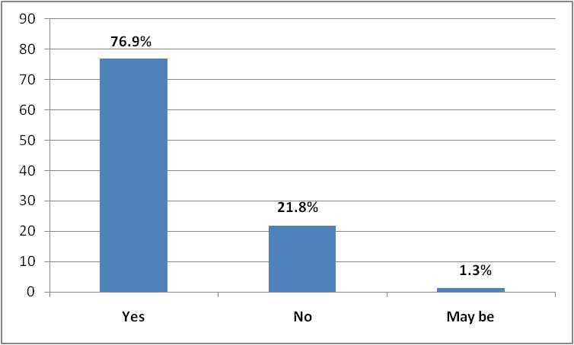
Fig 1.1: Knowledge on Role of Colostrums
Regarding having knowledge of Exclusive Breastfeeding (EB) of the participants, most of them (96.2%) had the knowledge of exclusive breastfeeding, where at least 3.8% never heard of exclusive breastfeeding before. The figure 2.1 shows the distribution of the knowledge and information about exclusive breastfeeding.

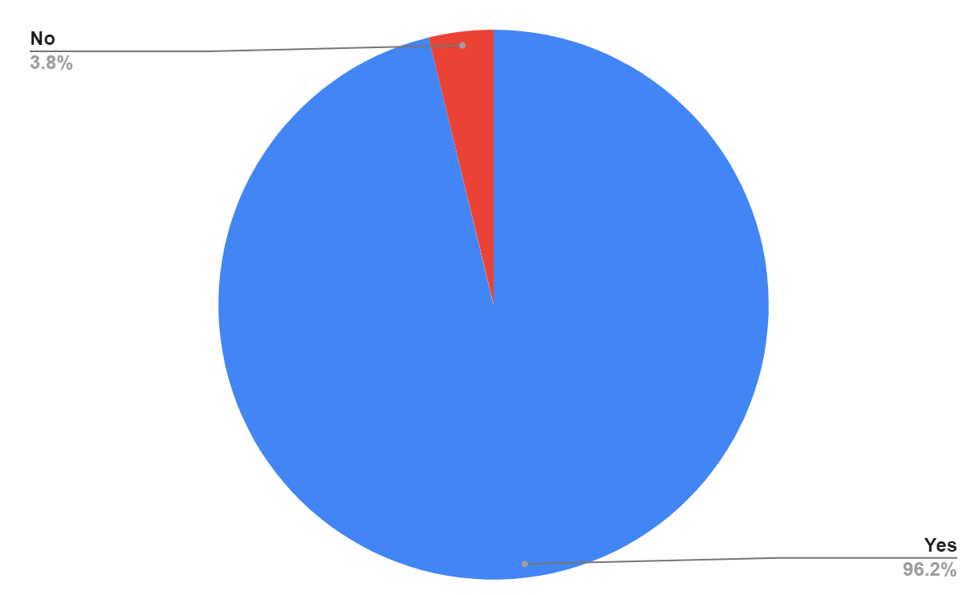
Fig. 2.1 : Knowledge of Exclusive Breastfeeding
Among 312 participants, 61.1% of the respondents got information about exclusive breastfeeding from community health workers, 19.6% from others which includes friends, books, social media and so forth, and 16.7% from family members. However, 2.6% of them are not applicable since they had not heard of exclusive breastfeeding before. In terms of mothers’ knowledge and information and the source they got information from are expressed in Figure 2.2.
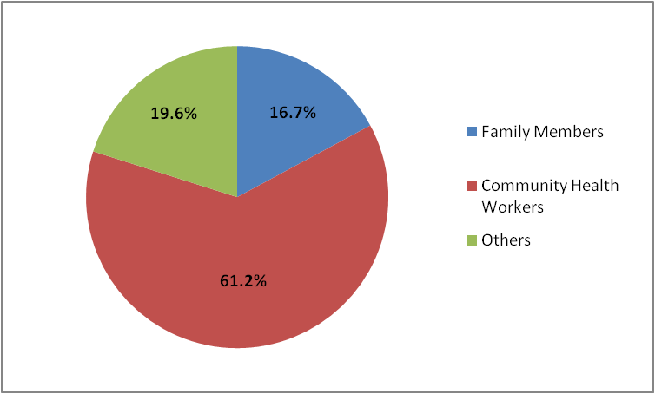

Fig. 2.2 : Source of Exclusive Breastfeeding Knowledge

Among all respondents, 90.7% of them think that six months of breastfeeding is crucial for their children’s growth and development. Additionally, 6.1% of them declined that there is any importance of exclusive breastfeeding for children’s growth and development, where 1.6% were not sure marked as “may be”, and 1.6% of them did not have any knowledge about it.The mothers' knowledge on role of six months of breastfeeding for their children’s growth and development according to the Figure 3.1.
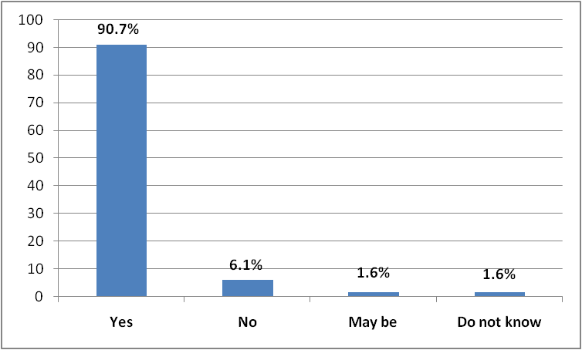
Fig. 3.1: Mothers’ Knowledge on importance of Six Months of Breastfeeding for Child’s Growth and Development

Considering the role of exclusive breastfeeding and its role to reduce children’s illness, 87.2% of the participants agreed that six months of breastfeeding is essential for their children’s illness reduction. However, 9.3% of them disagreed on it, 3.5% had no knowledge about it. The respondents’ knowledge on exclusive breastfeeding and its role for the reduction of illness of their children was recorded in Fig. 3.2.
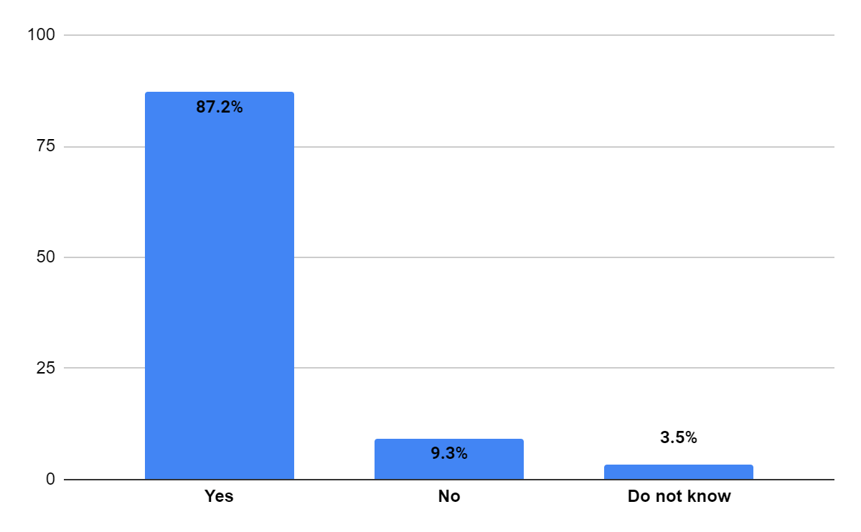
Fig. 3.2: Mothers’ knowledge on Exclusive Breastfeeding to Reduce Child’s Illness

Out of 312 participants, 87.8% of them were certainly confident about the exclusive breastfeeding for prevention of their children from infectious disease. 11.5 % of them disagreed, 0.6% were quite certain about the exclusive breastfeeding (passive immunization) to prevent the children from infectious disease. Figure 3.3 showed participants’ knowledge if exclusive breastfeeding can immunize their children against infectious disease.

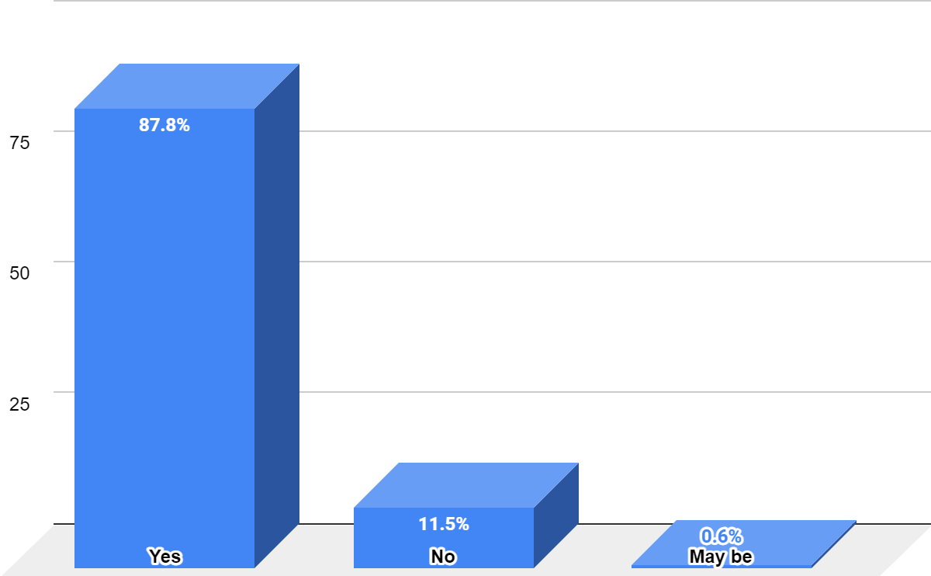
Fig. 3.3 : Mothers’ knowledge on EB as Passive immunization Against Infectious Disease

Among 312 mothers, 274 (87.8%) of them agreed that exclusive breastfeeding has the potential
to prevent children from infectious disease. However, 26 (8.3%) said “no”, 10 (3.2%) were not
aware, and 2 (0.6%) of the participants were less confident which was marked as “may be”. The
Fig. 3.3 shows the knowledge of the participants about the exclusive breastfeeding which is
considered as passive immunization for the children to fight against infectious disease.

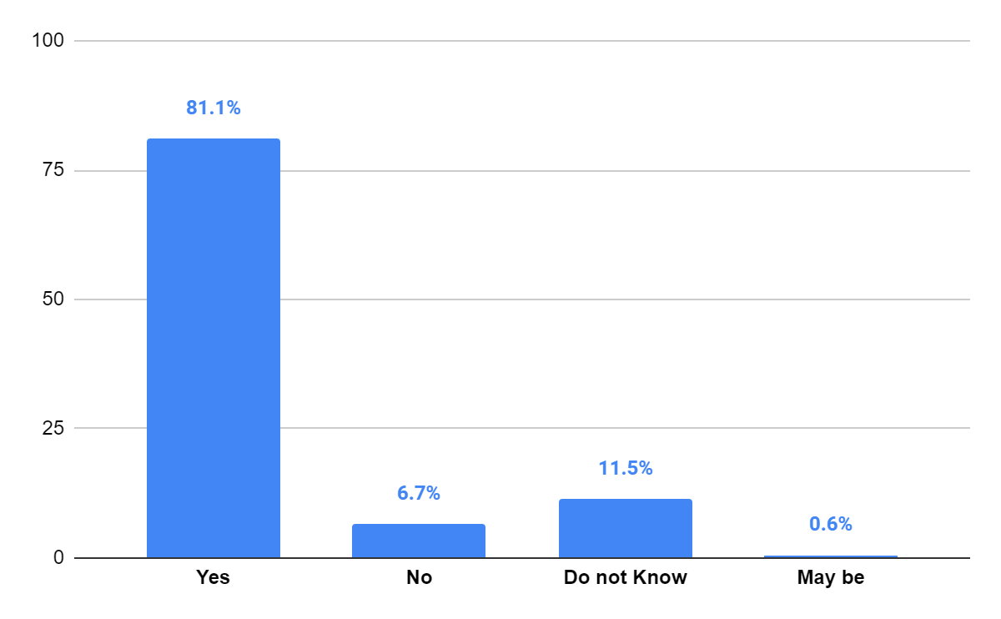
Fig. 3.4: Mothers’ Knowledge on breastfeeding to prevent Children from Diarrhea

Among all respondents, 253 (81.1%) mothers had the knowledge on the role of exclusive breastfeeding on prevention of children from Diarrhea, while 21 (6.7%) said “no”, where 36 (11.5%) were not aware, and 2 (0.6%) of the participants were not sure about it. The Fig 3.4 shows the knowledge of the mothers on breastfeeding and its role to prevent children from Diarrhea.

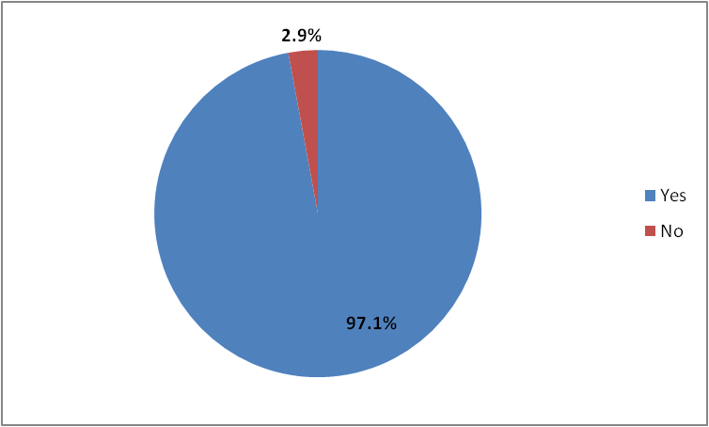

Fig 3.5: Number of Children got colostrum

According to Figure 3.5, 97.1% of children were given colostrum where, 2.9% did not due to the difficulties related to breastfeeding and mode of delivery

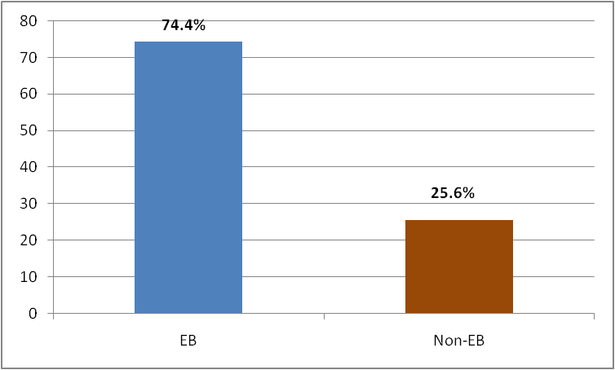
Fig 3.7: Status of Exclusive Breastfeeding
As shown in the figure 3.7, around 74.4% of the children were breastfed for six months and more, where 25.6% were not, which was marked as “Non-Exclusive Breastfeeding”.

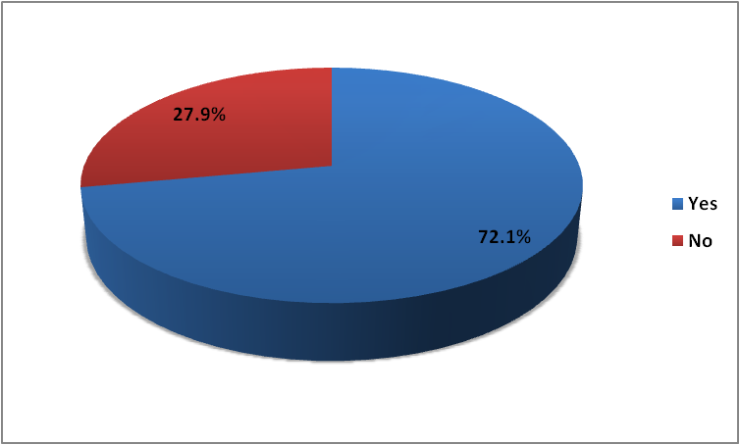

Fig. 3.7. Children had Diarrhea Within their Second Year of Life

According to the Fig. 3.5, out of 312 participants, 72.1% children of the participants had diarrhea in the past months or years, where 27.9% reported that their children never had diarrhea yet.
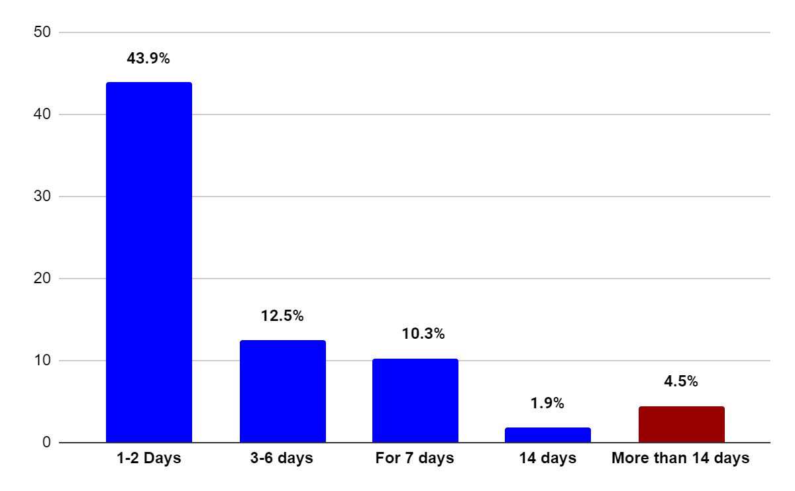
Fig 3.8. Duration of the Diarrhea among children

The children who had diarrhea before and during the data collection, the duration of the diarrhea among them is expressed in the Fig. above. Among all the children, 43.9% (137) children had diarrhea for 1 to 2 days, where 12.5 % of the children had it for 3 to 6 days, and 10.3% of them had it for 7 days. 1.9% of the children had diarrhea for 14 days and 4.5% of the children had chronic diarrhea which was more than 14 days. It was not applicable for 26.9% (84) of the children, they did not have diarrheal infection yet.

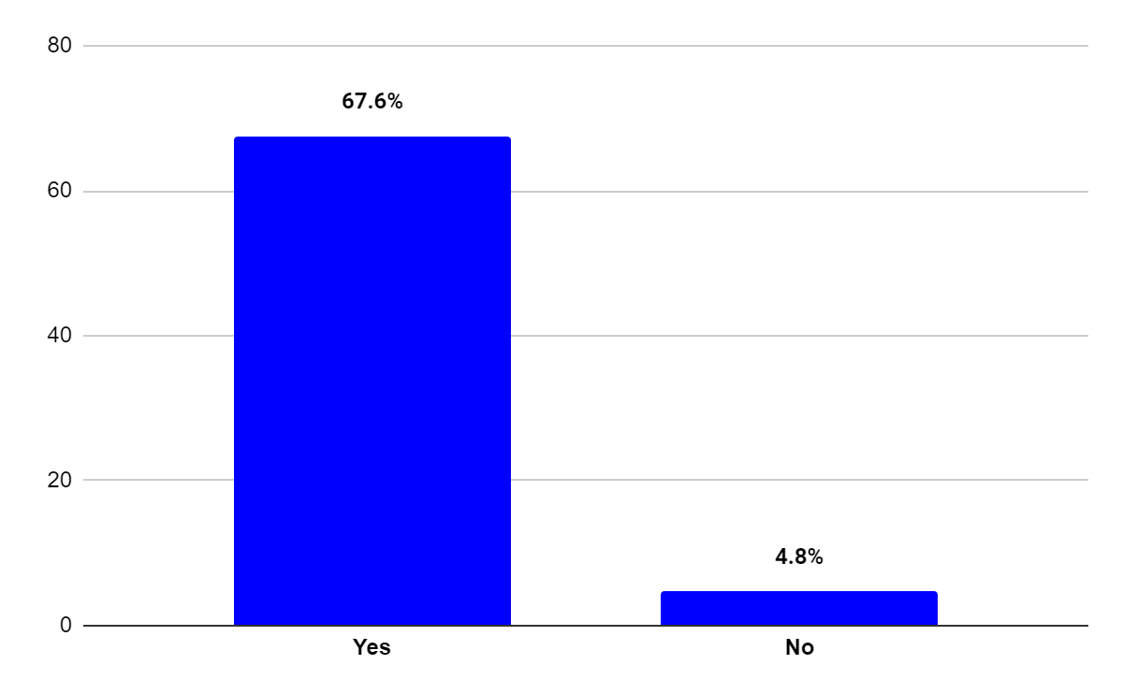

Fig. 4.1: Breastfeeding during diarrhea

Among all the respondents, 67.6 % continued breastfeeding when their children got diarrhea, where 4.8% of them did not breastfeed. However, it was not applicable for 27.6% of the mothers, since they did not get diarrhea. The Fig. 4.1 shows the number of the children who got breastfeeding during diarrheal infection.

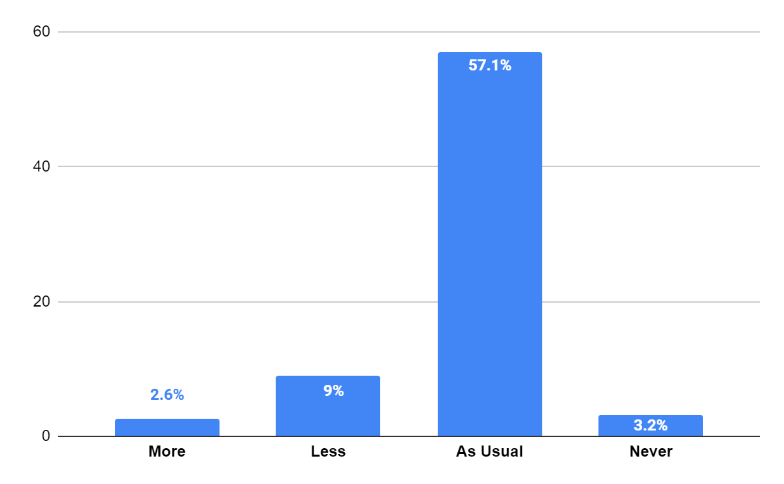
Fig. 4.2: Amount of breast milk provided to the children during

Furthermore, in terms of the amount of breast milk provided to the children when they got diarrhea, about 2.6% of them got more breast milk than the usual amount, where 9% got less, 57.1% continued with the same amount as before, where 3.2% did not get breast milk during diarrhea. The Fig. 4.2 shows the amount of breast milk fed to the children during the diarrheal infection.

Table 3: Status of drinking water and sanitation facilities

WASH Status | Frequency (n) | Percentage (%)
Availability of Toilets
Yes  No | 254  58 | 81.4  18.6
Access of Clean Drinking Water
Yes  No | 309  3 | 99  1
Sources of Drinking Water
Well  Hand Pump  Tap Water  Others | 80  133  75  24 | 25.3  42.6  24  7.7
Treatment of Unsafe Drinking Water
Bleach  Filter  Boil  No Treatment  Not Applicable | 67  3  11  22  209 | 21.5  1  3.5  7.1  67

Regarding availability of Water Availability, Sanitation, and Hygiene (WASH), 81.4% of the houses of the respondents had toilet facilities, where 18.6% of them did not have access. Among all, 99% had access to safe drinking water availability and facilities, where 1% of them did not have access. Around 25.3% of them had wells to get drinking water, 42.6% had access to water for drinking purposes from either public or private hand pumps. 24% of them had tap water which is from drilled boreholes or bore wells, and 7.7% had other sources including water dispensers, and water from dams. In order to treat the unsafe water, 21.5% of the respondents used bleaching to make water drinkable, where 1% has a water filter option, 3.5% simply boiled the water in all seasons, and 7.1% do not do any treatment of the unsafe water. However, 67% of the respondents cannot be considered, since they have access to safe drinking water. The Table 4.1 shows the water availability and sanitation facilities among the respondents above.

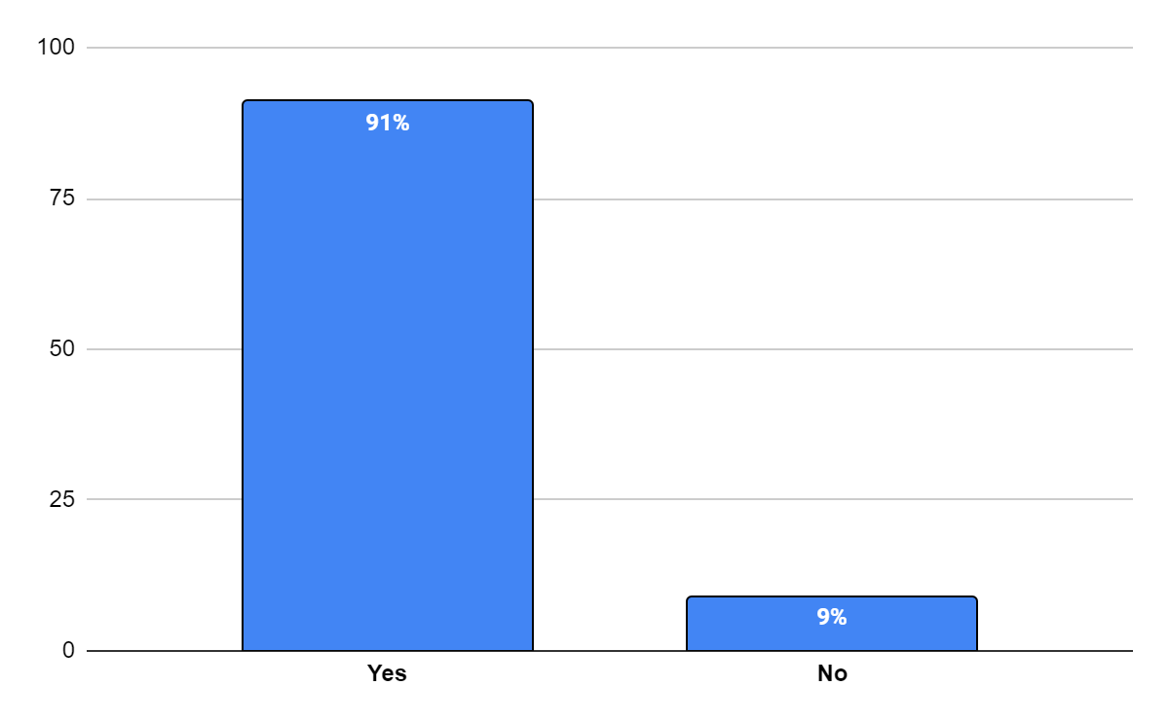
Fig. 5.1 : Mother’s knowledge on Oral Rehydration Saline (ORS)

Among 312 participants. 91% mothers had the knowledge and information about Oral Rehydration Saline (ORS), where 9% had no information about it. The Fig. 5.1 shows the bar graph based on knowledge of the mother on Oral Rehydration Saline (ORS).

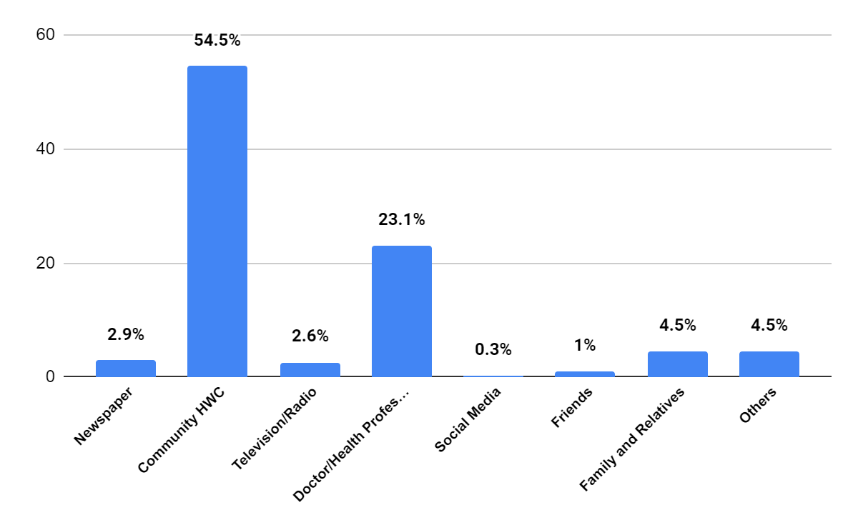
Fig. 5.2 : Sources of Information about ORS

In terms of source of the information on Oral Rehydration Saline (ORS) to the participants, 2.9% of the respondents got it from the newspaper, 54.5% of them were taught in a community health center which is referred to as “Aanganwadi”. 2.6% of them from Television or Radio based on health promotion advertisements, 23.1% received information from doctors or health professionals during their medical visits. 0.3% got from social media including networks including Facebook, youtube, and Whatsapp. 1% of the respondents got information about ORS from their friends, and 4.5% of them from their families and relatives. Around 4.5% of them got the information from their books or health based training during their schooling or college time which was marked as “others”, and it was not applicable for 6.7% of the respondents because they had never heard about ORS before which was mentioned in Fig 5.1. The Fig. 5.2 is used to show the sources of information about Oral Rehydration Saline (ORS) that the respondents have received from.

Table 4: Uses, preparation, accessibility of ORS, and alternatives to treat the children during Diarrhea

Variables | Frequency (n) | Percentage (%)
Used ORS during Diarrhea
Yes  No | 284  28 | 91  9
Given ORS during Diarrhea
Yes  No  Do not know  Not Applicable | 140  68  3  101 | 44.9  21.8  1  32.4
Mothers’ Knowledge on ORS preparation
Yes  No  Not applicable | 214  63  35 | 68.6  20.2  11.2
No. of times ORS was given a day
More than 5 times  Less than 5 times  Do not know  Not applicable | 29  114  7  162 | 9.3  36.5  2.2  51.9
Access of ORS from
Community Health Centre  Govt. Medical Hospital  Pharmacy  Local Shops  Not Applicable | 152  8  99  27  26 | 48.7  2.6  31.7  8.7  8.3
Alternative treatment of Diarrhea except ORS
Yes  No  Do not know  Not Applicable | 176  88  4  44 | 56.4  28.2  1.3  14.1

Out of 312 respondents, 91% of the children were given Oral Rehydration Saline (ORS) during diarrhea, where 9% were not given ORS for the treatment purpose. In terms of giving ORS solution to the diarrheal infected children, 44.9% of the children got ORS solution, where 21.8% did not get it. 1% mothers did not know what they gave to treat or could not recall the treatment they facilitated for the treatment, and it is not applicable for 32.4% of the participants, since their children did not get diarrheal infection. Among all the participants, 68.6% mothers had the knowledge about ORS preparation, where 20.2% were found not informed about how to prepare ORS to treat their children against diarrhea. However, 11.2% were not taken into this, since they did not hear about ORS before. Regarding the number of times infected children were given ORS a day, 9.3% were given more than 5 times, 36.5% got less than 5 times, 2.2% children’s mothers were not sure about it, and 51.9% is not into this consideration, since they did not give ORS to their children during diarrhea. In terms of Accessibility and availability of the Oral Rehydration Saline (ORS) to the families, 48.7% of them had access of free ORS packets from community health centers, 2.6% of the respondents get from Government medical hospital in free of cost, 31.7% buy from pharmacy, and 8.7% get from local shops. However, it is not applicable for 8.3% of the participants because they do not have information about ORS. The mothers use various treatments except ORS are 56.4%, 28.2% do not use any alternative beside ORS, where for 14.1% of the participants, it was not applicable, since their children did not get sick due to diarrheal infection. The alternative medicine and traditional remedies include gripe water, antibiotic, paracetamol solution, sugar, salt and lemon mixture and syrup including O2M, Oflaxacin, Bifilac, iron and multivitamin syrup were given to treat their children. The Table 4 shows the uses of Oral Rehydration Saline (ORS), mothers’ knowledge of ORS preparation, accessibility of it, and alternatives that mothers used to treat their children during diarrhea.

Table 5: Association between exclusive breastfeeding and diarrhea infection among children under two
Exclusive Breastfeeding | OR (95% CI) | p-Value
Yes | Ref.
No | 2.06(1.09-3.89) | <0.005

The odds of having diarrhea are more than two times higher than those who are not practicing exclusive breastfeeding which is shown in Table 5.

Discussion
This study helped to understand the role of exclusive breastfeeding in prevention of diarrheal morbidity under two in Ormanjhi block, of Ranchi, India. The study was done by making four objectives, gathering information, and making the association between them.
In this cross sectional study based on the role of exclusive breastfeeding in diarrheal prevention under five, 74.4% mothers had practiced exclusive breastfeeding. Others who could not were not aware about the role of exclusive breastfeeding, and had difficulties during breastfeeding. This shows the role of community health works including ASHA, ANM and others to monitor and give health education to the mothers from antenatal to post period via face to face training and m-health.
In terms of giving colostrums, the most of the respondents have given colostrums to their children which are 97.1%. About third-fourth of them had knowledge regarding colostrums. The gap between knowledge and practice here shows that mothers were advised right after the childbirth from the health professional to give first breast milk at the earliest.
Regarding the socio-economic background of the respondents, one-third of them are higher secondary school (HSC). More than half of the respondents are unemployed or housewives, where in terms of monthly household income, 84.6% of the participants had less than 10,000 INR. This shows the poverty based on the Below Poverty Line (BPL) services in Indian states.
Based on the knowledge, attitude and practice of the respondents regarding the importance of exclusive breastfeeding, 96.2% of the respondents had the knowledge of exclusive breastfeeding. Furthermore, most of them receive this from community health workers during their antenatal care ANC visits to the localized Aanganwadi. However, the media and family play an important role in this health education and promotion. In addition, more than three-fourth think that exclusive breastfeeding has positive correlation with child growth and development, illness reduction, child immunization, prevention from infectious disease, and prevention from diarrhea based on their observation and knowledge.
Based on Water, Sanitation and Hygiene facilities to the participants of this study were more than three fourth have availability of toilets, and clean drinking water. However, the majority of them get water from communal hand pumps which also show a source of diarrheal infection. Moreover, one-third of the respondents get water for drinking purposes from wells where they put bleach once a year during the rainy season and consume lukewarm water. These practices show that the bleaching once a year and boiling water at low temperature is not sufficient to avoid the microbes from the drinking water.
One of the important components of this study, the prevalence of acute diarrheal infection was found to be 72.1%, where less than one third had persistent diarrhea. This shows the diarrheal infection was spread indirectly through contaminated food, drinking water, and poor hygiene.
In this study about more than three fourth have the availability of access to drinking water and toilets and , where a study based diarrheal prevalence and its correlation with WASH under five in Nigeria shows that 49% of the participants have lack of drinking water and 44.2% of the respondents do not have access to sanitary toilets (He, Z., at al, 2018). Moreover, the participants were not practicing a proper hygienic method to dispose of their children’s waste.

Another study, about 27.4% of the children were breastfed exclusively and this study also shows that 97.1% of the children got colostrums which is high, where there is a breastfeeding gap between girl and boys children (Rohman, H., 2015). This is why childhood diarrhea was found to be one of the frequent diseases across Indonesia. However, comparatively, in this study, 74.4% of the children got exclusive breastfeeding regardless of any gender disparity in weaning practice.
About 27.9% of the children never had any type of diarrhea from 6 months to 24 months of their lives in this study. However, this finding is different in a study based in Indonesia 90.1% of children did not show diarrheal incidence (Rusyda, F., et al, 2017). This was primarily due to the practice of exclusive breastfeeding and sociodemographic status including educational level, employment status, and residence area.
Strength and Limitations
The questionnaire includes socio-demographic information, water, sanitation, and hygiene (WASH), early initiation of breastfeeding and exclusive breastfeeding make the study valid and can be generalized within the state. However, the study is based on cluster or area sampling, therefore the findings cannot be generalized in all regions of the country.
Recommendations
With the results consolidated from the research objectives and combining with the aim of the study in Ormanjhi block of India, the holistic approach from state, block and community based services are completely appreciable.
As it is found that there is a high prevalence of acute watery diarrhea in the study area, there is a need for effective implementation and on-going evaluation on Clean India Mission which aims to provide safe sanitation facilities, and Har Ghar Jal under Jal Jeevan Mission to supply the drinking water to each household in rural India. This will not only improve the WASH status but also be an effective barrier for oral fecal transmission.
There is more to focus on to achieve better health and well-being of the children. The pregnant women and reproductive aged women should get a thorough health education on the importance of exclusive breastfeeding, colostrums without introducing any liquid food before six months of the child after birth. Moreover, there should be monitoring evaluation on weaning practices of the mothers by the family members. Furthermore, there must be regulation on the providers who sell traditional oral medicine to feed newborn babies just after the childbirth without any consultation from a health professional. Another recommendation is to provide workshops based on diarrheal prevention and management and its transmission directly and indirectly by giving a global scenario of diarrheal and child mortality. Last recommendation would be for the Auxiliary Nurse and Midwife (ANM) to give details of vaccines during Antenatal Care (ANC) and Postnatal Care (PNC) to make the mothers aware of what vaccines are given to their children.
Conclusion
In conclusion, it is found that there is a significant association between exclusive breastfeeding and prevention of children under two against diarrhea. The children who are not exclusively breastfed are 2 times higher in risk of diarrheal infection. However, it is also found that there is a high prevalence of diarrhea under two, and the gap between knowledge of having exclusive breastfeeding and practice.
Therefore, since public health is a state subject, the state government of Jharkhand should focus more on effective health intervention including promotion of exclusive breastfeeding, rotavac vaccine coverage, health education and provision of safe WASH facilities to improve exclusive breastfeeding practice for reducing child morbidity due to diarrheal infection.

References

- Biswas, A, Mandal K. A. (2016), A study on association between breastfeeding and its protective role against diarrhoea in under five children in a rural block of West Bengal, India. International Journal of Community Medicine and Public Health. 3(9). 1-5.
https://dx.doi.org/10.18203/2394-6040.ijcmph20160001
- Cai, X., Wardlaw, T., & Brown, D. W. (2012). Global trends in exclusive breastfeeding. International breastfeeding journal, 7(1), 1-5.
https://doi.org/10.1186/1746-4358-7-12

- Centre of Disease Control and Prevention, 2021
https://www.cdc.gov/vaccines/parents/diseases/rotavirus.html
- Census of India, 2011. Literacy rate in rural and urban Jharkhand in 2011, by gender
https://www.statista.com/statistics/613870/literacy-rate-rural-and-urban-jharkhand-india/
- Chen, M. Y., Kirkwood, C. D., Bines, J., Cowley, D., Pavlic, D., Lee, K. J., ... & Danchin, M. (2017). Rotavirus specific maternal antibodies and immune response to RV3-BB neonatal rotavirus vaccine in New Zealand. Human Vaccines & Immunotherapeutics, 13(5), 1126-1135.
https://doi.org/10.1080/21645515.2016.1274474
- Dòrea, J. G. (2009). Breastfeeding is an essential complement to vaccination. Acta Paediatrica, 98(8), 1244-1250.
https://doi.org/10.1111/j.1651-2227.2009.01345.x
- Ferdous, F., Das, S. K., Ahmed, S., Farzana, F. D., Latham, J. R., Chisti, M. J., ... & Faruque, A. S. (2013). Severity of diarrhea and malnutrition among under five-year-old children in rural Bangladesh. The American journal of tropical medicine and hygiene, 89(2), 223.
https://doi.org/10.4269%2Fajtmh.12-0743
- Food Security Atlas of Rural Jharkhand, 2022. Institute for Human Development
https://www.ihdindia.org/pdf/FSA_JHARKHAND_2022.pdf
- Gedefaw, M., & Berhe, R. (2015). Determinants of childhood pneumonia and diarrhea with special emphasis to exclusive breastfeeding in north Achefer district, northwest Ethiopia: a case control study. Open Journal of Epidemiology, 5(02), 107.
https://publichealthreviews.biomedcentral.com/articles/10.1186/s40985-018-0107-6

- Ghosh, K., Chakraborty, A. S., & Mog, M. (2021). Prevalence of diarrhoea among under five children in India and its contextual determinants: A geo-spatial analysis. Clinical Epidemiology and Global Health, 12, 100813. https://doi.org/10.1016/j.cegh.2021.100813

- He, Z., Bishwajit, G., Zou, D., Yaya, S., Cheng, Z., & Zhou, Y. (2018). Burden of common childhood diseases in relation to improved water, sanitation, and hygiene (WASH) among Nigerian children. International journal of environmental research and public health, 15(6), 1241.https://doi.org/10.3390/ijerph15061241
- Kumar, A., & Singh, V. K. (2015). A Study of Exclusive Breastfeeding and its impact on Nutritional Status of Child in EAG States. Journal of Statistics Applications & Probability, 4(3), 435.
http://dx.doi.org/10.12785/jsap/040311
- Krishnendu M, Devaki G. Knowledge, Attitude and Practice Towards Breastfeeding Among Lactating Mothers in Rural Areas of Thrissur District of Kerala, India: A Cross-Sectional Study. Biomed Pharmacol J 2017;10(2).
https://dx.doi.org/10.13005/bpj/1156
- Koustav Ghosh, Atreyee Sinha Chakraborty, Mithun Mog (2021), Prevalence of diarrhea among under five children in India and its contextual determinants: A geo-spatial analysis, Clinical Epidemiology and Global Health, 12.
https://doi.org/10.1016/j.cegh.2021.100813
- Lakshminarayanan S, Jayalakshmy R. Diarrheal diseases among children in India: Current scenario and future perspectives. J Nat Sci Biol Med. 2015 Jan-Jun;6(1):24-8.
https://doi.org/10.4103%2F0976-9668.149073
- Mulatu, T., Yimer, N.B., Alemnew, B. et al. Exclusive breastfeeding lowers the odds of childhood diarrhea and other medical conditions: evidence from the 2016 Ethiopian demographic and health survey. Ital J Pediatr 47, 166 (2021).
https://doi.org/10.1186/s13052-021-01115-3
- National Family Health Survey (NFHS), 2021
https://main.mohfw.gov.in/sites/default/files/NFHS-5_Phase-II_0.pdf
- Poshan, 2022. District Nutritional Profile, Ranchi, Jharkhand.

https://www.niti.gov.in/sites/default/files/2022-07/Ranchi-Jharkhand.pdf

- POSHAN, 2015. Supporting Optimal Breastfeeding in India: What Will it Take?
https://poshan.ifpri.info/2015/08/06/supporting-optimal-breastfeeding-in-india-what-will-it-take/
- Roy, S. M. (2023). Development and Identity Crises: Exploring the role of Aanganwadi Centres (AWCs) in tribal areas.
https://doi.org/10.21203/rs.3.rs-2571537/v1
- The LANCET, 2013. Maternal and Child Nutrition
https://www.thelancet.com/series/maternal-and-child-nutrition
- Mulatu, T., Yimer, N. B., Alemnew, B., Linger, M., & Liben, M. L. (2021). Exclusive breastfeeding lowers the odds of childhood diarrhea and other medical conditions: evidence from the 2016 Ethiopian demographic and health survey. Italian Journal of Pediatrics, 47(1), 1-6.
https://doi.org/10.1186/s13052-021-01115-3
- National health mission, 2023. Child Health.
https://nhm.gov.in/index1.php?lang=1&level=2&sublinkid=819&lid=219
- Rohmah, H., Hafsah, T., & Rakhmilla, L. E. (2015). Role of exclusive breastfeeding in preventing diarrhea. Althea Medical Journal, 2(1), 78-81.
https://journal.fk.unpad.ac.id/index.php/amj/article/view/436
- Rusyda, F., & Ronoatmodjo, S. (2021). The Relationship between Exclusive Breastfeeding and Diarrhea in Under Six Months Infants in 2017 (Analysis of Indonesian Health Demography Data Survey 2017). Jurnal Epidemiologi Kesehatan Komunitas, 6(2), 333-340. https://doi.org/10.14710/jekk.v6i2.11815

- Turin, C. G., & Ochoa, T. J. (2014). The role of maternal breast milk in preventing infantile diarrhea in the developing world. Current tropical medicine reports, 1, 97-105.
https://doi.org/10.1007/s40475-014-0015-x
- World Health Organization. (2012). Diarrhoea. World Health Organization.
https://www.who.int/health-topics/diarrhoea#tab=tab_1

