Senior Thesis for credit requirement for Bachelor of Science in Environmental Sciences at Asian University for Women, Chittagong, Bangladesh



The Impacts of One Denim Jeans Pant on the Environment Through the Life Cycle Assessment (LCA) Approach: A Case Study

Submitted by: Aarati Shrestha (190064)

Supervisor: Dr. Mukesh Gupta
Co-supervisor: Dr. Sayed Mohammad Nazim Uddin
External supervisor: Miss Ann Marie Bingo

Submission Date: May 8th, 2023

Declaration

I hereby declare that the thesis titled, “The Impacts of One Denim Jeans Pant on the Environment Through the Life Cycle Assessment (LCA) Approach: A Case Study” is based on my own research. I have not committed to any form of plagiarism or academic dishonesty. All the resources used in this writing have been cited and acknowledged.

Date: 8th May, 2023
Signature: Aarati Shrestha

Acknowledgement

First and foremost, I would like to thank my supervisor Dr. Mukesh Gupta, Associate Professor of Environmental Science, for all his help, support, motivation, criticism, suggestions, and encouragement from the very beginning to the end of my entire research. Without his dedicated involvement and assistance in every step of my research, this paper would have not been accomplished. I would also like to thank my co-supervisor Dr. Sayed Mohammad Nazim Uddin, Head of Science and Math, and Miss Ann Marie Bingo, my mentor for their constant guidance, feedback, and encouragement throughout the research.

This research also owes deepest gratitude to Asian University for Women, for approving my thesis proposal and granting me funds to conduct and complete the research. I would also like to express my heartfelt gratitude towards Universal Jeans Limited for permitting me to research over there and providing me with all the necessary data and information.

I would also like to thank Mr. Sujarwo Suryaputra for helping me to work with GaBi Software. I would like to express my sincere gratitude to my research assistant, Sadikshya Khadka for assisting me to interview and collect data for my research.

Last but not least, I would like to thank my family, friends, roommates, and batch mates for their valuable suggestions, feedback, comments, and moral support.

Table of Contents Page Number
Declaration……………………………………………………………………….. 2
Acknowledgement……………………………………………………………….. 3
List of Tables…………………………………………………………………….. 6
List of Figures……………………………………………………………………. 6
Abstract………………………………………………………………………….. 7
CHAPTER 1
1.1 Introduction………………………………………………………….. 8
1.2 Background
1.2.1 Denim Jeans Pant…………………………………………. 9
1.2.2 Life Cycle Assessment (LCA).............................................. 10
1.2.3 Universal Jeans Limited…………………………………… 10
1.2.4 Justification………………………………………………… 11
CHAPTER 2
2. Literature Review……………………………………………………… 12
2.1 Cotton Production……………………………………………………. 12, 13
2.2 Manufacturing Process……………………………………………….. 13-15
2.3 Consumer Handle and Disposal……………………………………… 15, 16
2.4 Life Cycle Assessment (LCA).............................................................. 16, 17
2.4.1 Goal and Scope…………………………………………….. 17
2.4.2 Inventory Analysis…………………………………………. 18
2.4.3 Impact Assessment…………………………………………. 18
2.4.4 Interpretation……………………………………………….. 18
CHAPTER 3
3. 1 Aim, Goal, Objectives, and Research Questions
3.1.1 Aim………………………………………………………… 19
3.1.2 Goal………………………………………………………… 19
3.1.3 Objectives…………………………………………………. 19
3.1.4 Research Questions………………………………………... 19
3.2 Research Methodology
3.2.1 Study Design………………………………………………. 20
3.2.2 Study Site……………………………………………………… 20
3.2.3 Study Population……………………………………………… 20, 21
3.2.4 Study Methods……………………………………………….. 21
3.2.5 Data Collection Instruments………………………………….. 21
3.2.6 Data Management and Data Analysis………………………… 21-23
3.2.7 Ethical Consideration………………………………………… 23
3.2.8 Functional Unit………………………………………………. 23
3.2.9 System Boundaries…………………………………………… 23
3. 3 Impact Categories and Description……………………………………. 24
CHAPTER 4
4. Results and Discussions
4.1 Denim Jeans Pants Production…………………………………………. 25, 26
4.2 Water Consumption……………………………………………………. 26-29
4.3 Energy Consumption………………………………………………….. 29-31
4.4 Climate Change……………………………………………………….. 31, 32
CHAPTER 5
5.1 Conclusion……………………………………………………………. 33
5.2 Policy Recommendations…………………………………………….. 34
5.3 Limitation…………………………………………………………….. 34, 35
References………………………………………………………………………… 36-39

List of Tables
Table 1: Environmental impact categories and descriptions……………………………… 24
Table 2: Denim jeans pants production per year…………………………………………… 25
List of Figures
Figure 1: Universal Jeans Limited………………………………………………………… 11
Figure 2: Manufacturing Process of Denim Jeans Pants…………………………………. 14
Figure 3: Life Cycle of Denim Jeans Pants (Periyasamy et al., 2017)................................ 15
Figure 4: Phases of Life Cycle Assessment (Periyasamy et al., 2017)............................... 17
Figure 5: Location of Universal Jeans Ltd………………………………………………. 20
Figure 6: Universal Jeans Ltd…………………………………………………………….. 20
Figure 7: Respondents……………………………………………………………………. 21
Figure 8.1: Data analysis by using Gabi Software……………………………………….. 22
Figure 8.2: Gabi Software………………………………………………………………… 23
Figure 9: Excel…………………………………………………………………………… 23
Figure 10: The number of Denim Jeans Pants manufactured in Universal Jeans Ltd…… 26
Figure 11: The amount of water required to manufacture Denim Jeans Pants………….. 26
Figure 12: The percentage of water treated for further usage and disposal…………….. 28
Figure 13: Wastewater Recycling Plant…………………………………………………. 29
Figure 14: The energy consumption while manufacturing one denim jeans pants……… 30
Figure 15: Carbon dioxide emission in various production phases and climate change…. 32

Abstract

Denim jeans pants have become one of the most in-demand and common wears among people of all age groups, social strata, gender, and geographical region. The increasing demand for denim jeans pants has made it hard to find a wardrobe that does not consist of denim jeans pants. For the production of denim jeans pants, it has to go through different phases i.e. cotton cultivation, denim and garment manufacturing process, consumer use, and disposal. In each of these stages, it consumes extreme amounts of water, energy, chemicals, manpower, and emits harmful gasses which are degrading the environment. Thus, this paper studied the impact caused by one denim jeans pants during the gate-to-gate phase (garment manufacturing process) by focusing on water, energy, and climate change due to the release of carbon dioxide gasses into the environment. The GaBi software was used to analyze the impact caused by denim jeans pants during gate to gate phase. Moreover, Microsoft Excel was also used to study the environmental degradation caused by denim jeans pants.
This study found that for the garment manufacturing of one denim jeans pants, Universal Jeans Ltd uses 19 gallons of water. Mainly, groundwater is used in the manufacturing process of denim jeans pants which is leading to a decline in groundwater and destroying the water table. Moreover, 193 MJ of energy is consumed to manufacture one pair of denim jeans pants. Further, in a day, 9,650,000 MJ of energy is consumed by the garment factory which is equivalent to the energy that can be used to power an average house for 34 months in Bangladesh. In addition to this, 29 kg of carbon dioxide is released into the atmosphere during the garment production of one denim jeans pants which is equivalent to the carbon dioxide release by burying 8.1 kg of coal.
The findings from this study highlight the need to shift towards alternative methods to decrease water consumption, energy use, and carbon dioxide emission during garment production of denim jeans pants.

Keywords: denim jeans pants, water consumption, energy consumption, carbon dioxide, climate change, environmental degradation

Chapter 1

1.1 Introduction
Have we ever thought, how much denim jeans pants in our wardrobe cost to the environment? Denim is a woven fabric with 100% cotton yarn that is sewn into a pair of trousers and named jeans (Textile Today: Bangladesh an innovation, 2014). Denim jeans pants are in high demand in all countries, geographical regions, social strata, and all age groups. For the production of one pair of jeans pants, it has to go through different stages such as cotton cultivation, fabric formation, spinning, dyeing, weaving, stitching, and quality check. Furthermore, a large amount of energy, resources, chemicals, and manpower is required to manufacture one pair of jeans pants. Despite the changing fashion trend, the demand for jeans and pants is constantly increasing. In a study, it has been found that on average a man owns 6 pairs of jeans and a female owns 7 pairs of jeans (Fashion United, 2016). It is hard to find a wardrobe that does not have denim jean pants. Moreover, the sales of jean pants are expected to exhibit a growth rate of around 4.2% annually (Market Research Report, 2021). It states that demand for jeans pants is continuously growing as well as it is also contributing to the growth of the economy of the country. However, for the production of denim jean pants, large quantities of cotton, water, energy, and chemicals are required, which is leading towards various environmental issues. As it emits harmful gasses such as carbon dioxide, methane, and other greenhouse gasses along with fabric, chemical, and wastewater that pollutes the environment.
In each and every step of production of denim jeans pants a huge amount of water, chemicals, energy, technology, and manpower are used which are harmful for the environment (Periyasamy and Duraisamy, 2018). The extreme amount of water used for the garment manufacturing of denim jeans pants is leading to the water scarcity as well as the disposal of waste water in sea from garment factories are polluting the water bodies. Likewise, the increase in use of energy for the production of the garment product in factories is consuming the most of the energy that is leading to power cuts in other parts of the country. On the same hand, it also increases the carbon dioxide gas emission into the atmosphere due to the use of heavy machines, hard coal electricity, petroleum products, and liquified petroleum gas that pollutes the air. Basically, the environment is degrading due to the extreme resources usages and emission during the garment manufacturing process of denim jeans pants. Thus, the impact caused during the garment production of one denim jeans pants can be studied by using the Life Cycle Assessment (LCA) method. LCA is a useful method to evaluate the environmental impact and resource utilization of a product, from the very first collection of raw materials used in production to disposal of the product after use (Golsteijn, 2020). Basically, it states that LCA is an appropriate method to analyze the impact of the product towards the environment. Hence, this paper will analyze the impacts of one denim jeans pants during gate to gate phase (garment manufacturing process) in terms of water consumption, energy consumption, and carbon dioxide gas emission in the environment by using the LCA approach.

1.2 Background
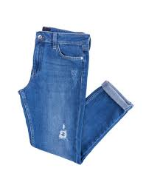
1.2.1 Denim Jeans pant

Jeans pants have entered the market from 1873 when Strauss partnered with a tailor who was named Jacob Davis had the idea of reinforcing pants with copper rivets in delicate areas where they used to break (Unzipped Staff Levi Strauss & C, 2019). In a nutshell, since the 18th century, jean pants have been ruling over the fashion industry. It is popular for its durability and easy maintenance. Furthermore, almost two billion pairs of jeans pants are sold per year in a global context which results in a global retail market of forty-two billion dollars (Impact Institute, 2019). It states that jean pants have become one of the most demanded products around the world. It is manufactured almost all over the world (Regan, 2015). Bangladesh ranks second largest denim garments exporter after China, as it is the most significant center for denim apparel production around the globe (Fashion Press 24, 2018). The demand for denim jean pants is throughout the world. Although fashion trends keep on changing, denim jeans pants are always in high demand. However, the raw materials, production and garment manufacturing process, along with the waste materials extracted during processing, packaging, transportation, and after use is impacting the environment by releasing waste products and harmful chemicals and gasses into the surrounding.

1.2.2 Life Cycle Assessment (LCA)
LCA is an analytical tool for the systematic and quantitative evaluation of a product that describes the entire lifespan of a product, from fibers to the disposal of the product (Sandin et al., 2019). It analyzes the environmental impacts of a product or service system throughout all stages of its life. The data or outcomes generated by using the LCA approach of a product's impact on the environment can provide valuable data for decision-makers that support sustainability. Moreover, LCA results can be used for improving product development, marketing, and strategic planning. Besides this, it also helps to identify which section/process is polluting the environment and what strategies will help to reduce the effect to achieve carbon footprint goals. Furthermore, life cycle studies can be performed for various scopes not only from cradle to grave (from raw materials to disposal) but also from cradle to gate (from raw materials until factory gate), and gate to gate (focusing only on manufacturing processes) (Golsteijn, 2020). Thus, LCA is a useful tool to evaluate the impact of a product in different phases and make effective plans and policies to reduce the impacts by using the result.
1.2.3 Universal Jeans Ltd
Pacific Jeans was founded in 1984 by Nasir Uddin (Pacific Jeans, n.d). It is one of the premium readymade garment manufacturing companies which has 35000 employees and exports denim jeans to over 50 countries in the world (Pacific Jeans, n.d). It consists of 12 production units, among which Universal Jeans ltd is one. Universal Jeans ltd is situated in CPEZ, Chittagong, Bangladesh. It manufactures denim jeans for both men and women. UNIQLO, ZARA, and AMERICAN EAGLE are some of the major brands of Universal Jeans. On an average it manufactures 50,000 denim jeans per day. Universal Jeans is popular for its quality production and management. It was also awarded with the best tax payer. Universal Jeans ltd is using the latest technologies to manufacture the denim jeans, in order to reduce its footprint in the environment. It also consists of a wastewater treatment plant to recycle and reuse the water for the garment washing process.

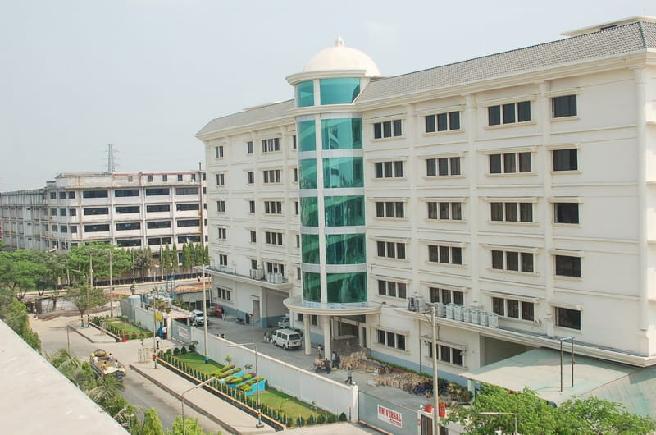
Figure 1: Universal Jeans Limited
1.2.4 Justification
Garment factories are one of the prominent polluters in the environment as it consumes extreme amounts of water, energy and releases harmful gasses and waste water. Among them, denim jeans pants garment manufacturing factories rank even higher as the increasing demand of denim jeans pants has led to environmental degradation. Thus, it has become important to carry out the research to analyze the impact of denim jeans pants during the garment manufacturing process.
There has been very limited research conducted in Bangladesh to understand the environmental impact of garment manufacturing of denim jeans pants. Being one of the prominent countries to manufacture denim jeans pants, there is not sufficient research to reduce its impact on the environment. Moreover, there has been no research conducted focusing only on the garment production process of denim jeans pants. Hence, this research not only serves as a base for future studies but also might work as helpful study in making effective policies regarding the garment manufacture of denim jeans pants.

Chapter 2

2. Literature Review
The fashion industry is the fourth most polluting industry in the world. Among them, denim jeans come in top rank as they are in high demand due to their durability and evergreen fashion trend (Demir, 2021). The increment in the production of denim jeans pants is gradually leading to the degradation of the environment from the excessive consumption of water, energy, waste excretion, and the emission of greenhouse gasses that includes carbon dioxide, methane, from the raw material extraction phase to the disposal of the product. So, it has become important to study the impacts of jeans pants on the environment to reduce the negative impacts and protect the environment. Although this paper will only help to analyze the impact of denim jeans during the garment manufacturing process, the literature review will help to give a brief idea of the impacts of denim jeans pants during cotton production, customer handling, and disposal phase in the environment.

2.1 Cotton Cultivation
The cotton production phase is the primary phase of denim jeans production. Cotton is an environmentally friendly natural fiber, however synthetic fibers are not environmentally friendly and can result in various environmental issues. Cotton is cultivated on 2.5% of the world's agricultural land by using 16% of insecticides, 7% of herbicides, and globally almost 1 kg of hazardous pesticides is used for every one-hectare cropland to produce cotton (The World Counts, 2023). The amount of insecticides, herbicides, and pesticides used for cotton cultivation is more than any other crops grown in the world. The excess amount of pesticides used for cotton production is degrading the fertility of the land which will result in unproductive land in the future (Barnes et al., 2012). In essence, the excessive use of chemicals, fertilizers, and pesticides is turning fertile soil into infertile soil. On the same hand, cotton that is used for producing denim jeans is cultivated by using excessive amounts of water (Hedmadn, 2018). It is reported that for denim jeans cotton production 10,000-20,000 liters of water are used (Demir, 2021). It demonstrates the huge amount of water being used for the cultivation of denim jeans cotton cultivation. It is affecting other sectors such as animal husbandry, crops cultivation, vegetables cultivation, and other essential goods production. In contrast, synthetic fibers require less land and water to manufacture. They are obtained from non-renewable resources such as fossil fuels. However, synthetic fiber consumes an enormous amount of energy which results in emission of greenhouse gasses that poses various toxicological threats in the environment and human health. Furthermore, transportation used while transporting raw materials (cotton) to textile and garment factories consumes a large amount of energy (fuel) and emits harmful gasses (Santero and Hendry, 2015). It demonstrates the transportation used while cultivating cotton to transport cotton for the manufacturing process has a contribution to air pollution. Thus, denim jeans cotton cultivation requires huge land, fertilizers, pesticides, water, and energy that is contributing towards degrading the environment.

2.2 Manufacturing Process
Once cotton for denim jeans is harvested, fibers are converted into yarn, then fabric, and finally are converted into garments (jeans pants). The manufacturing process of denim jeans pants can be categorized into two parts i.e: denim production and garment production as shown in figure 2. In denim production, fibers are converted into yarn, processed through coloration and then fabric is formed. Open-end spinning method is used for making the yarns for denim fabrics. Initially, cotton fibers are opened and blended. There are also several other processes to form yarn, which are carding, combing, drawing, roving, spinning, and winding. The diameter of yarn, hairiness, linear density, permeability, and strength properties depend on the end-use requirement of fabric that is to be produced for woven, sewing thread, or cordage (Uddib, 2019). The lubricants, chemicals, water, and other disposables are also used during this process. Moreover, a huge amount of energy is required to convert the cotton fibers into yarn as there are several processes involved. As a result, harmful greenhouse gasses along with dust and yarn waste are produced. Additionally, chemicals are used to dye warp yarns in a form of a sheet or rope, which are used for further weaving. The weft yarns are left undyed and are inserted during weaving. Indigo dye is the most commonly used dye for denim jeans (Sarkar, 2017). Stearic mechanism is used to color the fiber of denim jeans pants (Sarkar, 2017). Thus, after dying the fabric is brought for sewing and then jeans pants are formed. However, there is a health risk during this process due to inhalation of the dust particles that is released during the production process of cotton fiber to fabric.
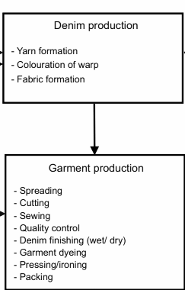
Figure 2: Manufacturing Process of Denim Jeans Pants

When the fabric is completed, it is sent to the factories for the manufacturing process of the jeans pants. This manufacturing process is also known as the Cut-Make-Trim stage, as in this stage denim fabric is brought, cut, and sewed. The finished fabric is used for cutting, sewing, washing, and finishing products with the use of more chemicals to get the desired look and quality of the denim jeans pants (Paul, 2015). In every step of manufacturing denim jeans pants water, energy, chemicals, and manpower are required which leaves a negative impact on the environment (Uddin, 2019). The automatic and manual machines are used to spread, check shrinkage, and cut the fabrics. Similarly, after cutting fabric into jeans pieces, it is sewed with the help of automatic machines and manual machines. Different parts of the jeans pants are brought together and sewed along with the tag of different brands at this stage. After this stage, jeans pants go through a dry/wet process, where huge amounts of chemicals and water are used to rinse the jeans. There is also a quality control center that examines the quality of the denim jeans, before packing the product and sending them to stores, to be sold to wholesalers, retailers, and other distributors. In a study, it was found that 8% of carbon dioxide emission takes place during the transportation of denim jeans to different distributors (Periyasamy and Duraiasmy, 2017). The leftover and damaged products are either recycled or disposed of as shown in figure 2. The plastics and papers used for packing the products contribute to water, air, and land pollution. Basically, denim fabric and the entire jeans production process is a part of a long and complex production chain with the starting of cultivation of cotton to ending with a problematic waste management system (Figure 3).
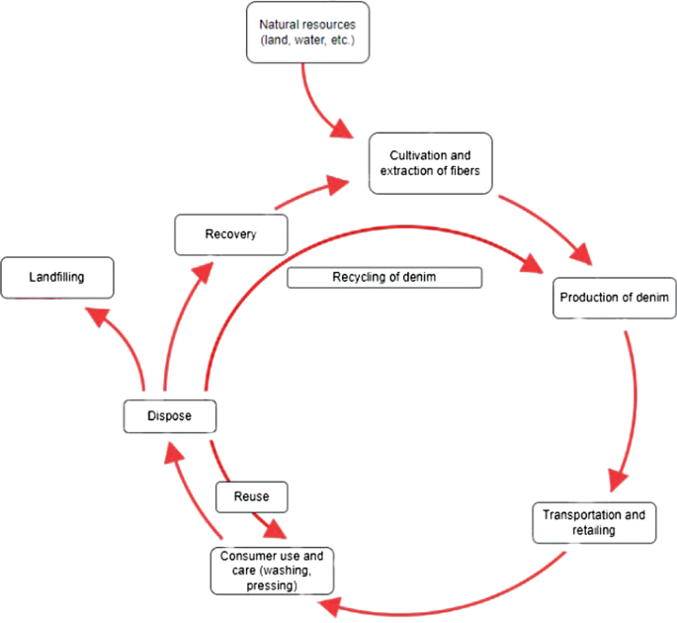
Figure 3: Life Cycle of Denim Jeans Pants (Periyasamy et al., 2017)

2.3 Customer Handle and Disposal
Among the different phases of denim jeans, it was reported that the customer handle phase has a greater impact on global warming. In a study, it was found that 37% of carbon dioxide and other greenhouse gasses are emitted during consumer phases in the denim jeans pant life cycle (Periyasamy et al., 2017). Denim jeans pants are washed, ironed, and reused using chemicals and energy during the customer phase. The detergents and chemicals used in washing denim jeans have negative effects on the environment. Moreover, the wastes and leftovers during the manufacturing process and excretion after the production, during packaging, transportation, and disposal remains in the environment for a long period of time which degrades the quality of the environment (Hackett, 2015). It states that waste excreted during the production of denim jeans pants results in pollution of water, land and air that welcomes the depletion of the environment. Furthermore, denim jeans pants can be used for 2-3 years and it takes 10-12 months to fully biodegrade (Mariano, 2021). However, most people prefer to wear one pair of denim jeans pants for a year and then dispose of them. Those jeans which cannot be recycled are sent to landfills which take a longer period of time to decompose. It has been reported that every year 2.8 billion pounds of clothing ends up in landfills (RadhaKrishna, 2017), where 5% of landfills are occupied by denim jeans pants (Aki et al., 2020). Basically, it states that denim jeans pants are contributing to polluting the environment. Every year the increment in the demand for denim jeans also invites the increment of denim waste and disposal of denim jeans pants in the landfill.

2.4 Life Cycle Assessment (LCA)
Life Cycle Assessment (LCA) accounts for all the environmentally related materials, chemicals, technology, and energy from cradle to grave of a product. It predicts the environmental impacts in terms of climate change, eutrophication, acidification, toxicity, water depletion, and land degradation. Consequently, LCA provides an overview of the effects of the product during its lifetime that is useful in the decision-making process to minimize the waste excretion and negative impacts of the product on the environment (Sandin et al., 2019). Basically, with the help of LCA, the impacts of the production of one pair of denim jeans pants on the environment can be predicted and necessary steps can be taken to protect the environment. Moreover, it is a useful technique to evaluate the negative impact of the production of denim jeans pants in each step from cultivating cotton to disposal of pants after use (Aki et al., 2020). It demonstrates LCA is a helpful approach in making environmentally friendly decisions by analyzing the impacts of a product in the surrounding area. In addition, this approach has helped to attract the attention of consumers and producers to change their behavior in the mode of transportation, packaging, storing, and laundering to proper disposal after use (Ross et al., 2019). However, LCA does not include the social or economic impacts of sustainability. It only helps in analyzing the impacts of a product on the environment and minimizing the negative sides of the product. Thus, LCA is a useful application for predicting and minimizing the negative impacts of denim jeans plants from their cradle to end of life.
There are four phases of LCA for evaluating the product i.e. Goal and Scope, Inventory Analysis, Impact Assessment, Interpretation as shown in figure 4.

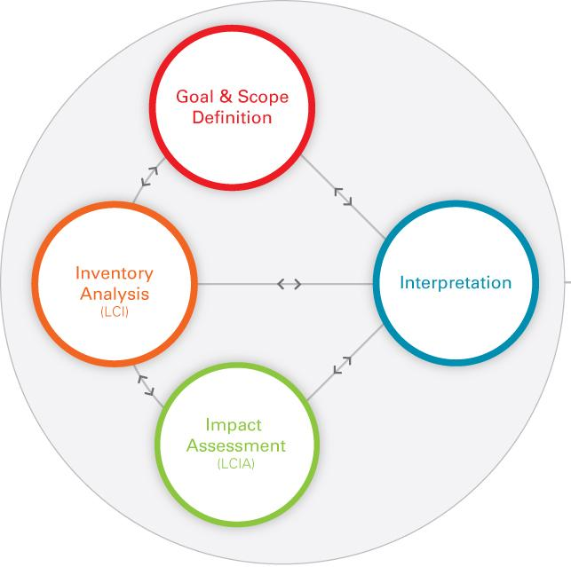
Figure 4: Phases of Life Cycle Assessment (Periyasamy et al., 2017)

2.4.1 Goal and Scope
The goal and scope phase describes the aim or reason for carrying out the study and also intended audience of the research (Golsteijn, 2020). It gives a precise definition of the product on which we are working, the product’s life cycle, a description of the system boundaries, and the limits of analysis (Rochester Institute of Technology, 2020). This helps to set an outline of a study, for a product from where it begins and where it ends.

2.4.2 Inventory Analysis
The inventory Analysis phase involves all the environmental input and output which are related to the product. It also includes the data collection and calculation process for the quantification and modification to study the input and output of the product (Golsteijn, 2020). In this phase, data are validated and are used to process by putting it into a relationship with a functional unit.

2.4.3 Impact Assessment
In the impact assessment phase, initial emissions are classified into impact categories (for instance, global warming, ozone depletion, acidification, depletion of resources, and pollution) (Periyasamy et al., 2017). Then it is characterized by common units for comparison and to make it meaningful to understand the damage to the environment and human health due to the product.

2.4.4 Interpretation
In the interpretation phase, it is tested whether the data and the process can be used or not for supporting the study and to draw a conclusion. Mainly, the purpose of this phase is to identify the priorities in light of an LCA’s initial goal (Rochester Institute of Technology, 2020). Moreover, it helps decision makers to draw conclusions and recommendations from the inventory analysis and the impact assessment (Periyasamy et al., 2017). Thus, with the help of different phases of LCA, it helps to analyze the product benefits and adverse effects on the environment.

Chapter 3

3.1 Aim, Goal, Objectives, and Research Questions

3.1.1 Aim
The aim of this research is to encourage producers and consumers of denim jeans pants to move towards sustainability throughout the raw material extraction phase to dispose of the product.

3.1.2 Goal:
This research goal is to analyze the impact of denim jeans pants on the environment and also to demonstrate the high consumption of water, energy, and emissions of carbon dioxide during the garment manufacturing process.

3.1.3 Objectives:
- To study the impact of one denim jeans on the environment during garment manufacturing process
- To analyze the impact on the environment with the high consumption of water and energy during garment manufacturing process of one denim jeans pants
- To demonstrate the greenhouse gas emission, climate change, and deterioration of aquatic life due to various gas emissions and waste excretion during the manufacturing process.

3.1.4 Research Question:
- What is the impact of one denim jeans pants in terms of water consumption, energy consumption, and climate change due to emission of carbon dioxide gaseous during the garment manufacturing process (gate to gate) on the environment?

3.2 Research Methodology:
3.2.1 Study Design
The study design was exploratory research as there has been less research conducted using the LCA approach in the garment manufacturing process. Moreover, there has been no research conducted in Chittagong, Bangladesh regarding the impacts of denim jeans pants in the environment.

3.2.2 Study Site
Chittagong is the second largest city in Bangladesh with 168.1 km² area (Ashraf et al., 2013). This research was conducted in Universal Jeans Limited of Chittagong, Bangladesh. Universal Jeans Limited is the sister group of Pacific Jeans.

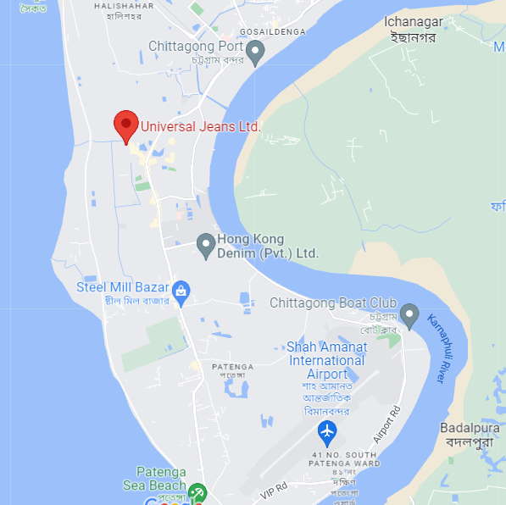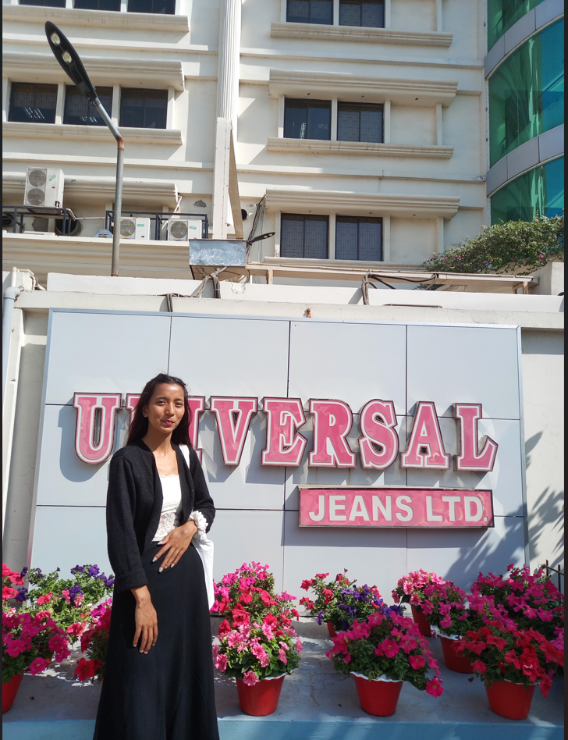
Figure 5 : Location of Universal Jeans Ltd. Figure 6: Universal Jeans Ltd.

3.2.3 Study Population
The data and information was collected from the Corporate Officers, Head of Departments, Managers, Engineers, and officers of Universal Jeans Limited.
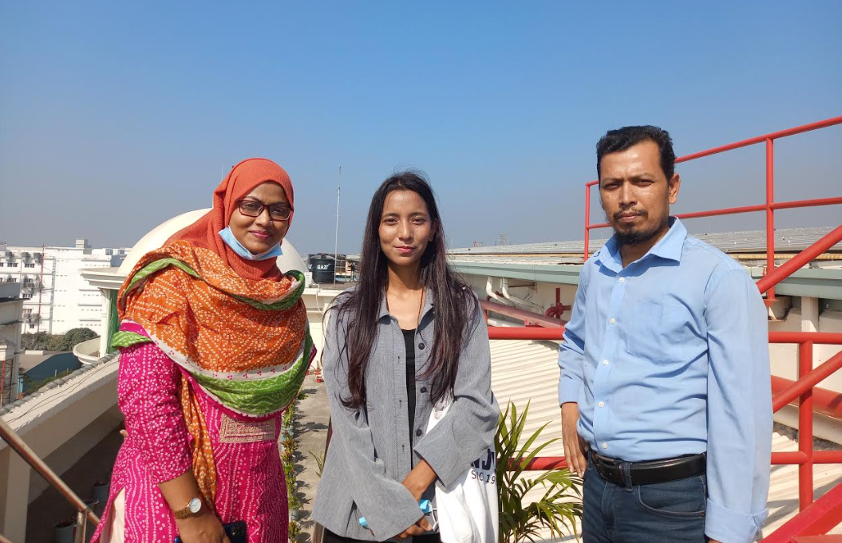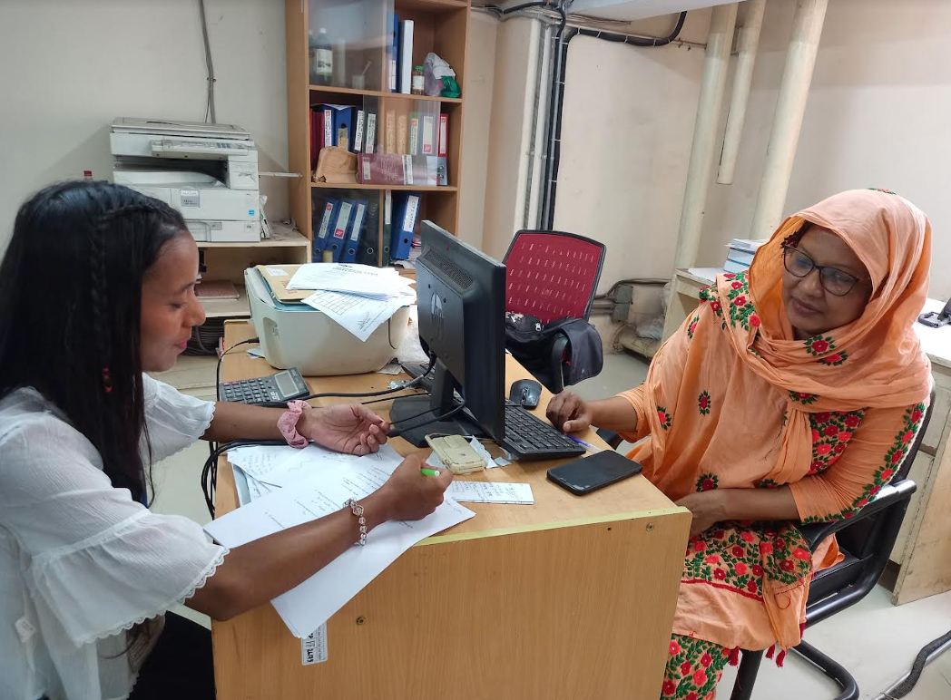
Figure 7: Respondents
3.2.4 Study Method
The study method was a quantitative research method as the data were collected in the form of numbers This method was helpful to analyze and understand quantitative data. Furthermore, LCA - environmental footprint 2.0 and ReCiPe2016 was used for assessing the environmental impact of denim jeans and the study followed the guidance presented in the ISO 14040-standard to ensure a methodological structure with high credibility.

3.2.5 Data Collection Instruments
The set of self-developed semi-structured questionnaires was used to collect data from the participants. The data was collected in English and local language as the respondents were not comfortable to understand and speak in English language. A volunteer was hired to translate the local language into English and vice versa. He/She was trained before going to the field by me and a book named Research Methods was given to volunteers for reference. Further, the recording app in mobile phones was used to record the data from the participants with their consent.

3.2.6 Data Management and Data Analysis
The collected data/information was reviewed to check if any questions are missed or repeated to eliminate missing and inconsistent data. The data was carefully entered into my personal laptop. For the protection of data, a separate folder will be created along with using a strong password. The stored data was gone through recheck again to avoid repetition and missing of any data. The collected data was analyzed with the help of Gabi software and Excel. The units of different quantities were converted using the respective conversion formula in order to analyze the result and data were collected in range and later on data was calculated on average using the average formula.
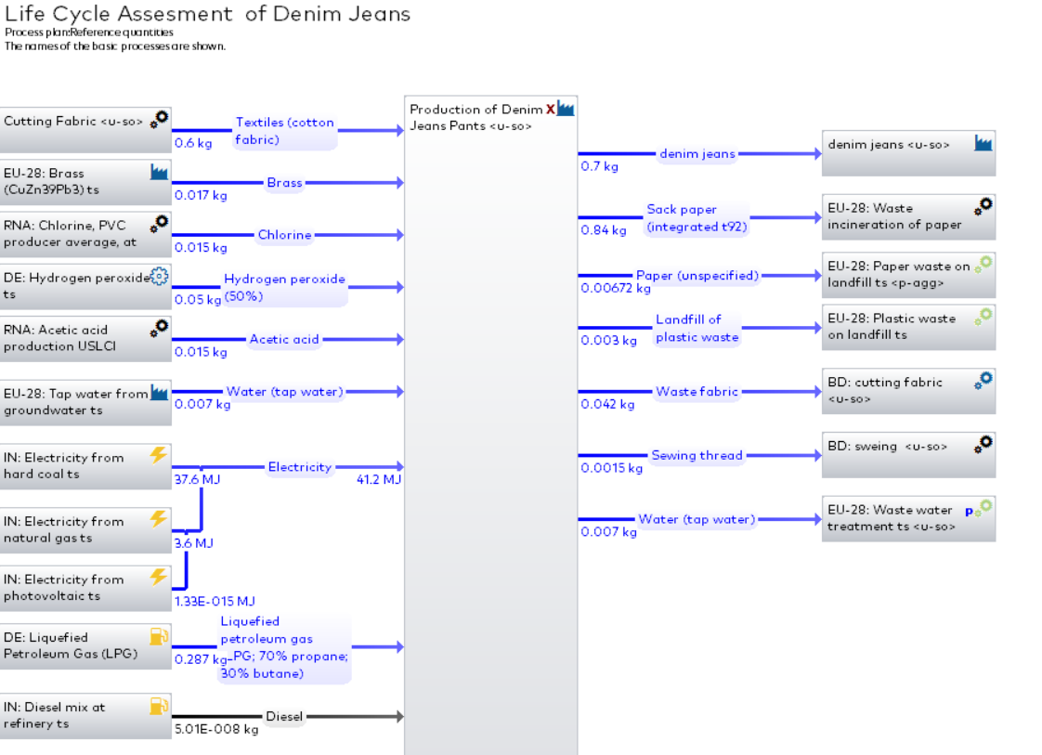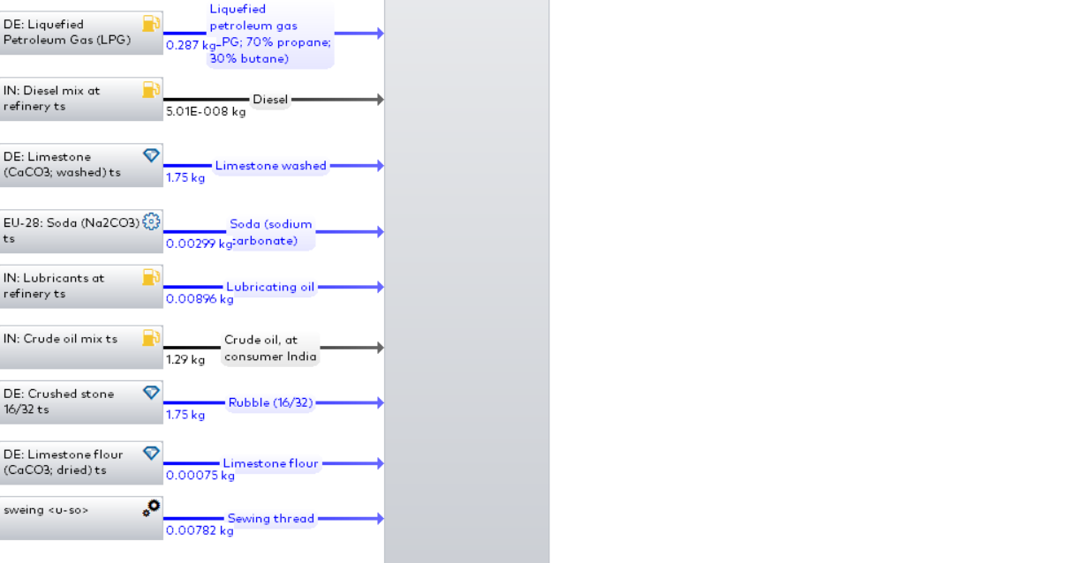
Figure 8.1: Data analysis by using GaBi Software
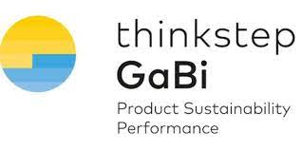
Figure 8.2: Gabi Software Figure 9: Excel

3.2.7 Ethical Consideration
The approval was taken from the Asian University of Women (AUW) Ethical Research Committee (ERC) and garment factories authority for collecting data in the targeted area. The study was conducted with the consent of respondents. There was a voluntary participation, so the participants could withdraw from the research anytime. The study was conducted under the supervision of Professor Mukesh Gupta and co-supervision of Professor Sayed Mohammad Nazim Uddin and Miss Ann Marie Bingo. Professor Mukesh Gupta is an Assistant Professor of Environmental Science in AUW. Similarly, Professor Sayed Mohammad Nazim Uddin is Head of Science and Math, and Associate Professor of Environmental Science in AUW and Miss Ann Marie Bingo is Associate Director, Corporate Social Responsibility, Sustainability & Impact at Horizon. There was no compromise regarding confidentiality and privacy of respondents.

3.2.8 Functional Unit
The number of items analyzed for the study are the functional units. In this study, the functional unit is the garment manufacture of one denim jeans pants.

3.2.9 System Boundaries
The boundaries of denim jeans pants are from gate to gate (garment manufacturing) phase of the life cycle. It includes, cutting of denim jeans fabric, sewing, washing, storing, packaging, and quality check in each process.

3. 3 Impact Categories and Description

Table 1: Environmental impact categories and description
Environmental Impact Categories
S.N. | Categories | Description | Units
1 | Water Consumption | Water extracted from underground | Gallons and Litters
2 | Climate Change | Global Warming potential of greenhouse gas release in the environment | Carbon Dioxide (CO₂) emissions (kg)
3 | Energy Consumption | Energy consumed during manufacture | MegaJoule (MJ)

Chapter 4
4. Result and Discussion

4.1 Denim Jeans Pants Production
Table 2: Denim jeans pants production per year
Denim Jeans Pant | Per Year Production
Worldwide | 12 billion
Bangladesh | 600 million
Pacific Jeans | 72 million
Universal Jeans | 18 million

Bangladesh is one of the prominent countries for the production of denim jeans pants. In a year, 12 billion denim jeans pants are manufactured worldwide, where Bangladesh contributes by manufacturing 600 million denim jeans pants (Table 2). Correspondingly, Pacific Jeans Limited is one of the largest denim jeans pants manufacturers in Bangladesh. They produce 72 million denim jeans annually. Despite being a sister group of Pacific Jeans Limited, Universal Jeans produces 18 million denim jeans yearly by following its own system and procedures (Table 2). On average, it manufactures 50,000 denim jeans pants per day. Similarly, it manufactures 1.5 million denim jeans pants per month, and 18.2 million denim jeans pants per year as shown in Figure 10. There is no significant decrease or increase in the production of denim jeans pants as jeans pants are worn in every season, and it goes with every changing fashion. Moreover, the quality and goodwill of Universal Jeans have always been marketing its products as a result there is no significant change in demand during off and on seasons. On the other hand, during the production process, 1-2% of denim jeans pants are damaged. The pants which can be rectified are rectified inside the company and the damaged products are either sold at a low price or sent to the storehouse for disposal along with the leftover fabric from the cutting and sewing department.
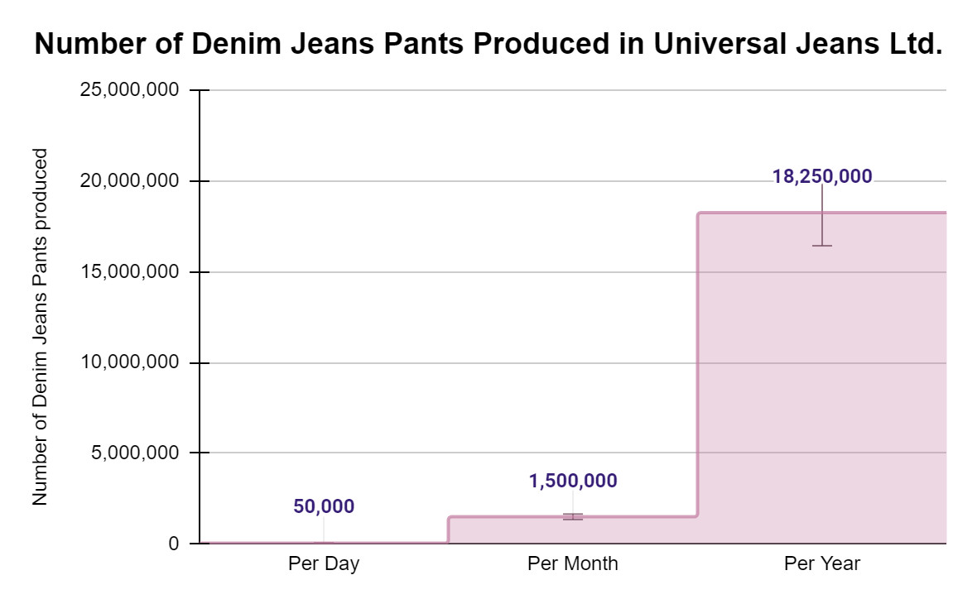
Figure 10: The number of Denim Jeans Pants manufactured in Universal Jeans Ltd.

4.2 Water Consumption
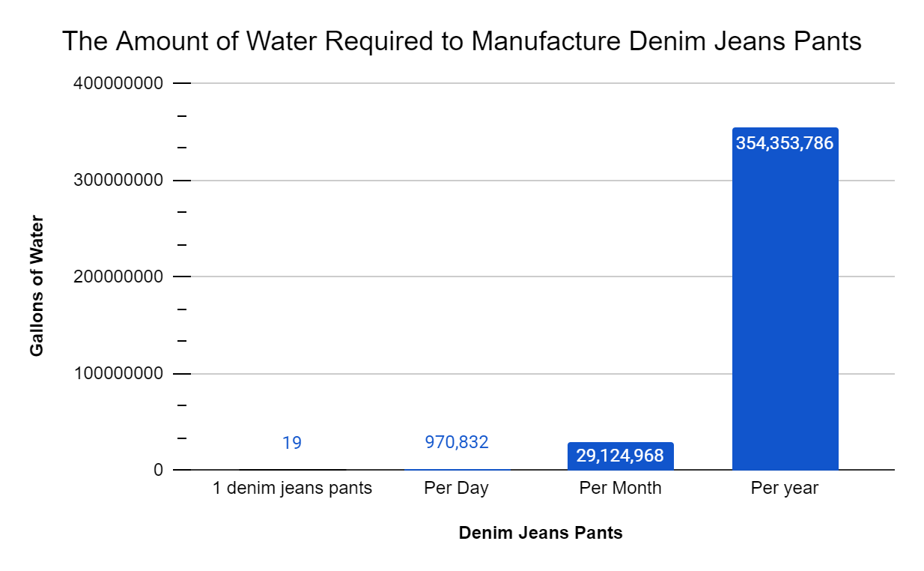
Figure 11: The amount of water required to manufacture Denim Jeans Pants
Groundwater is the primary source of water in the manufacturing process of denim jeans pants. Three deep tube wells are used for extracting water in Universal Jeans. In a day, 3000 cubic meters of water is extracted, where 2000 cubic meters of water is used for garment production after treatment and filtration of water. Likewise, 1000 cubic meters of water is used for administrative purposes. Water is an essential component in the washing stage of garment denim jeans production phase. It has been found that to produce one denim jeans pants 19 gallons of water is required (figure 11). Likewise, per month to produce 1.5 million denim jeans pants around 97 thousand gallons of water is required, and per year 35 million gallons of water is required to garment manufacture 18.2 million denim jeans pants (figure 11). The water used in garment production is in huge quantities, and extraction of water from deep tube wells is leading to disruption of the water table. In Chittagong, there are 700 garment factories and only in CPEZ, there are 179 garment factories that are using groundwater for the production process (RMG Bangladesh, 2016). This has seriously affected the groundwater level in Chittagong. The extreme extraction of groundwater and low recharge of water has caused water scarcity in the city. To reduce groundwater consumption, Universal Jeans has introduced a Rain Water Harvesting System with a storage tank of 300 cubic meters since 2017. Per day, 100-200 cubic meters of water is collected during the rainfall by using this method. The amount of water collected from the rainwater harvesting system is not enough as a result, they have to depend on groundwater which is leading to destruction in the water table. Moreover, the uncertain weather condition, less water holding capacity of the storage tank, and the initial stage of implementing rainwater harvesting have not contributed to reducing water extraction from the ground.
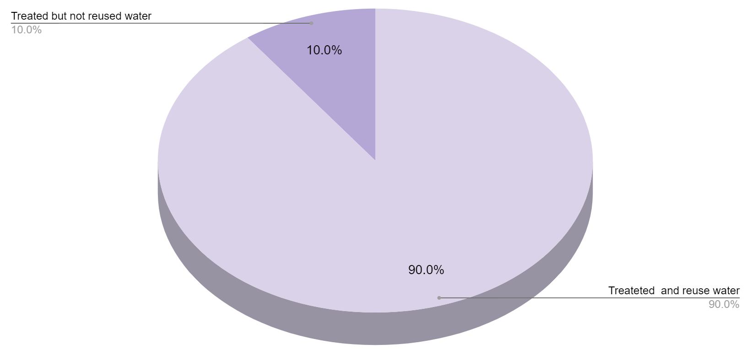
Figure 12 : The percentage of water treated for further usage and disposal

Universal Jeans Ltd has a water treatment plant that has been used to treat wastewater produced during the Wash Phase of denim jeans pants production. 90% of the wastewater is treated and reused while 10% of water is disposed of to sea after ETP (figure 12). The wastewater treatment plant is only used for treating wastewater while washing denim jeans pants, wastewater from handwashing, cleaning, toilet, and other usages in the company are not treated. Although the plan of treating wastewater from these sectors is going on, unfortunately, it has not come to action yet. The treatment of water from garment production as well as employer usage will help to save water. As water is used not only for production but also for other purposes by around 35000 employees of the company. Moreover, 1000 cubic meters of water is used every day for employee usage which is not treated and reused. Thus, not only the wastewater from garment production but also waste water from employee usage should be treated to reduce water consumption and save water resources.

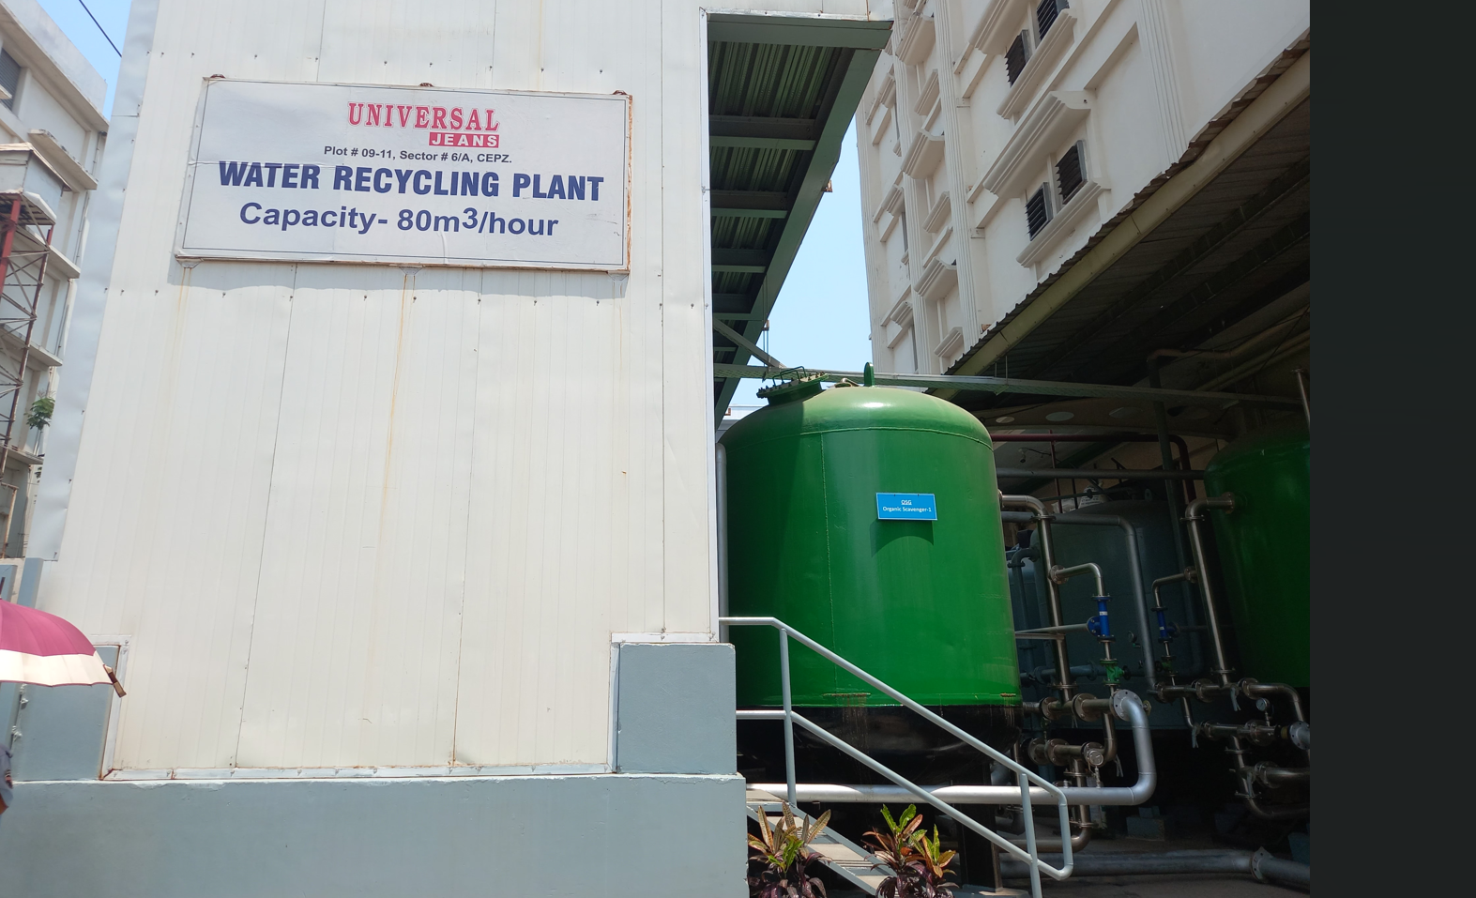
Figure 13 : Wastewater Recycling Plant

4.3 Energy Consumption
The energy demand is increasing day by day with the rapid growth of the population. The efficient utilization and conservation of energy are very important for future usage and also to meet the demand of people. Garment factories are one of the major sectors which require high energy to operate high-voltage machines and lights. Moreover, it requires high energy as it goes through different phases using different machines, techniques, and technologies. Only during the gate-to-gate phase 193 mega joules (MJ) of energy is consumed, which consists of 15.2 MJ from liquefied petroleum gas, 59.2 MJ from crude oil, 112 MJ from hard coal electricity, 11.1 MJ from natural gas and 1.15 MJ from other sources (figure 14).

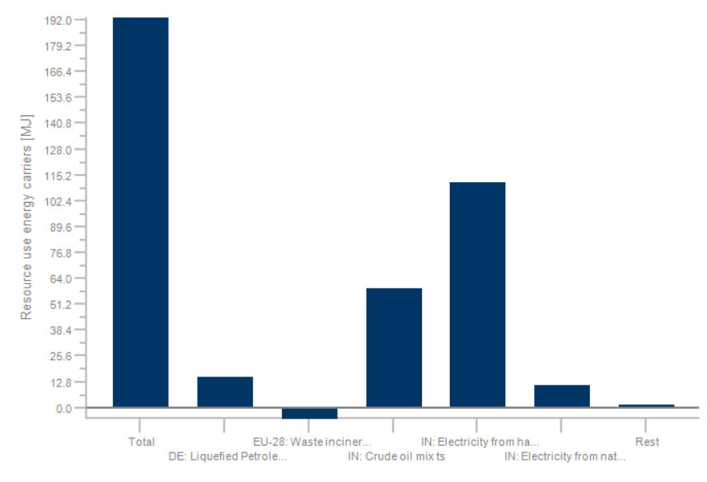
Figure 14: The energy consumption while manufacturing one denim jeans pants

In a day, Universal jeans consume 9,650,000 MJ of energy which is equivalent to the energy that can be used to power an average house for 34 months in Bangladesh as per hour they consumed around 3.6 MJ of energy (Kameke, 2021). Basically, it means that the energy which is consumed in one day for manufacturing denim jeans pants can be used to power a house for around 2.10 years. The development and usage of advanced technologies that can be operated by using less energy should be used to minimize the energy consumption in Universal Jeans. Although solar energy is planted to reduce energy consumption, it is not sufficient. As the solar power plant is less in comparison to the need and usage of energy in the factory. Moreover, they only use solar power during the time of power cuts. The increase in the number of solar power plants and their usage should be increased along with the advancement of technologies and the replacement of old machines and techniques that require high energy.

4.4 Climate Change
The emission of carbon dioxide in the atmosphere is the prominent reason for heating the planet and leading to climate change. The gate-to-gate phase of the denim jeans pant production process contributes to climate change as it emits carbon dioxide in different stages of garment production. During the fabric-cutting stage of garment production 2.81kg of carbon dioxide (CO2) is released, the crude oil used in machines to operate the factory releases 0.522kg of CO2, electricity used from hard coal emits 11.3 kg of CO2, similarly electricity used from natural gas emits 0.66kg of CO2, and in the overall production of denim jeans pants, 14 kg of CO2 is emitted (from figure 15). To sum up, in total it emits 29.2 kg of carbon dioxide during the whole garment production process, which is equal to carbon dioxide emitted by burning around 8.1 kg of coal as 3.6 kg of carbon dioxide is released while burning 1 kg of coal (Energy, 2020). Moreover, in a day a denim jeans pants manufacturing company releases 146,000kg of carbon dioxide which is equivalent to carbon dioxide emitted by burning around 41,000 kg of coal. The emission of 146,000 kg of carbon dioxide in the atmosphere is heating the Earth which is leading to climate change. As a result, summer is getting hotter, winter is getting colder, and there is a change in rainfall pattern. Hence, the CO2 emission during the garment manufacturing process of denim jeans pants is increasing the emission of CO2 in the atmosphere which is causing climate change.

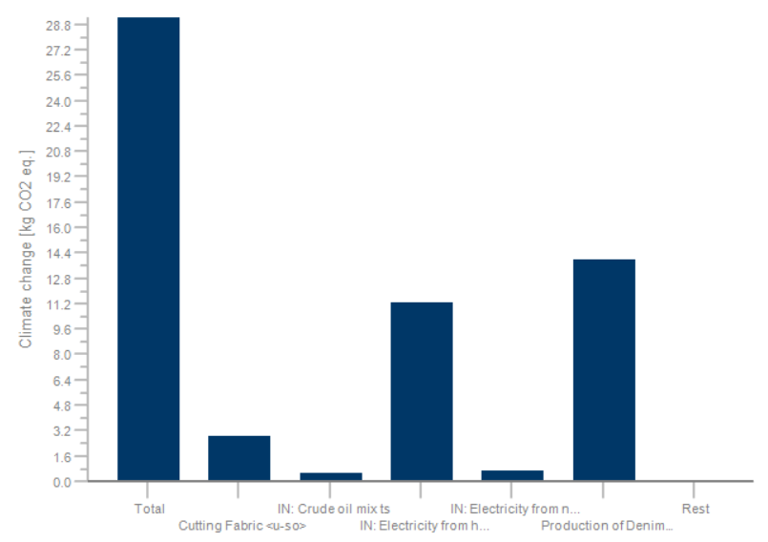
Figure 15: Carbon dioxide emission in various production phase and climate change

Chapter 5
5.1 Conclusion
The gate-to-gate stage (garment manufacturing process) of denim jeans pants has demonstrated the extreme amount of extraction of groundwater, consumption of energy, and release of carbon dioxide into the atmosphere. Only during the gate-to-gate impact assessment of denim jeans pants, it has resulted in the consumption of 19 gallons of water, 193 MJ of energy, and 29 kg of carbon dioxide emission into the environment. This impact of denim jeans pants will be even higher if we go through the whole life cycle of denim jeans pants from cotton cultivation of denim jeans pant fabric, yarning process, customer usage, and lastly disposal of the product. It's high time to think about the environment and shift towards sustainability for the production of denim jeans pants. The installation of rainwater harvesting systems will help to decrease the heavy groundwater extraction and wastewater treatment plants will help to reuse the water and disposal of wastewater to the water bodies after the treatment will help to reduce the water pollution and loss of aquatic life. Moreover, solar power plants should be developed and used efficiently to reduce energy consumption from hard coal, diesel, and liquefied petroleum gas. The shift towards the alternative source of water and energy will help to reduce the emission of carbon dioxide which is warming the Earth and leading to climate change during the denim jeans garment manufacturing process.
In a nutshell, the garment production of denim jeans pants has helped Bangladesh to create employment opportunities, export it to foreign countries, and earn remuneration. However, it has also harmed the environment of Bangladesh through the extreme amount of groundwater extraction, the huge amount of energy used for production, and the emission of carbon dioxide during the garment manufacturing process. Thus, the industrial groups should move towards a sustainable process by using alternative methods to produce denim jeans pants. To sum up, the shift towards a sustainable production process should be applied to the complete chain of denim jeans pants production not only during gate to gate phase. As in every step of production it is important to think about the environment and shift towards a safer alternative production process.

5.2 Policy Recommendation
The effective implementation of the policy is very important to reduce the denim jeans pants garment's production impact on the environment. Moreover, the policy of adding extra tax for the extreme use of groundwater and energy, and incentives to factories that are using alternative sources of water and energy during the production of denim jeans should be introduced. This will push the garment factories to reduce the extreme consumption of water and energy as well as to shift towards alternative methods and use advanced technologies that consume less water and energy in the production of denim jeans pants. Further, the policy of setting up wastewater treatment in each garment industry and an effective monitoring system will help to recycle the water along with that it will also help to treat the wastewater before disposing off in water bodies. Furthermore, the introduction of a policy to have a rainwater harvesting system in each garment industry will help to reduce the groundwater extraction and depletion of water tables. Consequently, the effective implementation of the policy for using solar power as an alternative means of energy to reduce the use of coal, fossil fuel, diesel, and petroleum products for energy will reduce pollution and environmental degradation. In addition to this, the policy of giving rewards and incentives to factories that have less impact on the environment will encourage the factories to shift towards alternative methods and use advanced technologies in the production of denim jeans pants.

5.3 Limitation
- This paper only focuses on the impact of denim jeans pants on the environment during the garment manufacturing process. It does not include the data and impact caused by denim jeans pants during cotton cultivation, yarning, colourization, dyeing, transporting raw materials to factories and finished products to market, customer handling, and disposal. This paper highlights the impact only during the garment production phase and gives scope to research on the impact caused by denim jeans pants in its whole life cycle to understand the overall impact of jeans.
- This paper only focuses on water consumption, energy consumption, carbon dioxide emissions, and climate change. It has not discussed the other impacts such as eutrophication, ozone layer depletion, land uses, and global warming potential due to limited time and resources.
- The data and information used in this paper is not free from biasness. As the respondents were very conscious and alert while giving interviews and answering the research questions.
- The education license of GaBi software was not able to provide a full database for the data analysis, so there might be some technical errors during analysis.

References

Amutha, K. (2017). Environmental impacts of denim. Sustainability in Denim, 27–48.
https://sci-hub.se/10.1016/B978-0-08-102043-2.00002-2
Asharf, A., Islam, R., Rahman, M. and Adnan, G. S. (February, 2013). Identification of
appropriate landfill sites for the city of Chittagong. International Conference on Solid Waste Management in the Developing Countries. 1-14.
https://www.slideshare.net/kazijonas/identification-of-appropriate-landfill-sites-for-city-of-chittagong
Aki, S. U., Candan, C., Nergis, B. and Onder, N. S. (June 15, 2020). Understanding denim
recycling: A quantitative study with life cycle assessment methodology. Intechopen.
https://www.intechopen.com/chapters/72493
Barnes. E, Reed. J, Wallace. M, Peterson. M and Leary. P. (2012). A life cycle assessment of the
cotton textile chain. Cotton Incorporated.
https://baumwollboerse.de/wp-content/uploads/2015/12/Vortrag-OLeary_2012.pdf
Bangladesh- household electricity consumption per capita 2016 | Statista. (n.d.). Statista.
Bangladesh- household electricity consumption per capita 2016
https://www.statista.com/statistics/598336/household-consumption-of-electricity-per-capita-in-bangladesh/#:~:text=This%20statistic%20represents%20the%20household,about%20110%20kilowatts%20per%20hour.
Demir, F. (February 2, 2021). Denim & Water. Textile for Life.
https://texinlife.com/denim-water/
Energy. (2020, October 20). How Does Using Energy Create Carbon Emissions? | Energy
Management | Carbon Reduction Consultants. Energy Management | Carbon Reduction Consultants | 360 Energy - Energy & Carbon Management. https://360energy.net/how-does-using-energy-create-carbon-emissions/#:~:text=As%20noted%20in%20our%20gasoline,about%203.3%20kg%20of%20CO2.
Fashion Press 24. (November 7, 2018). World Denim industry & market share comparison.
Fashion Press 24.
https://www.fashionpress24.com/world-denim-industry-market-share-comparison/
Fashion United. (September 26, 2026). Infographic - Data from the Denim Industry. Fashion
United. https://fashionunited.com/news/business/infographic-data-from-the-denim-industry/2016092613027
Focus, T. (November 22, 2021). Universal Jeans to achieve ‘tax card’ as best taxpayer. Textile
Focus. https://textilefocus.com/universal-jeans-achieves-tax-card-best-taxpayer/
Golsteijn, L. (July 17, 2020). Life Cycle Assessment (LCA) explained. Pre-sustainability.
https://pre-sustainability.com/articles/life-cycle-assessment-lca-basics/
Hackett, T. (2015). A comparative life cycle assessment of denim jeans and a cotton T-shirt: The
production of fast fashion essential items from Cradle to Gate. University of Kentucky.
https://uknowledge.uky.edu/cgi/viewcontent.cgi?article=1008&context=mat_etds
Hedman, A. E. (2018). Comparative Life Cycle Assessment of Jeans; A case study performed at
Nudie Jeans. KTH Royal Institute of Technology.
https://kth.diva-portal.org/smash/get/diva2:1221104/FULLTEXT01.pdf
Impact Institute. (2019). The true price of jeans. Impact Institute.
https://trueprice.org/wp-content/uploads/2019/06/Impact-Institute-Report-True-Price-of-Jeans.pdf
Kameke, A.V. (November 9, 2021). Household electricity consumption per capita in Bangladesh
from 2000 to 2016. Stastista.
https://www.statista.com/statistics/598336/household-consumption-of-electricity-per-capita-in-bangladesh/#:~:text=This%20statistic%20represents%20the%20household,about%20110%20kilowatts%20per%20hour.
Mariano, N. (December 22, 2021). How Long will it take for fabrics to decompose? Cottonique.
https://www.cottonique.com/blogs/articles/how-long-will-it-take-for-fabrics-to-decompose
Market Research Report. (November 2021). Denim Jeans Market. Market Research Report.
https://www.factmr.com/report/321/denim-jeans-market
Paul, R. (April 23, 2015). Denim: manufacturing, finishing, and applications. Elsevier.
https://www.elsevier.com/books/denim/paul/978-0-85709-843-6
Pacific Jeans. (n.d.). The Global Lifewear Solution Company. Pacific Jeans.
https://www.pacificjeans.com/
Periyasamy, A. P. and Duraisamy, G. (February 2018). Carbon Footprint on Denim
Manufacturing. Research Gate, 1-17.
https://www.researchgate.net/publication/348959120_Carbon_Footprint_on_Denim_Manufacturing
Periyasamy, A., Winer, J., and Militky, J. (2017). Life-cycle assessment of denim. The Textile
Institute Book Series, 83-110.
https://www.sciencedirect.com/science/article/pii/B9780081020432000046
RadhaKrishna, S. (January, 2017. Denim Recycling. Textile Science and Clothing Technology.
https://www.researchgate.net/publication/305943476_Denim_Recycling
Regan, C. (2015). Role of denim and jeans in the fashion industry. Carbon Footprint on Denim
Manufacturing, 191–217.
https://sci-hub.se/https://doi.org/10.1016/B978-0-85709-843-6.00007-X
RMG Bangladesh. (January 14, 2016). Apparel zone in Chittagong prepared. RMG Bangladesh.
https://rmgbd.net/2016/01/apparel-zone-in-chittagong-prepared/
Rochester Institute of Technology. (July 2, 2020). What is Life Cycle Assessment (LCA)?
Rochester Institute of Technology.
https://www.rit.edu/sustainabilityinstitute/blog/what-life-cycle-assessment-lca
Roos, S., Sandin, G., Zamani, B. and Peters, G. (2015). Environmental assessment of
Swedish fashion consumption – Five garments – sustainable futures. Sweden: Mistra Future Fashion (Mistra Fusion Fashion Report)
https://research.chalmers.se/en/publication/514322
Sandin, G., Ross, S., Spak, Bjron, Zamani, B and Peters, G. (May 2019). Environmental
assessment of Swedish clothing consumption. Mistra Future Fashion Report.
https://research.chalmers.se/publication/514322/file/514322_Fulltext.pdf
Santero, N and Hendry, J. (December 22, 2015). Harmonization of LCA methodologies
for the metal and mining industry. Springerlink.
https://sci-hub.hkvisa.net/10.1007/s11367-015-1022-4
Sarkar, P. (June 4, 2017). Denim Fabric Manufacturing Process –The Learner’s Guide. Online
Clothing Study.
https://www.onlineclothingstudy.com/2017/06/denim-fabric-manufacturing-proCess.html
Textile Today: Bangladesh an Innovation. (January 1, 2014). Denim and its prospect as a fashion
product. Textile Today: Bangladesh an Innovation.
https://www.textiletoday.com.bd/denim-and-its-prospect-as-a-fashion-product/
The World Count. (2023). Why is cotton called the dirtiest crop in the world? The World Counts.
https://www.theworldcounts.com/challenges/clothing/world-cotton-production-statistics
Torcellini, P., Long, N., & Judkoff, R. (December 1, 2010). Consumptive Water Use for U.S.
Power Production. https://www.researchgate.net/publication/255199399_Consumptive_Water_Use_for_US_Power_Production
Uddin F. (August 28, 2019). Introductory chapter: Textile manufacturing processes.
Intechopen.
https://www.intechopen.com/chapters/68157
Unzipped Staff Levi Strauss and Co. (July 4, 2019). The history of denim. Levi Strauss
and Co.
https://www.levistrauss.com/2019/07/04/the-history-of-denim/
Webber, K. (2018, March 8). The Environmental and Human Cost of Making a Pair of Jeans
EcoWatch. EcoWatch. https://www.ecowatch.com/environmental-cost-jeans-2544519658.html

