Towards Low Carbon Strategies - Carbon Footprint Calculation of Asian University for Women of the FY2022

Senior Thesis Submitted for credit requirement of
Bachelor of Science in Environmental Sciences
Asian University for Women, Chittagong, Bangladesh

by
Tusti Bose
190112
Undergraduate Level 3
ENVS 4980: Senior Seminar/Thesis Spring 2023

Faculty Supervisor: Professor Mukesh Gupta
Submitted to Professor Sayed Mohammad Nazim Uddin and Professor Mukesh Gupta

ACKNOWLEDGEMENTS

I would like to express my sincere gratitude towards my academic advisor and Thesis supervisor, Professor Mukesh Gupta for his constant encouragement and guidance throughout my thesis journey. His advice, valuable suggestions, and comments helped me clear any sort of confusion. His words still echos saying “Tusti you can do it, do not worry”.

The work to find greenhouse gas emissions of the campus, many staff members and offices of the AUW community. They have shared their insights on the campus operations and provided me valuable data. I would like to thank them for their contributions.

My utmost gratitude to the Environmental Sciences faculty for encouraging every student in every way possible.

Table of Contents

ABSTRACT……………………………………………………………………………………………. 5

1. INTRODUCTION………………………………………………………………………………….. 6
1.1. Why calculating carbon footprint of AUW and higher academic institutions?.......................... 6
1.2. Objectives of the study ………………………………………………………………………... 7

2. LITERATURE REVIEW ………………………………………………………………………….. 7
2.1. What is carbon footprint? …………………………………………………………………….. 8
2.2. GHG Selection and Methodology ……………………………………………………………. 9
2.3. Setting the boundaries for sources of emission ……………………………………………… 10
2.4. Emission Factors …………………………………………………………………………….. 11
2.5. Previous studies on the carbon footprint of universities …………………………………….. 12
2.6. Limitations of Carbon Footprint Study ……………………………………………………… 13

3. METHODOLOGY …………………………………………………………………………………. 13
3.1. University operational and organizational data ………………………………………………… 14
3.2. Inventory Procedure and Data Sources ………………………………………………………… 15
3.2.1. Institutional Data ………………………………………………………………………. 15
3.2.2. Scope 1 ………………………………………………………………………………… 15
3.2.2.1. Vehicle Fleet ……………………………………………………………….. 15
3.2.2.2. Other On-campus Stationary Sources …………………………………….. 16
3.2.3. Scope 2 ………………………………………………………………………………… 16
3.2.3.1. Purchased Electricity ………………………………………………………. 16
3.2.4. Scope 3 ………………………………………………………………………………… 17
3.2.4.1. Commuting ………………………………………………………………… 17
3.2.4.2. Study Abroad Air Travel …………………………………………………… 17
3.2.4.3. International Students’ Air Travel To/From Home ………………………… 18
3.2.4.4. Paper ……………………………………………………………………….. 18
3.2.4.5. Solid Waste ………………………………………………………………… 18
3.2.5. Offset …………………………………………………………………………………… 19

4. RESULTS ……………………………………………………………………………………………. 19
4.1. Overview of the results ………………………………………………………………………….. 19
4.2. Emissions by Categories ………………………………………………………………………… 22
4.2.1 Scope 1 …………………………………………………………………………………… 22
4.2.1.1. Direct Transport ……………………………………………………………… 22
4.2.1.2. Other On-campus Stationary Sources ………………………………………... 23
4.2.2. Scope 2 …………………………………………………………………………………... 24
4.2.2.1. Purchased Electricity …………………………………………………………. 24
4.2.3. Scope 3 …………………………………………………………………………………... 24
4.2.3.1. Commuting …………………………………………………………………… 24
4.2.3.2. Study Abroad Air Travel ……………………………………………………... 26
4.2.3.3. International Students’ Air Travel To/From Home …………………………... 27
4.2.3.4. Paper …………………………………………………………………………. 28
4.2.3.5. Solid Waste …………………………………………………………………… 29
4.2.4 Offset …………………………………………………………………………………….. 29

5. DISCUSSION ………………………………………………………………………………………. 30
6. LIMITATION ………………………………………………………………………………………. 31
7. FUTURE DIRECTION ……………………………………………………………………………. 32
8. CONCLUSION …………………………………………………………………………………….. 32
REFERENCES ……………………………………………………………………………………….. 34

Figures and Tables
Table 1: Global Warming Potential of Greenhouse Gasses (US EPA, 2022) 10
Figure 1: Operational Boundaries of GHG emissions 11
Figure 2: Campus Carbon Calculator™ v9.0 14
Table 2: Institutional data and normalized emissions of AUW in FY2022 20
Figure 3: Total emissions by scope of AUW in FY2022 21
Figure 4: Total emissions by source of AUW in FY2022 22 Figure 5: Total emission and net emission (with offset) of AUW in FY2022 22
Table 3: Asian University for Women Transportation Vehicles 23
Table 4: Amount of fuel purchased for AUW’s direct transportation (university fleet) in FY2022 23
Table 5: Number of commuters and commuting trips made by AUW’s students, faculty and staff 25
Table 6: Trip mode distribution and trip distance of AUW’s commuters 26
Table 7: Population of students country wise and air miles traveled in FY2022 (each student traveled in Fall 2022 and came back in January 2023) 27
Table 8: Population of students country wise and air miles traveled per year (considering each student takes one round trip per year) 28
Table 9: Paper Usage by AUW in FY2022 29
Table 10: CO₂ offset of AUW of FY2017 and FY2022 29
Table 11: Comparison of carbon footprint of 2017 and 2022 30
Table 12: Comparison of carbon footprint of different universities and AUW 30

ABSTRACT

Carbon Footprint (CF) is referred to as the total amount of direct and indirect emissions from various anthropogenic activities being done on a daily basis. It is normally expressed in carbon dioxide equivalents (CO₂e). Asian University for Women (AUW) plans to modify its Environmental Policy and missions to move towards a green campus. This was the second time the carbon footprint was calculated after 2017. The first step was to understand the guidelines incorporated by the GHG protocol and the Campus Carbon Calculator™ v9.0 (CCC). Next step was the data collection for different activities from different departments and populations of the university. Data calculated was converted into specified units by the CCC and then inputted. The results showed purchased electricity is the greatest contributor of carbon emissions at the university, representing 81.14% of the total carbon footprint, followed by international students’ air travel to/from home at 5.37%, solid waste at 2.63%, other on-campus stationary at 1.78%, and other sources represented less than 1%. The total amount of carbon dioxide (CO₂) emission from three scopes (1, 2, and 3) in FY2022 was 13914.70 metric tons of carbon dioxide (MTCO₂), which is equal to 9.5 MTCO₂/person/year. Findings from both the carbon footprint report of FY2017 and FY2022 was compared. The findings can be used to find solutions to reduce the emissions and build awareness among the community members of the university.

- INTRODUCTION
Global Climate Change is one of the most pressing issues facing humanity today. Increasing population, rapid growth of industrialization, and switching to urbanization is increasing the amount of emissions from anthropogenic sources. Approaching a carbon-neutral Earth is all we need at this point. A sustainable approach and moving towards sustainability have become an emerging topic to be discussed and implemented in this decade of rising anthropogenic activities. These actions are releasing harmful GHG emissions resulting in environmental degradation and causing climate change (Lima et al., 2020). Thus, mitigation, adaptation, and resilience should be given priority for combating the irreversible impacts caused by GHG emissions (Dountio et al., 2016). Earlier, it was reported by the Intergovernmental Panel on Climate Change (IPCC), in 2018, that global temperature must be limited to 1.5°C. Urgent action is mandatory for lowering GHG emissions occurring globally by 2030 and attaining the goal of zero emissions by the year 2050.

1.1. Why calculating carbon footprint of AUW and higher academic institutions?
Sufficient management of our environment from Climate Change requires leadership from the actors of this generation. Organizations like higher education institutions exemplify the leadership qualities to combat such environmental problems. Since organizations are one of the highest contributors to greenhouse gasses, their role in diminishing its effects is important (Robinson et al., 2018, Sprangers, 2011). Universities imposing a great impact on society should play a key role in transitioning toward a low-carbon economy by promoting, informing, evaluating, and supporting the initiatives that are required for achieving the changes for betterment (Gómez et al., 2018, Amaral et al., 2020). Thus, higher academic institutions are regarded as centralized organizations that have high populations, long-lasting timeframes, and are appropriate places to evaluate GHG emissions (Li, Tan & Rackes, 2015, p. 97).

Asian University for Women (AUW), is an international liberal arts university in Chittagong, Bangladesh. It aims to improve the AUW Environmental Policy and build a green campus. Previously, the first Carbon Footprint report of AUW was calculated in 2017 by Tien Thi Cam Huynh. No further carbon footprint of the university was calculated. Following her procedure and keeping some values of her results as a base, Carbon Footprint calculation of the FY2022 was obtained for AUW. As an Environmental Sciences major, it is our duty to contribute towards the sustainability of our university. Since many things have changed after the COVID-19 pandemic, there will very likely be changes in many of the activities of the university along with population and building space. The recent carbon footprint aims to help AUW reduce emissions, finding and adapting mitigation strategies, as well as be an example to other universities in the locality.

1.2. Objectives of the study
The primary objective of the study is to calculate the Carbon Footprint of AUW for FY2022, with the main objective to compare the result with the FY2017 report. Emissions per activities will be obtained through the calculation and certain mitigation measures will be provided as recommendations in the study.

The research questions of the study are as follows:
- Which scope has contributed to the greatest amount of emissions?
- How much will the net emissions in 2022 have increased compared to that of 2017?
- What are the causes of the increase in emissions?
- What are some developments that can be done to reduce emissions of AUW?
These questions will be answered in this study.

- LITERATURE REVIEW
In recent years, the consequences of climate change have been drastically affecting populations across the globe and the effects are getting increasingly worse. To minimize and potentially reverse these effects, we have to be conscious of our total carbon footprint and reduce our greenhouse gas (GHG) emissions. Harmful gas emissions from various organizational activities like using fossil fuels, electricity consumption, transportation, manufacturing products, paper usage, as well as waste disposal (Wiedmann & Minx, 2008) contribute to the total carbon footprint. As a measure towards reducing emissions, many universities worldwide have started calculating their carbon footprint. Almost 1400 universities have signed the Sustainability in Higher Education (SHE) declaration (Grindsted, 2011) to show commitment to the approach. To further understand the carbon footprint of the Asian University for Women (AUW), this study will apply the concept of calculating the GHG emissions of the university and indicate the key sources of such emissions. The amount of emissions per activity and the overall emission value associated with AUW will also be determined through the carbon footprint concept.

2.1. What is the carbon footprint?
Although footprints are referred to as the indicators of human pressure on our surrounding environment (Rees & Wackernagel, 2008), there has been no formal definition of carbon footprints in literature. As a result, there is a common confusion between carbon footprint and ecological footprint. In reality, ecological footprint covers a broader spectrum, of which carbon footprint is a subset. Ecological footprints are not only limited to the environment, and also include social and economical aspects that aim to target the triple-bottom-line (planet, people, profit) of sustainability (Čuček et al., 2012). Previously, footprint indicators were largely popular among businesses, NGOs, and media as they adopted their approaches to their own definitions and methodology. Currently, it is increasingly gaining popularity within academic research as well. Globally, universities have taken initiatives to assess and reduce environmental footprints such as carbon and water (Amaral et al., 2020).

An ecological footprint is a calculating methodology fabricated to trace the amount of resource usage and harmful emissions produced from human activities, therefore estimating human demand on the biosphere’s restoration capacity (Wackernagel et al., 2002). The World Wide Fund for Nature (WWF) defined ecological footprint as a measure of human activities' impact based on an area with biologically productive land and water resources needed for the formation of goods and the assimilation of waste generated. Simply, an ecological footprint which is expressed in units of the area is termed as the amount of environmental space needed for producing goods and providing services required in supporting a particular lifestyle (Galli et al., 2012).

Carbon footprint (CF) is a methodology used for investigating the impact of particulars, groups, countries, companies, or products on the climate. Authors as early as the 1970s have conceded the necessity of assessing GHG emissions from both the direct and indirect impacts of anthropogenic activities (Patterson et al., 2017). Commonly, CF refers to the measurement of the total amount of CO₂ emissions that are directly or indirectly generated by an activity or accumulated throughout a product’s life (Wiedmann & Minx, 2008). It is expressed in mass units of the total amount of greenhouse gasses calculated, but not expressed in terms of the area since uncertainties might arise from conversion calculations (Galli et al., 2012).

2.2. GHG selection and methodology
Numerous GHG gasses, including carbon dioxide (CO₂), methane (CH₄), and nitrous oxide (N₂O), are released as a result of anthropogenic activity. The selection of GHGs depends on the kind of activities considered while calculating the carbon footprint. When choosing GHGs for carbon footprint calculations, there are two approaches that are adopted: some authors account for only CO₂ emissions (Wiedmann & Minx, 2008), whereas others account for all six Kyoto gasses that include CO₂, CH₄, N₂O, hydro-fluoro carbons (HFCs), perfluorocarbons (PFCs), sulfur hexafluoride (SF₆) (Pandey, Agrawal & Pandey, 2011). The Campus Carbon Calculator (CCC) used in this study will account for the emissions emitted from direct and indirect sources in the form of CO₂, CH₄, and N₂O. By multiplying the activity data (such as fuel consumed) and its respective emission factor (such as kgCO2/kWh), the GHG emission for each activity will be determined.

“ISO14064, Greenhouse Gas (GHG) protocol, and Product and Supply Chain GHG Protocol” are some of the standards of carbon footprint (Madasu, 2019, p. 58). These standards help to measure and report the levels of direct and indirect GHG emissions from an organization. CF is measured in units like kilograms or tons of CO₂ or any other GHG gas equivalents (Vázquez-Rowe et al., 2013). The Intergovernmental Panel on Climate Change (IPCC) provides a Global Warming Potential (GWP) relative to carbon dioxide for all GHG emissions. Based on the information given by the GWP, the various GHG emissions will be converted to their CO₂ equivalents in this study. This enables us to compare and evaluate the GWP value of each gas (as shown in Table 1). All the emissions mentioned in Table 1 are in MTCO₂e (metric tons of carbon dioxide equivalent), a common unit of GWP measurement. For instance, one metric ton emission of N₂O is equivalent to 273 metric tons of carbon dioxide.

Table 1: Global Warming Potential of Greenhouse Gasses (US EPA, 2022)
Greenhouse Gas (GHG) | Global Warming Potential (100 years)
Carbon Dioxide (CO₂) | 1
Methane (CH₄) | 27-30
Nitrous oxide (N₂O) | 273
High-GWP gasses (HFCs, PFCs, SF₆) | Thousands or tens of thousands

2.3. Setting the boundaries for sources of emissions
The evaluation will be carried out by first setting the parameters for the operational tasks. The World Resources Institute and the World Business Council for Sustainable Development introduced the Greenhouse Gas Protocol, which is mostly used as an accounting tool internationally to quantify GHG emissions. Sources of emissions are categorized into three scopes (Figure 1) by the GHG protocol for universities (Ranganathan et al., 2004.):
- Scope 1 core emissions - Directly emitted from sources based within the organization such as on-campus fuel combustion, emissions from production and process units, organization-owned transportation, and refrigerant losses. This needs to be included.
- Scope 2 core emissions - Energy indirectly emitted from the usage of purchased electricity by the organization. These emissions are from the operational activities of the organization but are owned by other companies. This needs to be included as well.
- Scope 3 non-core emissions - Other indirectly emitted emissions from sources controlled by third-party companies such as commuting of employees/staff, waste disposal, and outsourced vehicles. The inclusion of emissions from these activities completely depends on the organization.

The GHG protocol used for setting the boundaries for emission sources enables the carbon footprint report and results from an organization to be presented according to internationally accepted standards. A similar procedure was used in earlier studies, and the outcomes can be used as references, and comparisons (UCC, 2017).

CO₂, CH₄, N₂O, HFCs, PFCs, SF₆

Scope 3
(Indirect emissions)

Scope 1
(Direct emissions)
Scope 2
(Indirect emissions)

Example: Owned vehicles, fuel combustion
Example: Purchased electricity for use
Example: travel, waste disposal, outsourced activities
Figure 1: Operational Boundaries of GHG emissions
2.4. Emission factors
Emission factors used for calculation and analyzing data are standardized into suitable units of energy, such as MBtu for thermal sources, and kWh for electricity consumption. In case of the amount of CO₂e per MBtu being sufficiently small, then the value will be converted into kgCO₂e/MBtu (Braham & Waegel, 2016).

Natural gas, gasoline, or other fuels are some examples of Scope 1 emission factors. These factors are precise and derived from the physics behind the fuel combusted. However, indirect sources (Scope 2 and 3) estimate the mix of fuels or procedures associated with imported energy from centralized utilities. Estimating the emission patterns of purchased electricity from a national grid can be a complex task as it involves multiple power plants, each with its own unique emissions. Therefore, using the Campus Carbon Footprint Calculator (CCC), this research aims to generate structured data and compute outcomes using emission factors derived from global standards, which is a commonly employed methodology across various academic campuses.

2.5. Previous studies on the carbon footprint of universities
Some universities have already attained carbon-free status. For example, the Leuphana University in Germany achieved carbon neutrality in 2014, seven years after setting the goal of becoming carbon-free (Opel et al., 2017). This university reached its target by lowering emissions from the usage of vehicles, electricity consumption, heating, water, and paper uses. In addition, a number of educational institutions in Canada, the United States, and Turkey have committed to achieving carbon neutrality within the next few years (Osorio et al., 2022).

Universities globally have a strategic commitment towards a sustainable environment and embrace different tools to calculate the carbon footprint. One such tool is the CCC, which has been widely used by a significant proportion of colleges and universities in the United States to track their GHG emissions and release their carbon footprint reports. The CCC was co-designed by the Sustainability Institute of New Hampshire and Clean Air-Cool Planet, an American non-profit organization based on the GHG protocol. For instance, in 2009, Colgate University, New York used CCC to track their GHG emissions. The calculator revealed that air travel was responsible for their highest emissions at 44%, followed by fuel oil (20%), electricity (9%), and faculty and staff commuting (9%) (Dove et al., 2018). The total emissions of the university were determined to be 6.81 MTCO₂e per student enrolled full-time and 8.14 MTCO₂e per 1000 square feet respectively.

Another example can be seen at Carnegie Mellon University, where the CCC was utilized in 2006 to determine their carbon footprint of 164,000 MTCO₂e. Subsequently, the institution used several other calculators to assess their campus carbon footprint. Nevertheless, they mentioned that CCC gave them a more comprehensive result, accurate inference of their hypothesis, and was considered to be the best calculator for their university. Their outcome section identified the major contributors of GHG emissions in the following order: electricity, steam usage, and faculty and student air travel (CMU, 2008).

UNAM, the Universidad Nacional Autónoma de México used a different methodology to report their carbon footprint. The calculation was performed using the Process Analysis (PA) method, which examines all the environmental impacts of a product over its lifespan. GHGs, such as CO₂, CH₄, N₂O, and sources, such as generation of electrical energy, vehicles, commuting, paper consumption, electricity purchased, courier shipments, commuting, and solid wastes were considered for assessment.

In 2016, the University of Talca (UT) in Chile traced their carbon footprint based on the GHG protocol for all of its five campuses. Scope 3 emissions was found to be the highest emission contributor with a value of 0.41 tCO₂e per person, thus concluding faculty and student transportation to and from campus to be the main emission source (Yañez et.al., 2019).

2.6. Limitations of carbon footprint study
The information conveyed by a carbon footprint calculation can vary depending on the calculation method and the level of responsibility assumed by the entity in review. However, there is a gap between the comprehensive measures developed and the practicality of data collection and analysis. Moreover, difficulty also arises in assessing the impact on intermediate businesses and tertiary consumers throughout the supply chain (Matthews, Hendrickson & Weber, 2008). Furthermore, any shortcomings in gathering data on GHG emissions activities can negatively affect the credibility and relevance of research findings (Dragomir, 2012). Keeping this in mind, this study will try to bridge the gap by strictly following the procedure directed by the GHG protocol and the CCC for accurately calculating the carbon footprint of AUW.

- METHODOLOGY
In this research, a Microsoft Excel-based tool named Campus Carbon Calculator™ v9.0 (CCC), was used for recording the GHG emissions data collected and to find the carbon footprint report of AUW. CCC was designed by Clean Air-Cool Planet and the Sustainability Institute of University of New Hampshire and exclusively made for use as a calculating carbon emissions for a college or university. The calculator is composed of standardized methodologies coded by GHG protocol. Three main modules are incorporated with the calculator - input, emissions factor, and summary module (Figure 2). The spreadsheets designed were mainly based on the workbooks given by the IPCC for national level inventories, containing data from the Fourth Assessment Report of the IPCC (Huynh, 2017).

The rules and guidelines mentioned by the CCC were followed for relevant, consistent, and accurate data. To begin with, in the input module, data regarding AUW’s building space and population size was collected. The next step is to identify and calculate the GHG emissions linked with various campus activities. In the emission factor module, conversion of the data into appropriate units of carbon footprint was done. The figures are later reduced by carbon offsets covered by the university. The summary module is basically the results section, containing sum of CO₂, sum of CH₄, sum of N₂O separately, as well as the total eCO₂ was given with the annual footprint data. In the annual data of the summary module, apart from categorical emissions and amount of emissions per GHG, there was data shown of emissions per scope, total emissions, offsets, and net emissions. The final step of the module contains data to manage inventory quality, account for GHG reductions, report and verify emissions (Huynh, 2017).
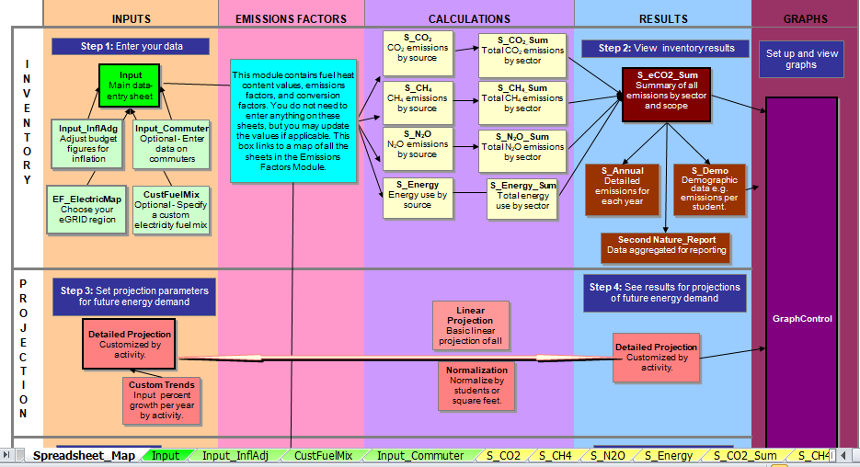
Figure 2: Campus Carbon Calculator™ v9.0

3.1. University operational and organizational data
Information about the organizational/spatial boundary was focused mainly on AUW’s temporary campus (20A, 20B, 20C, 20H, 20G and 20J), rented academic buildings (Sun Valley UG Campus) and residential flats accommodating students, faculty and staff (Continental 2, Tams Tower, and Khulshi flat). Operational data was taken based on closely-related university based operations (utility bills paid for electricity consumption). The university is located in Chittagong covering 4,34,303 square feet of area.

Operational data was based on the university’s activities:
- Scope 1 - Direct emissions from university owned fleet (gasoline and diesel), and other on-campus stationary sources (generators/co-generation machines and cooking gas).
- Scope 2 - Indirect emissions associated with purchased electricity.
- Scope 3 - Other indirect emissions related to commuting (students, and faculty/staff), air travels for AUW related activities (study abroad travel, and international student’s air travel to/from home), paper usage, and emissions generated from university’s solid wastes.
- Offsets - Forest preservation by the university (owned land).

The GHG protocol mainly focuses on Scope 1 and 2 emissions, leaving Scope 3 as optional. However, this study has shown a variety of ranges in Scope 3 emissions, to attain emissions reports on Scope 3 as well and try to minimize emissions.

3.2. Inventory Procedure and Data Sources
Data was collected from the concerned people of different departments. Institute’s operational and organizational data were collected through email and direct meetings with the people. Sections below shows the procedure followed to receive and calculate the required for every source of the university carbon footprint.

3.2.1. Institutional Data
Numbers of student population (both full time and day-scholars) were taken from the university’s Academic Registry Office and Dean of Students. Faculty population was counted from the university website, and staff population was obtained from the Dean of Students. The total building space was provided by the Maintenance Officer.

3.2.2. Scope 1
3.2.2.1. Vehicle Fleet
Vehicle fleet was categorized by fuel type (for example diesel, gasoline, natural gas) by the inventory calculator. In FY2022, AUW had a total of eight vehicles both licensed and rented. Fuel used per day was taken from the AUW drivers, since they have an idea about the amount of fuel taken and used. During the vacations, van and pick-up truck schedules remain the same as Fridays and Saturdays since most of the students remain in Bangladesh. Buses were assumed to be used twice a week and the car was assumed to be used once a day. Miles covered each day by each type of vehicle was obtained from the drivers as there were no official records kept. Accordingly, for the whole year the amount of vehicles gasoline and diesel fleet used were calculated in liters. Later, the values were converted to gallons as per the module.

3.2.2.2. Other On-campus Stationary Sources
AUW uses generators and household gas which are categorized as on-campus stationary sources. Other than electricity purchasing, the university burns diesel to meet electricity demand in case of power failures. There are altogether 11 generators installed in the buildings. The fuel usage data for one month was provided by one Maintenance Office employee. Total diesel consumed for FY2022 was calculated in liters and converted into gallons.

Natural gas used for cooking purposes at AUW was difficult to obtain with no records being kept and unlimited supply being an issue. Based on a study conducted by a university in Bangladesh, the average consumption was estimated to be 0.15422 m³/person/day (Habib, Elahi & Khandaker, 2016). The study included a total number of 300-550 dine-in students. Taking this into consideration and the study done in FY2017, the fuel usage for the total population each day was calculated. Academic holidays, one month of summer and winter vacations were considered for the calculation. Total natural gas consumption was found in m³ and converted into MMBTU (1 m³ of natural gas generates 0.0366 MMBTU) before inputting in the calculator.

3.2.3. Scope 2
3.2.3.1. Purchased Electricity
AUW’s electricity was purchased from the M.A Aziz Stadium in Kazir Dewri, Chittagong. Purchased electricity data for one month was obtained in terms of money (take - Bangladesh currency) from the Maintenance Office, which was available for each building. An average amount of the electricity bill was taken for each month. The average amount per kWh was estimated to be 6.20. Total electricity consumption in kWh was calculated for one month and to get the annual data it was multiplied with 12 and using the national precise-mix of Bangladesh (Bangladesh Economic Review 2022). No steam or chilled water were purchased by the university. Certain electricity is lost in the transmission and distribution to the end user. The total transmission and distribution (T&D) losses is included in Scope 3 emissions of the calculator.

3.2.4. Scope 3
3.2.4.1. Commuting
Student and faculty/staff commuting was the most difficult component to obtain information. It required average miles traveled by the daily commuters to and from the academic buildings. There was no information found related to trip distance and transportation used. Only information received was the number of commuters from the Academic Registry Office and the Dean of Students. Data was collected through direct meetings with the daily travelers, 20 students of day scholars were surveyed, 8 faculty members, and 20 staff members. The calculator needs information about the number of daily commuters, number of trips per week, percentage of mode of transportation used by the commuters, and percentage distance covered by each mode.

Questions asked were as followed:
- Where do you stay (given exact distance if you know)?
- Which mode of transportation do you use (example: CNG taxi, car, rickshaw?
- How many one-way trips do you make for one week?
(Distances were calculated for commuters who could not give the distance).

There was no section for CNG taxi in the calculator, the coefficient for this automobile was modified in the module. It was found that CNG releases 20% less emissions compared to other fuel-based vehicles (NGVA Europe, 2017).

3.2.4.2. Study Abroad Air Travel
This type of travel was mainly related to the one semester exchange program to other countries. Information about exchange students, mainly the number of students, was collected from the Center for Career Development and International Programs. Trip miles data was not recorded by this department of the university. It was assumed that they traveled from Dhaka airport to the airport of the exchange country, which were calculated by Air Miles Calculator tool and inputted in the CCC (https://www.airmilescalculator.com/ ).

3.2.4.3. International Students’ Air Travel To/From Home
A large population of International students come each year to study in AUW. This section was kept as optional in the CCC, however, estimation of the trip miles will give a more accurate value of the Carbon Footprint result. Records regarding the trip distance of students from each country were not found as most of the students book their own tickets. Number of students per country in FY2022 was taken from the Academic Registry Office and trip miles were calculated from Dhaka airport to the airport of each capital city using the Air Miles Calculator (https://www.airmilescalculator.com/ ).

3.2.4.4. Paper
In FY2022, printing papers and tissue papers were used. The Housekeeping Office provided information about the number of toilet rolls used and unit weight of one toilet roll. These two values gave the amount of toilet papers purchased in kg. The Office of Students Activities (OSA) mainly deals with printing papers, however, they did not keep any record regarding the amount of paper used. Printing paper used was found based on the result from the Carbon Footprint report of FY2017. Estimating that as the population increased approximately by 2 times that of 2017, thus the amount of paper usage was also doubled. This data was multiplied by the unit weight and the result obtained was in kg. The total paper usage was added and converted in lbs to input in the CCC. OSA provided information about year planners and notebooks distribution getting canceled because of wastage.

3.2.4.5. Solid Waste
No departments could provide data regarding tons of solid waste collected each day. Only data that was acquired was approximately 2-3 kg of waste being collected from each floor and the mass of one whole big plastic bag of waste (approximately 10-12 kg). The cleaners and dining food servers provided these data respectively. For each building approximate wastes per each floor each day in kg was calculated along with dining wastes. Total solid wastes in kg for all the buildings were added and converted into short tons. This data was inputted in the column no methane recovery, since all the wastes are land-filled.

3.2.5. Offset
The CCC has four categories of offsets namely on-campus composting, forest preservation, purchasing renewable energy credits (RECs), and off-campus carbon reduction projects. Carbon offsets help reduce the total emissions. It has been assumed that forest reservation carbon offsets is being done by AUW in its owned property. Offset data was not provided by any of the departments, thus it was calculated based on the 2017 carbon footprint data. It was found that 60% of the land in 2017 was natural forest and undergrowth jungle and the offset was 765 MT CO₂e,. Assuming that construction on the land has increased from 2022, the forest preservation has also decreased, estimating it to be 45%.

- RESULTS
4.1. Overview of the results
During the 2022 academic year (FY202), there were 1269 students in total, of which, 997 students lived in AUW dormitories and 272 students were Day Scholars (either have houses in Chittagong or do not stay in the university dorms). There were 97 faculty and 100 staff. These numbers made up the total AUW community of 1466 people.

The University’s building space occupies approximately 9.97 acres, that is equal to 4,34,304 square feet in Chittagong. This whole area includes the AUW’s temporary campus, and the rented academic and residential buildings and flats. The buildings include: 20A, 20B, 20C, 20H, 20G, 20J and Sun Valley, and off-campus Continental 2, Tams Tower and Khulshi flats. Construction is going-on to build a permanent campus on an area of 143 acres. It was supposed to start from 2020, however due to COVID-19 pandemic the construction work got delayed. All work re-started from January 2022. The foundations are in preliminary stages, thus the area was not included in the building space input and information regarding the operations was unknown. Only the net sequestration of the forests on the land is included in the offset category of the calculator. Table 2 shows the institutional data of AUW in FY2022.

Table 2: Institutional data and normalized emissions of AUW in FY2022
Students | Faculty | Staff | Total Building Space (square feet) | Emissions per capita (MT CO₂e) | Emissions per square feet (MT CO₂e)
1269 | 97 | 100 | 4,34,303 | 11.4 | 0.04

In FY2022, the total GHG emissions of AUW were 14,488.7 MT CO₂e. When considering emission demographics, averaged AUW’s carbon footprint per person (faculty, staff, and students) was 11.4 MT CO₂e. Considering the building space, it was 0.04 MT CO₂e per square feet (Table 2). Of this total, CO₂ emissions were 13,978,986.6 kg CO₂, CH₄ emissions were 15,485.5 kg CH₄, and N₂O emissions were 267.0 kg N₂O. Of these amounts, 292.4, 11756.6 and 2439.7 MT CO₂e, respectively, are attributed to Scope 1, Scope 2 and Scope 3 sources. The contribution of each scope is shown in the pie chart in Figure 3.

The major emission sources of AUW’s carbon footprint were purchased electricity (81.14%), scope 2 T&D losses (7.38%), international students’ travel to/from home (5.37%), solid waste (2.63%), and other on-campus stationary (1.78%). These results suggested that the biggest opportunities for reducing campus GHG emissions are related to these categories. Other categories such as commuting, paper usage, direct transportation, and study abroad air travel each accounted for less than 1 percent of emissions and did not affect total emissions greatly. The contribution of each source is illustrated in the pie chart in Figure 4.

The calculated offsets due to the natural forest preservation of the main campus was assumed and calculated from the previous data. The offsets were 574 MT CO₂e. This suggests that forest preservation had a tiny significant role in reducing emission of AUW because the net emissions after offset were only 13914.7 MT CO₂e, 0.96 times less than the total emissions. The total emissions and net emissions were illustrated together in Figure 5.
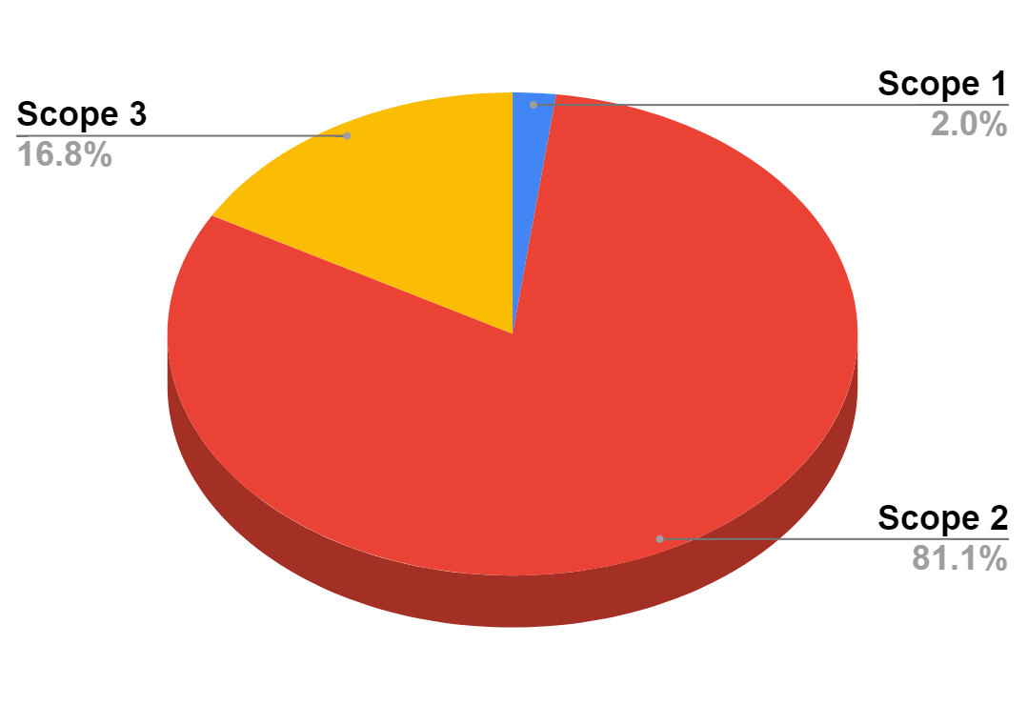
Figure 3: Total emissions by scope of AUW in FY2022

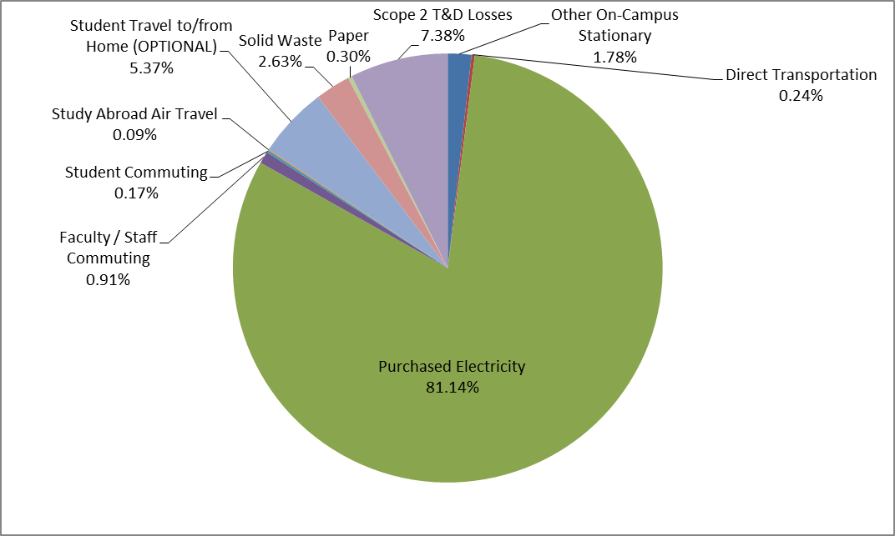
Figure 4: Total emissions by source of AUW in FY2022
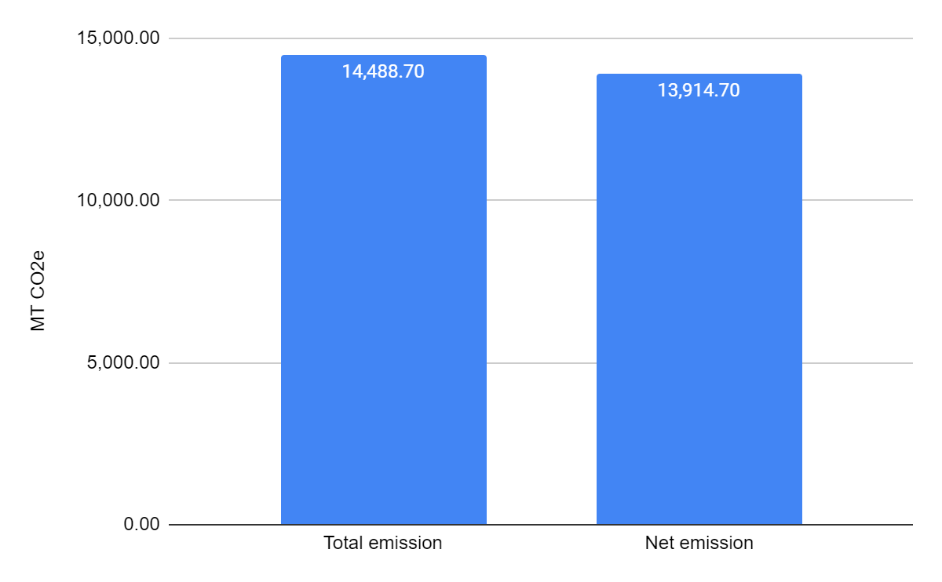
Figure 5: Total emission and net emission (with offset) of AUW in FY2022

4.2. Emissions by Categories
4.2.1. Scope 1
4.2.1.1. Direct Transportation
AUW had eight registered and rented vehicles, details of the vehicles are illustrated in Table 3. The university fleet is used for different purposes such as transporting faculty and students to and from campus, loading and unloading food containers for 4 times a day (breakfast, lunch, tea, and dinner), travel for university related events, and delivering different maintenance related items. Of these vehicles, car and all the vans are gasoline powered, and the buses and pick-up trucks are diesel powered.

The amount of fuel purchased for the whole FY2022 is shown in Table 4 below. In FY2022, AUW purchased 7700 liters of gasoline and 6324 liters of diesel. The total emissions of the fleet was 35.1 MT CO₂e. This contribution to the overall carbon footprint was minimal, only 0.24% of the total emission.

Table 3: Asian University for Women Transportation Vehicles
Vehicle Type | Fuel Type
Pick-up truck | Diesel
Pick-up truck | Diesel
Van | Gasoline
Van | Gasoline
Van | Gasoline
Car | Gasoline
Bus | Diesel
Bus | Diesel

Table 4: Amount of fuel purchased for AUW’s direct transportation (university fleet) in FY2022
Fuel type | Amount purchased (in liters) | Amount purchased (in gallons)
Gasoline | 7700 | 2035
Diesel | 6324 | 1670
Total CO₂e emitted | 35.1 MT

4.2.1.2. Other On-campus Stationary
AUW’s on-campus stationary sources of GHG emissions include the electric generators and cooking gas used in residence kitchens.

In FY2022, University’s generators consumed 12522 gallons (47400 liters) of diesel to meet the electricity demand during the times of power-cut.

In AUW, mass cooking is practiced in the residence buildings to meet the demand of most students, faculty and staff. Using the average consumption 0.15422 m3/person/day for mass cooking in a study done in a Bangladeshi university student hall, it was estimated that AUW’s kitchens consumed 66469 m³ of natural gas (equivalent to 2432 MMBTU) to prepare food for about 1466 people each day in normal academic periods; and about half of that population during national holidays, semester breaks, and long vacations (one month of winter break and one month of summer vacation) in FY2022.

Overall, these two on-campus stationary fuel sources emitted 257.3 MT CO₂e, representing 1.78% of the total carbon footprint.

4.2.2. Scope 2
4.2.2.1. Purchased Electricity
All the buildings are connected independently to Kazir Dewri, M.A. Aziz Stadium’s grid and bills are paid for the usage directly. Electricity bills of all the buildings were provided on a monthly basis by the Maintenance Office of the university. Information regarding the grid fuel mix was not included on the website, thus the general precise mix for Bangladesh in 2022 was taken into account for accurate estimation. Natural gas, coal, oil, hydroelectric, and imported power are some of the multiple fuel sources that power plants in Bangladesh use. Depending on several factors, the sources of grid fuel mix changes yearly. In 2022, the precise mix of sources was 51.35% natural gas, 27.46% furnace oil, 8.01% coal, 5.85% diesel, 5.26% power imported, 1.04% hydropower, and 1.04% renewable energy (Bangladesh Economic Review 2022). In FY2022, the university purchased 20903226 kWh in total which emitted 11756.6 MT CO₂e. This made up 81.14% of the total carbon footprint of AUW in FY2022.

Certain percentages of electricity generated at the power station is lost due to transmission and distribution to the end customer. Scope 2 transmission and distribution (T&D) losses from consumed electricity is included in the Scope 3 emissions of the calculator. In FY2022, transmission and distribution (T&D) losses generated 1068.7 MT CO₂e, representing 7.38% of the total emissions.

4.2.3. Scope 3
4.2.3.1. Commuting
On a daily basis, a small portion of the total population commutes to and from the AUW campus. Students (mainly day scholars), faculty, and staff residing in Chittagong commutes regularly. Adding this commuting category in the calculation process can increase the accuracy of the results even though it is a small emission source.

Information provided by the Dean of Students and Academic Registry Office the total number of student commuters was 272, faculty and staff commuters were estimated to be 95 (Table 5). According to the academic calender and direct meetings with the commuters, it has been analyzed and assumed that faculty and students commute 10 one-way trips to and from AUW campus for 38 weeks per year, however staff commutes 10 one-way trips to and from AUW but for 48 weeks per year as they still works during academic breaks. The national holidays, academic breaks and vacations were taken into account for the calculation.

Questions were also asked about the major means of transport and the commuting distance by each of the transportations. The trip distribution by modes and trip distance for each mode are all summed up in Table 6. Faculty and staff, 10% of the faculty and staff said they drive cars, 20% take CNG taxi, 30% use buses, 20% take rickshaws, and 20% walk. For each mode listed, the data received from the faculty and staff shows that the average trip distance for car and CNG taxi is 4 miles, bus is 5 miles, rickshaw is 2 miles, and walking is 0.8 miles. Student commuters surveyed say that they either live very close to the campus or very far away, and take all modes of transportation to reach campus. It was roughly estimated that 30% of the commuting trips were by car, 20% by CNG taxi, 5% by bus, 30% by rickshaw, and 15% by walking. The average trip distance is calculated to be 1.6 miles for commuters coming by car, 1.7 miles by CNG taxi, 3.9 miles by bus, and 0.6 miles by rickshaw and by walking.

Table 5: Number of commuters and commuting trips made by AUW’s students, faculty and staff
Commuters | Number of commuters | One-Way Trips / Week | Weeks / Year
Faculty | 15 | 10 | 38
Staff | 80 | 10 | 48
Students | 272 | 10 | 38

Table 6: Trip mode distribution and trip distance of AUW’s commuters
 | Trip Distribution (% Trips by Mode) |  |  |  |  | Trip Distance (Mile per One-Way Trip for Each Mode)
 | Car | CNG  taxi | Bus | Rickshaw | Walk | Car | CNG  taxi | Bus | Rickshaw | Walk
Faculty and Staff | 10 | 20 | 30 | 20 | 20 | 4 | 4 | 5 | 2 | 0.8
Students | 30 | 20 | 5 | 30 | 15 | 1.6 | 1.7 | 3.9 | 0.6 | 0.6

In FY2022, university’s student commuting generated 25.2 MT CO₂e, which represents only 0.17% of the total carbon footprint. Faculty and staff commuting emitted 131.3 MT CO₂e, contributing 0.91% of the total emissions. The amount of carbon dioxide emitted from student commuting was 5.35 times less than faculty and staff commuting, it is due to the trip distance which is more for the faculty and staff between their residential houses and campus. In addition, the staff also have to commute more days in a year.

4.2.3.2. Study Abroad Air Travel
Every year, some students get selected for exchange programs in different countries across Asia and Europe. In FY2022, it was found from the record provided by Center for Career Development and International Programs (CDIP) that six students went for exchange programs, out of which 3 students went to Italy, 2 in France, and 1 in South Korea. Considering that they traveled from Dhaka airport to the airport of the capital cities of their respective exchange countries, the trip miles were added in the CCC. Detailed information of the exchange population and flight distance are illustrated in Table 7. In FY2022, study abroad travel accounted for 12.4 MT CO₂e, representing 0.09% of the total carbon footprint.

Table 7: Population of students country wise and air miles traveled in FY2022 (each student traveled in Fall 2022 and came back in January 2023)

Country | No. of Students | Air Miles for 1 one-way trip | Total Air miles traveled
Italy | 3 | 4539 | 13617
France | 2 | 4905 | 9810
South Korea | 1 | 2345 | 2345
Sum |  |  | 25772 miles
Total CO₂ emitted | 12.4 MT CO₂ e

4.2.3.3. International Students’ Air Travel To/From Home
AUW encourages and intakes students from 18 different countries. Air Travel of International students includes a high proportion of the total carbon emissions. International student population is about 59.8% of the total student population at the university. Detailed information about this air travel was difficult to obtain from any of the university departments, since most of the students book the flight tickets by themselves. Assuming that the students took a one-round trip flight last year and traveled from Dhaka airport to the airport of the capital cities of their respective home countries, the trip miles were added in the CCC. Bangladesh residents were excluded from the calculation assuming that the students take bus or train to and from the campus. Table 8 shows the detailed information about the international population of AUW and the flight distance. In FY2022, student travel to/from home accounted for 777.8 MT CO₂ e, representing 5.37% of the total carbon emissions.

Table 8: Population of students country wise and air miles traveled per year (considering each student takes one round trip per year)
Country | No. of Students | Air Miles for 1 one-way trip | Total Air miles traveled
Afghanistan | 364 | 1473 | 1072344
Bangladesh | 510 | 0 | 0
Bhutan | 10 | 252 | 5040
Cambodia | 4 | 1272 | 10176
China | 1 | 1890 | 3780
India | 20 | 887 | 35480
Indonesia | 6 | 2350 | 28200
Laos | 6 | 883 | 10596
Myanmar | 240 (70 taking flights) | 473 | 66220
Nepal | 20 | 411 | 16440
Pakistan | 18 | 1256 | 45216
Sri Lanka | 27 | 1342 | 72468
Syria | 9 | 3303 | 59454
Timor Leste | 15 | 3254 | 97620
UAE | 1 | 2252 | 4504
USA | 2 | 8041 | 32164
Vietnam | 11 | 1001 | 22022
Yemen | 5 | 3050 | 30500
Sum |  |  | 1612224 miles
Total CO₂ emitted | 777.8 MT CO₂ e

4.2.3.4. Paper
Data regarding paper usage by AUW was taken from Office of Student Activities (OSA) and House-keeping Office. OSA provides students with printing papers and year planners, and House-keeping provides tissue paper in the campus. In addition, information regarding the notebook was taken from OSA. The amount of each time is illustrated in Table 9. Both OSA and the Housekeeping Office said no papers were reused or recycled in 2022, thus the data was inputted in the “0% recycled” column of the CCC. box. In FY2022, AUW consumed 3,1501 pounds paper items, which generated 43.0 MT CO₂e, accounting for 0.30% of the total carbon footprint.

Table 9: Paper Usage by AUW in FY2022
Item | Unit Weight (g) | Amount | Total Weight (g)
Printing Paper | 5 | 2417646 pieces | 12088230
Notebook | 227 | 0 | 0
Year Planner | 240 | 0 | 0
Tissue Paper | 88 | 25000 rolls | 2200000
Sum |  |  | 14288230 (g)  = 31501 (lbs)
Total Emissions | 43.0 MT CO₂e

4.2.3.5. Solid Waste
On a daily basis, solid waste is collected from the bins of residential and academic buildings. The wastes are kept for disposal and collected by the municipality at the end of the day. Wastes were mostly kitchen and household waste. For measurement, solid waste collected one day was taken (approximately 2-3 kg from each floor and 12 kg each huge packet of wastes). It was estimated that a total of 123 short tons of waste was sent to landfill in 2022. The total emissions from solid waste was 381.3 MT CO₂e, which represented 2.63% of the total carbon footprint of AUW.

4.2.4. Offset
The only source of offset that the university currently has is forest preservation in the Main Campus (owned land). The property was reported to be 143 acres / 57.87 ha. Since the percentage of construction/other usage on the land increased from 2017 to 2022, 45% land was estimated to be still natural forest and undergrowth jungle. Calculation of offset through CO₂ sequestration was calculated based on the data found from 2017, illustrated in Table 10. The data for offset is illustrated in Table 10. The total CO₂ offset of AUW‐preserved land indicates approximately 574 MT CO₂e.

Table 10: CO₂ offset of AUW of FY2017 and FY2022
Year | Forest Preservation (%) | Total emissions (MT CO₂e)
2017 | 60 | 765
2022 | 45 | 574

- DISCUSSION
AUW's first Carbon Footprint report calculated in 2017 showed 1.9 MT CO₂e emissions per capita. The calculated per capita emissions of AUW in FY2022 was 11.4 which is 5.79 times higher than that of FY2017. Emissions per square feet did not increase much. The net emission increased by 19.1 fold compared to that of 2017. There are huge changes in emissions per scope. In 2017, Scope 3 was the highest contributor. Scope 2 emissions for 2022 is the highest contributor towards the net carbon footprint, increased by great extent (45.8 times than 2017 Scope 2 emissions).

Table 11: Comparison of carbon footprint of 2017 and 2022
Year | Scope 1 | Scope 2 | Scope 3 | Net emission
2022 | 292.40 | 11,756.60 | 2,439.70 | 13,914.70
2017 | 129 | 256.8 | 1106.8 | 727.6

It does not seem very practical to compare the university’s carbon footprint with other universities, however, comparison has been done with two other universities from Asian countries. AUW’s carbon footprint is not the highest when compared with Table 12. It is mainly due to the varying organizational and operational data, different approaches being taken to find out the carbon footprint, and emission sources added in the studies. Asian countries were chosen to show a reasonable comparison having similar climate patterns.

Table 12: Comparison of carbon footprint of different universities and AUW
Region | University Name | Total emission/ MT CO₂e | Emission per capita/MT CO₂e
Jakarta, Indonesia (Ridhosari & Rahman, 2020) | Universitas Pertamina | 1,351.98 | 0.52
Karachi, Pakistan  (Mustafa et al., 2022) | NED University of Engineering and Technology | 21,500 | 1.79

The major sources of emissions from AUW was purchased electricity (81.14%), international students’ air travel to/from home (5.37%), solid waste (2.63%), and other on-campus stationary (1.78%). This suggests that immediate action is required in these categories of emissions.

There could be many reasons for the rise of emissions. As the total population of AUW has increased, more resources are being used by the community be it transportation or electricity. Accommodating the population more academic and residential buildings are taken on rent to provide a quality education and living conditions. Electricity consumption has risen and an increase in the number of rooms and room sizes. However, lights, fans, and AC are turned on even when not in use. Solid waste being generated every now and then, are just dumped on the dumping site without any methane recovery. Carbon offsets will decrease more with expanded construction

Immediate action must be taken to reduce the GHG emissions. New plantation activities can be done in all the buildings to increase offset. Additionally, reforestation in areas of the AUW-owned campus can be done in areas where there are no plants. To reduce Scope 2 emissions, energy conservation must be done through checking and switching off lights, fans, ACs when not required. Moreover, renewable energy can be adopted by using solar rooftop in the permanent campus/rented campus. Energy efficiency can be obtained by purchasing green electricity. Energy efficient lights (LED) can be installed, and AC can be set to 24 degree Celsius (standard temperature). Solid waste can be turned from trash to treasure, and a composting method can be used. Cooking burners can be turned off when not required to reduce emission from other on-campus stationary sources.

- LIMITATION
Most of the data was not found from any records of AUW, even though it was the second time of calculating the carbon footprint of the university. Whenever there was a chance to get exact data, it was not given due to confidentiality. Asking for in range data was a technique applied to obtain information from the departments. Most calculations were based on educated guesses based on 2017 findings. Some Scope 3 data like off-campus activities (commuting by population to different other places), and upstream GHG emissions (cement production. Data regarding Chayaneer dormitory and AUW-owned land (Main campus) was not obtained from the departments. Apart from these, Bangladesh’s most of the emission factors are not updated, calculations were made based on the CCC.

- FUTURE DIRECTION
AUW should continue calculating the carbon footprint report for each year. This will bring awareness among the community members, helping in reducing emissions. Lack of records delayed the data collection procedure. Each department of the university should start keeping both manual and computerized databases of the records for example air travel, university fleet, solid waste. This will help in obtaining the data smoothly and efficiently, easily providing an accurate result.

Many alumni of the university are doing jobs in good sustainability companies. They can be hired to give solutions to the increased carbon emissions. There are different departments in AUW, but it lacks a sustainability office. This office can be setted and the officer can gather information from every other department and keep records within that office. This would bring in a more feasible data collection and calculation of the carbon footprint. Even this officer can calculate the carbon emissions and immediate solutions can be proposed.

Findings from this study and the previous study can be used to promote awareness with actions among the community members through workshops and setting certain rules that are necessary for reducing emissions. AUW can be a good example to other universities in the locality in calculating its carbon footprint every year and adapting with the mitigation measures.

- CONCLUSION
This study presents the second Carbon Footprint report of AUW after 2017. The results show emissions from each activity, giving the major sources of carbon emissions. Comparisons were made with the first inventory report of AUW and two other universities in Asian countries.
Previous studies were first reviewed to get an idea about carbon footprint, emission sources, and major emission sources. Literature reviews concluded that Scope 3 is the highest contributor. The tool used had different sections for each scope where data was inputted in converted units. The annual module showed the carbon footprint data from each source.

Results showed major sources of emissions for FY2022, Scope 2 being the highest. The findings suggest that different strategies must be introduced to reduce the increased emission of AUW in 2022 compared to that of 2017. Carbon offsets have become an important way to decrease the net emissions. Different plantations and reforestation can be used to increase offsets of the university. Step by step moving towards the mission of a green campus.

REFERENCES
Amaral, A. R., Rodrigues, E., Gaspar, A. R., & Gomes, Á. (2020). A review of empirical data of sustainability initiatives in university campus operations. Journal of Cleaner Production, 250, 119558. https://www.sciencedirect.com/science/article/abs/pii/S0959652619344282.
Bangladesh Economic Review 2022. https://mof.portal.gov.bd/sites/default/files/files/mof.portal.gov.bd/page/f2d8fabb_29c1_423a_9d37_cdb500260002/19_BER_22_En_Chap10.pdf
Braham, W., & Waegel, A. (2016). The University of Pennsylvania Health System Main Campus Carbon Footprint. Weitzman - School of Design University of Pennsylvania. https://www.design.upenn.edu/sites/default/files/Guide%20to%20Plotting%20in%20Meyerson_2022.pdf.
Čuček, L., Klemeš, J. J., & Kravanja, Z. (2012). A review of footprint analysis tools for monitoring impacts on sustainability. Journal of Cleaner Production, 34, 9–20. https://doi.org/10.1016/j.jclepro.2012.02.036
CMU. (2008). It’s Not Easy Being Green Assessments and Strategies for Sustainable Institutions. Carnegie Mellon University. https://www.cmu.edu/environment/energy-water/documents/complete-report-2010-final.pdf
Dountio, E.G., Meukam, P., Tchaptchet, D.L.P, Ango, L.E.O, Simo, A. (2016). Electricity generation technology options under the greenhouse gases mitigation scenario: Case study of Cameroon. Energy Strategy Reviews; 13–14(); pp. 191–211. https://doi.org/10.1016/j.esr.2016.10.003.
Dove, I., Dunn, M., & Froelich, M. (2018). Colgate University’s 2008-09 Comprehensive Carbon Inventory. https://www.colgate.edu/about/sustainability/sustainability-news/2018-greenhouse-gas-emissions-inventory
Dragomir, V.D. (2012). The disclosure of industrial greenhouse gas emissions: a critical assessment of corporate sustainability reports. Journal of Cleaner Production, 29-30: 222–237. https://doi.org/10.1016/j.jclepro.2012.01.024
Galli, A., Wiedmann, T., Ercin, E., Knoblauch, D., Ewing, B., & Giljum, S. (2012). Integrating Ecological, Carbon and Water footprint into a “Footprint Family” of indicators: Definition and role in tracking human pressure on the planet. Ecological Indicators, 2012: 100–112. https://doi.org/10.1016/j.ecolind.2011.06.017.
Gómez, N., Cadarso, M. A., & Monsalve, F. (2016). Carbon footprint of a university in a multiregional model: the case of the University of Castilla-La Mancha. Journal of Cleaner Production, 138, 119-130. https://www.sciencedirect.com/science/article/abs/pii/S0959652616306771.
Grindsted, T. (2011). Sustainable universities–from declarations on sustainability in higher education to national law. Environmental economics, 2(2). https://papers.ssrn.com/sol3/papers.cfm?abstract_id=2697465.
Habib, M. M. L. M. L., Elahi, S. R., & Khandaker, N. R. (2016). To Investigate the Scale of Natural Gas Consumption for Mass Cooking Per Person Per Day in Bangladesh. DEStech Transactions on Environment, Energy and Earth Science. doi.10.12783/dteees/peem2016/5040
Huynh, T. T. C. (2017). Calculating the Carbon Footprint of a University Located in an Asian Developing Country.
Li, X., Tan, H., & Rackes, A. (2015). Carbon footprint analysis of student behavior for a sustainable university campus in China. Journal of Cleaner Production, 106(), pp. 97-108. https://www.sciencedirect.com/science/article/abs/pii/S0959652614013857.
Lima, M.A., Mendes, L.F.R., Mothé, G.A., Linhares, F.G., de Castro, M.P.P., da Silva, M.G., Sthel, M.S. (2020). Renewable energy in reducing greenhouse gas emissions: Reaching the goals of the Paris agreement in Brazil. Environ Dev 33. https://doi.org/10.1016/j.envdev.2020.100504.
Madasu, P. (2019). Assessing the Carbon Footprint of Virtual Institute of Management Studies (VIMS). Global Management Review; 13(1), pp. 58-65. https://www.researchgate.net/profile/Pardhasaradhi-Madasu/publication/350762869_Assessing_the_Carbon_Footprint_of_Virtual_Institute_of_Management_Studies_VIMs/links/607050da299bf1c911babd05/Assessing-the-Carbon-Footprint-of-Virtual-Institute-of-Management-Studies-VIMs.pdf.
Matthews, H.S., Hendrickson, C.T. and Weber, C.L. (2008). The importance of Carbon Footprint estimation boundaries. Environmental science & technology, 42(16): 5839–42. https://doi.org/10.1021/es703112w
Mustafa, A., Kazmi, M., Khan, H. R., Qazi, S. A., & Lodi, S. H. (2022, January 11). Towards a carbon neutral and sustainable campus: Case study of ned university of engineering and technology. MDPI. https://www.mdpi.com/2071-1050/14/2/794/htm
NGVA Europe. (2017). Greenhouse gas intensity of natural gas. http://www.energigas.se/library/1850/andrea-gerini.pdf
Opel, O., Strodel, N., Werner, K. F., Geffken, J., Tribel, A., & Ruck, W. K. L. (2017). Climate-neutral and sustainable campus Leuphana University of Lueneburg. Energy; 141(), pp. 2628-2639. https://www.sciencedirect.com/science/article/abs/pii/S0360544217314172.
Osorio, A.M., Úsuga, L.F., Vásquez, R.E., Nieto-Londoño, C., Rinaudo, M.E., Martínez, J.A., Leal Filho, W. (2022). Towards Carbon Neutrality in Higher Education Institutions: Case of Two Private Universities in Colombia. Sustainability, 14, 1774. https://doi.org/10.3390/su14031774.
Pandey, D., Agrawal, M., & Pandey J.S. (2011). Carbon footprint: current methods of estimation. Environ Monit Assess, 178(1-4), 135–160. https://link.springer.com/article/10.1007/s10661-010-1678-y
Patterson, M., McDonald, G., & Hardy, D. (2017). Is there more in common than we think? Convergence of ecological footprinting, emergy analysis, life cycle assessment and other methods of environmental accounting. Ecological Modelling, Elsevier, vol. 362(C), pages 19-36. https://ideas.repec.org/a/eee/ecomod/v362y2017icp19-36.html
Ranganathan, J., Corbier, L., Bhatia, P., Schmitz, S., Gage, P., & Oren, K. (2004). A corporate accounting and reporting standard (revised edition). Washington, DC: World Resources Institute and World Business Council for Sustainable Development. The greenhouse gas protocol. http://www.ghgprotocol.org/corporate-standard
Rees, W., & Wackernagel, M. (2008). Urban ecological footprints: why cities cannot be sustainable and why they are a key to sustainability. Urban ecology; pp. 537-555. https://link.springer.com/chapter/10.1007/978-0-387-73412-5_35?noAccess=true.
Ridhosari, B., & Rahman, A. (2020). Carbon footprint assessment at Universitas Pertamina from the scope of electricity, transportation, and waste generation: Toward a green campus and promotion of environmental sustainability. Journal of Cleaner Production, 246, 119172. doi:10.1016/j.jclepro.2019.119172
Robinson O.J., Tewkesbury A., Kemp S., Williams I.D. (2018). Towards a universal carbon footprint standard: A case study of carbon management at universities. Journal of Cleaner Production; 172(); pp. 4435–4455. https://www.sciencedirect.com/science/article/pii/S0959652617303736.
Sprangers, S. (2011). Calculating the carbon footprint of universities. Unpublished Master’s thesis in economics and informatics. [Google Scholar]
UCC (2017). Annual Sustainability Report. University College Cork. https://www.ucc.ie/en/media/support/sustainabilityandclimateaction/UCC-Annual-Sustainability-Report-17-18(1).pdf
US EPA. (2022). Inventory of US Greenhouse Gas Emissions and Sinks: 1990-2005. https://www.epa.gov/ghgemissions/inventory-us-greenhouse-gas-emissions-and-sinks-1990-2005.
Vázquez-Rowe, I., Villanueva-Rey, P., Mallo, J., De la Cerda, J. J., Moreira, M. T., & Feijoo, G. (2013). Carbon footprint of a multi-ingredient seafood product from a business-to-business perspective. Journal of Cleaner Production; 44; pp. 200-210. https://www.sciencedirect.com/science/article/abs/pii/S0959652612006439.
Wackernagel, M., Schulz, N.B., Deumling, D., Linares, A.C., Jenkins, M., Kapos, V., Monfreda, C., Loh, J., Myers, N., Norgaard, R. and Randers, J. (2002). Tracking the ecological overshoot of the human economy. Proceedings of the National Academy of Sciences, 99(14), pp.9266-9271. https://doi.org/10.1073/pnas.142033699
Wiedmann, T., & Minx, J. (2008). A definition of ‘carbon footprint’. Ecological economics research trends; 1(); pp. 1-11. https://books.google.com.bd/books?hl=en&lr=&id=GCkU1p_6HNwC&oi=fnd&pg=PA1&ots=D1D_FG8mRm&sig=Z9NJPwkriy5Qn2zUemS6kK49OHk&redir_esc=y#v=onepage&q&f=false.
Yañez, P., Sinha, A., Vasquez, M. (2019). Carbon Footprint Estimation in a University Campus: Evaluation and Insights. Sustainability, 12(1), 181–. https://doi.org/10.3390/su12010181

