

Prevalence and Determinants of Polycystic Ovarian Syndrome among
Young University Women: A Cross-Sectional Study

A Senior Thesis Submitted
for partial fulfillment of

Bachelor of Science in Public Health

Puja Barua

Supervisor
Professor Mohiuddin Ahsanul Kabir Chowdhury, PhD
Co-Supervisor
Professor Nazmul Alam, MPH, DrPH

9 May, 2023

ACKNOWLEDGEMENT
Firstly, I must express an enormous gratitude to my thesis supervisor Dr. Mohiuddin Ahsanul Kabir Chowdhury (MAK) for his tremendous support and help. A special thanks to my co-supervisor Dr. Nazmul Alam whose insight has been greatly appreciated. Without their steadfast direction, it would not have been feasible to complete my thesis. Their constructive criticism, feedback, and inquiries have pushed us to think critically and put in more effort to finish my thesis project.
Also, I want to express our sincere gratitude to the Department of Public Health for giving us the chance to conduct the study and for supporting us financially.
Lastly, I would not have accomplished my work without the constant support of my family members, friends and well-wishers, everyone supported and motivated me to complete my thesis the entire time.

Table of Contents
Content Page No.
Acknowledgement………………………………………………………………………………….…2
Abstract……………………………………………………………………………………...…….….4

1. Introduction
1.1 Background……………………………………………………………………………….… 5
1.2 Literature Review…………………………………………………………………..…….…6-9
1.3 Research Aims and Objectives……………………………………………………..…….… 9

2. Methodology
2.1 Study Design …………………………………………………………………………….… 10
2.2 Study Site…………………………………………………………………………...…….… 10
2.3 Study Population………………………………………………………………………….… 10
2.4 Sample Size……………………………………………………………………………….… 10
2.5 Sampling Method………………………………………………………………….…….…. 11
2.6 Data Collection Method ………………………………………………………………….… 11
2.7 Data Management and Analysis …………………………………….…………………….... 11
2.8 Dissemination Plan………………………………………………………….………………. 11
2.9 Ethical Consideration……………………………………………………….……………...... 11
- Results………………………………………………………………………….……………….. 11-19
- Discussion…………………………………………………………………….………………….19-21
- Limitation…………………………………………………………………….………………… 21
- Conclusion and Recommendation………………………………………….…………………. 22-23
- Reference………………………………………………………………………………………… 24-26

Abstract
Background: Polycystic ovarian syndrome (PCOS), known as most widespread endocrinological disorder, affects 5–10% of women of reproductive age. In adult women, PCOS prevalence range is from 2.2% to 26%. In a recent study, the proportion of adolescents with a verified diagnosis of PCOS ranged from 5 to 15% to 10 to 22%. Women who had not yet been identified but had symptoms that met NIH (National Institute of Health) criteria for PCOS were included. PCOS is a complex endocrine condition that most frequently affects women who are fertile. Since the diagnostic criteria for PCOS in the adolescent age group are still being developed, it is unknown how common PCOS is in adolescents. PCOS symptoms also frequently coincide with those of normal pubertal development, making a diagnosis even more difficult. Studying the prevalence and determinants of polycystic ovarian syndrome (PCOS) in adult university women is the main objective of this study.
Objective: This study objective was to identify the prevalence and determinants of polycystic ovarian syndrome among young university women
Methods: A total of 300 participants aged 18-25 years old from studying in three different universities of Chattogram were sampled. Systematic random sampling was used to select potential participants. A list of young women was gathered from the study site and the sample from 3 different universities was divided equally. Data was collected through questionnaires and surveys.
Results: The study observed that 24.7% women had PCOS meaning 74 women out of 300 answered yes that they have PCOS according to their medical diagnosis. Students who participated in the study were mostly aged from 18 to 25 years old where 58% women were 23 years old which is the highest and 12.3% women were 24 years old and the rest of the age was below 10%. The percentage of married women was 29.3 and unmarried women was 69.7. Women who had PCOS among them 40 were married and 33 were unmarried them. Clearly, age and marital status played vital roles for determinants of PCOS.
Conclusion: This study showed that women who are in their young adulthood have more tendency to get PCOS. Married women have PCOS more than unmarried ones. Menstrual irregularity, weight gain, excessive hair growth, hair loss, acne are the main problems that PCOS affected women go though. Besides, PCOS affects the quality of life as well as mental health. Therefore, there is an imminent need for raising awareness among women. It is vitally important that young women take initiative to change their lifestyle in order to prevent the long-term effects of PCOS.
Keywords: Polycystic Ovarian Syndrome (PCOS), reproductive age, heterogeneous, and metabolic

1. Introduction
1.1 Background
Polycystic ovary syndrome (PCOS), a hormonal condition that disproportionately affects women of reproductive age. The main causes of PCOS are uncertain but there are some significant symptoms including insulin resistance, abnormal gonadotropin dynamics, and androgen excess. It is the most prevalent endocrine condition in young women that raises the risk of infertility, metabolic and cardiovascular illness. Generally, this disorder affects 5-10% of women in the reproductive age. In adult women aged 18 to 45, the prevalence ranges from 2.2 percent to 26 percent (Laddad. et al, 2019). In a recent study, 5-15 percent of adolescents aged 10 to 19 years had a verified diagnosis of PCOS, which climbed to 10-22 percent. According to the criteria of NIH (National institute of Health), when undiagnosed cases with documented symptoms qualifying for PCOS, these criteria are taken into consideration.
The main characteristic of this condition is an exceedingly erratic menstrual cycle without ovulation [2]. The hypothalamus, pituitary gland, ovaries, adrenal gland, and peripheral adipose tissue are the main endocrine glands involved with PCOS, and they work in concert to produce an overall imbalance. Around the beginning of menstruation in adolescence, the majority of symptoms first arise. Some women, nevertheless, don't have symptoms until their early to mid-20s.
Understanding the many biopsychosocial and cultural implications for female metabolic and reproductive health is crucial to understanding the intricacies of a PCOS diagnosis. PCOS's pathogenesis is still not fully understood. Individual differences exist in how PCOS symptoms such polycystic ovaries, high levels of androgen hormone 3, and irregular periods emerge and are expressed. The debate over a PCOS diagnosis and course of therapy further adds to the syndrome's overall complexity at the moment. The first researchers to identify the reproductive phenomenon that would later be referred to as PCOS were I.F. Stein and M.L. Leventhal (1935).
The major finding of Stein and Leventhal's initial 1935 study was that irregular menses and polycystic ovaries had a co-relational effect. PCOS is caused by a hormonal imbalance. It is possible for the ovary to develop several tiny fluid-filled sacs or follicles (cysts), each of which contains an immature egg that will not develop to the point where it will trigger ovulation in this circumstance. This lack of ovulation alters levels of hormones such as estrogen, progesterone, FSH, LH and especially androgen. (Unluturk. et al, 2007). Androgen is a male sex hormone and its excess production in women is what mainly causes the syndrome, regardless of the presence of cysts. PCOS is a disorder that affects almost every woman in the world, and its incidence is rising all the time, including in Bangladesh.
The prevalence of PCOS was 4.6% ranging from 3.5 to 11.2% according to previous studies conducted (Begum, 2009). According to Allahbadia and Merchant (2008), high PCOS prevalence rates are estimated in nations with a high incidence of type 2 diabetes and obesity diagnoses. Despite the fact that PCOS affects women differently depending on how skinny or fat they are, 30–75% of PCOS cases struggle with being overweight or obese (Pasquali et al. 2006). Both metropolitan areas of developing countries like India and China as well as much of the developed world have been touched by these parallel trends between metabolic health disturbances and PCOS (Allahbadia and Merchant 2008). These developing countries started relying on Westernized foods and lifestyles within the last twenty years. In the next ten years, obesity prevalence could expand by up to six times, especially in India, which already has a high rate. In a developing country like Bangladesh, most people are unaware that they have the disease, they are usually diagnosed only when it causes infertility and they seek treatment from a gynecologist. It has become important to think about the symptoms and the prevalence of PCOS to aware the women of young age. This paper is going to focus on the prevalence and determinants of polycystic ovarian syndrome which will help to raise awareness among the target population that is the young women of Chattogram.

Research Question
How many of the young women population know about the PCOS and its symptoms? Does PCOS have any severe effects on the body of a young woman? Does PCOS make any changes in affected women’s lifestyle? Can PCOS affect the fertility and chances of getting pregnant?

1.2 Literature Review
Polycystic ovarian syndrome (PCOS) is a chronic condition with no known cause that was initially characterized by Stein and Leventhal in 1935. The reproductive, heterogeneous, and metabolic systems are all impacted by this disease. Also, the disease affects 8.7% to 17.8% of reproductive-age women (Zueff et al., 2012). The initial clinical symptoms of PCOS develop around adolescence. However, there is proof that the illness has genetic roots and develops in the intrauterine environment. Therefore, several investigations have demonstrated a clear influence of interleukin-6 and interleukin-10 gene polymorphisms, interferon-c, and transforming growth factor-beta1 on the emergence of PCOS despite the lack of a clear pattern of inheritance (Sóter et al., 2015). The link between intrauterine exposure, maternal androgens, and syndrome-related traits is highlighted by epigenetic exposures as another cause (Demissie et al., 2008). Ethnic differences in PCOS may be influenced by environmental variables, such as socioeconomic status and way of life.
According to a systematic review on PCOS among 4473 Indian young women (18-30). Out of 3,945 young girls, 528 had PCOS (Sharma et al., 2021). Between 2011 and 2014, four studies were conducted, followed by five from 2015 to 2018 and three from 2019 to 2020. In India, seven studies were carried out in the south zone, three in the west, one in the east, and one in the center. Solely two research used National Institute of Health (NIH) and Rotterdam criteria, nine studies only utilized Rotterdam criteria, and one study combined AES and Rotterdam criteria. All 13 of the studies were cross-sectional, with the exception of one. Six studies were conducted: two in the community, four in schools and colleges, and four in the hospital area. In order to investigate the impact of the study setting and design on the prevalence of PCOS, they performed a sensitivity analysis. PCOS prevalence ranged from 11 in a community environment with six studies to 25% in a hospital setting. In one study, the proportion of PCOS was 36% (28%-44%), but the pooled proportion in cross-sectional studies was 16% (10%-22%). Therefore, the study found a wide prevalence of PCOS in India.
In order to ascertain PCOS incidence, knowledge, and information sources in a young multiethnic community, cross-sectional research was conducted in Texas in 2020. A formal PCOS diagnosis was given to about 28.5 percent of the female respondents, while 40.5 percent of those who did not get a diagnosis experienced showed two or more symptoms that were typical of PCOS. The majority of respondents said they "Know some" or "Know little" about PCOS (66.3 percent women and 83 percent of men). The majority of women with a PCOS diagnosis (83.7%) reported getting their information from medical experts identified by education level, differences were also seen. Despite the fact that women in this research had a PCOS prevalence above the national norm (6%–12%) and were more likely to seek advice from medical experts, these figures may have been distorted since polycystic women were more likely to reply to the questionnaire. However, when creating educational materials for PCOS women, their families, and friends, ethnicity and education levels must be taken into consideration (Rao et al., 2020).
Estimates of PCOS prevalence vary widely around the globe, from 2.2% to as high as 26%. Rotterdam criteria-based community-based studies among women in the reproductive age group have shown a range of prevalence figures in a few Asian nations, from 2% to 7.5% in China to 6.3% in Sri Lanka. Studies among various Caucasian groups using NIH criteria found that 5-8% of subjects have PCOS.
Judy McCook's published Ph.D. dissertation from 2002 is one of the first thorough psychosocial examinations of women with PCOS. In this study, 128 PCOS patients from two reproductive endocrinology clinics in the Southeast of the United States Johnson City, Tennessee, and Asheville, North Carolina were examined for their psychological health and well-being. The study's participants ranged in age from 18 to 48, and their average age was 30.4.48 years. These participants were mostly classified as being white (97%), married (78%), and working full-time 77%; (McCook 2002).
In McCook's study, a survey made up of eight standardized questionnaires was used to evaluate psychosocial health and well-being. Three of the questionnaires were for emotional health [Brief Symptom Inventory (BSI), Derogates Affects Balance Scale (DABS), PCOS Health Related Quality of Life Questionnaire], three were for relationship satisfaction [Brief Index of Sexual Functioning (BISF), Index of Sexual Functioning (ISS), Dyadic 17 Adjustment Scale Statistics were used to correlate the survey's findings to hyperandrogenic hormone levels, the degree of obesity, and fertility. Despite the fact that emotional anguish was important, McCook reported in 2002 that there was little evidence that hyperandrogenic hormone levels predicted or mediated the symptoms of emotional distress, relationship satisfaction, and personal image.
Only the PCOS weight subscale was substantially and adversely correlated with BMI when it came to obesity (a greater BMI was linked to a lower perceived quality of life in the weight subscale). There was no statistically significant correlation between any of the other PCOS subscales (emotion, body hair, infertility, and menstrual issues) and fat (McCook, 2002). None of the three survey techniques employed found a connection between relationship satisfaction and obesity. There was no discernible difference between the BMI groups in terms of self-perceptions of masculinity and femininity within the personal image area. In contrast to non-obese participants, obese PCOS participants reported considerably higher levels of body dissatisfaction, which is crucial for our thesis. Obesity severity was substantially linked with greater body dissatisfaction
McCook investigated the potential effects of hyperandrogenemia, obesity, and reproductive status (independent variables) on the emotional wellbeing, relationship satisfaction, and self-esteem in PCOS-affected women. Under the broad heading of "personal image," McCook merged her inquiries into gender identity and body image. The only aspect of body image she looked at in her study (body part and overall attractiveness) was body dissatisfaction;
Regardless, this study is one of the few to specifically examine how PCOS-positive women perceive their bodies. It might be possible to better understand the links between levels of obesity and body image evaluations by conducting independent, more in-depth investigations of gender identity and body image dissatisfactions.
According to a study conducted in Bangladesh, the majority of patients (92%) were between the ages of 30-32. The patient's major (72%) or secondary (28%) complaint was infertility. Women had irregular periods in 80% of instances, were overweight in 30% of cases, and were obese in 17% of cases. 20% of patients with pelvic ultrasonography had polycystic ovaries, whereas 80% had normal ovaries. 30% of the patients had an LH/FSH ratio between 2.1-2.9, 32% had >3, and in 38% of instances, it was determined to be normal (Khanam & Parvin, 2014).
An evaluation of the Body Image Concern Inventory (BICI), the Rosenberg's Self-Esteem Scale, and PCOS clinical data was done on 300 PCOS-affected women in Kashan, Iran. Common clinical PCOS symptoms include obesity (BMI), abundant body hair (hirsutism score), acne, irregular menstrual cycles, and infertility. It is important to comprehend the mental health of patients with the illness, particularly in light of concerns with low self-esteem, poor body image, and weight, as well as irregular monthly cycles, hirsutism, and infertility. The results of this study have therapeutic ramifications and suggest that PCOS management for women should be interdisciplinary (Bazarganipour et al., 2013).
According to one study especially examined food and weight problems among 130 affluent adolescent females (16–18 years old) in Delhi, India (Chugh and Puri, 2001). These young women, who were divided into one of three groups based on their BMI: underweight, normal weight, and "obese" (overweight to obese), were given a survey designed to compare perceptions of body image and eating patterns. The findings showed that, despite worries about weight growth in each of the three groups, body image problems grew as BMI climbed. The "obese" group had dieted more, had weight loss failure less frequently than the normal and underweight groups, and was more likely to have anorexia (Chugh and Puri 2001). Since adolescence is the time when pathological habits start to take shape, it needed for additional study on body image and eating among teenagers in India. Understanding the behavioral, pathological, and developmental consequences of media, cultural, and Western influences on body image concerns and diets will be made easier with more studies like this one.
Overall, the current literature on PCOS and PGWB suggests that women with PCOS are at significant risk of dealing with psychosocial distress, such as anxiety, depression, and stress, but the etiology for these disturbances is still unknown. Because of the multiple aspects of the syndrome, such as obesity, infertility, insulin resistance, and hyperandrogenemia, it has been challenging to find direct links with psychosocial disturbances. However, it is possible that women with PCOS are more likely to experience psychosocial distress.
1.2 Research Aims and Objectives
Aim: The major goal of this research is to find out the prevalence and determinants of PCOS so that awareness can be raised among the young women of Chattogram
Objectives
● To determine the prevalence of PCOS among young women
● To discover the other health consequences created by PCOS in women
● To identify the psychological impairments of PCOS
● To explore the main factors that cause PCOS in female body
2 Methodology
2.1 Study Design
This study will be conducted through a cross-sectional method and quantitative research. The purpose of this study is to find out the prevalence and determinants of PCOS among young women as well as to observe the effect of PCOS on the female body. This study will also measure the effects of PCOS through observing the young women with PCOS.
2.2 Study Site
This study will be conducted among randomly selected females from three different universities including Chittagong Independent University, East Delta University and International Islamic University Chittagong, Bangladesh.
2.3 Study Population
Most of the women between the age of 18 to 25 are highly vulnerable to get PCOS. So, this study will be including women of the age group. It will mainly focus on the female university students who are diagnosed with or without PCOS.
2.4 Sample size
The sample size was determined by using a single population proportion formula considering prevalence of 95%. Using the formula:
Formula: n = Z²₁-α/₂ p(1-p)
d²
Here,
n = sample size,
z = z statistic for a level of confidence, (1.96)
p = expected prevalence or proportion (in proportion of one; if 5%, P = 0.5), and d = precision (in proportion of one; if 5%, d = 0.05)
the calculated sample size was 321 where I was able to take surveys from 300

2.5 Sampling Method
As this study was randomly chose its elements from the target population of female students from different universities by selecting a random starting point. So, the sampling method will be systematic random sampling.
2.6 Data collection Method
Data was collected quantitatively in the field. This study's survey was created in reference to a collection of previously published, standardized questionnaires. Its goal was to look into the prevalence of PCOS among young women, which and how the symptoms affect a woman's life. The questionnaire also asks about sociodemographic details including occupation, marital status, level of education, and membership with a particular religion. Questionnaire was spread to the university students through google forms.
2.7 Data management/ data analysis
Maintaining the participants' complete confidentiality was one of the most important aspects of data management. While filling out the questions, participants in this study had the option of remaining anonymous or revealing their identities. Participants' informed consent, incentives for participating in the study, assurances of no damage, and respect for their anonymity, privacy, and confidentiality were followed in the research. Popular data analysis program, SPSS was used to analyze the data. Also, Excel was used as another data analysis tool.
2.8 Dissemination Plan
It is crucial for me to inform people about PCOS as a researcher. In order to raise awareness among young women and the general public about the PCOS and how it affects women’s reproductive system, lifestyle and mental health. The study's findings will be disseminated through posters and report writings. This will allow people to develop proper medications and treatment to prevent the long-term effects of PCOS.
2.9 Ethical Consideration: Ethical issues such as, voluntary participation, informed consent, anonymity, confidentiality, potential for harm and results communication were taken on account to avoid any type of overlapping.

3. RESULTS
The study sample included 300 female students from 3 different universities of Chattogram who were aged between 18 to 25 years of age. Table 1 shows the socio-demographic profiles of the study population. Female who participated in the study were mostly aged 23 years of age (58%). Number of unmarried female students’ participation was higher than the married ones. Also, 71.7% women are full-time students and others are doing full time or part time jobs along with study.

Variable | Frequency | Percentage (%)
Age  18 - 22  23  24 – 25  Marital Status  Married  Unmarried  Occupation  Full time student  Part time employed  Full time employed  Unemployed | 60  174  66  88  209  215  54  24  7 | 20  58  22  29.3  69.7  71.7  18  8  2.3

Table 1: Socio demographic characteristics of the study populations

Figure 1 shows that, in a whole percentage, 24.7% females have PCOS and 75.3% female said no when asked if they have PCOS or not.
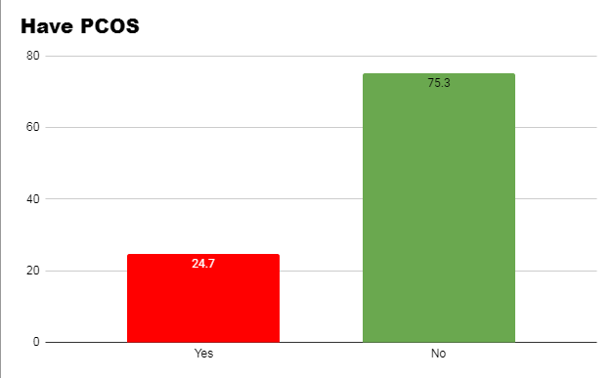
Figure 1: Women have PCOS or Not

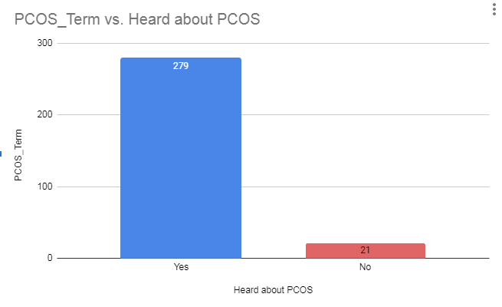
Figure 2: If women heard the term of PCOS

Figure 2 represents the number of women who have heard the term PCOS. The number of women who do not have heard of PCOS is very few which indicates that most of the young women nowadays are aware of PCOS.

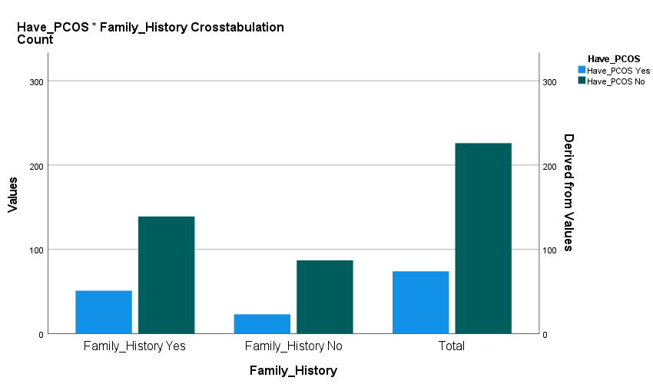

Figure 3: Women with PCOS and their family history

Figure 3 illustrates that, 51 of them have been diagnosed with PCOS and have a family history of PCOS. One of the key factors influencing the likelihood of getting PCOS is family history. According to one study findings, a woman's risk of acquiring PCOS increases by about 40% if her sister has the condition (Kahsar-Miller & Azziz, 1998).
In figure 4, causes and symptoms according to the respondents are presented, in causes, abnormal hormone level takes the lead followed by overweight issues. In symptoms, responses for all the symptoms were the most according to the young women. Although the exact etiology is unknown, PCOS frequently runs in families. It has to do with the body's aberrant hormone levels, which include elevated insulin levels (National Health Service, NHS, 2022).

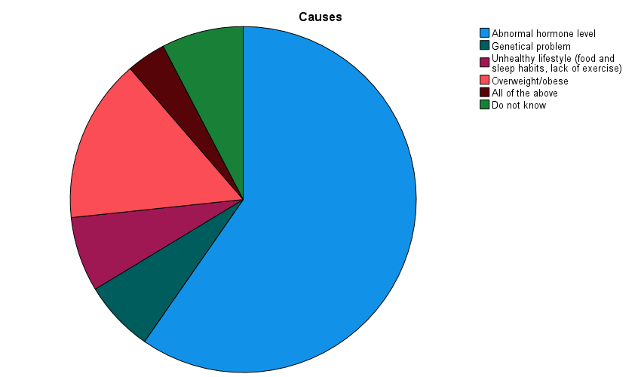
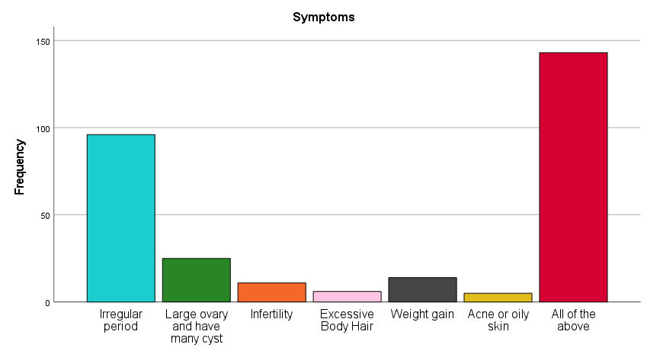
Figure 4: Causes and Symptoms of PCOS

Family History of Having PCOS | Age  18  19  20  21  22  23  24  25  19  20  21  22  23  24  25 | Have PCOS  Yes No |  | P Value
Yes |  | 1  1  2  1  1  31  6  8 | 0  1  0  12  13  87  18  8 | 0.049
No |  | 0  1  1  1  16  3  1 | 6  3  3  13  40  10  12 | 1.183

Table 2: Association between family history and women with PCOS

According to one journal, (Laddad. et al, 2019), women aged 18-45 years old have the tendency of getting PCOS, table 4 proves the same again. Here, Chi-square statistics used to examine the association between
family history, age and women who might have PCOS or not. There is a significant association with a p value of 0.049 between them which proves that women of early mid age (23 years) have family history of PCOS and they can get PCOS as well.

Marital Status | Have PCOS |  |  |  | P value
Marital Status | Yes |  | No |  | 1.56  0.138  0
Marital Status | Married | 40 |  | 48 | 1.56  0.138  0
Marital Status | Unmarried | 33 |  | 176 | 1.56  0.138  0
Marital Status | Divorced | 1 |  | 2 | 1.56  0.138  0

Table 3: Association between marital status and women with PCOS

In Table 3, in order to determine the association of marital status with having PCOS, chi square test was applied. But the p values are not statistically significant. Therefore, it illustrates that marital status does not have any significant association of getting affected with PCOS.

Menstrual Irregularity | PCOS Present (%) | PCOS Absent (%)
Menstrual Irregularity | 54 74.61 | 20 25.84
Table 4: Menstrual Cycle Irregularity

In the PCOS group, irregular menstruation was the most typical manifestation. Table 4 shows that of the 54 PCOS cases or 74.61%, had menstruation difficulties. Additionally, it was found that 20 cases of non-PCOS, or 14.51%, had menstruation complaints. These cases may have been caused by puberty changes, hormonal imbalances, or another endocrine disorder unrelated to PCOS.

Weight | Frequency | Percentage (%)
Normal | 64 | 21.3
Overweight | 129 | 43
Underweight | 74 | 24.7
Obese | 15 | 5
Don’t know | 12 | 4
Don’t want to answer | 6 | 2
Table 5: Weight
In table 5, it was observed that, those diagnosed with PCOS, 88.6% women are overweight and rest are obese. PCOS cases have higher rate of overweight patient and significantly higher BMI. Overweight women are more likely to experience reproductive issues regardless of their PCOS diagnosis. Compared to women of average weight, overweight women are more prone to experience irregular menstruation.
Clinical Manifestations | Number | Frequency (%)
Hair Loss | 256 | 85.3
Acne | 244 | 81.3
Conceive Problem | 20 | 6.7
Miscarriage | 16 | 5.3
Table 6: Clinical Manifestations

Nowadays women face different health problems associated with PCOS. Table 6 represents that 85.3% women go through hair loss. Acne related problems were observed in 81.3% young women. Then, in terms of conceiving, 6.7% women faced issues, rest of the women were not trying or not having any problem. Regarding miscarriage, 5.3% women had miscarriage. Here, Hair loss and acne problems were the most common problems faces by young women. Hirsutism, or excessive body and facial hair, alopecia, and acne are frequent signs of PCOS and are brought on by high amounts of androgen hormones. PCOS sufferers are frequently extremely distressed by these symptoms. Because PCOS causes the ovaries to generate more androgens, which increase the development of oil in the skin that acne can result. Acne on the face, back, neck, and chest is common in people with PCOS.

4. Discussion
The most significant finding of this study is that, the prevalence of PCOS among young university women which is 24.7, while the percentage is 36% in a study (Sharma et al., 2021) done among young Indian women. When the family history of PCOS was examined, it was found 51 of them have been diagnosed with PCOS and have a family history of PCOS. One of the key factors influencing the likelihood of getting PCOS is family history. According to one study findings, a woman's risk of acquiring PCOS increases by about 40% if her sister has the condition (Kahsar-Miller & Azziz, 1998). This demonstrates that PCOS is genetically predisposed. PCOS primarily affects women between the ages of 15 and 35 who are in the early to late stages of pregnancy. In the world today, PCOS affects 1 in 10 women. Female who participated in the study were mostly aged 23 years of age (58%). Number of unmarried female students’ participation was higher than the married ones.
Among the young women, 51 of them have been diagnosed with PCOS and have a family history of PCOS. One of the key factors influencing the likelihood of getting PCOS is family history. According to one study findings, a woman's risk of acquiring PCOS increases by about 40% if her sister has the condition (Kahsar-Miller & Azziz, 1998). PCOS can run in families in some cases. Women are frequently at a higher chance of acquiring PCOS if any of your relatives, such as their mother, sister, or aunt, do. Although particular genes linked to PCOS have not yet been discovered, this shows that the disorder may have a hereditary component.
Causes and symptoms according to the respondents were also included in the study, in causes, abnormal hormone level takes the lead followed by overweight issues. There is no recognized cause for PCOS. There is proof that genetics are involved. Abnormal hormonal level and overweight are the main two causes contribute to PCOS. In symptoms, responses for all the symptoms were the most according to the young women. Although the exact etiology is unknown, PCOS frequently runs in families. It has to do with the body's aberrant hormone levels, which include elevated insulin levels (National Health Service, NHS, 2022). PCOS symptoms frequently appear around the time of the first menstrual cycle. Sometimes, after having periods for a while, symptoms appear later. Also, different PCOS symptoms exist in different cases.
According to one journal, (Laddad. et al, 2019), women aged 18-45 years old have the tendency of getting PCOS, this study. Here, Chi-square statistics used to examine the association between family history, age and women who might have PCOS or not. There is a significant association with a p value of 0.049 between them which proves that women of early mid age (23 years) have family history of PCOS and they can get PCOS as well.
In order to determine the association of marital status with having PCOS, chi square test was applied. But the p values are not statistically significant. Therefore, it illustrates that marital status does not have any significant association of getting affected with PCOS.
In the PCOS group, irregular menstruation was the most typical manifestation. 54 PCOS cases or 74.61%, had menstruation difficulties. Additionally, it was found that 20 cases of non-PCOS, or 14.51%, had menstruation complaints. These cases may have been caused by puberty changes, hormonal imbalances, or another endocrine disorder unrelated to PCOS. The disorder known as polycystic ovarian syndrome (PCOS) results in irregular menstrual cycles because monthly ovulation does not take place and levels of androgens (male hormones) are increased. Approximately 5 to 10 percent of women have the disease (Harris. Et al, 2017).
Moreover, it was observed that, those diagnosed with PCOS, 88.6% women are overweight and rest are obese. PCOS cases have higher rate of overweight patient and significantly higher BMI. Overweight women are more likely to experience reproductive issues regardless of their PCOS diagnosis. Compared to women of average weight, overweight women are more prone to experience irregular menstruation. Overweight-related conditions include polycystic ovary syndrome. As a result, gaining weight and being obese help PCOS develop. 38% to 88 percent of women with PCOS are overweight or obese. According to data from the Northern Finland Birth Cohort (NFBC) 1966, body mass index (BMI) and signs of PCOS are significantly correlated at all ages (Barber & Franks, 2019).
Nowadays women face different health problems associated with PCOS. This study found that 85.3% women go through hair loss. Acne related problems were observed in 81.3% young women. Then, in terms of conceiving, 6.7% women faced issues, rest of the women were not trying or not having any problem. Regarding miscarriage, 5.3% women had miscarriage. Here, Hair loss and acne problems were the most common problems faces by young women. Hirsutism, or excessive body and facial hair, alopecia, and acne are frequent signs of PCOS and are brought on by high amounts of androgen hormones. PCOS sufferers are frequently extremely distressed by these symptoms. Because PCOS causes the ovaries to generate more androgens, which increase the development of oil in the skin that acne can result. Acne on the face, back, neck, and chest is common in people with PCOS.
5. Limitations
Since the study's sample size was not that big, as a result, it is possible that some associations will not be able to reach statistical significance. The study was done through online survey, if face to face interviews could be taken it would have been more significant. The amount of time available for the research was limited. Some responses may reflect the pickers' biases, particularly those that pertain to their job, knowledge, and experience. Also, this study could cover only 3 universities. If more universities were in option, the result would have been more precise. More exploration is needed to know prevalence in large population, the main causes and associated symptoms of PCOS.
6. Conclusion and Recommendation
Due to the overlap between PCOS symptoms and common adult changes for reproductive age, diagnosing PCOS in young women remains difficult. Although the prevalence of PCOS in young adult women is generally modest, there has been an upward trend in PCOS prevalence among them. Inculcating early lifestyle changes that will prevent metabolic and reproductive issues requires early diagnosis. These young girls benefit greatly from psychological counseling, dietary changes, and lifestyle changes for weight loss in order to avert long-term issues. Even while PCOS has a low overall frequency and is difficult to diagnose in adolescents, it is becoming more common during adolescence. For the sake of preventing long-term metabolic and reproductive issues, lifestyle change is essential at this age.
Along with anovulation and infertility, women with PCOS are more likely to develop metabolic syndrome, which increases their risk of hypertension and cardiovascular disease. PCOS must first and foremost be diagnosed clinically. Since the origin of PCOS is uncertain, treatment is restricted to managing indications and symptoms. More research is required to comprehend the pathophysiology of PCOS and the emergence of high blood pressure in PCOS-affected women.
PCOS frequently manifests during adolescence, a period of vulnerability. All medical practitioners have a responsibility to be aware of the suffering of women and girls with PCOS and the complexity of its pathophysiology. With regard to the presence and rise of mental and emotional health issues, in particular, we must handle these patients with compassion, understanding, and a proactive approach. Given the stigmatization of mental illness and overweight in our society, this is especially crucial. We must adopt a comprehensive strategy for weight management in PCOS, one that addresses not just lifestyle modifications but also any potential psychological and emotional obstacles to its successful implementation.
Weight by following a low-calorie diet and engaging in moderate exercise. PCOS patient condition could be improved even slightly by decreasing a small amount of weight, like 5% of the total body weight. Losing weight and maintaining a healthy lifestyle can assist with infertility and may boost the effectiveness of PCOS drugs prescribed by your doctor. Furthermore, the following steps can be taken for a better life with PCOS-
- Better diagnostics and medications limiting the side effects majorly faced by women
- Breaking the general stereotypes of PCOS through unprejudiced discussions and workshops
- Establishing of regular check-up and information centers in every institution
- Lifestyle training sessions for women especially in the context of South Asian families
- Observing PCOS Awareness Month in September

References
Allahbadia, G. N., and R. Merchant (2008). Polycystic Ovary Syndrome in the Indian Subcontinent.
Seminars in Reproductive Medicine 26(1):22-34.
Barber, T. M., & Franks, S. (2019). Genetic and Environmental Factors in the Etiology of
Polycystic Ovary Syndrome. The Ovary, 437–459. https://doi.org/10.1016/b978-0-12-813209-8.00027-3
Bazarganipour, F., Ziaei, S., Montazeri, A., Foroozanfar, F., Kazemnejad, A., &
Faghihzadeh, S. (2013). Body image satisfaction and self-esteem status among the patients with polycystic ovary syndrome. Iranian journal of reproductive medicine, 11(10), 829–836.
Begum, F. (2009). Clinical and Hormonal Profile of Polycystic Ovary Syndrome. Journal of South Asian Federation of Obstetrics and Gynaecology, 1(2), 22–25. https://doi.org/10.5005/jp-journals-10006-1023
Bentley-Lewis, R., Seely, E., Dunaif, A. (2011). Ovarian hypertension: polycystic ovary syndrome. Endocrinol Metab Clin North Am. 40(2):433-49.
Demissie, M., Lazic, M., Foecking, E.M., Aird, F., Dunaif, A., Levine, J.E. (2008). Transient prenatal androgen exposure produces metabolic syndrome in adult female rats. Am J Physiol Endocrinol Metab. 295(2):E262-8.
Frequency of Polycystic Ovary Syndrome among the Students of a Medical College in
Dhaka City. (2020). International Journal of Diabetes & Metabolic Disorders, 5(3), 50–51. https://doi.org/10.33140/ijdmd.05.03.04
Hailes, J. (2020, September 1). Irregular periods - management & treatment. Jean
Hailes. https://www.jeanhailes.org.au/health-a-z/pcos/irregular-periods-management-treatment
Harris, H. R., Titus, L. J., Cramer, D. W., & Terry, K. L. (2017). Long and irregular menstrual cycles,
polycystic ovary syndrome, and ovarian cancer risk in a population-based case-control
study. International journal of cancer, 140(2), 285–291. https://doi.org/10.1002/ijc.30441
Joseph N, Reddy AG, Joy D, Patel V, Santhosh P, Das S, et al. Study on the proportion and determinants
of polycystic ovarian syndrome among health sciences students in South India. J Nat Sci
BiolMed.2016;7(2):166
Kahsar-Miller, M., & Azziz, R. (1998). The development of the polycystic ovary syndrome: family
history as a risk factor. Trends in endocrinology and metabolism: TEM, 9(2), 55–58. https://doi.org/10.1016/s1043-2760(98)00021-6
Khan, M. J., Ullah, A., & Basit, S. (2019). genetic basis of polycystic ovary syndrome (PCOS): Current perspectives. The Application of Clinical Genetics, Volume 12, 249–260. https://doi.org/10.2147/tacg.s200341
Khanam, K., & Parvin, M. (2014). An Observational Study on 100 Patients with Polycystic
Ovarian Syndrome (PCOS). Journal of Enam Medical College, 4(3), 156–160. https://doi.org/10.3329/jemc.v4i3.20944
Laddad, M. M., Kshirsagar, N. S., Shinde, G. P., & Shivade, V. S. (2019, July 19). Study of
prevalence and determinants of polycystic ovarian syndrome among adolescent girls in rural area: A prospective study. International Journal of Reproduction, Contraception, Obstetrics and gynocology https://www.ijrcog.org/index.php/ijrcog/article/view/6803/4727
McBreairty, L. E., Chilibeck, P. D., Gordon, J. J., Chizen, D. R., & Zello, G. A. (2019).
Polycystic ovary syndrome is a risk factor for sarcopenic obesity: a case control study. BMC endocrine disorders, 19(1), 70.
https://doi.org/10.1186/s12902-019-0381-4
National Health Service, NHS. (2022, August 15.). NHS choices. https://www.nhs.uk/about-us/
OWH, Grigorescu, V., Plowden, T. C., & Pal, L. (2019, April 1). Polycystic ovary
syndrome | Womenshealth.gov. Womenshealth.Gov. https://www.womenshealth.gov/a-z-topics/polycystic-ovary-syndrome
Pasquali, R., A. Gambineri, and U. Pagotto (2006). The Impact of Obesity on Reproduction in Women
with Polycystic Ovary Syndrome. BJOG: An International Journal of Obstetrics and Gynaecology
113(10):1148-1159.
Rao, M., Broughton, K. S., & LeMieux, M. J. (2020). Cross-sectional Study on the
Knowledge and Prevalence of PCOS at a Multiethnic University. Progress in Preventive Medicine, 5(2), e0028. https://doi.org/10.1097/pp9.0000000000000028
Sharma, M., Khapre, M., Saxena, V., & Kaushal, P. (2021). Polycystic ovary syndrome among Indian
adolescent girls - A systematic review and metanalysis. Nepal journal of epidemiology, 11(3), 1063–1075. https://doi.org/10.3126/nje.v11i3.38460
Singh, A., Vijaya, K., & Sai Laxmi, K. (2018). Prevalence of polycystic ovarian syndrome among adolescent girls: A prospective study. International Journal of Reproduction, Contraception, Obstetrics and Gynecology, 7(11), 4375. https://doi.org/10.18203/2320-1770.ijrcog20184230
Sóter, M.O., Ferreira, C.N, Sales., M.F., Candido, A.L., Reis, F.M., Milagres, K.S. et al. (2015)
Peripheral blood-derived cytokine gene polymorphisms and metabolic profile in women
with polycystic ovary syndrome. Cytokine.76(2):227-35.
Unluturk, U., Harmanci, A., Kocaefe, C., & Yildiz, B. O. (2007). The Genetic Basis of the
Polycystic Ovary Syndrome: A Literature Review Including Discussion of PPAR-γ. PPAR Research, 2007, 1–23. https://doi.org/10.1155/2007/49109
Zueff, L.F.N., Martins, W.P, Vieira, C.S, Ferriani, R.A. (2012). Ultrasonographic and laboratory
markers of metabolic and cardiovascular disease risk in obese women with polycystic
ovary syndrome. Ultrasound Obstet Gynecol. 39(3):341-7.

