
PHST5005: Experiential Learning/Senior Thesis (WI) Spring 2025
A Review Paper
Name: Maneelay Juleethor
ID: 192071
Instructor: Tuhin Biwas
Date: 13/04/2025

The mental health status of international students: A review article

Introduction
International students play a vital role in shaping the global education landscape, bringing diverse perspectives and experiences to educational institutions worldwide. Bangladesh is a country that is increasingly becoming a popular destination for international students to pursue higher education. However, the cultural differences and environmental factors associated with living in a foreign country can present unique challenges for these students, which can impact their mental health. The mental health of international students is a topic of growing concern, especially in multicultural countries and societal differences may cause additional stressors. In recent years, the mental health of adolescents and international university students have been significantly higher levels of emotional and stress related problems (Stallment, 2012). Economic, social and cultural factors are associated with it which has eventually altered the social parameters of the students (Eckersley, 2008). Mental health issues such as anxiety, depression, and homesickness are common among international students living in foreign countries (Redstone &amp; Wan, 2017). These challenges can be compounded by factors such as language barriers, academic pressures, financial difficulties, and being far away from family and friends (Najeeb et al., 2016). Studies have shown that the prevalence of mental health issues among international students varies across different countries and cultures. For example, research conducted in Australia found that international students were more likely to experience psychological distress compared to domestic students (Farrer et al., 2016). Similarly, a study conducted in the United States found that international students were more likely to report symptoms of depression compared to their domestic counterparts (Ege, 2017). These findings highlight the need for a better understanding of the impact of living in Bangladesh on the mental health of international students. One of the main challenges international students face when studying in a foreign country is the cultural differences they encounter. Living in Bangladesh can be a unique experience for students from other parts of the world due to the country’s distinct cultural traditions and practices. For example, the conservative nature of Bangladeshi society can be a challenge for international students who come from more liberal cultures (Najeeb et al., 2016). The conservative values and norms of the society can limit social interactions for female students, leading to feelings of isolation and loneliness (Kumar &amp; Ghosh, 2015). Moreover, the cultural differences can lead to misunderstandings, which can contribute to social anxiety and isolation among international students. In Bangladesh, a country that attracts a significant number of international students each year, it is essential to investigate the impact of living in this environment on students' mental well-being. This research project aims to explore the causes of mental disorders among foreign students studying in Bangladesh, focusing on factors such as academic pressure, financial difficulties, and homesickness. The objective of this research is to identify the determinants that contribute to adverse mental health conditions among international students during their studies in Bangladesh. By examining these factors, this study hopes to contribute to the development of strategies to improve the mental health and well-being of international students in Bangladesh. Hypothesis: Students who are facing cultural adjustment, academic pressure and staying far from home seem to have a mental pressure compared to the other non-international students in Bangladesh.
Literature review
A study by Ahmed et al. (2019) examined the mental health status of international students in Bangladesh. The study found that international students experienced high levels of stress, anxiety, and depression. Factors such as academic pressure, cultural adjustment, and financial difficulties were found to contribute to these mental health problems. On the other hand, Similarly, a study by Chowdhury et al. (2021) found that international students in Bangladesh faced significant challenges in adapting to a new culture and academic system. The study also highlighted the lack of mental health support services available for international students in Bangladesh. Living in a foreign country as an international student can be a challenging and stressful experience, which can impact mental health. Bangladesh, a country located in South Asia, is becoming an increasingly popular destination for international students to pursue their higher education. However, research on the impact of living in Bangladesh on the mental health of international students is limited. This literature review aims to explore the available literature on the impact of living in Bangladesh on the mental health of international students. One of the main challenges that international students face when studying in a foreign country is cultural differences they encounter. The conservative nature of Bangladeshi society can be a challenge for international students who come from more liberal cultures (Najeeb et al., 2016). For example, the dress code and restrictions on socializing with the opposite sex can limit social interactions for female students, leading to feelings of isolation and loneliness (Kumar &amp; Ghosh, 2015). Moreover, the cultural differences can lead to misunderstandings, which can contribute to social anxiety and isolation among international students. Language barriers can also contribute to the mental health challenges that international students face in Bangladesh. Many international students may not be proficient in Bangla, the official language of the country, which can create challenges in communication and academic performance. A study conducted in Bangladesh found that language barriers were a significant predictor of depression among international students (Rahman et al., 2017). The study suggests that universities should provide language support services to help international students improve their language skills and reduce the negative impact of language barriers on their mental health. Academic pressures can be another significant contributor to the mental health challenges faced by international students in Bangladesh. The expectation to perform well academically can be stressful, especially when combined with language barriers and cultural differences. A study conducted in Malaysia found that academic stress was a significant predictor of psychological distress among international students (Hamid et al., 2017). In Bangladesh, the academic environment is highly competitive, which can lead to increased levels of stress and anxiety among international students. Financial issues can also be a significant source of stress for international students living in Bangladesh. The cost of living in Bangladesh is relatively low compared to many other countries, but international students still have to pay for tuition fees, accommodation, food, and other expenses. Many international students may also face financial difficulties due to a lack of employment opportunities or limited access to scholarships or other financial aid. A study conducted in the United Kingdom found that financial difficulties were a significant predictor of mental health problems among international students (Stevens et al., 2018). Social support can play a critical role in promoting the mental well-being of international students living in Bangladesh. The lack of social support can exacerbate the mental health challenges faced by international students. A study conducted in Bangladesh found that international students who had social support from peers and faculty members reported better mental health compared to those who lacked social support (Rahman et al., 2017). Moreover, the study suggests that universities should provide social support services, such as counselling and peer support groups, to promote the mental well-being of international students. In another study, Islam et al. (2020) examined the impact of discrimination on the mental health of international students in Bangladesh. The study found that international students faced discrimination and racism, which contributed to their feelings of isolation, stress, and anxiety. Moreover, a study by Rahman et al. (2018) investigated the social support and mental health status of international students in Bangladesh. According to a study, international students who received more social support had better mental health outcomes. However, the study also highlighted the challenges that international students faced in establishing social connections in Bangladesh due to cultural differences and language barriers. Finally, a study by Akter et al. (2021) examined the impact of COVID-19 on the mental health of international students in Bangladesh. The study found that the pandemic had a significant negative impact on the mental health of international students, as they experienced increased stress, anxiety, and depression due to isolation and uncertainty.
Methodology

Research Design
This study employs a qualitative research design through a systematic review of existing literature on the mental health status of international students. The research integrates findings from various studies to analyze the key factors contributing to mental health challenges among international students. A secondary data analysis approach was adopted to synthesize insights from previous empirical studies and reports.

Data Collection
The data for this review were collected from peer-reviewed journal articles, published research papers, and credible sources that address the mental health challenges faced by international students. Studies examining academic stress, cultural adjustment, financial difficulties, and social isolation were prioritized. Data were sourced using online academic databases such as Google Scholar, PubMed, and ResearchGate. Keywords such as "mental health of international students," "academic stress," "cultural adjustment," "financial burden," and "social isolation" were used to identify relevant studies. Only those studies were included that met the following inclusion criteria:
Inclusion Criteria
- Studies must be done and written in English
- Studies must be published after 2010
- Studies must be conducted at reputable institutes.
- Studies must be primarily concerned with mental difficulties, with no regard for other diseases.
Exclusion Criteria:
- Studies written or done in any language other than English.
- Studies published before 2010.
- Studies that do not belong to any prominent institution.
- Studies that consider any other condition other than mental disorders in students.

Data Analysis
The collected data were analyzed using a thematic approach. The findings from selected studies were categorized into key themes, including academic stress, cultural adaptation, financial difficulties, social isolation, and coping mechanisms. A comparative analysis was conducted to identify commonalities and differences in mental health challenges among international students.

Ethical Considerations
Since this study relies on secondary data, ethical considerations were addressed by ensuring proper citation and acknowledgment of original research sources. No direct interaction with human participants was conducted, minimizing ethical risks. Data was used solely for academic purposes, maintaining objectivity and integrity in the analysis.
Results
The characteristics of the 20 articles included in the study are presented in Table 1. Twelve (60%) were cross-sectional studies [1,2,6,7,8,10,12,14,17-20], One (5%) was longitudinal studies [4], Six (30%) were qualitative studies [3,9,11,13,15,16], and One (5%) was a Systematic review[5].
The population involved in the study was a mix of students, including international, domestic, university, and undergraduate students [1,20].
Table 1 Characteristics of included studies

Characteristics | Number of Studies (n=20)
Study type  Cross-sectional  longitudinal  Qualitative  Systematic review  Population  International Students  Domestic students  University Students  Undergraduate students | 12  1  6  1  8  4  6  2

According to (Jiaying Lin ,2023), the analysis revealed that domestic students reported significantly higher burnout levels (M = 2.95, SD = 0.68) compared to international students (M = 2.45, SD = 0.75). This finding contradicts the initial hypothesis, which predicted that international students would experience greater burnout. Regarding hopelessness levels, no significant difference was found between domestic students (M = 0.65, SD = 0.25) and international students (M = 0.68, SD = 0.22). As a result, the hypothesis suggesting higher hopelessness levels among international students was rejected. Additionally, the correlation between burnout and hopelessness was not statistically significant (r = 0.3175, p = 0.0521), though the relationship approached significance.
The results indicate that among the participants, there are four males and twelve females. One of the most significant challenges faced by international students is the language barrier, particularly difficulties with English and unfamiliar teaching and learning methods. Chinese students, in particular, struggle with adapting to different academic practices, as they are accustomed to rote learning in China, whereas in Australia, they are expected to synthesize information. Additionally, financial pressures pose a major challenge. In some cases, parents have borrowed money to support their children’s education abroad, adding to the financial burden. Many students also experience excessive workloads, leading to insufficient rest. Some are required to work long hours to cover their expenses, often at the cost of their well-being and academic performance (Forbes-Mewett et al., 3016).
According to (Akiba et al., 2024), there are several significant disruptions experienced by international students during the pandemic. Students faced challenges with online learning, including difficulties accessing labs, internships, and career opportunities. Visa regulations that required in-person classes added to their stress and uncertainty. Many international students experienced anxiety over deportation, travel restrictions, and visa expirations. Frequent changes in government policies created confusion and fear. Lockdowns and remote learning reduced opportunities for social interaction. The loss of peer support networks and cultural organizations contributed to increased feelings of isolation and loneliness. Some students lived in overcrowded housing, increasing their risk of infection, while others lived alone, leading to severe loneliness and mental distress. The loss of part-time jobs caused financial strain, making it difficult for students to afford tuition, rent, and food. Fear of infection, along with concerns for the well-being of family members back home, caused significant emotional distress. Additionally, stigma around contracting COVID-19 added to students' psychological burden. Many international students, particularly those from East Asia, experienced racism and were unfairly blamed for the pandemic. The anticipation of discrimination further increased anxiety and led to social withdrawal.
According to (A Systematic Review, 2024), the results reveal that international students faced significant mental health challenges, including heightened levels of stress, depression, and anxiety. Financial difficulties and job losses were major stressors, particularly during the COVID-19 pandemic. Loneliness and social isolation were widespread, with approximately 60%–65% of students reporting feelings of loneliness. Additionally, discrimination and racism affected up to 50% of international students, further contributing to their distress. Despite these challenges, many international students did not utilize mental health services due to language barriers, stigma, and a lack of awareness. Cultural adjustment difficulties also played a role in increasing stress and anxiety, making it harder for students to adapt to their new environments.
The results indicate that students aged 21–25 and 26–30 are more likely to experience higher levels of depression and anxiety, suggesting that these age groups may be particularly vulnerable to mental health challenges. Further analysis reveals that female students and unmarried students face a higher risk of experiencing depression and anxiety. These findings highlight the need for targeted support and interventions to address the mental health and well-being of these specific demographic groups (Rahman et al., 2024).
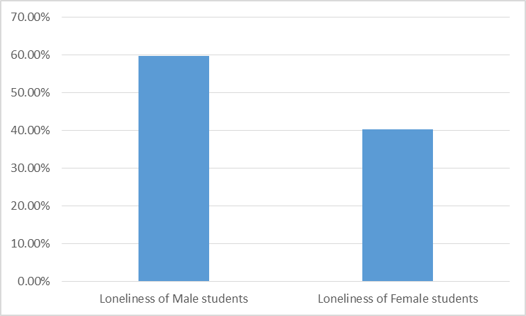
Figure 1: Prevalence of loneliness among Male and Female student
Based on Figure 1, among the subjects, 40.3% were male, while 59.7% were female. The international students represented ten different countries, highlighting a diverse participant group. Analysis of loneliness levels revealed that third-year university students experienced high levels of loneliness, with an average score of 36.92 points. Among adult students, men reported a loneliness score of 38.79, whereas women had a slightly lower score of 35.38. These findings suggest that loneliness is a significant issue among university students, particularly among adult male students.
According to (Furnham, 2023), foreign students face greater psychological challenges due to cultural adjustment difficulties, social isolation, loneliness, and higher academic pressure. Despite cultural differences, no significant mental health disparities were found among the various foreign student groups. This suggests that the challenges faced by international students are generally universal, regardless of their cultural background. These findings emphasize the importance of social support and integration programs in helping foreign students adapt to university life and improve their overall well-being.
The results indicate that financial pressure is a major contributor to mental health challenges among international students. Many students struggle to afford tuition fees, rent, and daily expenses, forcing them to take on part-time or full-time jobs. As a result, they often work long hours, leaving little time for academic responsibilities, rest, or social interactions. This excessive workload can lead to exhaustion, sleep deprivation, and heightened stress levels, negatively impacting their mental well-being. Additionally, financial insecurity creates constant anxiety, as students worry about making ends meet each month. The burden of supporting themselves, coupled with the pressure to succeed academically, further exacerbates their emotional distress. Some students also feel the weight of family expectations, especially when parents have made financial sacrifices for their education (Forbes-Mewett et al., 2011).

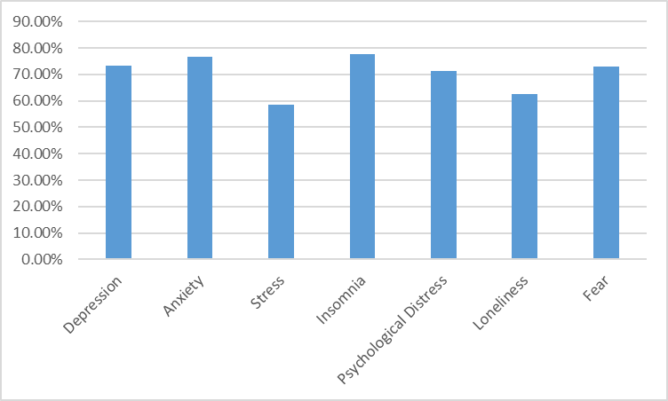
Figure 2: Prevalence of Psychological Symptom among international students

According to the Figure 2, high prevalence of psychological symptoms among international students during the COVID-19 pandemic, with 73.4% experiencing symptoms of depression, 76.6% of anxiety, 58.5% of stress, 77.6% of insomnia, 71.4% of psychological distress, 62.4% of loneliness, and 73.1% of fear. Further analysis showed that the severity of these symptoms was significantly associated with certain factors. Students aged 26–30, those living with roommates, and those who had been in China for less than two years were more likely to experience moderate to extremely severe psychological symptoms. Additionally, male students were more likely to report symptoms of depression, anxiety, insomnia, and fear compared to female students. These findings highlight the significant mental health challenges faced by international students, particularly those in specific age groups or living situations, and suggest that targeted support may be needed to address these issues

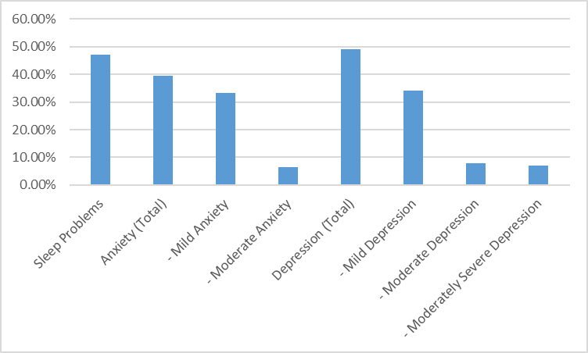
Figure 3: Prevalence of Mental Health Issue Among International Students

According to Figure 3, a significant prevalence of mental health issues among international students such as, sleep problems were reported by 47.1% of students, while 39.6% experienced anxiety, with 33.2% having mild anxiety and 6.4% reporting moderate anxiety. Depression affected 49% of students, with 34% experiencing mild depression, 8% reporting moderate depression, and 7% experiencing moderately severe depression. Several demographic factors were found to influence mental health outcomes. Male students exhibited higher levels of anxiety and depression compared to their female counterparts. Students living with others reported more sleep problems, anxiety, and depression than those living alone. Interestingly, higher-income students (earning more than USD 883 per month) experienced higher levels of depression. Rural students were more likely to have sleep problems, while urban students reported higher levels of anxiety. Students who experienced COVID-19 symptoms showed significantly higher levels of mental health issues. Additionally, greater media exposure to COVID-19 was linked to more severe anxiety and depression, suggesting the impact of external stressors and information overload. These findings highlight the need for tailored mental health support that takes into account these demographic factors and experiences
The results show that 19.57% of participants exhibited symptoms of depression, while 20.28% experienced symptoms of anxiety. Female students were more likely to seek mental health support compared to male students. Additionally, single students were found to have higher intentions to seek help than married students. Students who faced financial difficulties were also more inclined to seek mental health assistance. The findings further suggest that higher levels of mental health literacy (MHLS-H), which refers to knowledge about how to access mental health support, were positively associated with increased help-seeking intentions. On the other hand, higher levels of stigma—negative attitudes towards seeking help—reduced the likelihood of students reaching out for support. Furthermore, students with more severe symptoms of depression and anxiety were more likely to seek help if they had better mental health literacy, highlighting the importance of promoting mental health awareness and reducing stigma to encourage help-seeking behaviors (Zeng et al., 2023).
According to (Kono et al., 2014), a wide range of mental health issues among students. Anxiety was reported by 2.4% to 43% of students, while depression affected between 3.6% and 38.3% of students. Psychological stress or distress was reported in 31.6% to 54% of students. Additionally, gambling problems were identified in 3.3% to 50.7% of students, suggesting that this is a significant concern for some individuals. Several factors were found to affect students' overall well-being. Loneliness and isolation were experienced by 60-65% of students, highlighting the social challenges many face during their studies. Work and financial difficulties were reported by 15.4% to 95% of students, with financial stress being a major contributor to mental health struggles. Discrimination and safety concerns affected 9% to 50% of students, further complicating their sense of security and well-being. Other challenges impacting students included cross-cultural transitions, language difficulties, difficulties with social interactions, and technology-related issues. Some students also struggled with self-harm, and a lack of mental health literacy hindered their ability to seek appropriate support. These findings underscore the need for comprehensive mental health resources and targeted interventions to address the diverse challenges faced by students, particularly those related to social, cultural, and financial factors.
Among 43.1% of students exhibited depressive symptoms. Interestingly, depressive symptoms were not significantly linked to financial status, suggesting that while financial challenges may contribute to overall stress, they are not the direct cause of depression. Key risk factors for depression included poor sleep quality, which was associated with a significantly higher likelihood of depressive symptoms (Adjusted OR 7.35; 95% CI 3.87–14.0). Lack of exercise also emerged as a contributing factor (Adjusted OR 1.87; 95% CI 1.09–3.22), as well as unsatisfactory housing conditions, which increased the likelihood of depression (Adjusted OR 2.98; 95% CI 1.69–5.26). Other observations highlighted that arts students reported more depressive symptoms than their peers in science disciplines. Additionally, students who had been in Japan for longer periods (1-4 years or more) were at a higher risk of developing depressive symptoms. While financial struggles did not directly cause mental health issues, they were found to contribute indirectly, emphasizing the need for a holistic approach to addressing student well-being (De Moissac et al., 2020).

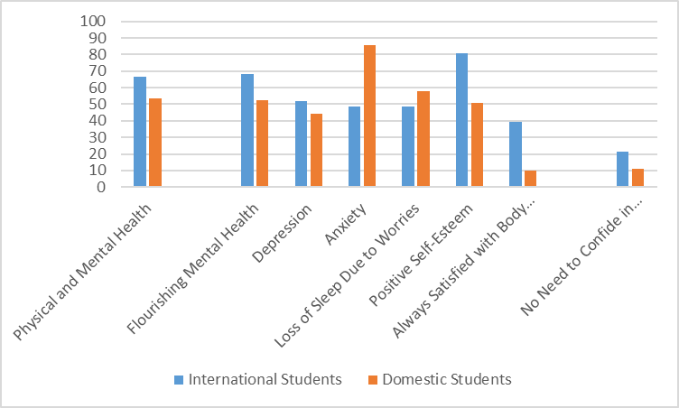
Figure 4: Prevalence of Health Issue Between International Students and Domestic Students

Based on Figure 4, international students generally reported better physical and mental health compared to domestic students. Specifically, 66.7% of international students reported excellent or very good health, higher than the 53.6% of domestic students. International students were also more likely to report flourishing mental health (68.2%) compared to domestic students (52.2%). However, international students experienced higher rates of depression (51.9%) compared to domestic students (44.2%). On the other hand, they reported lower levels of anxiety (48.8%) compared to domestic students (85.9%). International students were also less likely to experience loss of sleep due to worries (48.4%) compared to domestic students (57.8%). Psychologically, 80.5% of international students reported positive self-esteem, significantly higher than the 51% of domestic students. Moreover, 39.5% of international students were always satisfied with their body image, far exceeding the 9.8% of domestic students. In terms of help-seeking and coping strategies, international students were less likely to seek professional help (e.g., counseling, medication). Furthermore, 21.5% of international students reported not feeling the need to confide in anyone, compared to 10.9% of domestic students. For coping, international students most commonly used strategies like healthy living and meditation/mindfulness.
According to (Jmilah et al., 2020), a significant deterioration in mental health among students post-pandemic compared to pre-pandemic levels. Depression scores increased from an average of 14.07 (SD = 2.74) before the pandemic to 14.65 (SD = 4.07) after the pandemic. Similarly, anxiety scores rose from 16.96 (SD = 4.02) pre-pandemic to 19.46 (SD = 5.91) post-pandemic, highlighting a clear worsening of mental health. Demographic differences also played a role in mental health outcomes. Female students reported higher levels of anxiety than their male counterparts. Younger students, particularly those aged 20-30, experienced higher levels of depression compared to older students. Single students were more likely to experience both anxiety and depression than married students. Additionally, students living in urban areas reported worse mental health outcomes compared to those in rural areas, suggesting that urban environments may contribute to heightened stress or other mental health challenges.
The results indicate that 47.7% of international students showed depressive symptoms, as measured by a CES-D 10 score of 10 or higher, highlighting the significant mental health challenges faced by this group. Several factors were found to be strongly associated with depression among international students. Older students had a higher prevalence of depressive symptoms, suggesting that age might play a role in mental health outcomes. Married students were more likely to experience depressive symptoms than their single counterparts, indicating that marital status could influence emotional well-being. Additionally, dissatisfaction with housing was strongly linked to higher levels of depression, underscoring the impact of living conditions on mental health. Students with lower cumulative grade point averages (CGPA) also reported higher levels of depressive symptoms, indicating that academic performance may contribute to emotional distress. Common problems experienced by students living in Bangladesh were reported by 83.9% of participants. Homesickness and difficulties adapting to Bangladeshi food affected more than two-thirds of students. Accommodation problems were reported by 45.6%, while financial difficulties (38.4%) and health issues (34.4%) were also significant stressors. These findings highlight the multiple challenges international students face, and the importance of addressing both personal and academic factors in supporting their mental health and well-being (Alnaim et al., 2024).
Among 40.4% of Saudi international students were diagnosed with major depression, as indicated by a PHQ-8 score of 10 or higher, reflecting a significant prevalence of mental health concerns within this group. Several factors were found to be significantly associated with depression. Students with a previous history of mental illness were 2.89 times more likely to develop major depression, highlighting the importance of prior mental health issues in predicting future depressive symptoms. Feelings of social alienation also played a crucial role: students who sometimes felt like a stranger were 7.06 times more likely to develop depression, while those who felt like a stranger most or all of the time were 5.07 times more likely to experience depression. This suggests that isolation and difficulty integrating into the new environment can significantly increase the risk of depression. Marital status also emerged as a factor, with single students having a higher likelihood of depression compared to married students. Additionally, lower levels of social engagement, such as infrequent contact with family and reduced social interactions, increased the risk of depression. However, factors such as gender, country of study, living status, academic degree, and financial aid status were not found to be significant predictors of depression in this study, indicating that the emotional and social experiences of the students were more influential than these demographic factors. These findings highlight the importance of addressing social integration and mental health history when providing support for international students (Alsaad, n.d)
According to (Tunc et al, 2021), international students had a moderate level of health perception, indicating that while they generally viewed their health positively, there is room for improvement. A positive perception of health was associated with healthier lifestyle behaviors, suggesting that how students perceive their health influences their actions toward maintaining it. In terms of health-promoting behaviors, 45.4% of students engaged in physical activity, demonstrating a moderate level of physical health engagement. Nutrition habits were reported as moderately healthy, suggesting that students were somewhat conscious of their dietary choices but may not consistently follow ideal eating habits. Students who had higher health perceptions were better at managing stress, implying that a positive outlook on health can lead to better emotional regulation and coping strategies. Interpersonal relationships and spiritual growth were found to have the strongest positive relationships with overall health perception, highlighting the importance of social and emotional well-being in shaping students’ health perceptions. Key issues identified included struggles with health responsibility, such as neglecting medical check-ups, and concerns about physical inactivity and poor stress management. Obesity, affecting 32% of students, was also identified as a rising issue, likely due to lifestyle habits. These findings suggest that while students generally have a moderate view of their health, they face significant challenges in maintaining a fully healthy lifestyle, particularly in terms of physical activity, stress management, and addressing emerging health issues like obesity.
Discussion
The mental health of international students is a significant concern, shaped by various interrelated factors. The literature reviewed highlights that international students often experience heightened levels of stress, anxiety, and depression compared to their domestic counterparts. Several key themes emerge in understanding the challenges they face and the necessary interventions to address them. One of the most prominent challenges is cultural adjustment. Moving to a new country involves adapting to unfamiliar social norms, academic expectations, and living conditions, which can create a sense of isolation and psychological distress. Language barriers further compound this difficulty, making it harder for students to engage with peers, faculty, and support services, ultimately affecting their mental well-being.
Academic pressure is another critical factor affecting international students’ mental health. Many students experience immense pressure to succeed academically, often due to high personal aspirations, financial investments, and expectations from their families. This pressure can lead to excessive stress, burnout, and feelings of inadequacy, particularly if students struggle with different educational systems and teaching methodologies. Financial stress is also a recurring theme in the literature. Many international students face significant financial burdens, including tuition fees, living expenses, and, in some cases, restrictions on employment opportunities. Financial insecurity can increase anxiety and stress, making it harder for students to focus on their academic and social well-being.
Social support plays a crucial role in mitigating mental health risks. Studies suggest that students with strong peer networks, supportive academic environments, and access to mental health resources demonstrate greater psychological resilience. However, stigma surrounding mental health issues, especially among students from cultural backgrounds where discussing mental health is taboo, often prevents individuals from seeking professional help. This highlights the need for universities to provide culturally sensitive mental health services and awareness campaigns to normalize seeking help.
Universities have a vital role to play in addressing these challenges. Providing accessible counseling services, peer mentorship programs, and workshops on stress management can significantly improve students' mental health outcomes. Institutions must also create inclusive environments where international students feel valued and supported. Proactive outreach programs, student-led support groups, and initiatives promoting cross-cultural interaction can help foster a sense of belonging and reduce social isolation. Overall, addressing the mental health challenges of international students requires a comprehensive approach that combines academic, social, and institutional support. By recognizing and addressing these challenges, universities can help international students navigate their academic journeys with improved mental well-being and overall success.
Limitation
One key limitation of this review is its reliance on secondary data from existing literature, which may introduce selection bias due to the inclusion criteria restricting studies to those published in English after 2010 from reputable institutions. This may have excluded relevant research conducted in other languages or from less prominent sources. Additionally, the predominance of cross-sectional studies limits the ability to assess long-term mental health outcomes among international students, and the absence of primary data collection restricts the depth of individual experiences. Cultural diversity among international students was acknowledged but not deeply examined, which may affect the generalizability of the findings. Moreover, variations in methodological quality across the included studies were not critically assessed, potentially impacting the consistency and reliability of the results.
Conclusion
The mental health challenges faced by international students require urgent attention and strategic intervention. Given the significant impact of cultural, academic, financial, and social stressors on their psychological well-being, universities must adopt holistic approaches to support their students effectively. Providing accessible and culturally sensitive mental health resources, including counseling services, peer mentorship, and community-building initiatives, can greatly enhance students’ well-being. Furthermore, addressing stigma through awareness campaigns and encouraging open discussions about mental health can foster an environment where students feel safe seeking help. Institutions should also invest in research-driven policies to better understand the evolving needs of international students and implement targeted solutions that promote resilience and academic success.
Ultimately, a collaborative effort among educational institutions, mental health professionals, and policymakers is essential in creating a more inclusive and supportive academic environment. By prioritizing mental health, universities can not only improve the student experience but also contribute to their long-term success and overall quality of life.

References
Ahmed, S., Alam, M., & Islam, M. S. (2019). Mental health status of international students in Bangladesh: A cross-sectional study. Asian Journal of Psychiatry, 43, 129-134.
Akter, F., Basher, M. S., & Khan, M. A. (2021). COVID-19 pandemic and its impact on international students in Bangladesh: A study on the mental health status. Journal of International Students, 11(2), 417-432.
Andrabi, T., Das, J., & Khwaja, A. I. (2006). A dime a day: The possibilities and limits of private schooling in Pakistan. Comparative Education Review, 52(3), 329–355. https://doi.org/10.1086/588796
Bor, W., Dean, A. J., Najman, J. M., & Hayatbakhsh, R. (2014). Are child and adolescent mental health problems increasing in the 21st century? A systematic review. Australian and New Zealand Journal of Psychiatry, 48(7), 606–616. https://doi.org/10.1177/0004867414533834
Chowdhury, A. H., Afrin, S., & Alam, M. M. (2021). Challenges of international students in Bangladesh: Exploring the way forward. Journal of International Students, 11(1), 141-159.
Cooper, D. A. (2015). Social justice and South African university student enrolment data by ‘race,’ 1998-2012: From ‘skewed revolution’ to ‘stalled revolution.’ Higher Education Quarterly, 69(3), 237–262. https://doi.org/10.1111/hequ.12074
Islam, M. S., Hassan, M. R., & Sakib, M. N. (2020). Discrimination and mental health among international students in Bangladesh: An exploratory study. Bangladesh Journal of Medical Science, 19(Special Issue), S10-S15.
Jamilah, A., Haque, M. I., Muhammad, F., Harun, G. D., Chowdhury, A. R., Akramuzzaman, M., Arafat, S. Y., & Kabir, R. (2020). Depression and associated factors among international students in a private university of Bangladesh. Global Psychiatry, 0(0). https://doi.org/10.2478/gp-2020-0021
Kabir et al. (2021). Depression among the non-native international undergraduate students studying dentistry in Bangladesh. National Center for Biotechnology Information (NCBI)
Parry et al. (2020). Acculturation and adaptation issues among international students: Experiences from the largest public university of Bangladesh. Research Square
Rahman, A. H. M. M., Karim, M. A., & Rahman, M. M. (2018). Social support and mental health status of international students in Bangladesh: A cross-sectional study. BMC Research Notes, 11(1), 1-6.
Said, E. W. (2000). Invention, memory, and place. Critical Inquiry, 26(2), 175–192. https://doi.org/10.1086/448963

Lin, J. (2023). Research on the mental health of international students in college. Lecture Notes in Education Psychology and Public Media, 11(1), 194–200. https://doi.org/10.54254/2753-7048/11/20230740
Forbes-Mewett, H., & Sawyer, A. (2016). International Students and Mental health. Journal of International Students, 6(3), 661–677. https://doi.org/10.32674/jis.v6i3.348
Akiba, D., Perrone, M., & Almendral, C. (2024). Study Abroad Angst: A literature review on the mental health of international students during COVID-19. In Lorenzo Tarsitani (Ed.), Int. J. Environ. Res. Public Health. https://pmc.ncbi.nlm.nih.gov/articles/PMC11675418/pdf/ijerph-21-01562.pdf
Mental health and wellbeing of international students in Australia: a systematic review. (2024). Journal of Mental Health. https://doi.org/10.1080/09638237.2024.2390393
Rahman, M. A., & Kohli, T. (2024). Mental health analysis of international students using machine learning techniques. PLoS ONE, 19(6), e0304132. https://doi.org/10.1371/journal.pone.0304132

Furnham, A., Trezise, L., & Department of Psychology, University College London. (2023). THE MENTAL HEALTH OF FOREIGN STUDENTS. In Sot. Ki. M Ed. Vol. 17. No. 6 (pp. 365–370). Pergamon Press Ltd.
Forbes-Mewett, H., & Sawyer, A.-M. (2011). Mental Health Issues amongst International Students in Australia: Perspectives from Professionals at the Coal-face. In The Australian Sociological Association Conference Local Lives/Global Networks, University of Newcastle New South Wales, The Australian Sociological Association Conference Local Lives/Global Networks, University of Newcastle New South Wales [Conference-proceeding]. https://www.navitas.com/wp-content/uploads/2023/08/mental-health-issues-among-students.pdf
Kim, H. R., & Kim, E. J. (2021). Factors Associated with Mental Health among International Students during the COVID-19 Pandemic in South Korea. International Journal of Environmental Research and Public Health, 18(21), 11381. https://doi.org/10.3390/ijerph182111381
Zeng, F., John, W. C. M., Qiao, D., & Sun, X. (2023). Association between psychological distress and mental help-seeking intentions in international students of national university of Singapore: a mediation analysis of mental health literacy. BMC Public Health, 23(1). https://doi.org/10.1186/s12889-023-17346-4
Kono, K., Eskandarieh, S., Obayashi, Y., Arai, A., & Tamashiro, H. (2014). Mental health and its associated variables among international students at a Japanese university: with special reference to their financial status. Journal of Immigrant and Minority Health, 17(6), 1654–1659. https://doi.org/10.1007/s10903-014-0100-1
De Moissac, D., PhD, Graham, J. M., Prada, K., Gueye, N. R., & Rocque, R. (2020). Mental Health Status and Help-Seeking Strategies of international students in Canada. In Canadian Journal of Higher Education | Revue Canadienne D’enseignement Supérieur (Vol. 50, Issue 4, pp. 53-). https://files.eric.ed.gov/fulltext/EJ1288032.pdf
Jamshaid, S., Bahadar, N., Jamshed, K., Rashid, M., Afzal, M. I., Tian, L., Umar, M., Feng, X., Khan, I., & Zong, M. (2023). Pre- and Post-Pandemic (COVID-19) Mental Health of International Students: Data from a Longitudinal Study. Psychology Research and Behavior Management, Volume 16, 431–446. https://doi.org/10.2147/prbm.s395035
Jamilah, A., Haque, M. I., Muhammad, F., Harun, M. G. D., Chowdhury, A. M. A., Akramuzzaman, M., Arafat, S. Y., & Kabir, R. (2020). Depression and Associated Factors among International Students in a Private University of Bangladesh. Global Psychiatry. https://doi.org/10.2478/gp-2020-0021
Alnaim, M. A., Alghamdi, A. H., Aljawair, M. R., Alhadi, F. A., Alomair, A. M., & Alsaad, A. (2024). Depression among Saudi international university students and its associated risk factors. BMC Public Health, 24(1). https://doi.org/10.1186/s12889-024-20565-y
Tunc, G. C., Bilgin, N. C., & Cerit, B. (2021). The relationship between international students’ health perceptions and their healthy lifestyle behaviors. Journal of Religion and Health, 60(6), 4331–4344. https://doi.org/10.1007/s10943-021-01336-0

