
Prevalence and Determinants of Diarrheal Disease Among Under Five Children in Chattogram Urban Slums

Submitted by
Salwa Saira
210015
Supervised by

Dr. Mohiuddin Ahsanul Kabir Chowdhury
Dr. Tuhin Biswas
Faculty of Public Health Program
Asian University for Women
20/A M M Ali Road, Chattogram, 4000, Bangladesh

Abstract

Background:

A serious worldwide health concern, diarrheal disease kills approximately 443,832 people each year and causes 1.7 billion cases, especially in children under five (World Health Organization, 2024). In countries with low or middle incomes, diarrhea continues to be a major cause of child mortality (UNICEF, 2024). Due to inadequate sanitation, contaminated water, hygiene practices and a lack of access to healthcare, slum people in Bangladesh are particularly vulnerable to diarrhea, which causes more than two-thirds of child deaths (Mitra et al., 2001). In order to reduce childhood morbidity and death rates, it is critical to address the factors that contribute to childhood diarrhea in these slums, given the prevalence of the disease, particularly among this vulnerable population. Thus, the purpose of this study is to determine the prevalence of diarrhea and its determinants among under five living in urban slums in Chattogram, Bangladesh.

Methodology:

A cross-sectional study with a quantitative research design was conducted using a semi-structured questionnaire. Cluster sampling was used to choose 385 mothers of children under five from four distinct Chattogram slum regions. To guarantee intelligibility and cultural relevance of the study, pretesting was done. Participants gave their informed consent and were free to withdraw from the study at any time. One to one, in- person interviews were done to gather data, which was then entered into SPSS version 20 for analysis. To investigate associations between diarrheal illness and other determinants, frequency and crosstab analyses were conducted. Data dependability and accuracy were guaranteed by quality control procedures.

Results:

Among all 385 participants surveyed, it was found that diarrhea affected 48.8% of children living in urban slums during the previous eight months, with the largest prevalence occurring in children between the ages of 2 and 31 months. Moreover, younger mothers had a higher prevalence of child diarrhea compared to older mothers. Additionally, low maternal education was also noted with 42.6% of mothers having only a primary education, and the highest prevalence of diarrhea, 39.4%, was found among this category. Furthermore, children from lower-income households had a significantly higher prevalence of diarrhea. The rotavirus vaccine was taken only by 6.8% of children, indicating a very low level of immunization coverage. Additionally, postnatal care (PNC) coverage was extremely low with only 2.1% mothers getting recommended 8+ PNCs, limiting opportunities for early health interventions and education on hygiene practices Unsafe drinking water, where 73.8% reported not treating it before drinking and inadequate sanitation where 90.9% reported using shared toilets and 51.2% reported open defecation, were important risk factors. Moreover, 67.8% of mothers did not wash their hands with soap before feeding their children, indicating inadequate handwashing practices. Majority 62.3% of children showed symptoms of malnutrition prior to acquiring diarrhea. Therefore, to reduce the burden of diarrheal disease among under five children of slums, these findings emphasize the critical need for improved water, sanitation, hygiene, education, income, focused healthcare access and awareness.

Conclusion:

The significant prevalence of diarrheal illness which was 48.8% among children under five in Chattogram's urban slums was highlighted by this study. It emphasizes factors such as low maternal education, low household income, poor sanitation, and restricted access to healthcare. The risk was further enhanced by inadequate postnatal care, poor hand hygiene, and low rotavirus vaccination. Diarrhea and child malnutrition were found to be correlated, which furthers the cycle of malnutrition and increased susceptibility to the disease. To lessen the burden in these vulnerable communities, the findings recommend integrated policies that prioritize better access to healthcare, community led total sanitation approaches, and more maternal and health education.

Acknowledgement:

I extend my sincere appreciation towards Asian University for Women (AUW) and the AUW Public Health Department for giving me the chance, assistance and adequate funding to carry out this research as a part of my undergraduate studies. I'm deeply thankful to my supervisor, Director and Associate Professor of Public Health, Mr. Mohiuddin Ahsanul Kabir Chowdhury and Assistant Professor of Public Health, Mr. Tuhin Biswas, for their valuable mentorship and advice during this research. My sincere gratitude is also extended to my research assistants from AUW, Ayesha Shafika Bhuiyan and Marziah Habib, for their commitment and help with data collection. Additionally, I would also like to extend my heartfelt gratitude to the study participants from the slums, whose valuable insights and willingness to share their experiences were essential to the success of this research. All the help AUW and others have provided was crucial to the effective completion of this study.

Prevalence and Determinants of Diarrheal Disease Among Under Five Children in Chattogram’s Urban Slums

Introduction

Diarrheal disease was referred to as the passage of three or more liquid or loose stools in a day and was caused by a number of viral, bacterial, and parasitic species (World Health Organization, 2024). Diarrheal disturbances and symptoms included intestinal motility, digestion, pain in the stomach, cramping, bloating, dehydration, fever, decreased appetite, the presence of pus or blood found in stools, frequent vomiting, and changes in stool frequency and consistency (MacGill, 2024). In fact, this infectious disease remained one of the leading causes of morbidity and mortality among children under the age of five worldwide (World Health Organization, 2024). In the early years of a child's life, when their natural immunity was weaker and they were more likely to come into contact with contaminants, diarrhea happened more frequently (Mitra et.al, 2012). According to the World Health Organization (2024), globally there were 1.7 billion cases of childhood diarrhea every year. Moreover, approximately 443,832 children under the age of five died from diarrhea each year. In fact, in children aged 59 months and under, diarrheal illness ranked as the third most common cause of mortality. Furthermore, even in recent years, diarrhea was among the top 10 illnesses that contributed to the worldwide DALY (Walker et.al, 2012). In fact, according to a report by the World Health Organization and UNICEF (2009), globally diarrhea killed far more children under the age of five compared to AIDS, malaria, and measles combined. Additionally, approximately 88% of children's deaths in low- and middle-income countries were associated with malnutrition and degradation caused by diarrhea (UNICEF, 2024). Even in a country like Bangladesh, which had the lowest newborn death rates and the longest life expectancy in South Asia, the prevalence of childhood diarrheal illness was still concerning (Institute for Health Metrics and Evaluation, 2014). About 30% of children in Bangladesh who were hospitalized in the intensive care unit (ICU) because of diarrheal problems faced the danger of mortality. However, hospitalized patients with uncomplicated diarrhea had a mortality rate of less than 1% (Mitra et al., 1997). Additionally, more than two-thirds of Bangladesh's annual child mortality rate was attributable to diarrheal diseases (Mitra et al., 2001). In Bangladesh, with a total population estimated to be over 170 million, 38% of the population was said to dwell in urban areas, with 52% of those residents living in the slums, or over 33 million individuals. These slums were typified by poor housing conditions, a lack of essential amenities, poor waste management, and restricted access to safe drinking water (Inspira, 2023). Numerous other issues affected these slums, including lifestyle, health care, and education (Farthing et.al, 2013). Thus, people who lived in slums were more likely to experience diarrheal disease morbidity and mortality, especially children under the age of five, being the most vulnerable group.

Aim:

The aim of this research is to assess the prevalence of diarrhea and its associated factors among under five children in urban slum settings in Chattogram, Bangladesh.

Specific objectives:

i) To estimate prevalence of diarrheal diseases among under 5 years children in Chattogram slums

ii) To assess the determinants of diarrhea for under 5 years children in Chattogram slums

Research Questions:
- What is the prevalence of diarrhea among under five children in Chattogram slums?
- What are the factors associated with diarrhea among the under five children in Chattogram slums?

Literature Review

Diarrheal disease is a global issue that poses a serious risk to human health. The majority of people have had diarrhea at some point in their entire lives (Lancet, 2016). Diarrhea kills 525,000 children under five globally each year, or around 2195 per day (UNICEF, 2016). This is the second most common cause of mortality for children under five and accounts for 8% of all mortality (UNICEF, 2016). There were 1.7 billion cases of diarrhea among children under five worldwide each year (UNICEF, 2019). In developing nations, children under five typically experience diarrhea three times a year (World Health Organization, 2017). In low and middle income nations like South and West Africa, India, Central United States, Pakistan, Mexico, Ghana and Senegal's metropolitan central zones, a high prevalence of diarrhea is typically associated with poor health (Odo, et.al, 2021). Only five countries including China, Pakistan, Nigeria, India and Congo accounted for half of all diarrhea related child deaths in 2008, with over 4.25 million cases. Globally, between 2016 and 2020, the incidence of diarrhea increased from 9% to 9.2% in India (Ghosh et.al, 2021). The Global Brden of Diseases study from 2019 estimates that diarrhea caused 13.01% of all disability adjusted life years (DALYs) in Sub Saharan Africa and in the eastern Sub-Saharan region, diarrheal illnesses accounted for 10.21% of all DALYS among children under five (Global Burden of Disease, 2019). According to much research, East African nations have a high prevalence of diarrheal illnesses among children under five. According to the National Family Health Survey, between 2016 and 2020, the prevalence of childhood diarrhea in India increased from 9% to 9.2%. It is the third most prevalent illness that kills children under five. Many studies have shown that diarrhea continues to be a leading cause of death in India for children under five (Ghosh et.al, 2021). However, between 1990 and 2010, the prevalence of diarrheal illness among children under five years old in Central America dropped by more than 80%. The regional burden of diarrhea is still high now in spite of the progress they made (Colombara et.al, 2016). The prevalence of diarrhea is steadily rising in China as well, particularly among children aged 0-4 years (Chen et.al, 2021). Pakistan also has 6 fatalities from diarrhea per 1000 live births, the highest rate among South Asian nations. The prevalence of diarrhea in children dropped from 23% in the years 2012–13 to 19% in 2017-2018, however this is still one of the highest rates (Naghavi et al., 2017).

Over the past few years, Bangladesh has made significant progress toward improving children's health, including increases in nutritional status and decreases in overall morbidity (Mahmud et.al, 2019). However, in 2015, diarrhea in children was listed as one of the main causes of death (Alam et.al, 2017). Between 1990 and 2018, Bangladesh's child mortality rate decreased from 143 to 30 per 1000 live births, as per the United Nations Children's Emergency Fund. However, over the same time period, changes in the prevalence of diarrhea in children stayed the same (Bangladesh Demographic and Health Survey, 2014). Numerous research evaluates childhood diarrheal illness prevalence and contributing factors at the national, regional, and global levels and both individual and community level factors were found as potential factors of diarrheal illnesses in children under the age of five. (Hassan et.al, 2017). In Bangladesh, a Demographic and Health Survey which was a national study done in 2014 revealed the odds of diarrhea were higher in children between the ages of 6 and 11 months (odds ratio = 2.26; 95% CI) and 12 and 23 months (odds ratio = 2.31; 95% CI) than in children above the age of five (Kamal et al., 2022). This shows that children who are under the age of five are the most vulnerable group of contracting diarrheal disease. Moreover, about 5.7 million people reside in urban slums that lack adequate housing and sanitary facilities (Farthing, et.al, 2013). Furthermore, the national average for under five mortality is almost 50% higher among slum residents (Razzaque et.al, 2019). In order to study the frequency and association of key sociodemographic and behavioral characteristics related with diarrhea in slums, a study conducted in Bangladesh examined the incidence of diarrhea between urban slums and rural areas. The study revealed the greatest incidence was seen in urban slums which was 41.58%, (n= 111/190) people, whereas in rural areas it was 34.42%, (n= 383/584 people (Farhana & Raihan, 2022). In fact, according to a study children who have greater access to food and health care, as was discovered in urban as compared to rural areas, are less likely to suffer from diarrheal illnesses and the negative consequences that go along with them (Hassan et.al, 2017). Whereas, other research has found a link between inadequate immunization and diarrhea in children (Dewey et.al, 2011). According to a Bangladeshi study, a variety of factors, including socioeconomic level, maternal influences like work, education, feeding practices, and environmental problems like water quality and sanitation, are potential contributors to childhood diarrhea. According to a study conducted in Bangladesh, the child's age, weight, education level of parents, wealth index, and family housing area are all important factors that affect childhood diarrhea. It was also discovered that both socioeconomic class and the educational level of parents affected the prevalence of diarrhea among different socioeconomic classes among the urban and rural (Islam et.al, 2023). However, most of the studies done in Bangladesh predominantly focused on water, sanitation and hygiene factors in particular. A study for determinants of diarrhea in urban slums of Dhaka found various socio-cultural factors such as unhygienic conditions, eating stale and stationary food from vendors or roadsides, limited breastfeeding practices, unsafe drinking water and lack of treatment are frequently noticed in slum areas drive under five children to high risk of persistent diarrhea (Saha, 2012). Another study done in Chittagong distinct found factors predispose under-five children to diarrhea, including washing hands with soap following defecating and before preparing food, toilet cleanliness, washing hands after using the toilet (Sujon et al., 2022). However, most research that looks into the prevalence of diarrhea among under five slum children is conducted in Dhaka and very few studies have been done in Chittagong. The literature that is currently available indicates that multiple studies have been conducted in various parts of the world, including Bangladesh, with an emphasis on the prevalence and contributing factors of diarrhea in children under five. However, the majority of these studies in Bangladesh have been done in Dhaka, with relatively little research being done in Chittagong. Therefore, with a focus on the slums of Chittagong, this study aims to investigate the important factors associated with childhood diarrhea and its prevalence.

Methodology

Conceptual Framework

The figure below shows the conceptual framework of the potential determinants and prevalence of diarrheal disease among under five children. Where demographic factors, socioeconomic factors, environmental factors, nutritional factors, health and hygiene practices are independent variables and diarrhea among under five children is the dependent variable.

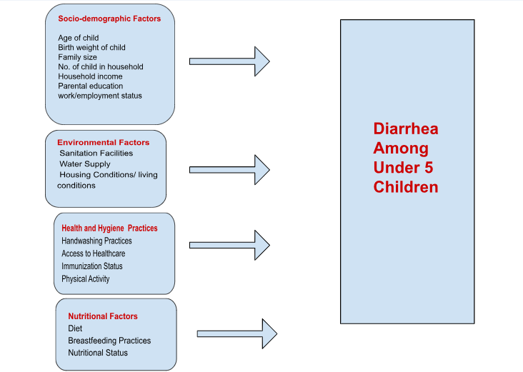

Study Design
This study used a cross-sectional design to assess the prevalence and determinants of diarrheal diseases among children under five in selected urban slums of Chattogram. The cross-sectional approach was chosen as it allows for the identification of key determinants of diarrhea at a specific point in time, which provides valuable epidemiological insights for public health interventions.

Study Population
The study population included mothers of children under five years living in the four selected slum areas. The inclusion of mothers as respondents was based on their primary role in childcare, making them the most reliable sources of information regarding child health, sanitation practices and household conditions. There was no age restriction for participating mothers, ensuring a diverse representation of caregiving experiences.

Study Sites
To capture a comprehensive overview of the factors influencing diarrheal diseases in urban slums, data were collected from four distinct slum areas in Chattogram: Sholoshohor, Moti Jhorna, Newmarket, and Halishahar. These sites were selected based on their high population density, poor sanitation infrastructure, and limited access to healthcare facilities. Each of these areas represents a unique environmental and sociodemographic landscape, allowing for a broader understanding of the conditions contributing to childhood diarrheal diseases in Chattogram’s urban slums.

Sampling Method
A cluster sampling approach was used to ensure that the sample was representative of the population across different slum areas. This method enabled the inclusion of multiple households within each selected cluster, reflecting the diversity of socioeconomic and environmental conditions within the study areas. Every nth household with an eligible respondent was selected for participation, ensuring systematic representation across the different sites. This approach maximized resource efficiency while minimizing potential biases in participant selection.

Sample Size
The sample size for the study was calculated using a formula that considered the confidence level, the desired degree of precision, and an estimated prevalence of diarrheal diseases. The estimated sample size was approximately 384 participants (excluding any non-response rate), based on a conservative 50% prevalence rate, a 5% margin of error, and a 95% confidence level.

Formula Used:
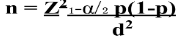
Where:
n = required sample size
Z = Z-value (the number of standard deviations from the mean, corresponding to the desired
confidence level) For a 95% confidence level, here Z = 1.96
p = estimated proportion of the population with the characteristic of interest (conservative
estimate = 0.5)
e = margin of error (desired precision), here 5% or 0.05
Calculation:
n = (1.96)² * 0.5 * (1 - 0.5) / (0.05)² n = 3.8416 * 0.5 * 0.5 / 0.0025 n = 0.9604 / 0.0025
n = 384.16
Therefore, the estimated sample size was approximately 384 participants. Considering a 10%
percent non-response rate, the sample size was estimated to be 423 participants.

Data Collection Tools
A well structured questionnaire with appropriate response options was used, featuring sections on socio-demographic information, healthcare access and health related information, breast feeding practices and diet Information, hygiene practices, water and sanitation conditions. Participants were asked:
Socio-Demographic Information:
- Age: What is your age (in completed years)? The answers were recoded into categories below: (1= 15-21 years, 2= 22-28 years, 3= 29-35 years, 4= 36-40 years)
- Last Year Completed Class/Grade: What is the highest level of education you have completed? (1 = No education, 2 = Primary education, 3 = Secondary education, 4 = Higher secondary or above)
- Age of Child in Months: How old is your child (in months)? (1= 2-16 months, 2= 17-31 months, 3= 32-46 months, 4= 47-60 months)
- Weight of Child at Birth (Kg): What was your child’s birth weight? (1= low birth weight, 2= normal weight, 3= over weight)
- Household Members: How many people live in your household? (1= 1-4 members ,2= more than 4 members)
- Household Children: How many children live in your household? (1= 1-2 children , 2= more than 2 children)
- Occupation of Respondent: What is your employment status?
- Occupation of Household Head: What is the occupation of the household head?
- Household Monthly Income (Estimated): What is the total monthly household income (in BDT)? (1= 2000-14000 TK , 2= 15000-20000 TK ,3= 21000- 25000 TK, 4= 26000-70000 TK)
Healthcare Access and Health-Related Information
- What are the health facilities accessible to you?
- Did your child suffer from diarrhea in the last 8 months? (1 = Yes, 2 = No)
- Where did you go to treat them?
- Has the child received immunizations for diarrhea (Rotavirus Immunization)? (1 = Yes, 2 = No)
- How often does the child engage in physical activity?
- How long does the child usually spend in physical play daily?
7. How many ANC received when pregnant with a child? (1= 1-4 ANC received, 2= More than 4 ANC received)
8. How many times did you receive PNC along with the child? ( 1= 1-8 PNC received, 2= more than 8 PNC received)

Breast Feeding Practices and Diet Information

- Did you breastfeed your last child after the birth took place?
- Are you still breastfeeding?
- For how many months did you breastfeed? (1= Exclusive Breast Feeding (0-6 months)
, 2= Continued Breastfeeding (7-24 months), 3= Extended Breastfeeding (25 + months))

- At what age did you first provide additional food along with breast feeding to your last child?below:
(1= Early Introduction (0-5 months) , 2=Recommended Introduction (6-12 months), 3= Late Introduction ( after 12 months))
- What is the primary type of complementary food given to the child?
- Has the child been assessed for growth (weight and height) in the past six months?
- Does the child appear to be underweight, overweight, or at a healthy weight according to health assessments?
- Has the child experienced any symptoms of malnutrition (such as thin hair, fatigue, swollen belly, or frequent infections)?
- How many meals does the child typically eat per day?
- How often does the child consume protein-rich foods (e.g., meat, fish, eggs, legumes)?
- How frequently does the child consume fruits and vegetables?
- Does the child consume sugary drinks or snacks?

Water Related Information
.
- What is the main source of drinking water?
- Where is that water source located?
- How do you store drinking water?
- Do you usually treat the water in any way to make it safer to drink? (1 = Yes, 2 = No)
- If yes, what do you usually do to make the water safer to drink?
- Is the water source used for bathing and washing the same as the one used for drinking?
- What is the main source of water for taking baths and washing clothes and dishes etc.?

Sanitation Related Information

- Does your household have access to the toilet facility that is in use? (1 = Yes, 2 = No)
- If there is a communal toilet, how many chambers? ( 1=1-2 chambers, 2=3-6 chambers, 3=more than 6 chambers)
- If yes (6.1), please observe and indicate the type of toilet?
- Please tell me about who in your family uses the toilet for defecation?
- Do people practice open defecation in your community? (1 = Yes, 2 = No)

Hygiene Practices Information

- Hand washing of mothers before feeding the child ?
- Handwashing of mother with?
- How many times per day does each child under five typically wash their hands with soap and water?
- Where do you dispose of the child’s stool?
- Place where child food is prepared ?

Data Collectors

Alongside the researcher, two trained research assistants who speak Bengali were chosen to gather data from locals in certain places. The training program covered techniques for interviewing, emphasizing rapport-building and maintaining awareness of regional traditions and health issues related to childhood diarrhea.
Data Collection Technique

Pre-testing of the Tool:
To take local and cultural settings into consideration, the questionnaire was pre-tested with people of another Chattogram slum prior to the start of data collecting. This made the questionnaire more culturally relevant and understandable, giving the chance to make any modifications required prior to the start of extensive data collection.
Data Collection Method:
To obtain precise and thorough answers to the questions about childhood diarrhea and its determinants, in-person interviews were done at the household level.
Training of Data Collectors:
Extensive training was provided to the data collectors before starting the data collection process.
The training included:
● Demonstrations of how to conduct interviews properly.
● Verbal instructions on managing interviews, maintaining ethical standards, and engaging
with respondents effectively.
● Mock interviews where data collectors practiced administering the questionnaire to a peer
or trainer to build confidence and refine techniques.
● Sharing feedback before and after interviews to improve skills and address any issues.
Data collectors initially conducted supervised interviews to ensure accuracy and consistency. As
they gained experience, they transitioned to conducting unaccompanied interviews, though
occasional scrutiny was still provided by the researchers to ensure quality.

Monitoring and Quality Control:
Following the collection of data for each day, the completed questionnaires were randomly examined to look for any trends in non-responses, missing data patterns, or possible data entry errors. This made certain that any problems were found and fixed as soon as possible. Before each new day of data collecting began, group meetings were held to provide the data collectors with feedback and any necessary instructions. This guaranteed uniformity throughout all interviews and enhanced the quality of the data.
Sample Supervision and Management:
The principal researcher was in charge of overseeing the entire sample frame and making sure that the sampling procedure was strictly adhered to. This investigator monitored the accuracy of the sample process, making certain that every data collector closely followed the rules and guidelines.

Data Entry and Analysis

Data entry in SPSS
● IBM SPSS Statistics (version 20) was used to analyze data, where a database was created
by entering the MS Access templates.
● Samples were used for overall analysis.
● Univariate analysis was carried out first to determine frequency distribution and central
tendencies (mean, median, standard deviation) across study variables.
● Variables were recorded into categorical data from numeric data where required (e.g.,
age, PHQ-9 score, household income).
● Bivariate analysis was carried out by cross-tabulating the outcome variables against
variables of interest.
● Binary logistic regression was carried out to predict outcome variables in terms of
selective variables of interest (selection was made during bivariate analysis).
Finally, data was organized, reviewed, and displayed in the form of tables and charts.

Plan for Supervision and Quality Control
Skilled supervisors managed data collection to guarantee that study procedures were followed and data quality requirements were maintained. To maintain the integrity of the data, evaluations and frequent debriefing sessions with the researchers were held. Supervisors gave direction and handled any difficulties with data collection, making sure that all protocols were correctly followed to produce accurate and high quality data.

Results

A cross-tabulation study was performed, demonstrated by Table 1 below, to investigate the prevalence of diarrheal disease with respect to several sociodemographic variables such as level of education and household income, therefore, making it easier to understand how these factors affect the disease burden.

Of all 385 respondents, it was found that for age of mothers (P value= 0.705), where mothers between the ages of 15 and 21, reported that (n=50) 26.6% of their children had diarrhea, while (n=46) 23.4% did not. In the 22–28 age group, they reported that (n=97) 51.6% of their children suffered from diarrhea, whereas (n=99) 50.3% did not. Of the respondents who were between the ages of 29 and 35 reported that (n=37) 19.7% of their children had diarrhea, whereas (n=48) 24.4% did not. The mothers in the 36–40 age range had the lowest prevalence, with (n=4) 2.1% of their children having diarrhea and (n=4) 2.1%. Majority of responders were mothers between the ages of 22 and 28, who had the highest percentage of diarrheal diseases among their children. Of the children between the ages of 2 and 16 months, (n=50) 26.6% experienced diarrhea, whereas (n=65) 33% did not. It was found that for age of child in months (P value= 0.492). Of children between the ages of 17 and 31 months, (n=54) 28.7% had diarrhea, whereas (n=46) 23.4% did not. Those who were between 32 to 46 months, (n=43) 22.9% of them experienced diarrhea while (n=44) 22.3% did not. Children between the ages of 47 and 60 months had the lowest prevalence, with (n=41) 21.8% having diarrhea and (n=42) 21.3% not. Given that younger children have the highest prevalence, it is likely that infants and toddlers are more vulnerable, possibly as a result of weakened immune systems and increased exposure to other determinants. It was found that for low birth weight (P value=0.607). Among children born with low birth weight, (n=39) 20.7% had diarrhea, and (n=36) 18.3% did not. Among the children in the normal birth weight group, (n=145) 77.1% experienced diarrhea, whereas (n=154) 78.2% did not. Just (n=4) 2.1% of the overweight children had diarrhea, compared to (n=7) 3.6% who did not. It was found for household member (P value= 0.558). Of children in households with 1 to 4 members, (n=109) 58% had diarrhea, whereas (n=120) 60.9% did not. Children of the families with 4 or more people, had (n=77) 39.1% of diarrheal cases, whereas (n=77) 39.1% did not. Because of overcrowding and difficulties with hygiene, larger households may lead to greater infection rates. (n=147) 78.2% of the children in families with 1 to 2 children had diarrhea, whereas (n=147) 74.6% did not. It was found that for number of household children (P value= 0.410). In households with more than 2 children, (n=41) 21.8% had diarrhea, while (n=50) 25.4% did not. Due to shared exposure to infected food and water, having more children in a home may raise the risk of diarrheal illnesses.

Table 1: Sociodemographic Characteristics and Prevalence of Diarrhea
 |  | Diarrhea |  |  | P value
 |  | Yes | No | Total
Age of respondent | 15 to 21 | 50(26.6) | 46(23.4) | 96(24.9) | 0.705
Age of respondent | 22 to 28 | 97(51.6) | 99(50.3) | 196(50.9) | 0.705
Age of respondent | 29 to 35 | 37(19.7) | 48(24.4) | 85(22.1) | 0.705
Age of respondent | 36 to 40 | 4(2.1) | 4(2) | 8(2.1) | 0.705
Education level | No Education | 35(18.6) | 36(18.3) | 71(18.4) | 0.590
Education level | Primary | 74(39.4) | 90(45.7) | 164(42.6) | 0.590
Education level | Secondary | 49(26.1) | 46(23.4) | 95(24.7) | 0.590
Education level | Higher Secondary or above | 30(16) | 25(12.7) | 55(14.3) | 0.590
Age of child in months | 2 to 16 months | 50(26.6) | 65(33) | 115(29.9) | 0.492
Age of child in months | 17 to 31 months | 54(28.7) | 46(23.4) | 100(26) | 0.492
Age of child in months | 32 to 46 months | 43(22.9) | 44(22.3) | 87(22.6) | 0.492
Age of child in months | 47 to 60 months | 41(21.8) | 42(21.3) | 83(21.6) | 0.492
Birth weight | Low Birth Weight | 39(20.7) | 36(18.3) | 75(19.5) | 0.607
Birth weight | Normal Birth Weight | 145(77.1) | 154(78.2) | 299(77.7) | 0.607
Birth weight | Overweight | 4(2.1) | 7(3.6) | 11(2.9) | 0.607
Household member | 1 to 4 | 109(58) | 120(60.9) | 229(59.5) | 0.558
Household member | More than 4 | 79(42) | 77(39.1) | 156(40.5) | 0.558
Number of household children | 1 to 2 | 147(78.2) | 147(74.6) | 294(76.4) | 0.410
Number of household children | More Than 2 | 41(21.8) | 50(25.4) | 91(23.6) | 0.410
Monthly income | 2000-14000 TK | 51(27.1) | 71(36) | 122(31.7) | 0.315
Monthly income | 15000-20000 TK | 103(54.8) | 94(47.7) | 197(51.2) | 0.315
Monthly income | 21000-25000 TK | 18(9.6) | 17(8.6) | 35(9.1) | 0.315
Monthly income | 26000-70000 TK | 16(8.5) | 15(7.6) | 31(8.1) | 0.315

The results in Figure 1 below show that among children under five in the population under study, diarrhea is quite prevalent. Of the 385 respondents, (n=188) 48.8% children had diarrhea within the previous eight months, compared to (n=197) 51.2% who did not. This indicates that diarrhea impacted almost half of the sample's children throughout this time, indicating the disease's ongoing prevalence in Chattogram's urban slums.

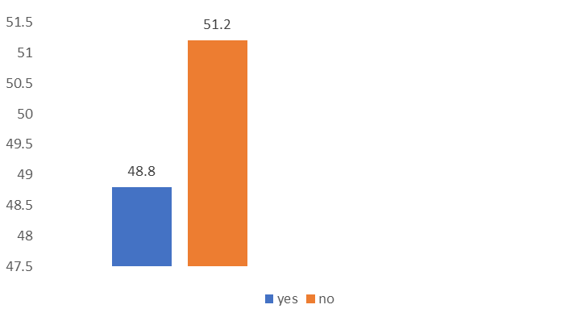
Figure 1: Prevalence of diarrhea

Figure 2 below demonstrates the association of diarrheal prevalence and education level of mothers. Among mothers who had no formal education at all, (n=35) 18.6% reported their child had diarrhea, while (n=36) 18.3% did not. Of mothers who had primary education, (n=74) 39.4% children experienced diarrhea, and (n= 90) 45.7% did not. For mothers with secondary education, (n=49) 26.1% reported diarrhea, whereas 46 (23.4%) did not. Among mothers who had higher secondary education or above, (n=30) 16% children had diarrhea, while (n=25) 12.7% did not. The highest prevalence was observed among those with primary education, which may indicate a knowledge gap in hygiene and sanitation practices. It was found that for maternal education (P value= 0.590)

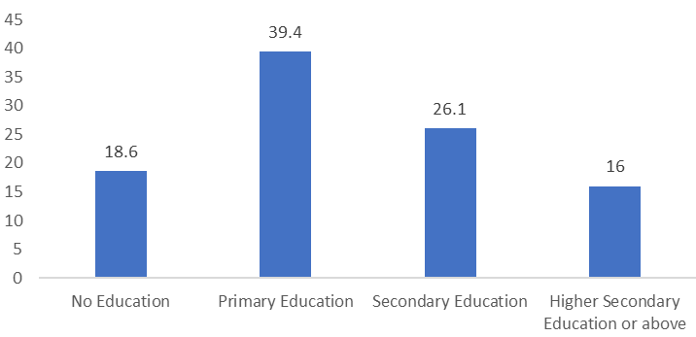
Figure 2: Prevalence of diarrhea by maternal education

Figure 3 below demonstrates the association of diarrheal prevalence and monthly income of the families. Monthly Income and Diarrhea Prevalence: Of families with monthly incomes between 2,000 and 14,000 TK, 51 (27.1%) children had diarrhea and 71 (36%) did not. Families which earned 15,000 to 20,000 TK income, 103 (54.8%) children had diarrhea, whereas 94 (47.7%) did not. Households with incomes between 21,000 and 25,000 TK, 18 (9.6%) children suffered diarrhea, while 17 (8.6%) children did not. Finally, in families earning 26,000 to 70,000 TK, 16 (8.5%) had diarrhea, while 15 (7.6%) did not. Lower income households had the highest prevalence, suggesting that access to clean water, sanitary facilities, and medical care may be restricted due to financial restrictions, hence raising the risk of diarrheal illnesses. It was found that for household monthly income (P value= 0.315).

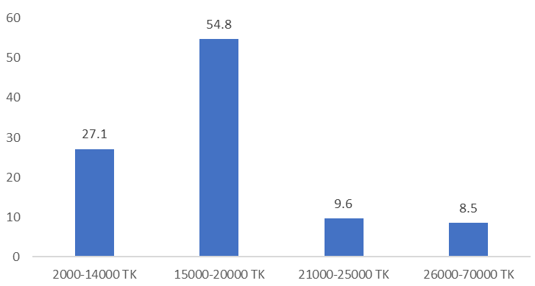
Figure 3: Prevalence of diarrhea by household income

Figure 4 below, illustrates the prevalence of diarrhea among children by their rotavirus vaccination status. Among those who had received the vaccine, only (n=13) 6.8% experienced diarrhea. In contrast, (n=127) 67.5% of children who had not received the vaccine suffered from diarrhea. Additionally, (n=48) 25.7% of diarrhea cases occurred among children whose vaccination status was unknown. This suggests a significantly lower prevalence of diarrhea among vaccinated children compared to unvaccinated or uncertain groups. It was found that for Rotavirus vaccine (P value= 0.064).
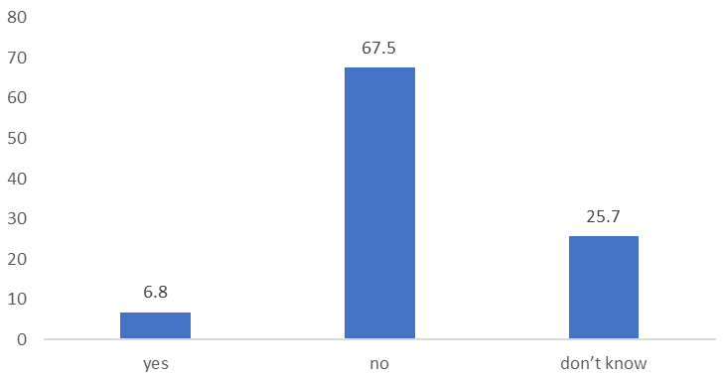
Figure 4: Prevalence of diarrhea by Rotavirus vaccine coverage
Figure 5 below shows the prevalence of diarrhea among children based on their mothers’ postnatal care (PNC) visits. Among children whose mothers did not receive any PNC, (n=98) 52.2% had diarrhea. In cases where mothers received fewer than eight visits, (n= 86) 45.7% of children experienced diarrhea. Only (n=4) 2.1% of diarrhea cases were reported among children whose mothers had eight or more PNC visits. This indicates a higher prevalence of diarrhea when postnatal care is limited or absent. It was found that for postnatal care PNC (P value= 0.699).

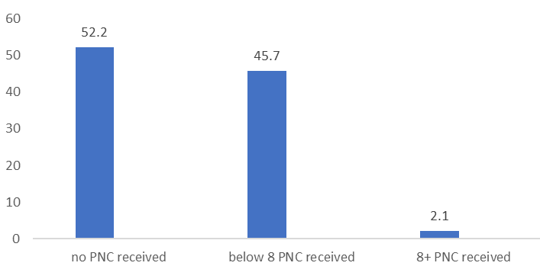Figure 5: Prevalence of diarrhea by postnatal care (PNC) coverage
Figure 6 below presents the prevalence of diarrhea in relation to reported symptoms of malnutrition. Among children who showed symptoms of malnutrition, (n=117) 62.3% had diarrhea. In contrast, (n=65) 34.5% of diarrhea cases were found among children without such symptoms, while (n=6) 3.1% were reported among those whose nutritional status was uncertain. This highlights a strong association between malnutrition and the occurrence of diarrhea. It was found that for malnutrition (P value=0.075).

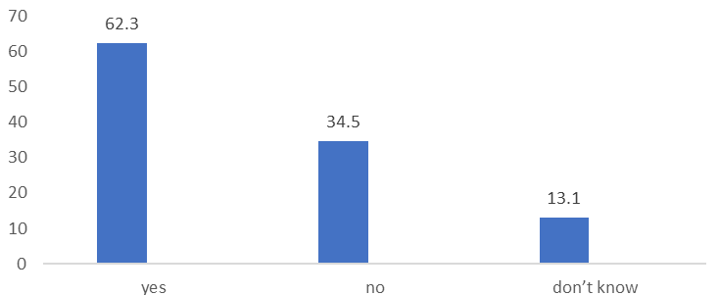
Figure 6: Prevalence of diarrhea by malnutrition status
Figure 7 below illustrates the prevalence of diarrhea based on household water treatment practices. Among children from households that treated water by boiling, (n=49) 26.2% had diarrhea. In contrast, (n=139) 73.8% of diarrhea cases occurred in households that did not treat their drinking water. This suggests a higher prevalence of diarrhea where water treatment was not practiced. It was found that for water treatment (P value=0.941).
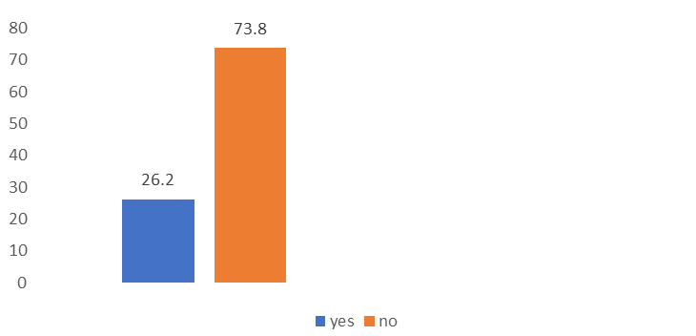
Figure 7: Prevalence of diarrhea by water treatment

Figure 8 below illustrates the prevalence of diarrhea based on the water source used for bathing and washing. Among children whose households used the same water source for bathing and drinking, (n=185) 97.9% had diarrhea. In contrast, (n=4) 2.1% of diarrhea cases occurred in households that used a different water source for bathing and drinking.

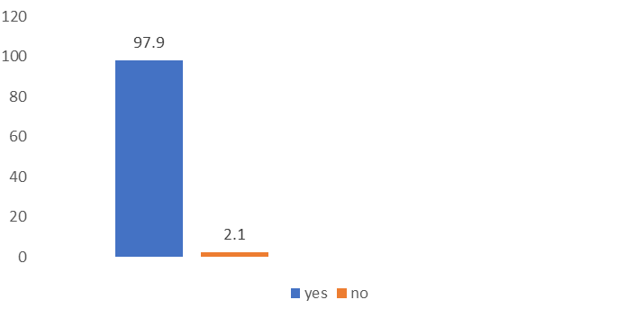
Figure 8: Prevalence of diarrhea by water source for bathing and washing being the same or not

Figure 9 below illustrates the prevalence of diarrhea based on the practice of open defecation in the communities. Among children from communities where open defecation was common, (n=96) 51.2% had diarrhea, while (n=92) 48.8% cases were reported in areas where open defecation wasn’t reported. It was found that for open defecation (P value= 0.165).

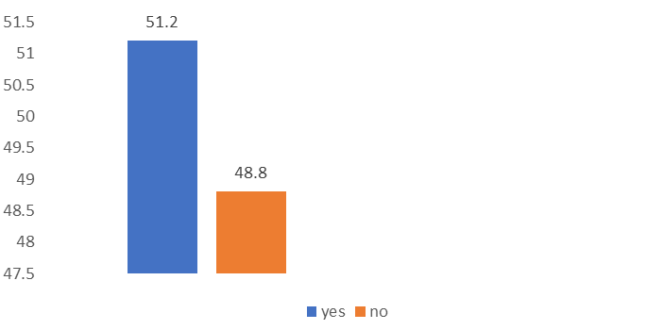
Figure 9: Prevalence of diarrhea by open defecation
Figure 10 below illustrates the prevalence of diarrhea based on the hand-washing practices of mothers. Among children whose mothers washed their hands with water only, (n=127) 67.8% had diarrhea, while among those whose mothers washed their hands with both water and soap, (n=60) 32.2% had diarrhea. It was found that for handwashing practices of mothers (P value= 0.009).
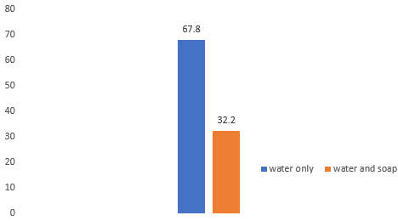

Figure 10: Prevalence of diarrhea by hand washing of mother

According to Table 2 below, among the surveyed population, (n=301) 78.2% reported having access to community clinics, whereas (n=84) 21.8% did not. Access to satellite clinics or EPI outreach was reported by only (n=1) 0.3%, with (n=384) 99.7% having no access. None of the respondents had access to UH & Family Welfare Centers, Upazila Health Complexes or MCWCs. A total of (n=55) 14.3% had access to district hospitals, while (n=330) 85.7% did not. NGO clinics were accessible to (n=5) 1.3%, and (n=380) 98.7% had no access. However, (n=22) 5.7% had access to private primary-level hospitals and (n=263) 94.3% did not. Only (n=3) 0.8% reported access to secondary-level private hospitals, whereas (n=382) 99.2% did not. Pharmacies were accessible to (n=267) 69.4% of the population, whereas (n=118) 30.6% did not have access. Other healthcare facilities were accessed by (n=2) 0.5%, while (n=10) 2.6% reported not knowing about healthcare access. In terms of physical activity, (n=295) 76.6% of children engaged in daily physical activity, (n=25) 6.5% a few times a week, (n=18) 4.7% rarely, and (n=47) 12.2% never. Regarding playtime, (n=268) 69.6% of children played for more than two hours daily, (n=51) 13.2% for 1-2 hours, (n=16) 4.2% for less than an hour, and (n=47) 12.2% never played. During pregnancy, (n=71) 18.4% of mothers did not receive ANC, (n=268) 69.6% received 1 to 4 visits, and (n=46) 11.9% had more than four.
Table 2: Healthcare Access and Health Related Characteristics of the Study
 | Frequency | Percent
What are the health facilities accessible to you? (Community Clinic)
no | 84 | 21.8
yes | 301 | 78.2
What are the health facilities accessible to you? (Satellite Clinic/EPI Outreach)
no | 384 | 99.7
yes | 1 | .3
What are the health facilities accessible to you? (UH & Family Welfare Centre)
no | 385 | 100.0
What are the health facilities accessible to you? (Upazila Health Complex)
no | 385 | 100.0
What are the health facilities accessible to you? (MCWC)
no | 385 | 100.0
What are the health facilities accessible to you? (District Hospital)
no | 330 | 85.7
yes | 55 | 14.3
What are the health facilities accessible to you? (NGO Clinic)
no | 380 | 98.7
yes | 5 | 1.3
What are the health facilities accessible to you? (Private Hospital (Primary Level))
no | 363 | 94.3
yes | 22 | 5.7
What are the health facilities accessible to you? (? (Private Hospital (Secondary Level)))
no | 382 | 99.2
yes | 3 | .8
What are the health facilities accessible to you? (Pharmacy)
no | 118 | 30.6
yes | 267 | 69.4
What are the health facilities accessible to you? (Others)
no | 383 | 99.5
yes | 2 | .5
What are the health facilities accessible to you? (Don’t Know)
no | 375 | 97.4
yes | 10 | 2.6
Did your child suffer from diarrhea in last 8 months?
yes | 188 | 48.8
no | 197 | 51.2
Where did you go to treat them?
hospital/clinic | 104 | 27.0
drug/ medical shop | 60 | 15.6
home remedy | 24 | 6.2
no treatment as no diarrhea | 197 | 51.2
Has the child received immunization for diarrhea (Rotavirus Immunization)?
yes | 26 | 6.8
no | 260 | 67.5
Don’t know | 99 | 25.7
How often does the child engage in physical activity?
daily | 295 | 76.6
few times a week | 25 | 6.5
rarely | 18 | 4.7
never | 47 | 12.2
How long does the child usually spend in physical play daily?
less than 1 hour | 16 | 4.2
1-2 hours | 51 | 13.2
more than 2 hours | 268 | 69.6
don’t know | 3 | 0.78
never | 47 | 12.2
How many ANC received when pregnant with a child?
No ANC received | 71 | 18.4
1 to 4 ANC received | 268 | 69.6
More than 4 ANC received | 46 | 11.9
How many PNC did you receive along with the child?
No PNC received | 201 | 52.2
Below 8 PNC received | 176 | 45.7
8+ PNC received | 8 | 2.1

According to Table 3 below, all (n=385) 100.0% surveyed mothers breastfeed their children after birth. At the time of data collection, (n=209) 54.3% were still breastfeeding, while (n=176) 45.7% had stopped. Exclusive breastfeeding for 0-6 months was practiced by (n=46) 11.9% mothers, continued breastfeeding for 7-24 months by (n=248) 64.4% mothers, and extended breastfeeding beyond 25 months by (n=91) 23.6% mothers. Additional food was introduced at 0-5 months to (n=57) 14.8% of children, at 6-12 months to (n=78.4%) children, and after 12 months to (n=26) 6.8% children. The primary complementary food given was porridge (n=260) 67.5%, while (n=4) 1.0% children were primarily given vegetables, (n=78) 20.3% were provided other foods like rice, cake, chips, and (n=43) 11.2% children had not been introduced to complementary food yet. Growth assessments in the past six months were done by (n=117) 30.4% children, while (n=268) 69.6% children did not have any assessment for weight and height. Health assessments categorized (n=63) 16.4% of children as underweight, (n=54) 14.0% as having a healthy weight, and (n=268) 69.6% as not assessed. Daily meals consisted of 1-2 meals for (n=197) 51.2% of children, 3 meals for (n=132) 34.3%, more than 3 meals for (n=13) 3.4%, and (n=43) 11.2% had no meals. Protein-rich food was consumed daily by (n=45) 11.7% children, a few times a week by (n=125) 32.5% children, rarely by (n=94) 24.4% children, and never by (n=121) 31.4% children. Vegetables and fruits were consumed daily by (n=100) 26.0% children, a few times a week by (n=117) 30.4% children, rarely by (n=61) 15.8% children, and never by (n=107) 27.8% children. Sugary drinks or snacks were consumed daily by almost the majority (n=237) 61.6% children, a few times a week by (n=52) 13.5% children, rarely by (n=27) 7.0% children, and never by (n=69) 17.9% children.

Table 3: Breast Feeding Practices and Diet Characteristics of the Study
 | Frequency | Percent
Did you breastfeed your child after birth?
yes | 385 | 100.0
Are you still breast feeding?
yes | 209 | 54.3
no | 176 | 45.7
For how many months did you breast feed in months?
Exclusive Breastfeeding (0-6 months) | 46 | 11.9
Continued Breastfeeding (7-24 months) | 248 | 64.4
Extended Breastfeeding (25 + months) | 91 | 23.6
At what age did you provide additional food along with breast milk in months?
Early Introduction (0-5 months) | 57 | 14.8
Recommended Introduction (6-12 months) | 302 | 78.4
Late Introduction (after 12 months) | 26 | 6.8
What is the primary type of complementary food given to the child?
porridge | 260 | 67.5
vegetables | 4 | 1.0
Others (e.g.- rice, cake, chips etc.) | 78 | 20.3
not given yet | 43 | 11.2
Has the child been assessed for growth (weight, height) in the past 6 months?
yes | 117 | 30.4
no | 268 | 69.6
What does the child appear to be according to health assessments?
underweight | 63 | 16.4
healthy weight | 54 | 14.0
not assessed | 268 | 69.6
Has the child experienced any symptoms of malnutrition (thin hair, fatigue, fever, infection, swollen belly)?
yes | 240 | 62.3
no | 133 | 34.5
Don’t know | 12 | 13.1
How many meals does a child typically eat per day?
1-2 meals | 197 | 51.2
3 meals | 132 | 34.3
more than 3 meals | 13 | 3.4
zero/no meals | 43 | 11.2
How often does the child consume protein rich foods?
daily | 45 | 11.7
few times a week | 125 | 32.5
rarely | 94 | 24.4
never | 121 | 31.4
How often does the child consume vegetables and fruits?
daily | 100 | 26.0
few times a week | 117 | 30.4
rarely | 61 | 15.8
never | 107 | 27.8
How often does the child consume sugary drinks or snacks?
daily | 237 | 61.6
few times a week | 52 | 13.5
rarely | 27 | 7.0
never | 69 | 17.9

According to Table 4 below, the main source of drinking water for (n=4) 1.0% of respondents was a shallow tube well, while (n=26) 6.0% relied on deep tube wells. No respondents used unprotected or protected springs, unprotected or protected dug wells, or rainwater collection, or surface water. A total of (n=6) 1.6% used carted water with small tanks or drums, and (n=5) 1.3% relied on tanker trucks. Piped water into the dwelling was the primary source for (n=277) 71.9%, while (n=67) 17.4% used piped water into the yard or plot. A communal source was reported by (n=341) 88.6% of respondents. Drinking water was stored in plastic or metal containers by (n=377) 97.9%, in clay pots by (n=3) 0.8%, in roof tanks by (n=1) 0.3%, and (n=4) 1.0% did not store water at all. The main sources of water for bathing and washing included piped water into dwellings by (n=277) 71.9% respondents, piped water into yards or plots by (n=67) 17.4% respondents, shallow tube wells by (n=4) 1.0% respondents, and deep tube wells by (n=37) 9.6% respondents.
Table 4: Water Related Characteristics of the Study
 | Frequency | Percent
What is the main source of drinking water (Shallow tube well/borehole)?
no | 381 | 99.0
yes | 4 | 1.0
What is the main source of drinking water (Deep tube well)?
no | 362 | 94.0
yes | 26 | 6.0
What is the main source of drinking water (unprotected spring)?
no | 385 | 100.0
What is the main source of drinking water (protected spring)?
no | 385 | 100.0
What is the main source of drinking water (unprotected dug well)?
no | 385 | 100.0
What is the main source of drinking water (protected dug well)?
no | 385 | 100.0
What is the main source of drinking water (rainwater collection)?
no | 385 | 100.0
What is the main source of drinking water (cart with small tank /drum)?
no | 379 | 98.4
yes | 6 | 1.6
What is the main source of drinking water (tanker truck)?
no | 380 | 98.7
yes | 5 | 1.3
What is the main source of drinking water (surface water)?
no | 385 | 100.0
What is the main source of drinking water (piped water into dwelling)?
no | 108 | 28.1
yes | 277 | 71.9
What is the main source of drinking water (piped water into the yard/plot)?
no | 318 | 82.6
yes | 67 | 17.4
What is the main source of drinking water (others specify)?
no | 385 | 100.0
Where is the water source located?
in own dwelling | 33 | 8.6
in own yard/plot | 8 | 2.1
communal | 341 | 88.6
elsewhere | 1 | .3
not possible to observe | 2 | .5
How do you store drinking water?
plastic/metal container | 377 | 97.9
clay pot | 3 | .8
roof tank | 1 | .3
don’t store water | 4 | 1.0
Do you treat water in any way to make it safe to drink?
yes | 101 | 26.2
no | 284 | 73.8
If yes, which method is used to make water safe?
boil water | 101 | 26.2
none method used | 284 | 73.8
Is the water source for bathing and washing the same as drinking one?
yes | 374 | 97.9
no | 11 | 2.1
What is the main source of water for bathing, washing clothes dishes etc.?
piped water into dwelling | 277 | 71.9
piped water into yard/plot | 67 | 17.4
shallow tube well/borehole | 4 | 1.0
deep tubewell | 37 | 9.6

According to Table 5 below, all (n=385) 100.0% respondents had access to a toilet facility. Among those using communal toilets, (n=350) 90.9% reported 1-2 chambers, (n=32) 8.3% had 3-6 chambers, and (n=3) 0.8% used communal toilets with more than 6 chambers. All (n=385) 100% respondents used low commodes. All (n=385) 100% reported that toilet use for defecation was practiced by all age family members, including men, women, and children.

Table 5: Sanitation Related Characteristics of the Study
 | Frequency | Percent
Do you have access to the toilet facility?
yes | 385 | 100.0
if communal toilet, how many chambers
1-2 chambers | 350 | 90.9
3-6 chambers | 32 | 8.3
more than 6 chambers | 3 | .8
If yes, then what type of toilet?
low commode | 385 | 100.0
Who in your family uses the toilet for defecation?
all age men women and children | 385 | 100.0
Do people practice open defecation in your community?
yes | 197 | 51.2
no | 188 | 48.8
According to Table 6 below, handwashing was performed using water only by (n=261) 67.8%, while (n=124) 32.2% used water and soap. Children washed their hands with water and soap once a day in (n=60) 15.6% of cases, twice a day in (n=162) 42.1% cases, three times a day in (n=109) 28.3% cases, more than three times a day in (n=25) 6.5% cases, and never in (n=29) 7.5% cases. Child stool disposal was done in communal dustbins by (n=171) 44.4%, in toilets by (n=56) 14.5%, in open areas by (n=76) 19.7%, and in household waste bins by (n=82) 21.3%. The place where child food was prepared was cleaned daily by (n=279) 72.5%, 1-2 times a week by (n=35) 9.1%, once a week by (n=60) 15.6%, and less than once a week by (n=11) 2.9%. Flies were present in the food preparation area in (n=232) 60.3% of cases and (n=138) 35.8% reported the presence of animals such as cats and dogs in that area.

Table 6: Hygiene Related Characteristics of the Study
 | Frequency | Percent
Hand washing of mothers before feeding children?
always | 256 | 66.5
sometimes | 91 | 23.6
usually, | 33 | 8.6
never | 5 | 1.3
Hand washing of mother with?
water only | 261 | 67.8
water and soap | 124 | 32.2
How many times per day do children wash their hands with water and soap?
1 time/day | 60 | 15.6
2 times/day | 162 | 42.1
3 times/day | 109 | 28.3
more than 3 times/day | 25 | 6.5
never | 29 | 7.5
Where do you dispose child stool?
Toilet | 56 | 14.5
communal dustbin | 171 | 44.4
open area | 76 | 19.7
household waste bin | 82 | 21.3
Place where the child food is prepared is (cleaned everyday)?
no | 106 | 27.5
yes | 279 | 72.5
Place where the child food is prepared is (cleaned 1-2 times per week)?
no | 350 | 90.9
yes | 35 | 9.1
Place where the child food is prepared is (1 time every week)?
no | 325 | 84.4
yes | 60 | 15.6
Place where the child food is prepared is (not regularly/ less than 1 time per week)?
no | 374 | 97.1
yes | 11 | 2.9
Place where the child food is prepared is (flies keep flying in that place)?
no | 153 | 39.7
yes | 232 | 60.3
Place where the child food is prepared is (animals like cat, dog etc. enter that place)?
no | 247 | 64.2
yes | 138 | 35.8

Discussion

The aim of this study was to determine the prevalence of diarrhea among under-five children in the urban slums of Sholoshohor, Moti Jharna, Halishahar, and New Market areas in Chattogram, Bangladesh, and to identify the determinants contributing to this prevalence. The study examined various factors, including sociodemographic characteristics, access to healthcare and health information, dietary and nutritional status, as well as water, sanitation, and hygiene (WASH) conditions. The participants were mothers of under-five children, with a total sample size of 385. This cross-sectional study found that the prevalence of diarrhea among under-five children in these urban slums was 48.8%, which is consistent with studies that suggests high prevalence of childhood diarrhea in slum settings of low and middle income countries (Nantege et.al, 2022). Therefore, highlighting the need for targeted interventions to improve child health outcomes in these vulnerable communities.

The results showed that mothers with primary education had the highest prevalence of childhood diarrhea 39.4%, followed by mothers with secondary education 26.1%. The lowest prevalence was among mothers with higher secondary education or above 16%. This points to a possible knowledge gap in sanitation and hygiene practices among mothers with low education and literacy which could be a factor in the increased prevalence of diarrhea in their children. The results of this study are consistent with other research from Nigeria, Ghana, and Ethiopia that found a strong negative correlation between the prevalence of childhood diarrhea and maternal education. Mothers with a secondary or higher levels of education, the prevalence of diarrhea decreased. According to (Opeyemi et.al, 2017), the prevalence of diarrhea in Nigeria declined with maternal education, rising from 15.5% childhood diarrhea among mothers with no formal education to 6.4% childhood diarrhea among those with tertiary education. In Ghana, a higher prevalence of diarrhea is linked to lower maternal education levels (Boadi & Kuitunen, 2005). Similarly, in Ethiopia there was a significant correlation between the incidence of childhood diarrhea and maternal education. Children whose mothers were illiterate were 1.7 times more likely to experience diarrhea (Alebel et al., 2018). The results of this study also showed a strong association between children's diarrhea prevalence and household income. The burden was highest for lower income families, affecting 54.8% of children from whose families earned between 15,000–20,000 TK. As income rose to 26,000–70,000 TK, prevalence decreased significantly to 8.5%. This pattern is consistent with previous research from Bangladesh, Vietnam, Nigeria, Thailand, Nepal, and Rwanda that found that low income groups had greater rates of diarrhea. In Bangladesh, the prevalence for low income households in urban areas were 60.87%, and it decreased as household income increased (Raihan & Farhana, 2022). Low family income was also found to be a significant risk factor for diarrhea in children under five in urban slums in Tansen, Nepal, highlighting the negative effects of financial constraints on child health (Kalakheti et.al, 2016). Therefore, financial limitations make it more difficult to find healthcare, clean water, and better sanitation, which makes children of these families more vulnerable to diarrheal illnesses. This study also discovered that the mother's age had a substantial impact on the prevalence of diarrhea in children. The highest frequency (51.6%) was found in children of mothers aged 22 to 28, followed by those aged 15 to 21 (26.6%), and the lowest prevalence (2.1%) was found in children of mothers aged 36 to 40. This suggests that, perhaps due to their inexperience or ignorance, younger mothers, particularly those in their early to mid-20s may find it challenging to manage childcare, hygiene, and illness prevention. This finding was consistent with a previous study by (Li et.al, 2020), which discovered a similar correlation between younger mother age and a higher rate of diarrhea.

Additionally, a significant disparity in rotavirus immunization coverage is seen in this study. Only 6.8% of children had received the rotavirus vaccine, with 67.5% not immunized and 25.7% of mothers not knowing their child's vaccination status. Considering that rotavirus is one of the main causes of severe diarrheal illness in children under five, this shortage is concerning. According to a study (Troeger et.al, 2018), rotavirus infections killed almost 128,500 children under the age of five worldwide and caused more than 258 million cases of diarrhea. In 2016, rotavirus immunization prevented almost 28,000 deaths and 100% vaccination coverage might have prevented an additional 83,200 deaths. For example, a study conducted in Ethiopia revealed similar difficulties in reaching high vaccination coverage, highlighting the necessity of focused interventions to increase uptake (Derso et al., 2020). Additionally, studies conducted in India showed that children who received all three doses of the rotavirus vaccination had a 16% lower risk of diarrhea than children who did not receive any doses, highlighting the vaccine's efficacy in lowering the burden of diarrheal illness (Dhalaria et al., 2023). Thus, these results demonstrate how vital it is to increase rotavirus vaccination coverage in order to reduce the incidence of diarrheal illnesses in children. The prevalence of diarrheal illnesses is also closely linked with the significant incidence of malnutrition in children as seen by the 62.3% of children who show malnutrition symptoms. A vicious cycle exists between diarrhea and malnutrition. Malnourished children are more vulnerable to illnesses, including diarrhea, because their immune systems are weak. Furthermore, an investigation conducted by the World Health Organization (2024), emphasizes that malnutrition predisposes children to a higher frequency and duration of diarrhea. Thus, to end this and enhance the health of children, it is essential to address both diarrheal illnesses and malnutrition. Moreover, among the mothers in the research, 52.2% did not receive postnatal care (PNC), and 45.7% had fewer than the minimum eight visits. PNC visits give healthcare providers vital chances to teach mothers about important childcare habits which are crucial in reducing diarrheal illnesses in young children. According to (Tebeje et al. 2024), a study carried out in Sub Saharan Africa found that infants whose mothers went to postnatal visits within two months of giving birth were more likely to receive medical attention for diarrhea than children whose mothers did not. The World Health Organization (2014) also stresses the value of PNC in teaching mothers about newborn care techniques that can stop infections that cause diarrhea.

Furthermore, most people 73.8% did not treat their water before drinking it, and a significant portion of the population 88.6% relied on communal water sources, raising their risk of contracting diarrhea causing waterborne bacteria. This result is consistent with concerns about contaminated drinking water around the world. The World Health Organization (2014) estimates that 1.8 billion people globally drink water contaminated by human waste, emphasizing the pressing need for measures to enhance water quality and stop diarrheal illnesses. Furthermore, billions of people still do not have access to safely managed drinking water, which raises the prevalence of diarrheal illnesses, according to a recent ecological observational study by Lui et al. (2024). In order to reduce the burden of waterborne infections like diarrhea, these findings highlight the urgent need for greater access to safe drinking water and an emphasis on increased water treatment procedures. The transfer of microorganisms that cause diarrhea in children can be facilitated by inadequate hand washing habits of mothers. Only 32.2% of mothers in this study used soap and water and only 66.5% of mothers regularly washed their hands before feeding their children. Similarly, a study in Ethiopia revealed that the prevalence of diarrhea in children under five was highly correlated with the fact that only 42.2% of mothers practiced regular handwashing (Sahiledengle et al., 2024). Moreover, a study carried out in Peshawar, Pakistan, which revealed that children whose mothers did not wash their hands before feeding had a higher risk of diarrhea (Abbas et. al, 2019). Furthermore, according to the World Health Organization (n.d.) systematic review, using good handwashing techniques can decrease the prevalence of diarrhea by 28%.

According to the study, 90.9% of participants used toilet facilities with only one or two chambers, despite the fact that all participants had access to toilets. Furthermore, 51.2% of participants reported that open defecation was common in their community. Consistent with earlier research, the prevalence of diarrhea is significantly influenced by this poor sanitation. For instance, in rural Tanzania, better waste management decreased the risk of diarrhea in children by 63%, while in rural Ethiopia, children from households without toilet facilities were 1.50 to 4.8 times more likely to get diarrhea than those with proper sanitation (Merid et al., 2023). Similarly, a study conducted in India's Himachal Pradesh revealed that areas with extensive open defecation had a 38% prevalence of diarrhea while those that were confirmed to be free of open defecation saw a dramatic drop to 7% (World Bank, 2007). The adoption of Community-Led Total Sanitation (CLTS) in Mali District decreased the prevalence of diarrhea as open defecation reduced (Pickering et al, 2015). These results emphasize the urgent need for better toilets and waste management in slum areas, as well as the crucial role of improved sanitation in reducing diarrheal illnesses.

Recommendations

Targeted interventions are needed on improving sanitation, healthcare access, and health education in order to successfully lower the prevalence of diarrhea among children under five living in urban slums. In order to eradicate open defecation, local government officials and public health groups should give priority to building better and more sanitation facilities and putting community-led sanitation initiatives into action. Preventing waterborne illnesses also requires expanding access to safe drinking water and encouraging home level water treatment techniques like boiling or chlorination. Raising awareness of the benefits of good handwashing techniques, and maternal hygiene should be the main goal of health education initiatives. Reducing diarrhea related morbidity and death also requires expanding immunization efforts, especially for rotavirus. The government or NGOs can provide awareness campaigns on rotavirus vaccine as well as provide these vulnerable populations with free vaccinations. Additionally, the vicious cycle of diarrheal illnesses and malnutrition can be broken by including nutrition assistance programs within mother and child health initiatives by healthcare providers. The healthcare providers can set up mobile clinics in these areas to offer them a balanced diet chart according to the child's age as well as assess their height, weight, and growth from time to time. Moreover, by offering financial assistance and subsidized medical care, policymakers can also try to improve the financial circumstances of low-income families. Finally, diarrhea rates in children can be considerably reduced by improving postnatal care services and making sure mothers receive the right advice on child care and illness prevention. This can be done by the government by spreading PNC awareness in these regions and providing PNC booths nearby to increase their access. Therefore, a comprehensive and long-term strategy to enhance child health outcomes in terms of diarrhea in urban slum settings can be established by addressing these important issues.

Conclusion

This study emphasizes the significant burden of diarrheal illnesses among children under five in Bangladesh's Chattogram slums with a diarrheal prevalence of 48.8%. For this prevalence, a number of socioeconomic, environmental, and health related factors were found to be closely correlated. Key variables that reflected differences in health knowledge and access to clean water, sanitation, and healthcare services were lower maternal education and lower household income. The risk of diarrheal infections was further increased by poor hand hygiene, low immunization coverage, especially for rotavirus, and inadequate postnatal care. The cyclical linkage between malnutrition and increased susceptibility to infections was further supported by the study's high correlation between diarrhea and childhood malnutrition. Additionally, the transmission of diarrheal infections in these slum communities was greatly contributed by poor sanitation, which included open defecation, shared toilets, and improper waste management. In order to lessen the prevalence of childhood diarrhea in these susceptible groups, the results highlight the urgent need for various approaches that increase access to critical healthcare services, improve sanitary infrastructure, and raise health education.

References

- Alebel A, Tesema C, Temesgen B, Gebrie A, Petrucka P, Kibret GD. Prevalence and determinants of diarrhea among under-five children in Ethiopia: a systematic review and meta-analysis. PloS one. 2018;13(6):e0199684. doi: 10.1371/journal.pone.0199684
https://journals.plos.org/plosone/article?id=10.1371/journal.pone.0199684

- Alam, T., Ahmed, T., Sarmin, M., Shahrin, L., Afroze, F., Sharifuzzaman, N., Akhter, S., Shahunja, K. M., Shahid, A. S. M. S. B., Bardhan, P. K., & Chisti, M. J. (2017). Risk factors for death in Bangladeshi children under 5 years of age hospitalized for diarrhea and severe respiratory distress in an urban critical care ward. Global Pediatric Health, 4, 2333794X1769668. https://doi.org/10.1177/2333794x17696685

- Boadi, K.O. and Kuitunen, M. (2005) Childhood diarrheal morbidity in the Accra Metropolitan Area, Ghana Socio-economic, environmental and behavioral risk determinants. Journal of Health & Population in Developing Countries. - References - Scientific Research Publishing. (n.d.). https://scirp.org/reference/referencespapers?referenceid=971271
- Chen, C., Guan, Z., Huang, C., Jiang, D., Liu, X., Zhou, Y., Yan, D., Zhang, X., Zhou, Y., Ding, C., Lan, L., Lin, Y., Wu, J., Li, L., & Yang, S. (2021). Epidemiological trends and hotspots of other infectious diarrhea (OID) in mainland China: a Population-Based Surveillance study from 2004 to 2017. Frontiers in Public Health, 9. https://doi.org/10.3389/fpubh.2021.679853

- Colombara, D. V., Hernández, B., McNellan, C. R., Desai, S. S., Gagnier, M. C., Haakenstad, A., Johanns, C., Palmisano, E. B., Ríos-Zertuche, D., Schaefer, A., Zúñiga-Brenes, P., Zyznieuski, N., Iriarte, E., & Mokdad, A. H. (2016). Diarrhea prevalence, care, and risk factors among poor children under 5 years of age in Mesoamerica. American Journal of Tropical Medicine and Hygiene, 94(3), 544–552. https://doi.org/10.4269/ajtmh.15-0750

- Das, S., Chandra, H., & Saha, U. R. (2019). District level estimates and mapping of prevalence of diarrhoea among under-five children in Bangladesh by combining survey and census data. PLoS ONE, 14(2), e0211062. https://doi.org/10.1371/journal.pone.0211062

- Derso, T., Kebede, A., Wolde, H. F., Atnafu, A., & Dellie, E. (2020). <p>Rotavirus Vaccine Coverage and Associated Factors Among a Rural Population: Findings from a Primary Health-Care Project in Two Northwest Ethiopia Districts</p> Pediatric Health Medicine and Therapeutics, Volume 11, 429–435. https://doi.org/10.2147/phmt.s276037

- Dhalaria, P., Kapur, S., Singh, A. K., Verma, A., Priyadarshini, P., & Taneja, G. (2023). Potential impact of rotavirus vaccination on reduction of childhood diarrheal disease in India: An analysis of National Family Health Survey-5. Vaccine X, 14, 100319. https://doi.org/10.1016/j.jvacx.2023.100319

- Farhana, S., & Raihan, A. (2022). Comparative study of the prevalence and risk factors associated with diarrhoea among the people of rural. . . ResearchGate. https://www.researchgate.net/publication/360805223_Comparative_study_of_the_prevalence_and_risk_factors_associated_with_diarrhoea_among_the_people_of_rural_areas_and_urban_slums_in_Chittagong_Bangladesh

- Farthing, M., Salam, M. A., Lindberg, G., Dite, P., Khalif, I., Salazar-Lindo, E., LeMair, A. (2013). Acute diarrhea in adults and children: a global perspective. Journal of clinical gastroenterology, 47(1), 12-20
https://pubmed.ncbi.nlm.nih.gov/23222211/

- Fischer Walker CL, Perin J, Aryee MJ, Boschi-Pinto C, Black RE. Diarrhea incidence in low- and middle-income countries in 1990 and 2010: a systematic review. BMC Public Health. 2012;12(1):220 https://doi.org/10.1186/1471-2458-12-220.

- GauriVarunRahmanTasmiaSenIman, K. (n.d.). Shifting social norms to reduce open defecation in rural India. World Bank. https://documents.worldbank.org/en/publication/documents-reports/documentdetail/987801545256336106/shifting-social-norms-to-reduce-open-defecation-in-rural-india
- Global Burden of Disease Study. (2016). Global, regional, and national incidence, prevalence, and years lived with disability for 310 diseases and injuries, 1990-2015: a systematic analysis for the Global Burden of Disease Study 2015. Lancet, 388(10053), 1545-1602.
https://www.thelancet.com/journals/lancet/article/PIIS0140-6736(16)31678-6/fulltext

- Islam, M. S., Chowdhury, M. R. K., Bornee, F. A., Chowdhury, H. A., Billah, B., Kader, M., & Rashid, M. (2023). Prevalence and determinants of diarrhea, fever, and coexistence of diarrhea and fever in Children Under-Five in Bangladesh. Children, 10(11), 1829. https://doi.org/10.3390/children10111829

- Kalakheti, B., Panthee, K., & Jain, K. C. (2016). Risk factors of diarrhea in children under five years in urban slums: an epidemiological study. https://www.nepjol.info/index.php/JLMC/article/view/16473

- Kamal, M. M., Tewabe, T., Tsheten, T., & Hossain, S. Z. (2022). Individual- and Community-Level Factors Associated with Diarrhea in Children Younger Than Age 5 Years in Bangladesh: Evidence from the 2014 Bangladesh Demographic and Health Survey. Current Therapeutic Research, 97, 100686. https://doi.org/10.1016/j.curtheres.2022.100686

- Li, R., Lai, Y., Feng, C., Dev, R., Wang, Y., & Hao, Y. (2020). Diarrhea in under five year-old children in Nepal: A spatiotemporal analysis based on demographic and health survey data. International Journal of Environmental Research and Public Health, 17(6), 2140. https://doi.org/10.3390/ijerph17062140

- MacGill, M. (2024, March 7). What you should know about diarrhea. https://www.medicalnewstoday.com/articles/158634

- Mahumud, R. A., Alam, K., Renzaho, A. M. N., Sarker, A. R., Sultana, M., Sheikh, N., Rawal, L. B., & Gow, J. (2019). Changes in inequality of childhood morbidity in Bangladesh 1993-2014: A decomposition analysis. PLoS ONE, 14(6), e0218515. https://doi.org/10.1371/journal.pone.0218515

- Nantege, R., Kajoba, D., Ddamulira, C., Ndoboli, F., & Ndungutse, D. (2022). Prevalence and factors associated with diarrheal diseases among children below five years in selected slum settlements in Entebbe municipality, Wakiso district, Uganda. BMC Pediatrics, 22(1). https://doi.org/10.1186/s12887-022-03448-2

- Pickering, A. J., Djebbari, H., Lopez, C., Coulibaly, M., & Alzua, M. L. (2015). Effect of a community-led sanitation intervention on child diarrhoea and child growth in rural Mali: a cluster-randomised controlled trial. The Lancet Global Health, 3(11), e701–e711. https://doi.org/10.1016/s2214-109x(15)00144-8

- Raihan, M. S., & Farhana, A. (2022). The prevalence of childhood diarrhea in low-income households in urban Bangladesh: A case study of Dhaka. International Journal of Child Health, 10(1), 51-59. https://www.researchgate.net/publication/360805223_Comparative_study_of_the_prevalence_and_risk_factors_associated_with_diarrhoea_among_the_people_of_rural_areas_and_urban_slums_in_Chittagong_Bangladesh
- Sahiledengle, B., Atlaw, D., Mwanri, L., Petrucka, P., Kumie, A., Tekalegn, Y., Desta, F., Zenbaba, D., Mesfin, T., Gomora, D., & Agho, K. E. (2024). Burden of childhood diarrhea and its associated factors in Ethiopia: A review of observational studies. International Journal of Public Health, 69. https://doi.org/10.3389/ijph.2024.1606399

- T, D. A., M, O. M., O, J. Y., Opeyemi, O., & Ayo, A. S. (2017, October 13). Maternal Education and Diarrhea among Children aged 0-24 Months in Nigeria. T | African Journal of Reproductive Health. https://ajrh.info/index.php/ajrh/article/view/1078

- Tebeje, T. M., Tesfaye, S. H., Abebe, M., Seboka, B. T., Tesfa, G. A., Seifu, B. L., Mare, K. U., & Aragaw, F. M. (2024). Healthcare-seeking behavior for diarrhea in under-five children and associated factors in sub-Saharan Africa: a multilevel robust Poisson regression model. Frontiers in Public Health, 12. https://doi.org/10.3389/fpubh.2024.1441360

- THME. (2014). Institute for Health Metrics and Evaluation. Global burden of disease compare, estimates of under-five deaths. Retrieved from http://vizhub. healthdata.org/gbd-compare
https://vizhub.healthdata.org/gbd-compare/

- Troeger, C., Khalil, I. A., Rao, P. C., Cao, S., Blacker, B. F., Ahmed, T., Armah, G., Bines, J. E., Brewer, T. G., Colombara, D. V., Kang, G., Kirkpatrick, B. D., Kirkwood, C. D., Mwenda, J. M., Parashar, U. D., Petri, W. A., Riddle, M. S., Steele, A. D., Thompson, R. L., . . . Reiner, R. C. (2018b). Rotavirus vaccination and the global burden of rotavirus diarrhea among children younger than 5 years. JAMA Pediatrics, 172(10), 958. https://doi.org/10.1001/jamapediatrics.2018.1960

- UNICEF . Monitoring the situation of children and women. 2019. https://data.unicef.org/

- UNICEF: Diarrhea remains a leading killer of young children, despite the availability of simple treatment solution, updated. 2016: UNICEF.org/child-health/ diarrheal disease.html
https://data.unicef.org/topic/child-health/diarrhoeal-disease/#:~:text=Diarrhoea%20is%20a%20leading%20killer,of%20a%20simple%20treatment%20solution.

- Water, Sanitation, Hygiene and Health (WSH). (2009, January 1). Diarrhoea: Why children are still dying and what can be done. https://www.who.int/publications/i/item/9789241598415

- World Health Organization (2014)
https://www.who.int/docs/default-source/mca-documents/nbh/brief-postnatal-care-for-mothers-and-newborns-highlights-from-the-who-2013-guidelines.pdf

- World Health Organization: WHO. (2024, March 1). Malnutrition. https://www.who.int/news-room/fact-sheets/detail/malnutrition

- World Health Organization: WHO. (2024, March 7). Diarrhoeal disease. https://www.who.int/news-room/fact-sheets/detail/diarrhoeal-disease

- World Health Organization. Review summaries. (n.d.). https://www.who.int/tools/elena/review-summaries/wsh-diarrhoea--hand-washing-promotion-for-preventing-diarrhoea

