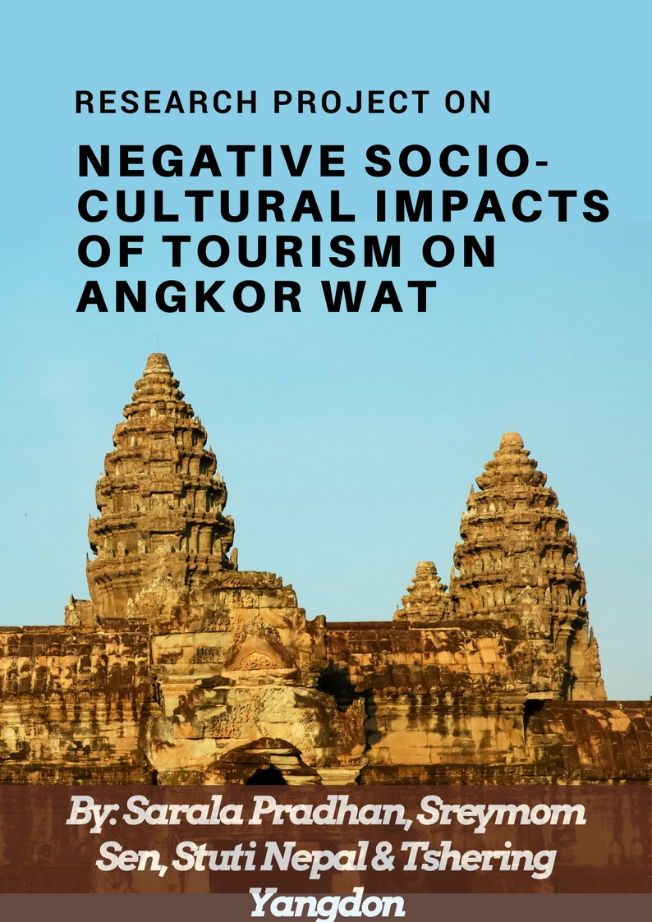

Table of Contents

1. Acknowledgements
2. Abstract
3. Introduction
4. Methodology
5. Questionnaire and Results
6. Reflection on Research Process
7. Conclusion
8. Works Cited

Acknowledgement
Since this was one of our first we got to learn many things that was new to us. We would like to thank Asian University for Women for this unforgettable opportunity. We are very grateful to our two advisors, Professor Tiffany Cone and Professor Sharmistha Ghosh for their guidance, expertise, feedback and support. We would like to extend our gratitude to the our volunteers (Chantrea Chek, Thida Kim, Meta Sen, Panith Puy, Danich Chhut, Savin Ky, Sokphanaly Eum, Ratha Touch). Lastly we are obliged by the participation of the people of Angkor Wat and the tourists who came to visit for spearing their valuable time and making this study possible.

Abstract
The increasing popularity of Angkor Wat, , the largest monument of the Angkor group as tourist destination in both national and international tourism resulted in economic growth but also caused irreparable destruction to the local culture and environment. The purpose of this study is to analyze the socio-cultural impacts of this tourism on the people living around the Angkor Wat area, to see how tourism and socio-cultural impact as interconnected. The study is based on primary data collected through a mixed methodology approach, with direct observation and semi structured interviews to see the current status of the resident perceptions of tourism. Results from this study support the idea that there is a strong interrelationship between tourism and socio cultural impact upon residents. This research will highlight the importance of community perceptions of tourism and how far it has impacted them.

Introduction
Angkor Wat, the largest monument of the Angkor group was recognized by UNESCO as a World Heritage Centre in 1992. According to UNESCO, Angkor is an archaeological site that extends over approximately 400 square kilometers and has a very significant importance because it contains the remains of The Khmer Empire that has been part of Cambodian identity. Therefore, Angkor Wat has a strong cultural, religious, and symbolic value, as well as aesthetic and artistic significance (UNESCO). As result, with its impressive proportion of unique architectural style and sculptural decoration, a lot of domestic and international tourists come each year to visit. The increasing popularity of Angkor as a tourist destination has brought economic growth but also caused irreparable destruction to culture and environment.
Our project aims to analyze the socio-cultural impacts of this tourism on the people living around the Angkor Wat area. We believe that there are indications of significant socio- cultural impacts on the people but there are limited resources for reference so this project would help us understand and get a firsthand knowledge about the current impacts tourism has on the community surrounding it. This is done to better understand problems facing Cambodia through observation and interviewing local people as well as tourists.

In our research group, we come from different countries that have different historical sites that attract tourists. It would thus be a base study to apply these patterns of Angkor Wat to our own communities.

Methodology
Due to the limitation of the budget, only one of our members was able to carry out the field work and collect data. The research method for our project was primarily qualitative, based on observation and questionnaires. The observation was based on what happened around Angkor Wat during the two weeks of field work. One of our members went to the field every single day within two weeks, out of which half day was for observation and the other half for interviews. The observation included their way of greetings, behaviors, education, price of commodities, and the use of languages. Sometimes, people were observed during the morning and the afternoon. While the observation was done, random questions were asked to the people who were affected by the tourists that came and visited Angkor Wat. Then, the data was recorded down. The observation was not only based on what was seen, but also based on the questions asked on how does it affect them in a negative way.
While carrying out the questionnaires, we got help from volunteers that live in the region. There were eight volunteers and they were divided into four groups. Before they decided whether they wanted to volunteer with the project, a small information session about the project was conducted to make sure they understood the study, the purpose of the study, and how it was going to be conducted. Our aim was to interview drivers, sellers, and local tourists because they had been there throughout the years and experienced the changes in the region. When we got the targets, the group were spread in different directions and conducted interviews all over the place. Even though the participants were randomly chosen during the interview, still the target groups were in our mind. Before conducting the interviews, the interviewers (Sreymom and volunteers) who carried out the interview introduced themselves and explained about the study. There were few participants who denied to take part in the interview because of their different interest and they were not questioned. While interviewed the participants, we added some questions because our aim was to get the negative impacts but people only gave us the positive that they had experienced. In addition, some participants could not answer the questions due to their lack of education and some found it hard to answer so we told them they could stop the interview or they could pass to the next questions.

Questionnaire, Observation And Findings:
As mentioned in the methodology, our project was based on observation and questionnaires. A few of the results were based on the observation and the rest on questionnaire. In total, a series of 13 questions related to the project were asked to the individuals for the findings. The questions were focused on the individual’s thoughts regarding the impacts of tourism in Angkor Wat area. Out of thirteen questions, three of them were put on priority as our topic was based on the negative socio-cultural impacts of Tourism in the area. The rest of the questions that were asked added support to the main topic. It was considered not only to ask many questions and get many responses, but also to include a few topic related questions so as to gather a wide range of thoughtful answers.

Foreign Influence in Language
According to the responses we got from the participants, most of them were happy about the language influence. They said that it is actually an opportunity for them to learn another language and culture that comes with the language. As per our topic, the questions and the observations were related to the negative part of foreign influence but in contrast, most of the participants took it as an opportunity. However, there were definitely other participants who thought foreign influence had negatively impacted their lives and the society. These differences in the answers were actually because of the age gap between participants. The group that said it was actually an opportunity belonging to the younger generation who were enthusiastic and excited about learning new things. On the other hand, the group that said the foreign influence was not a positive impact belonged to the older generation who wanted to preserve the Khmer tradition be it a language or other cultures.

Increase in Beer, Karaoke, Pubs and Clubs
Some of the participants, especially those who were involved in tourism business took this in a positive way. According to them, the increase in these things actually helps them foster their business and job. Besides them, there were other few participants who were also positive about these as they get the chance to go and enjoy in the clubs and pubs. According to them, it was not doing any harm to the community. On the different note, there were also few participants who said this has negatively impacted an individual’s life and society. The increase in alcoholic goods and clubs have increased the mortality rate as people started drinking and driving and due to the same reason there has been an increase in family disputes that sometimes result in violence. In addition to that, the number of prostitutes has increased and even the rate of rape.

Erosion and Degradation of Sculptures and Environment
According to the participants, there has been soil erosion because of the rapid deforestation. As the number of tourists has been rapidly increasing in that area, the trees around it has been cut off by the Government in order to start the new construction and that has negatively impacted the environment and the whole society nearby. The participants also said the sculptures inside Angkor Wat area have been degrading because tourists are repeatedly touching those with their hands. Talking about the environment, the participants seemed to be happy about how the cleanliness of the area has improved with the increase in tourism. The local people have become quite a lot careful regarding the cleanliness of the area and a result it has improved a lot.
Below is the graph that shows the result of the project:
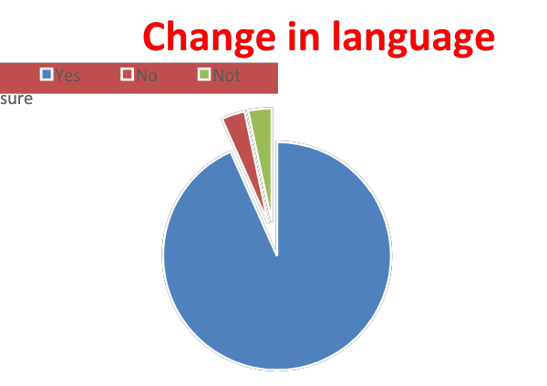
- As shown in the graph, most of the participants said that has been change in language due to the foreign influence, whereas only few of them said there hasn’t been any change and the rest weren’t certain about it.
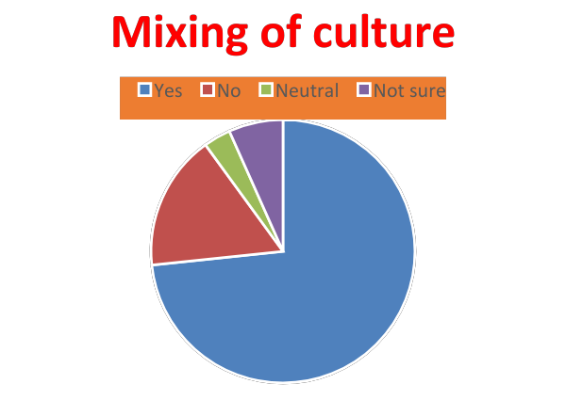
- According to the graph, more than half of the participants said there have been mixing in the culture due to the foreign influence. Some of them said that there has not been any impacts in the Khmer culture due to the foreign influence, very few of them were neutral about it and the rest weren’t sure either there has been mixing of cultures or not.
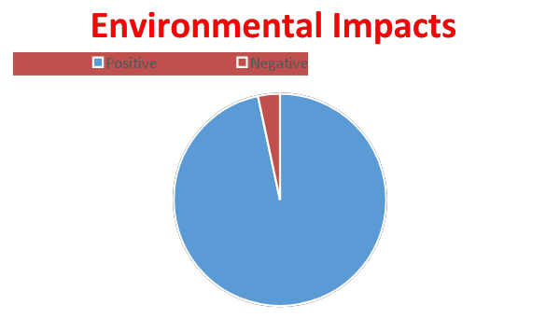
- As shown in the graph, almost all the participants were positive about the environmental impacts because of the tourism whereas very few of them said there have been negative impacts as well.
Education
Due to the increase in the number of tourists, some of the school children stop their studies and get involved in selling souvenirs and working in tourism industries. In some cases, the parents are the ones who force their children to drop out from the school and start working in the tourism sector as they can easily make money. This has certainly impacted their education in a negative way. But in addition to that, it has changed the perspectives of the children about school and education. Due to this reason, the number of kids going to school has decreased and this has greatly affected in the literacy rate in whole Cambodia.

Increase in the Price of Commodities
Most of the daily required products in Cambodia are imported mainly from Thailand and other neighboring countries due to the lack of factories in Cambodia. Aas there is very high demand of the domestic products by tourists, their prices have increased a lot. Not only the domestic products, but also the imported ones are very expensive as well. This has a great impact on the locals especially poor and lower middle class and their day to day lives. Due to this, the savings of the local has dropped by a lot and they aren’t able to save even for the emergency situation. As a result, the local people tend to migrate to the countryside as they are unable to afford the goods there anymore.

Change in the Behavior of Local People (Greeting, tone)
Some tremendous changes in the behavior of the locals were found during the observation. Due to the regular foreign influence, the local people especially the younger group tend to copy the foreign gestures that includes greetings, tone. This leads to the disrespect to the Khmer culture and keeps it in shadow.

Findings
1. Foreign Influence in language
With the rapid growth of tourists in Angkor region, the foreign influence in language has increased by a lot. According to the people we interacted with, there have been positive and negative change occurred in language. There were different responses from different age groups given that we interviewed both adult and older population. As per the finding, the adult population tends to take it as a positive aspect whereas the population of older ones said that has a negative impact. They said it was positive as they took it as a learning process and the other groups took it negative because they were scared that Khmer language might be dissolved and disappeared in the period of years.

2. Increase in Beer, Karaoke, Pubs and Clubs
There has been a lot of increment in Pubs and Clubs. Being one of the busiest tourist areas, the local restaurants have started pubs and clubs and the consumption of beers and other alcoholic
beverages has increased. According to the responses we got, the only group that was benefited by this increment was the seller. According to them, their business has increased tremendously after the addition of alcoholic beverages in their shops. On the other hands, rest of the responses we got was negative. According to them, the increase in beers, karaoke, pubs and clubs have done nothing good but increased the violence in the family and the society. There were also some responses regarding in the increase in rape cases and prostitution.

3. Erosion and Degradation of Sculptures and Environment
There has been degradation in the sculptures inside Angkor Wat. Due to the lack of proper rules and regulations especially for the tourists, according to the participants are the main cause of degradation. The main cause of degradation is the ways tourists repeatedly touch those sculptures. Another major concern is soil erosion caused due to the deforestation. According to the local responders, the Government made an order to cut down trees so that the empty space can be used for the further construction works.
In contrast to our assumption prior the fieldwork, there was tremendous improvement in case of environment. Due to the increase in tourists and for the attraction of more, the environment has been cleaner than before and all the responder took it positively.

4. Education
According to almost all the responders, education has been highly fallen down. Numbers of school children are busy taking part in tourists business and dropped out of the school. Some of them do it by their own will but there are others who are forced by their parents in order to sell the souvenirs to the tourists as it is the easiest way to make money. According to them, this has not only affected the education in that area but the education in whole Cambodia.

5. Increase in the price of Commodities
The Price in commodities have raised by several percentages as Angkor Wat is the tourist area. According to the responses, the local people have been greatly affected due to the raise in the prices of even the daily products. Whereas, the sellers seem to be happy about it as they get more profit than before. But this has increased the migration as the people there are unable to afford the goods with the increase in price and leave the place.

6. Change in the Behaviour of Local People (Greetings, tone)
Few changes in the behaviour of local especially the younger population was found. Most of the responders were not very happy seeing the changes in youths. According to them, the younger generation have started to greet differently than the traditional Khmer greetings and their behaviors upon Khmer culture is disappearing bit by bit. It gives rise to disrespect to the Khmer culture.

Reflection on Research Process
We were able to meet our aims of the project in the following ways. Firstly we were able to learn to apply classroom knowledge such as critical thinking, teamwork, writing skills and decision making while carrying out the project. In different stages of the project from the proposal, data collection, analyzing the data to writing the report we were able to convert the theoretical knowledge we learnt in classes to practical use. Secondly we were able to learn to carry out a research with proper methodology. For our research we used both qualitative and quantitative paradigms of research. By using both the methods we were able to get a better understanding of our topic. Qualitative questions like whether there is a negative or positive impact of tourism on the environment, or whether there is any influence of other cultures on the Cambodian culture gave us a general idea about the issues. While the qualitative research questions such as specifying the environmental impacts on Angkor Wat gave us more opinion orientated insight into the subject such as degradation of sculptures due to physical touch. Thirdly there was a limitation to our study because of the language barrier as three out of the four researchers were non Khmer speaker. We were able to overcome this set back by recruiting volunteers from the locality that helped us in the project.
The biggest constraint for us was not being able to convince people to participate. People usually thought that this study was related to the government and if they participate they might get into trouble. Some people seemed a little lenient to participate hence it took longer for us to find participants who would participate freely. A lot of them were uneducated, which made understanding the subject more difficult and explanation longer. Despite the shortcomings we were able to find 30 participants who added their valuable insight.

Conclusion
In terms of our research question, our overall summary is as follows. We found that there are negative socio-cultural impacts of tourism on Angkor Wat site. To summarize the negative impacts, these included: foreign influence on language, increase in beer-drinking, karaoke, pubs and clubs, erosion and degradation of sculptures and environment, increase in the price of commodities, education of school going children by dragging them into labor market (to sell souvenirs), and finally change in the greeting tone of the locals. On contrary there was also some positive impacts of tourism which proved one of the claims in our hypothesis wrong. Angkor Wat being a tourist spot made the authority take care of its surrounding by regular cleaning and maintenance. Can you make a comment here perhaps about what you would look at in any future study, to follow up on some of these findings?

Work Citation
Glancey, Jonathan. “Culture: The Surprising Discovery of Angkor Wat.” BBC, 14 March 2017.
http://www.bbc.com/culture/story/20170309-the-mystery-of-angkor-wat
“Impacts of Negative Issues That Affect Tourist Tourism Essay.” UKessays.com, 23 March 2015.
https://www.ukessays.com/essays/tourism/impacts-of-negative-issues-that-affect-tourist- tourism-essay.php
Rod-ari, Melody. “Angkor Wat.”College aboard, Khan Academy, 13 May 2015.
https://www.khanacademy.org/humanities/ap-art-history/south-east-se-asia/cambodia-art/a/angkor-wat
Soubert, Son. “Case Study on the Effects of Tourism on Culture and the Environment.” UNESCO Principal Regional Office for Asia and the Pacific, 2 June 2015.
http://unesdoc.unesco.org/images/0012/001226/122618Eo.pdf
“World Heritage List: Angkor.” World Heritage convention, UNESCO, 20 Dec 2017.
http://whc.unesco.org/en/list/668

